Low Reynolds Number Vertical Axis Wind Turbine for Mars

Vimal Kumarª,∗, Marius Paraschivoiuª, Ion Paraschivoiu^{b}
ªDepartment of Mechanical and Industrial Engineering, Concordia University, Montreal, Quebec, CANADA
^{b}Department of Mechanical Engineering, Ecole Polytechnique Montreal, Montreal, Quebec, CANADA

Abstract
A low Reynolds number wind turbine is designed to extract the power from wind energy on Mars. As compared to solar cells, wind turbine systems have an advantage on Mars, as they can continuously produce power during dust storms and at night. The present work specifically addresses the design of a 500 W Darrieus-type straight-bladed vertical-axis wind turbine (S-VAWT) considering the atmospheric conditions on Mars. The thin atmosphere and wind speed on Mars result in low Reynolds numbers (2000–80000) representing either laminar or transitional flow over airfoil, and influences the aerodynamic loads and performance of the airfoils. Therefore a transitional model is used to predict the lift and drag coefficients for transitional flows over airfoil. The transitional models used in the present work combine existing methods for predicting the onset and extent of transition, which are compatible with the Spalart-Allmaras turbulence model. The model is first validated with the experimental predictions reported in the literature for an NACA 0018 airfoil. The wind turbine is designed and optimized by iteratively stepping through the following tasks: rotor height, rotor diameter, chord length, and aerodynamic loads. The CARDAAV code, based on the “Double-Multiple Streamtube” model, is used to determine the performances and optimize the various parameters of the straight-bladed vertical-axis wind turbine.

Keywords: Wind, Mars, aerodynamic coefficients, Vertical-axis wind turbine (VAWT), CARDAAV, Transition modeling, Computational Fluid Dynamics (CFD)

1. Introduction

Wind turbines and solar cells are excellent devices for the production of power by utilizing the available natural resources on Mars. However, both wind energy and sunlight are highly variable source for energy production on the surface of that planet. Power generation with solar panels is dependent on the availability of sunlight, while for wind turbines it depends on favorable wind conditions. From the environmental study on Mars¹, it can be seen that in some locations Mars is subjected to regular high-velocity winds. Mars has local dust storms of at least a few hundred kilometers in extent every year and, in some years, has great dust storms which can span most of one or both hemispheres. Global dust storms on Mars absorb solar radiation high in the atmosphere and thereby both decrease the surface maximum temperature and increase the upper atmospheric temperature, leading to the high wind speeds on the planet’s surface. Herein lies the disadvantage of solar cell application on the Mars surface, during the dust storm sand particles prevent the sunlight from reaching the surface. Considering the above mentioned facts, in the present work a wind turbine has been designed to produce power on Mars utilizing its wind resources.
The wind is an environmental friendly energy source that has been used for a very long time for various applications on Earth such as pumping water, grinding grain, supplying electricity, etc. For the design of wind turbines on Mars it is necessary to understand the atmosphere of that planet with comparison to the Earth’s atmosphere. The Martian atmosphere differs greatly from the Earth’s environment. In summary, the solar constant for Mars is 597 W/m² while for Earth it is 1373 W/m² (Larsen². However, for both Mars and Earth there is significant overlap between the temperature bands, on Mars surface the reported temperature variation is: −125 ⁰C to +25 ⁰C, while on Earth the corresponding range is: −80 ⁰C to +50 ⁰C. Furthermore, (1) Mars atmospheric pressure is approximately 1.0% that of Earth, (2) Mars is much colder than Earth, and (3) Mars has no liquid water; nonetheless many of its meteorological features are similar to terrestrial ones. The characteristics of the atmospheres of Mars and Earth are summarized in Table 1.
From Table 1 it can be seen that the largest difference is in the air pressure and density, a difference that in turn produces similar differences between the kinematic viscosity, heat conductivity and heat capacity of the air on both planets, which results into thinner atmosphere on Mars as compared to the Earth. The thin atmospheric on Mars would first appear to indicate that it would be an unlikely candidate for wind energy. However, the extraction potential of power from the wind is a function of velocity cubed and only proportional to density (Eq. 1), therefore, high winds can make-up for low density.

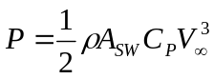 (1)
where P is power (W), ρ is the wind density (kg/m³), A_{SW} is the swept area (m²), C_{P} is the power coefficient and V∞ is the free stream velocity.
A straight vertical axis wind turbine (SVAWT) is considered for the power generation on Mars due to its various advantages as compared to the horizontal axis wind turbines. The main advantage of VAWT is its single moving part (the rotor) where no yaw mechanisms are required, thus simplifying the design configurations significantly and allows them to operate independent of the wind direction. Blades of straight-bladed VAWT may be of uniform section and untwisted, making them relatively easy to fabricate or extrude, unlike the blades of HAWT, which should be twisted and tapered for optimum performance. Furthermore, vertical wind turbine blades do not experience fatigue stresses during rotation from gravitational forces³. Additionally, the Darrieus S-VAWT may be much more amenable to a deployable installation. For the design of S-VAWT on Mars various aspects covered in the present paper are:
- Assessment of the wind resources on Mars,
- Present a wind turbine design methodology based on CARDAAV appropriate for these conditions (aerodynamics loads and performance);
- Present a preliminary design for low Reynolds number flows (chord length, rotor diameter, rotor height, aerodynamic loads and etc.)

2. Wind resources on Mars

Considering the fact that the Mars atmosphere is thin, an intermediate size wind turbine is designed which can generate power of 500 W on Mars. The range of wind speeds needed to be determined in order to optimize the aerodynamic performance of the wind turbine. Because there is little data on Martian wind speeds, this decision needed to be based on a combination of analysis of the data and engineering judgment. The existing data consists of measurements taken at the Viking lander site and several meteorological studies. It is difficult to make any decisions based on the Viking data as the measurements were made separately for north-south and east-west winds with no correlation between the two. Further the wind speed reported for the height of 1.5 m from Mars surface^{4–5}. In the present work the wind profiles on the surface of the Mars reported by Greeley and Iversen⁶ are considered for the wind turbine design (Figure 1). From Figure 1 it can be seen that for the height of 0.5–10 m from the surface of Mars the wind speed vary from 15–26.5 m/s. Therefore an intermediate value of 20 m/s of wind speed have been considered for the design of wind turbine.

3. Design and modeling of wind turbine (aerodynamics loads and performance)

The CARDAAV code, based on the double-multiple-streamtube model⁷, is used to predict the aerodynamic loads and performance of wind turbines. In multi-streamtube modeling the volume swept by the revolution of the rotor is considered as a series of adjacent aerodynamically independent stream tubes. The CARDAAV model considers a partition of the rotor in streamtubes and each streamtube is treated as an actuator disk (Figure 2). Figure 2 shows the streamtube and the velocity values of the flow at various key stations along it. The multiple-streamtube model divided in two parts: the upstream half-cycle (disk 1) and the downstream half-cycle (disk 2) of the rotor. The calculation of the velocity values through the rotor is based on the principle of the two actuator disks in tandem at each level of the rotor. The different values of the velocity (see notations in Figure 1 and relations 2–4) depend on the incoming (“free stream”) wind velocity and on the interference factors u and u′:

V = u.V∞ (2)
V_{e} = (2u-1).V∞ (3)
V′ = u′.(2u-1).V∞ (4)

where u′=V′/V_{e} is the second interference factor. To determine the interference factors, a second set of equations is used. The upwind and downwind velocities were obtained by iterating and equating the forces given by the blade element theory and actuator disk theory⁷. The aerodynamics loads, lift (C_{l}) and drag (C_{d}) coefficients obtained from airfoil data are used to predict the normal and tangential forces using blade element theory. Then the torque and the mechanical power are computed.
The CARDAAV code requires three main sets of input parameters to design the wind turbine: geometrical parameters (diameter, height, blade section airfoil, blade shape etc.), operational conditions (wind velocity, rotational speed, atmospheric conditions) and control parameters (convergence criterion, computation of the secondary effects and the effect of dynamic stall). Further the CARDAAV code has the following capabilities:
- It can analyze several predefined or user-defined rotor shapes with straight or curved blades (parabola, catenary, ideal and modified troposkien, and Sandia shape).
- It has several dynamic stall semi-empirical models: its variations (Strickland, Paraschivoiu and Berg) and one based on the indicial method⁷. In the present work the dynamic stall model used is the Berg version of the Gormont model, because it was found to be the best correlated with the experimental studies reported on similar rotor configurations.
- It is also able to account for the secondary effects (rotating central tower, struts, and spoilers).
- Wind speed can vary with height above ground according to a power law.

The program output consists of the local induced velocities, the local Reynolds numbers and angle of attack, the blade loads, and the azimuthal torque and power coefficient data. Each of these is parameters calculated separately for the upwind and downwind halves of the rotor. The numerical models used by the program have been validated for different Darrieus-type VAWTs, through comparison with experimental data obtained from laboratory tests (wind or water tunnels) or from field tests, thus making CARDAAV a very attractive and efficient design and analysis tool. Recently, Saeed et al.⁸ have shown the application of CARDAAV code in combination with XFOIL code for the design of airfoils.
The CARDAAV code uses the values of aerodynamic lift and drag forces to calculate the torque and normal forces which in turn are used to calculate overall turbine performance. Considering the wind speed and atmospheric characteristics (Table 1) on Mars the Reynolds number (based on chord length, c = 1.0 m) varies from 5000 to 80000, even some times it may be lower than the 5000. For low Reynolds numbers transition and separation of the boundary layer is a dominant feature and influences the lift and drag characteristics. The lift and drag coefficients typically available in the literature may not be completely accurate for Martian conditions as values at lower Reynolds numbers are often extrapolated. The wrong values of lift and drag coefficients may results into inaccurate predictions of power coefficients, which may results into inaccurate power production on Mars. Therefore for low Reynolds number airfoil flows (Re ≤ 10⁶), proper modeling of the transitional flow is crucial for predicting the performance of the wind turbine.
A new data set of the aerodynamic coefficient for the blade used is required for low Reynolds numbers. The newly predicted values of C_{L} and C_{D} will be used in CARDAAV to predict the aerodynamics loads of wind turbine on Mars. In the next section the approach to predict the airfoil characteristics for low Reynolds numbers is discussed.

3.1 Transition modeling
Laminar to turbulent transition modeling is one of the key factors affecting CFD-based lift and drag predictions using Reynolds Averaged Navier-Stokes (RANS) equations. Failing to accurately predict the transition behavior in the boundary layer has an adverse effect on the computed lift and drag, as well as on the other flow properties. This is due to the large discrepancy in shear stress between the laminar and the turbulent regions and flow separation (which is usually followed by transition in the free shear layer and reattachment). [This is not strictly true: the main issue at low Re is laminar separation which is usually followed by transition in the free shear layer and reattachment]The flow behavior in these two zones differs significantly and thus all the flow variables. Add to this the fact that the transition zone might, in some cases, extend over a significant part of the airfoil surface. Thus in cases where the laminar and the transition zones occupy a relatively large portion of the airfoil surface, neglecting the effects of these two zones by assuming fully turbulent flow over the entire airfoil will definitely result in numerically computed flow properties that diverge from the actual ones. This will lead to an inaccurate evaluation of the viscous properties in the boundary layer as well as capturing the existence of a separation bubble, and consequently an in accurate lift and drag prediction.
In the present work the model and methodology developed by Basha and Ghaly⁹ have been used to predict the lift and drag coefficients at low Reynolds numbers (1000–160000). The transition region in a fully turbulent boundary layer is developed and implemented into the flow solver, Fluent, using intermittency function Γ, which is introduced using the user-defined function (UDF) feature that is available in Fluent. The modified effective viscosity is equal to:

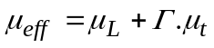 (5)

Thus for Γ equal to zero, the boundary layer is fully laminar and Γ equal to one the boundary layer is fully turbulent. For any value in between 0 and 1, the flow is in the transition region. The UDF gives access to different variables in the flow solver and thus allows for modifying them. For the prediction of intermittency function the equations proposed by Cebeci and Smith¹⁰ and Cebeci¹¹ were used. The turbulent viscosity μ_{t}, computed using the fully turbulent Spalart-Allmaras turbulence model, is multiplied by Γ to reflect the introduction of the laminar and the transition zones into the fully turbulent boundary layer. Thus the modified effective viscosity μ_{eff} is computed using equation (5). Then the procedure is implemented into the flow solver Fluent, where the Spalart-Allmaras (SA) model is used as the turbulence model. Further details for the model equations and methodology for transition predictions can be seen from Basha and Ghaly⁹.
3.1.1 Accuracy assessment
To assess the accuracy of the solver (FLUENT) and to verify the effectiveness of the transitional model, flow simulations were carried out for NACA0018 airfoil. Before creating the data set for the complete Reynolds number range (1000–160000) needed for our Mars project, the results from new transition model were compared with the experimental data of Pawsey¹² and were also compared with those obtained with the fully turbulent flow simulations. The computational domain extends 20–30 chords away from the airfoil. A structured C-mesh shown in Figure 3 is built around the airfoil so as to control y+ and the mesh stretching near the airfoil surface, and it extends for about 25% of the chord length at the trailing edge to capture the boundary layer and wake. The distance of the first cell from the airfoil surface was taken to be 10⁻⁵ chord with the boundary layer structured mesh stretching for 35 cells in the direction normal to the airfoil surface (Basha and Ghaly⁹). As for the grid distri-bution in the trailing edge-region, dx(dy) starts at 10⁻⁴ (10⁻⁵) at the trailing edge and gradually increases in the streamwise direction away from the trailing edge. As for the grid, the number of nodes used to define the airfoil surface is 490, clustered near the leading and trailing edges to capture the flow behavior there; the whole mesh is composed of 70,400 nodes. The far fields boundary conditions follow from the Riemann invariants (FLUENT, 2005).
Basha and Ghaly⁹ reported that the fully turbulent Spalart-Allmaras model provided results for C_{D} and C_{L} more accurate than the renormalization group (RNG) k-ε models. For the convergence of the solution, the value of the residuals varies between 10⁻¹⁰ for low angle of attack cases and 10⁻⁵ for near-stall-angle of attack. More information on the numerical scheme and accuracy can be found from Basha¹³.
The numerical simulations for the comparison with experimental predictions correspond to the following freestream conditions: Mach number Ma∞ = 0.00762, Reynolds number Re_{C} = 160000, and a range of angle of attack varying between 0⁰ and 25⁰. Figure 4a and 4b compares the variation of drag and lift coefficients with angle of attack, α for four sets of data: one set is given by experimentally and other two sets are obtained numerically by using the fully turbulent and the free transitions models and the data of Sheldahl and Klimas¹⁴.
Examining the lift coefficient (Figure 4a), the improvement achieved in numerical drag computations by switching from fully SA turbulence model to the developed free-transition one is quite-clear. For α = 5º, the experimental value of lift coefficient deviated from the free transition model prediction by ~10% whereas the value predicted using the fully turbulent model is in error by 21%. On the other hand, for α = 10⁰ the deviation between the experimental and free transition model is 1.4%. For angle of attacks between 15 and 25 deg, the deviation between the measured lift coefficient and those obtained using the fully turbulent model is on the average 10%, whereas the deviation between the experimental values and those obtained using the free-transition model is on the average of 1%. As for drag coefficients (Figure 4b), the curve can be divided into two sections: one corresponding to low values of angles of attack where α ≤ 10⁰ and another one that α >10⁰. For the first section, the free transition model over-predicts the drag with a maximum deviation of 15% at zero angle of attack, whereas the difference between the experimental and predicted values using the fully turbulent model is less than 3%. However for angles of attack higher than 10⁰ the values predicted using the free-transition model are closer to the experimental data with a deviation equal to 2.8%.
The values obtained from free-transition SA model was found in good agreement with the experimental values of C_{D} and C_{L} at Re = 160000 for various angle of attacks. Further the comparison of lift and drag coefficients obtained using Fluent S-A free transition model has been made with the calculated NACA 0018 data of Sheldahl and Klimas¹⁴ for Reynolds number ranging from 10000 to 160000. Figure 5a and 5b show the comparison of aerodynamics coefficients calculated with free transition model and the data of Sheldahl and Klimas¹⁴. From Figure 5a it can be seen that the lift coefficient is higher for the free transition model predictions as compared to the values reported by Sheldahl and Klimas¹⁴ for the entire range of Reynolds number and angle of attacks. Figure 5a also shows the negative values of lift coefficients reported by Sheldahl and Klimas¹⁴ for Reynolds number from 40000–160000 while smooth trends can be seen for the values obtained using free transition model.
In case of drag coefficients (Figure 5b), the curved can be divided into three sections: first section corresponding to low values of angles of attack where α < 10⁰, second for 10⁰ ≤ α ≤ 20⁰ and third section for α ≥ 20⁰. For α ≤ 10⁰ the drag coefficients predicted by free transition model are higher as compared to the results of Sheldahl and Klimas¹⁴, while for α ≥ 20⁰ values of drag coefficients obtained using free transition model are similar to the Sheldahl and Klimas’s predictions. For angle of attack ranging between 10⁰ and 20⁰ the drag coefficient values obtained using free transition model are less then the values reported by Sheldahl and Klimas¹⁴.

The novel aerodynamic feature of the flow around the turbine blade on Mars is the low Reynolds number due to the thin atmospheric conditions. A study (ref 15) of such a flow around a NACA0012 indicates that this airfoil does not stall at a Reynolds number of 5000. It is argued that at a low Reynolds number there is no separation bubble indicating that the separated boundary layer remains laminar and does not reattach, therefore preventing stall where stall is the condition when the angle of attack increases beyond a certain point such that the lift begins to decrease. [I know Ref. 15 says this but a non-reattaching boundary layer means the flow has stalled. The key Re-issue is lack of transition in the separated laminar flow]. This flow is also observed in our simulations. From Fig. 6 it can be seen that the boundary layer separates but does not reattach. Similarly, in Fig. 7a, there is no stall for Reynolds number less than and equal to 10,000 but appears for Reynolds number of 20,000. For the NACA0012 stall was measured and observed for a Reynolds number of 10,500 and higher.
To predict the power coefficient and optimize the design of wind turbine for Mars, a large data set was constructed for C_{D} and C_{L} values for Reynolds number varying from 1000–160000 and angle of attack varying from 0⁰–25⁰ (Figs. 7a and 7b) using Fluent S-A free transition model for NACA 0018. Note that to investigate a different airfoil a new data set must be built.

4. Wind turbine for Mars

The turbine design presented here is a Darrieus straight bladed vertical axis wind turbine (S-VAWT). The different parameters considered for the wind turbine design on Mars to maximize power output (P) and aerodynamic efficiency (C_{P}) are:
- Blade profile type
- Number of blades, N
- Turbine radius, R (m)
- Blade length, H (m)
- Blade chord length, c (m)
- Rotation speed as a function of the wind speed, ω (rad/s)

Results were analyzed in terms of the solidity of the turbine (σ = Nc/R), ratio of rotor radius to rotor height (β = R/H), and the ratio between the blade tip speed and the wind speed, the tip speed ratio (TSR = Rω/V∞) where N denotes the number of blades, c the chord length, R the turbine radius, H the turbine height, and V∞ is the free stream velocity. All the above mentioned design parameters are not free. Some can be chosen based on the data reported in the literature, such as number of blades, blade profiles and tip speed ratio (TSR). Other parameters are held fixed to shorten the amount of time needed. Following parameters are held fixed:
- Number of blades: 2
- Blade profile type restricted to symmetrical airfoils: NACA0018
- Tip speed ratio (TSR): 3, 3.5 and 4

The choice of two blades is mainly motivated by minimizing weight and reduction in complexity. Initially three TSR values were chosen as it is the range of earlier VAWT designs. The three values for TSR (3, 3.5 and 4) are chosen based on the operating range of vertical axis wind turbines reported in the literature^{16–18}. The optimization process was limited to the symmetric NACA 0018 due to boundary layer uncertainties and the peak power obtained for a lower tip speed ratio for the same power coefficient¹⁷. The dynamic stall behavior of the NACA 0018 has been considered for low Reynolds number range. The NACA 0018 section has been extensively used both in previous Darrieus and H-rotor projects¹⁹. Its use is well documented in terms of vertical axis wind turbine motion²⁰, and it offers a good compromise in terms of thickness and dynamic behavior. Table 2 summarizes the parameters of the reference design.
The wind turbine for Mars has been designed by optimizing the power output for the wind distribution on Mars (maximize but with constraint that it should be on average more than 500 W and tip speed ratio nearly equal to 4), minimize the swept area (A_{SW}) and maximize the aerodynamic efficiency, C_{P} (Eq. 1). When choosing the turbine with best performance, not only power at the optimal TSR concludes but also power coefficients (C_{P}) value on which the performance is best. When the best performing reference design (number of blades, blade profiles, TSR and reference velocity) is chosen it was optimized (with respect to the swept area and chord length) to more exactly meet the mean power output demand. The last step is to redo the design process in a simplified way to ensure that the optimization process did not deteriorate the aerodynamic performance. [this paragraph is not clear: I do not see how the design needs to be scaled down as surely the required power of 500 W takes care of the size?]

4.1 Optimization of aspect ratio (β)
The design of wind turbine has been carried out by varying ratio of rotor radius to the rotor height from 1.0–2.0 and solidity (σ = Nc/R) from 0.2–0.3. The aerodynamic performance of a wind turbine is strongly affected by its tip-speed ratio. Tip speed ratio (λ = Rω/V∞), which is the tip-speed divided by the ambient wind velocity. Using a wind-speed using wind profiles on Mars surface, the tip-speed ratio is determined so that straight bladed VAWT for Mars would generate the maximum average power. For optimizing the dimensions of S-VAWT and maximizing the average power, the value of tip speed ratio is varied from 3–4. The value of free stream velocity (V∞) is kept constant at 20 m/s during the optimization of S-VAWT. Figure 8 shows the variation in aerodynamic efficiency with tip speed ratio for different values of aspect ration (β) and solidity (σ). It can be seen that aerodynamic efficiency when β = 1.75 and σ = 0.3 is higher than the other configurations for the objective function and constraints considered in the present work. Figure 8 also shows the optimum value of TSR as 3.8. Therefore for the final wind turbine configuration comprised β = 1.75, σ = 0.3 and TSR = 3.8 . For TSR values greater than 4 the flow becomes compressible as the Mach number is equal 0.32. The analysis here in is assuming incompressible flow but this effect should be included in future work.

4.2 Optimizing the solidity
In the analysis of the optimum solidity, the chord length is varied for NACA 0018 airfoil. The rest of the parameters in the reference design are held fixed. The results of Templin²¹ suggest that lower solidity generates a wider operating range in means [?] of TSR’s. A higher solidity generally makes the structure endure higher stresses and achieve maximum aerodynamic efficiency at lower TSR’s. Based on simulations performed by Templin²¹, Bouquerel²² and in the present work (Figure 8) a first guess for optimum rotor solidity is 0.3 to achieve an optimum C_{P} at TSR 3.8. A rotor solidity of 0.3 with a design using two blades and a radius of 4.725 m results in a blade chord of 0.71 m. To verify this assumption, simulations in the CARDAAV model have been performed for symmetrical blade profiles, NACA 0018. The solidity has been varied between 0.20 and 0.375 implying a chord length from 0.47 m to 0.89 m. The results from these simulations are presented in Figure 9. Based on the results using the CARDAAV model a solidity of 0.30 is chosen, which implies a blade chord of 0.71 m. This solidity is found near the maximum at λ = 3.8 in CARDAAV model and can meet the demand of a strong structure.

5. The proposed 500 W design

The above optimized reference design resulted in a mean power output of 500 W after the optimization of C_{P} (every C_{P} point along the C_{P} vs. TSR curve, Figure 10). The mean power output is calculated using CARDAAV model by incorporating the real wind speed frequency distribution and the control strategy described above. Table 3 summarizes the design parameters for the fully optimized 500 W wind turbine. Figures 10 and 11 present the power curve and C_{P} vs. TSR curve respectively for the proposed optimized S-VAWT design.

6. Conclusions

In the present work a low Reynolds number wind turbine is designed to extract power from wind on Mars. The design of a Darrieus-style straight blade Vertical Axis Wind Turbine (SVAWT) specifically performed for low Reynolds number wind turbine due to thin atmosphere on Mars as compared to Earth. Considering the density, viscosity and speed of wind on Mars the Reynolds number vary from 5000–80000, which is either laminar or transitional flow over airfoils. Transition from laminar to turbulent plays an important role in determining the flow features and in quantifying the airfoil performance such as lift and drag. Therefore a model developed by Basha and Ghaly⁹ has been used for transitional flows, which combines existing method for predicting the onset and extent of transition and is compatible with the Spalart-Allmaras turbulence model. The model is first validated with the experimental predictions reported in the literature. The lift and drag values obtained were used to compute the aerodynamic loads and performance for the airfoil used in the wind turbine design and implemented in the CARDAAV. The wind turbine is designed by iteratively stepping through the following tasks: chord length, rotor height and diameter, aerodynamic loads and etc. During the design and optimization of the wind turbine dynamic stall (Berg version of Garmont’s model) have been considered. However the secondary effects, such as those due to the rotating central tower, struts, and spoilers were not considered.
The objective of the present work is to develop a methodology to design a wind turbine for low Reynolds number as well as its application on Mars. For this first design of wind turbine on Mars a NACA 0018 airfoil is considered due to Mars harsh conditions (sand storm for several months and below absolute zero temperature) as it is structurally stronger and also tend to increase starting torque.
This work identified new important research directions. First, the design of a specific airfoil for very low Reynolds number but for Mach number as high as 0.5 with the main objective to increase the power coefficient of the turbine. To start the NACA 0009 airfoil which shows higher lift coefficient for low Reynolds number²³ will be investigated next. Second, design a turbine to maximize power to weight ratio. This optimization problem could be solved using CARDAAV together with an optimization code.
Acknowledgments
This work was supported in part by the Natural Sciences and Engineering
Research Council of Canada (NSERC).
References
- Kaplan, D., 1988. Environment of Mars, NASA Technical Memoradum 100470.
- Larsen, S.E., Jorgensen, H.E., Landberg, L. and Tillman, J.E., Aspects of the atmospheric surface layers on mars and Earth, Boundary-Layer Meteorology, 2002, 105, 451–470.
- Walker, J.F. and Jenkins, N., Wind Energy Technology, John Wiley and Sons, New York, NY, 1997.
- Haslach, H.W.Jr., Wind Energy: A Resource for a Human Mission to Mars, Journal of the British Interplanetary Society, 1989, 42, 171–178.
- Sullivan, R.J., Threshold-of-motion wind friction speeds at the mars pathfinder landing site, Lunar and Planetary Science XXXIII, 2002, 2022.
- Greeley, R. and Iversen, J.D., Wind as a Geological Process: On Earth, Mars, Venus and Titan, Cambridge University Press, 1987.
- Paraschivoiu, I., Wind Turbine Design: With Emphasis on Darrieus Concept, Polytechnic international press. Canada, 2002, 42, 377–378.
- Saeed, F., Paraschivoiu, I., Trifu, O., Hess, M., Gabrys, C., An inverse airfoil design method for low-speed straight-bladed Darrieus-type VAWT applications, The Proceedings of the 7th World Wind Energy Conference 2008, Kingston, Ontario, Canada, 2008.
- Basha, W.A., Ghaly, W.S., Drag prediction in transitional flow over airfoils, Journal of Aircraft, 2007, 44, 824–832.
- Cebeci, T. and Smith, A.M.O., CS Method for Turbulent Boundary Layers, Analysis of Turbulent Boundary Layers. 1st ed., Academic Press, New York, 1974.
- Cebeci, T., Two-Dimensional Incompressible Flows: Transition Method, Engineering Approach to the Calculations of Aerodynamics Flow. 1st ed., Springer, New York, 1999.
- Pawsey, N.C.K., Development and evaluation of passive variable-pitch vertical-axis wind turbines, Ph.D. thesis, The University of New South Wales, Sydney, Australia, 2002.
- Basha, W.A., Accurate drag prediction for transitional external flow over airfoils, M.Sc. Thesis, Concordia University, Montreal, Canada, 2006.
- Sheldahl, R.E. and Klimas, P.C., Aerodynamics characteristics of seven symmetrical airfoil sections through 180-degree angle of attack for use in aerodynamic analysis of vertical axis wind turbines, Report number SAND80-2114, 1981.
- Alam, M.M., Zhou, Y., Yang, H.X., The Ultra-low Reynolds number airfoil wake. Exps Fluids, 2010, 48, 81–103.
- Wahl, M., Designing an H-rotor type wind turbine for operation on Amundsen-Scott south-pole station. UPTEC ES07 030, Sweden, 2007.
- Solum, A., Deglaire, P., Eriksson, S., Stålberg, M., Leijon, M. and Bernhoff, H., Design of a 12kW vertical axis wind turbine equipped with a direct driven PM synchronous generator, in EWEC 2006 – European Wind Energy Conference & Exhibition, Athens, 2006.
- Deglaire, P., Eriksson, S., Kjellin, J., Leijon, M. and Bernhoff, H., Design of a 12kW vertical axis wind turbine equipped with a direct driven PM synchronous generator, in EWEC 2007 – European Wind Energy Conference & Exhibition, Milan, 2007.
- Mays, I.D. and Morgan, C.A., The 500KW VAWT Demonstration project, in EWEC 1989 – European Wind Energy Conference & Exhibition, 1989.
- Angell, R.K., Musgrove, P.J. and Galbraith RAMcD., Collected data for tests on a NACA 0018 airfoil, Report 8817, University of Glasgow, Department of Aerodynamics Fluid Mechanics, 1988, 3.
- Templin, R.J., Aerodynamic Theory for the NRC Vertical AxisWind Turbine, National Research Council, Canada, LTR-LA-160, 1974.
- Bouquerel, M., Swedish Centre for Renewable Electric Energy Conversion, Division for Electricity and Lightning. The Ångström Laboratory, Uppsala, 2000.
- Sunada, S., Sakaguchi, A., Kawachi, K., Airfoil section characteristics at low Reynolds number, Journal of Fluids Engineering, 1997, 119, 129–135.

Figure Captions [please indicate airfoil section and Re in the figure captions]

Fig. 1. Wind profile from wind speed data measured at four heights, with indicated z₀ = 0.01 m (Source: Greeley and Iversen⁶).
Fig. 2. Two actuator disks model (Source: Paraschivoiu⁷).
Fig.3. Grid topology over a NACA0018 airfoil.
Fig. 4. a) Pressure coefficient (C_{L}) vs angle of attack (α) and b) Drag coefficient (C_{D}) vs angle of attack (α) for NACA 0018 at Re = 160000.
Fig. 5. Comparison of present Fluent S-A free transition results with Sheldahl and Klimas¹⁴ for lift (a) and drag (b) coefficients vs angle of attack (α) for NACA 0018 for Re = 10000 - 160000.
Fig. 6. Velocity magnitude and streamlines for NACA 0018 at Re = 5000 and α = 5⁰ – 20⁰.
Fig. 7. Lift (a) and drag (b) coefficient values obtained using Fluent S-A free transition model for Reynolds number ranging from 1000 to 160000 for NACA 0018.
Fig. 8. Tip speed ratio vs power coefficient at various R/H (β) and solidity (σ) for NACA 0018.
Fig. 9. Tip speed ratio (TSR) vs power coefficient (C_{P}) for NACA 0018.
Fig. 10. Chord length (C) vs power coefficient (C_{P}) for NACA 0018
Fig. 11. Free stream velocity (V∞) vs power (P) for NACA 0018.

Table Captions

Table 1. Parameters characterizing climate and atmosphere for Mars and Earth (Source: Larsen et al.²)
Table 2. Reference design parameters for wind turbine on Mars.
Table 3. Optimized parameters for the 500 W wind turbine.

Table 1

Parameter | Mars | Earth | Units
Solar constant | 591 | 1373 | W/m²
Length of day | 24.62 (1 Sol) | 23.94 | hours
Length of year | 686.98 (667 Sols) | 365.26 | Earth days
Gravity, g | 3.7 | 9. 8 | m/s²
Atmospheric gas constant, R | 188 | 287 | J/kg.K
Typical surface pressure, p | 7 | 1015 | hPa
Typical surface density, ρ | 1.5 10⁻² | 1.2 | Kg/m³
Typical surface temperature, T | 220 | 300 | K
Kinematic viscosity, ν | 10⁻³ | 1.5 10⁻⁵ | m²/s

[is it necessary to include the "Scale Height"?]

Table 2

Parameters | Parameters to be optimized
Number of blades | 2
TSR | 3, 3.5 and 4
Radius (m) | will be optimized
Blade length (m) | will be optimized
Blade chord length (m) | will be optimized
Airfoil section | NACA 0018
Free stream velocity (m/s) | 20

Table 3
Mean power output (W) | 500
Number of blades | 2
Radius (m) | 4.475
Blade length (m) | 5.4
Blade chord length (m) | 0.71
Airfoil section | NACA 0018
C_{P} | 0.2 (TSR @ 3.8)
Tip speed ratio | 3.8
Free stream velocity (m/s) | 20
ω (rad/s) | 13.8
RPM | 132

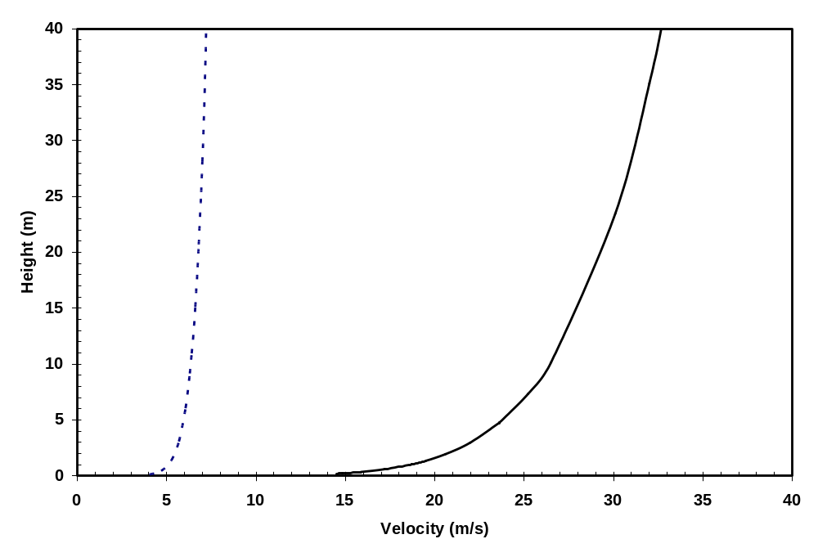

Figure 1

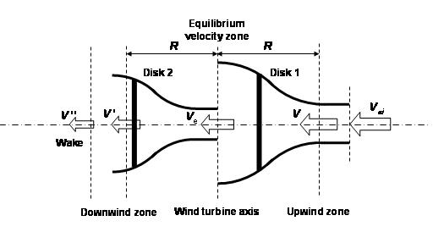

Figure 2

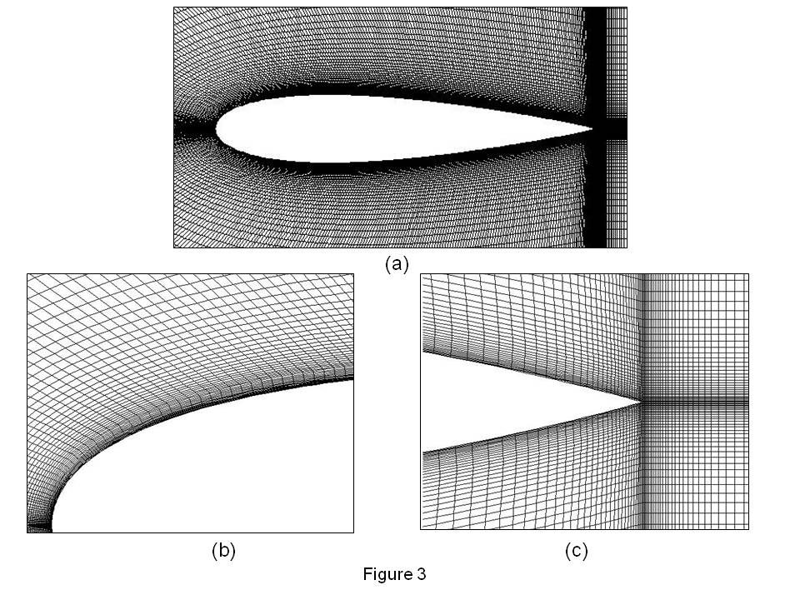

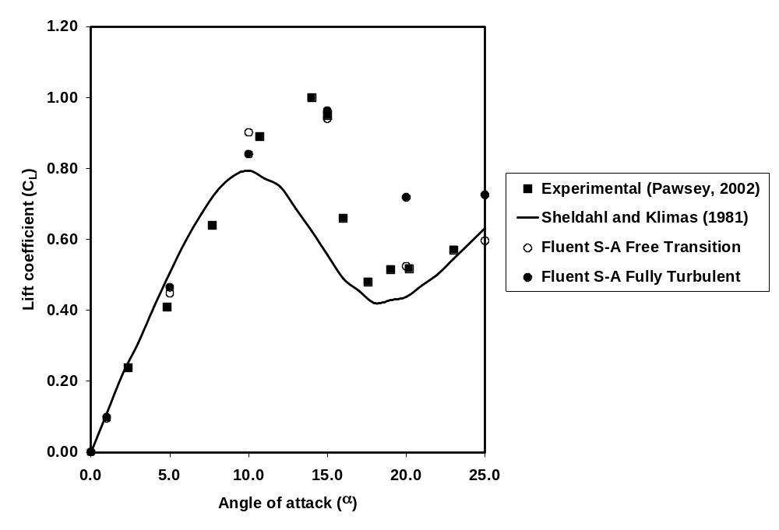

Figure 4a

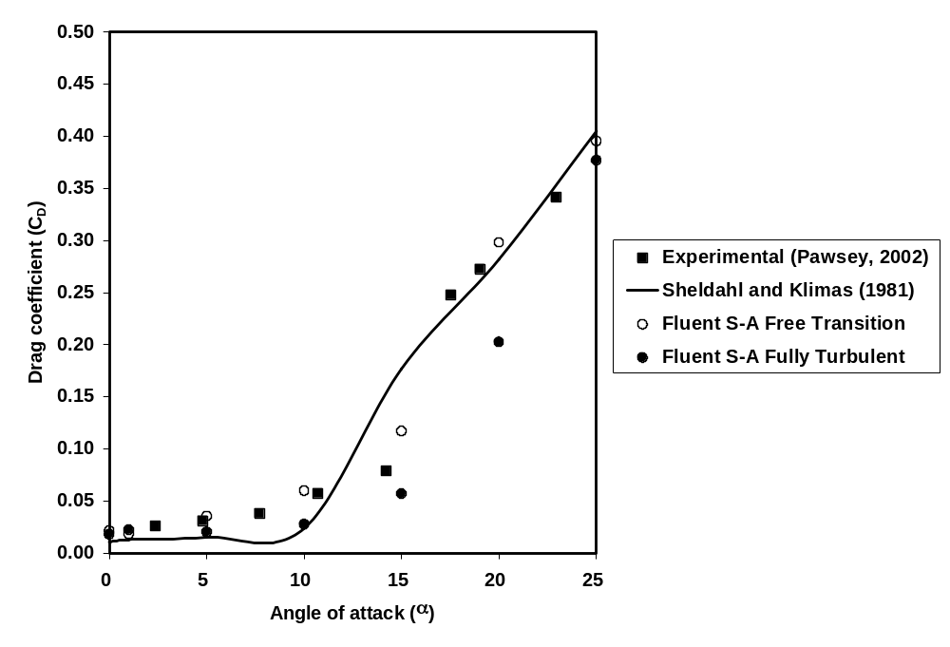

Figure 4b

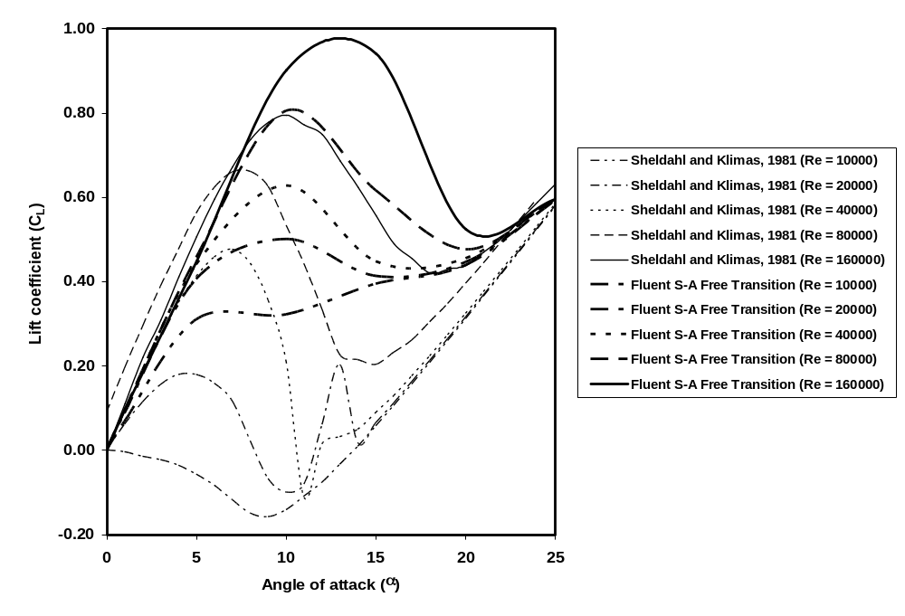

Figure 5a

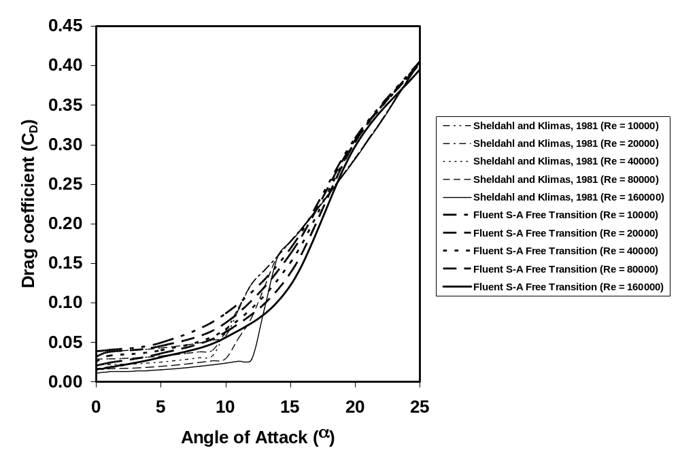

Figure 5b

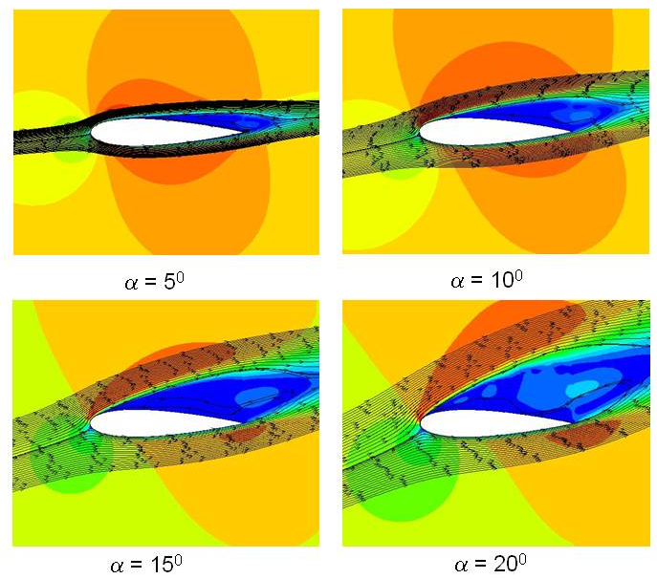

Figure 6

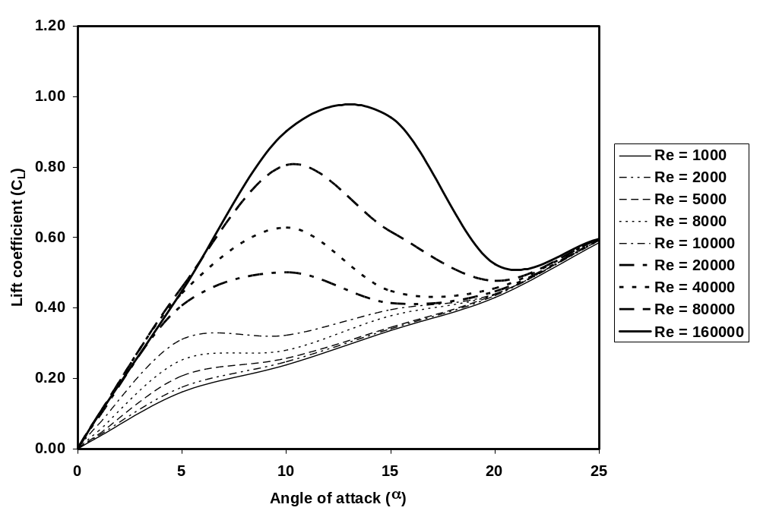

Figure 7a

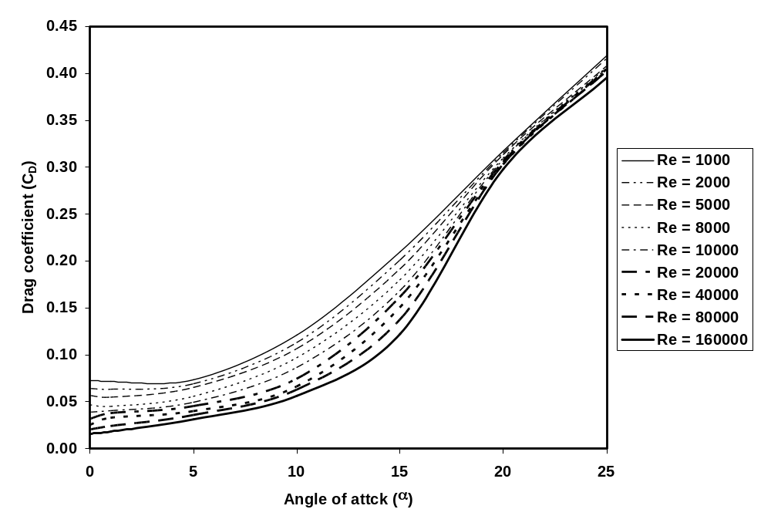

Figure 7b

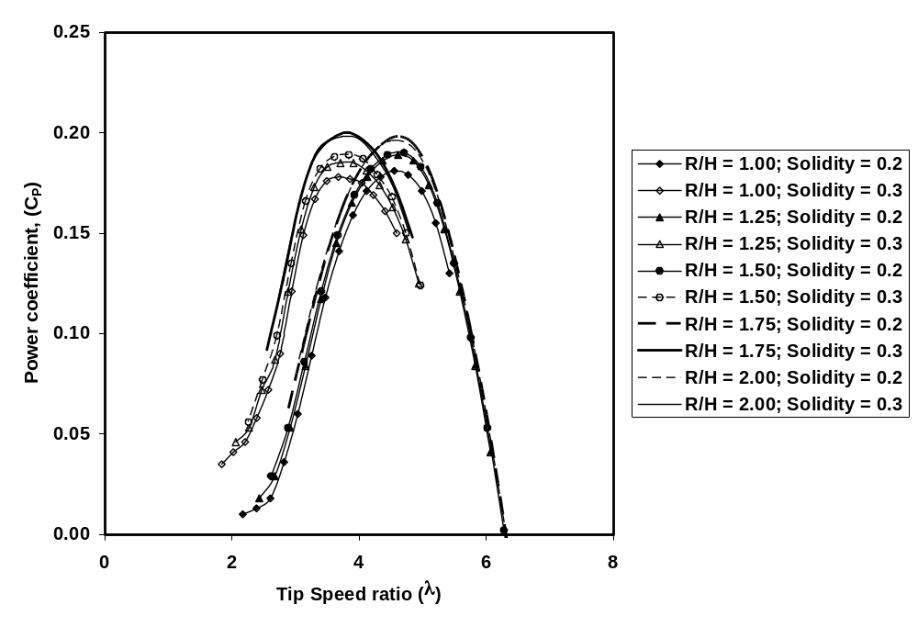

Figure 8

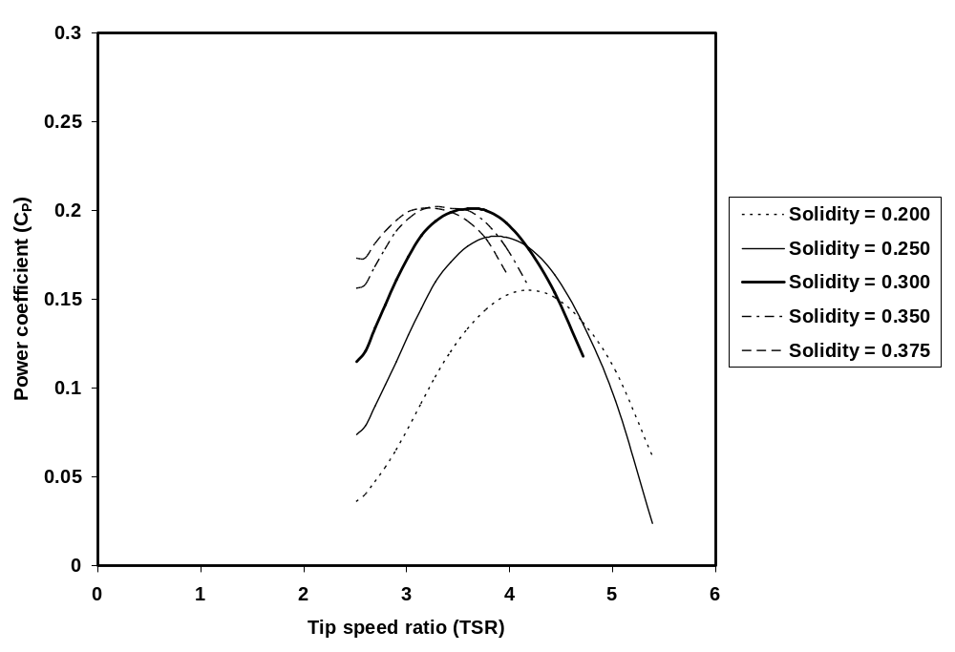

Figure 9

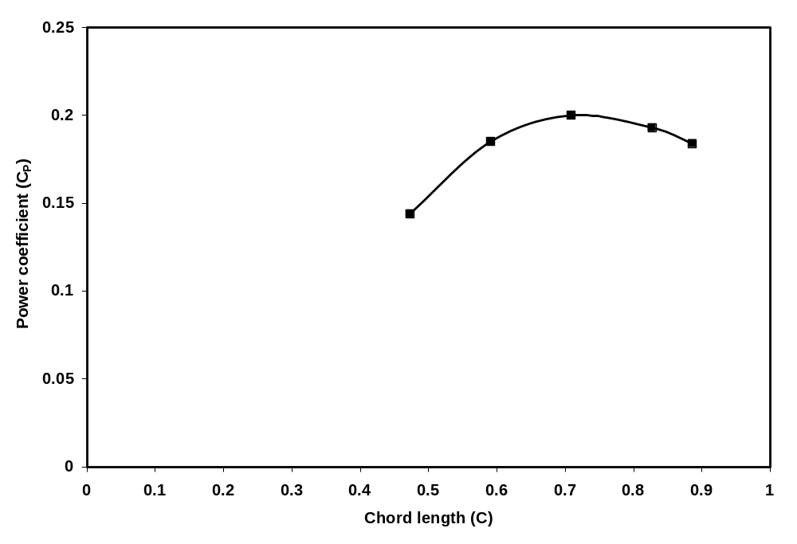

Figure 10

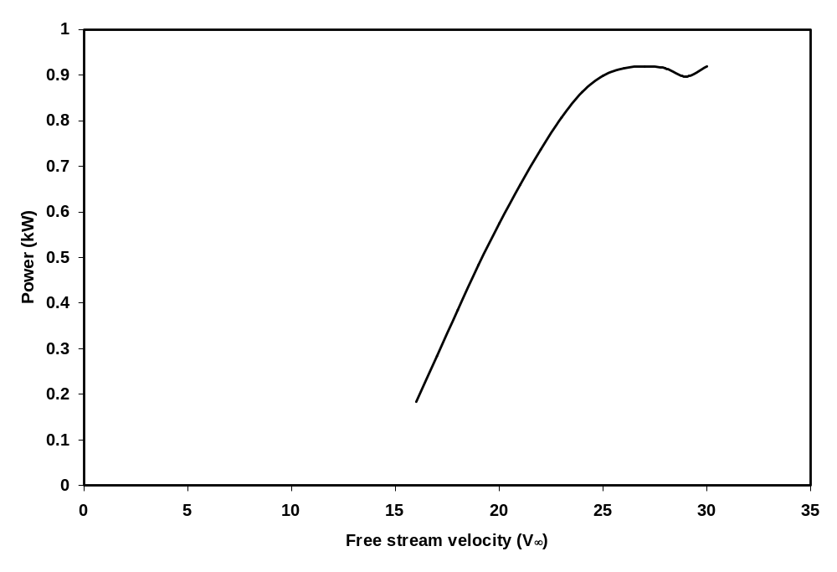

Figure 11

 Corresponding author. Tel.: +1 514 848 2424 (ext. 7036) Email address: vkumar@encs.concordia.ca

