Comparing Full Bayes Likelihoods to Predict Road Accidents and Identify Potential Hazardous Sites
Mohammad Heydari¹, Luis Amador-Jimenez²
Department of Building, Civil and Environmental Engineering, Concordia University
Montreal, Quebec, Canada H3G 2W1
¹heydari_sm@yahoo.com, ²amador@encs.concordia.ca

Abstract- Developing reliable safety performance functions (SPFs) capable of estimating expected accident frequencies and identifying hazardous sites is a major concern of departments of transportation. In Bayesian accident data analysis, sites are commonly ranked based on their posterior expected accident frequency in order to be selected for safety countermeasures. The primary objective of this research was therefore to propose an alternative method to evaluate the level of accuracy of an SPF and identify potential hazardous sites; both directly through a single step or measurement. A case study of the Trans-Canada highway in New Brunswick was used applying Bayesian statistics with three different likelihoods: Poisson, hierarchical Poisson-gamma, and hierarchical Poisson-lognormal. As a secondary and validating objective the above mentioned models were investigated and compared. At the same time, the effect of environmental exposure on the occurrence of accidents was studied showing minor effects. The posterior means of the model parameters indicated that, for the case study, various likelihoods provided roughly similar estimates. However, there were significant differences in the way in which these likelihoods captured the uncertainty around the posterior mean through the standard deviation, 95% credible interval, and model-fitting. Moreover, a series of computational and graphical goodness-of-fit measures were examined. In particular, the hierarchical Poisson-gamma likelihood presented the best model-fitting. Furthermore, a measure of relative risk was computed for each site based on the error term presented in Poisson mixture models. The rankings of sites using this measure and the posterior expected accident frequency were generated and compared. A positive covariance between the adopted relative risk factor and the expected accident frequency per segment length was observed. The results and discussions suggested that such a factor can be employed (1) to verify the dependability of SPFs and (2) as an alternative to identify and prioritize potential hazardous sites.

Keywords- safety performance functions, Bayesian inference, potential hazardous sites, goodness-of-fit, relative risk factor

- Introduction

Road safety audits are popular tools for assessing the safety condition of a particular road facility. However, they lack the ability to account for variations in site characteristics (e.g., changes in geometric design, traffic flow, pavement condition, traffic control, etc.). Typically, the consideration of safety improvements, in the road network, arrives from a cost-benefit analysis [1, 2, 3]. Therefore, a precise evaluation of safety treatments is inevitable to be able to allocate resources appropriately. In fact, incorporating road safety into performance-based optimization [4] to support tradeoff analysis between competing objectives (i.e., condition, safety, cost, mobility, environmental impact, social cost, etc.) at the network level, requires accurate estimate of the current safety condition (e.g., road segment) and its progression across time. Safety is defined as the number of accidents, or accident consequences, by type and severity, expected to occur during a given period of time [5]. Safety performance function (SPF) that represents a mathematical relationship between accident frequency (expected number of accidents per unit of time) and a set of causal factors - like traffic flow, environmental conditions, etc. - is used for evaluating the safety state of a road facility. Thus, developing reliable SPFs is a noteworthy task in road safety engineering where these functions are mainly employed for hotspot (hazardous sites) identification and safety countermeasures assessment.

The base of Bayesian statistics, the Bayes theorem, has been around for centuries [6]. The use of Bayesian statistics in engineering can be traced back to the nineteen seventies [7] with more widespread applications since the nineties [8]. The full Bayes approach [9, 10] has recently gain popularity in engineering specially for predicting the performance of fixed assets [11]. Bayesian inference presents some advantages over classical methods, such as the capacity to deal with uncertainty associated to causal factors. Then, it can produce more accurate estimates for data including small number of observations [9, 12]. Classical methods basically provide point estimates for model parameters and further computation (through standard errors) is necessary to provide the uncertainty around the estimated values [13]. However, Bayesian estimation directly provides the posterior distribution for each parameter in the model. Additionally, in the Bayesian framework, a variety of models with different levels of complexity can be employed, which makes it more suitable for complex data [9]. For instance, hierarchical models and those considering spatial and/or temporal correlations can be adopted properly in a full Bayes approach [9]. The use of Bayesian statistics in road safety has recently been studied by some researchers [12, 13, 14, 15]. The aim of these studies has been mainly to: (1) recognize casual factors that may affect accident frequencies and (2) identify hotspots; sites that require safety improvements.

Under the Bayesian context and regarding causal factors, studies that consider environmental exposure are rare. However, in this paper, firstly, the presence of snowfall and rainfall in the SPF is examined. Secondly, different likelihoods commonly used in analyzing accident data (Poisson and Poisson mixture models) are applied to a case study from New Brunswick (the Trans-Canada Highway) and the outcomes our compared. Poisson mixture models are introduced in analyses in a hierarchical fashion. Lastly, an alternative method is suggested in order to (1) verify the reliability of an SPF and (2) identify potential sites (hotspots) for safety improvement programs or further safety investigations.
- Methodology

Four main steps were followed in order to develop SPFs for the adopted case study in a full Bayes framework: (a) the choice of a model function (functional form for SPF), (b) the choice of likelihoods (regression approaches), (c) assigning prior distributions to SPF parameters, and (d) estimation of the SPF parameters via Markov Chain Monte Carlo (MCMC) methods [10] based on local observations.

- Safety performance function (SPF)

Equation 1 is the functional form that represents the SPF for road segments in this study [14]. The causal factors used in this equation are: segment length, annual average daily traffic (AADT), density of horizontal curves, and the amount of snowfall and rainfall. These were the only available variables for this case study, which also reflect the lack of data faced in many cases and yet the need to establish an SPF. In addition, the use of more independent variables was out of the scope of this research.

$\ln\left(μ\right)=\ln\left(a_{0}\right)+a_{1}\ln\left(x_{1}\right)+a_{2}\ln\left(x_{2}\right)+a_{3}x_{3}+a_{4 }x_{4}+a_{5}x_{5} (1)$

where: μ = expected accident frequency;
a_{i} = stochastic parameters (i=0 to 5);
x₁ = L = segment length (km);
x₂ = AADT = annual average daily traffic (vehicles per day);
x₃ = number of horizontal curves/km;
x₄ = annual snowfall (cm);
x₅ = annual rainfall (cm).

- Likelihoods (Regression Approaches)

Three different regression approaches were investigated in the Bayesian paradigm in order to estimate SPF parameters and to predict accident frequencies. In other words, it was assumed that accidents (as count data) may follow three likelihoods: (a) Poisson, (b) hierarchical Poisson-gamma, and (c) hierarchical Poisson-lognormal.

- Poisson Likelihood

Accident occurrences being random events and positive integers are assumed to follow the Poisson distribution in which mean and variance are equal. Therefore, such a model may not be efficient since it cannot deal with the over-dispersion issue resulting from heterogeneity across sites that is usually associated to accident data [12, 15, 16, 17]. In the case of over-dispersion, variance is greater than mean. The accident frequency in Poisson models (for site i) is expressed as k_{i} ~ Poisson(μ_{i}), where k_{i} and μ_{i} are observed and expected accident frequencies, respectively. μ_{i} is a function of site characteristics vector X_{i} and unknown parameters vector a; i.e., μ_{i} = exp(aX_{i}). In other words, μ_{i} is the mean value obtained from the SPF.

- Hierarchical Poisson-gamma Likelihood

In this case the assumption is that accidents within sites are Poisson and unobserved accident heterogeneity across sites is gamma distributed [13, 14]. Therefore, the expected number of accidents is described by the SPF and a multiplicative random variable that varies across sites. The model is expressed as k_{i} ~ Poisson(θ_{i}), where k_{i} is the observed accident frequency. And the expected accident frequency θ_{i} = μ_{i}r_{i}. Where μ_{i} is a function of site characteristics vector X_{i} and unknown parameters vector a; (μ_{i} = exp(aX_{i})). And r_{i} is a multiplicative random effect that is typically assumed to follow a gamma distribution; r_{i} ~ Gamma(φ,φ). Hence, based on this parameterization, r_{i} has a mean of 1 and a variance of 1/φ, where φ is the inverse dispersion parameter [13]. Then, in hierarchical models, φ is in turn assumed to follow a hyper-prior, mainly a gamma distribution φ ~ Gamma(a, b) with hyper-parameters a and b. Usually, a non-informative hyper-prior is assumed for φ by choosing a small value for shape and scale parameters a and b, respectively. For instance, a = b = 0.001 [13].

- Hierarchical Poisson-lognormal Likelihood

Here, the assumption is that accidents occur following a Poisson distribution with a mean that is lognormally distributed; θ_{i} ~ Lognormal (ln (μ_{i}), υ) [13]. In particular, k_{i} ~ Poisson(θ_{i}), with k_{i} being the observed accident frequencies. And the expected accident frequency θ_{i} = μ_{i}r_{i}. μ_{i} is the mean from the SPF, similar to the Poisson-gamma model. Instead, here, the multiplicative random effect is assumed to be lognormally distributed; r_{i} ~ Lognormal (0, υ). Then in a hierarchical fashion, υ⁻¹ (the inverse of variance) is also assumed to follow a gamma distribution with parameters a and b; υ⁻¹ ~ Gamma(a, b) [13, 14].

- Bayesian Estimation of the Parameters

1) Bayesian Inference

Different methods are available to estimate the parameters of a regression model being the most popular: the method of moments [18], maximum likelihood estimation [19], and Bayesian estimation [9]. The latest has been used in this study because of its interesting properties, advantages, and capacities to deal with limited data and uncertainty and randomness related to the causal factors presented in SPFs [9, 12, 20]. Moreover, Bayesian regression can combine the expert criteria (through the prior distribution) with local observations in order to calibrate mathematical equations for various engineering performance models [11]. Bayesian inference is structured based on prior, likelihood, and posterior. The Prior distribution, which may represent some sort of initial knowledge about a parameter, can be selected based on previous studies, expert criteria, or experience. The Likelihood is represented by data containing local observations. And the posterior is the product of the likelihood and the prior. Equation 2 shows the estimation of the posterior distribution.

$$p\left(a | k\right)= \frac{p\left(k | a\right).p(a)}{\int{p\left(k | a\right).p\left(a\right)da}} (2)$$

where a: model parameter;
k : observed data
p(k|a): likelihood distribution
p(a): prior distribution
ʃ p(k|a).p(a): marginal likelihood
Because of the complexity issues (high dimensional integrations), Equation 2 cannot be solved analytically. Therefore, the posterior distribution is estimated by using MCMC methods (e.g., Gibs sampler) [20] that samples the space of the causal factors and takes into account the randomness associated to these factors. Four main steps to apply the Bayesian estimation technique to a dataset are:

1. choice of priors for model parameters; i.e., regression parameters, precision and over dispersion parameters, etc.;
2. setting initial values for parameters mentioned in step 1;
3. specification of the Likelihood distribution that is basically the type of the regression approach - like Poisson regression;
4. running the MCMC simulation to obtain Posteriors for the SPF parameters.

2) Deviance Information Criterion (DIC)

DIC is a Bayesian model-fitting measure [21], which is a generalization of the Akaike information criterion (AIC). Similarly, DIC can be used to compare models in terms of goodness-of-fit and is given by Equation 3:

$$DIC= \overline{D}+ p_{D} (3)$$
$$\overline{D}=E[D\left(a\right)]$$
$$D\left(a\right)= -2log⁡(f\left(k | a\right))$$
$$p_{D}= \overline{D}- D\left(\overline{a}\right); \overline{a}=E[a]$$
$$D(\overline{a})= -2log⁡(f\left(k | \overline{a}\right))$$

where k are data, a are unknown parameters, $\overline{D}$ is the expectation of the deviance given a, and $p_{D}$ represents the complexity of the model. In other words, it is the effective number of parameters. Basically, a smaller DIC value indicates the model that provides a better fit to a particular dataset. As stated by Spiegelhalter et al. (2002), DIC differences of greater than 10 might definitely rule out the model with higher DIC value, differences between 5 and 10 are considered to be significant, and those smaller than 5 are not important. In addition, one must take into account that DIC can provide a measure of comparison between models - nested or not – applied to the same dataset [12, 21].

D) Assigning Relative Risk to Sites based on Poisson Mixture Models in the full Bayes Context

As mentioned in section II.B, Poisson parameter θ (in Poisson mixture models) is defined by μ multiplied by a random effect r, which may have different structures depending on the model. As it is a common practice in the field of disease mapping, r can represent the relative risk associated to each site [22, 23, 24]. Moreover, in the Bayesian framework this relative risk, r, can vary according to a probability density function (e.g., gamma distribution). Thus, r is not a point estimate (Equation 4).

k_{i} ~ Poisson(μ_{i}r_{i}) (4)
where μ_{i}: mean estimated from the SPF for site i;
r_{i}: relative risk, for site i, with a certain PDF.
In Poisson-gamma models r can be assumed to be gamma distributed and in Poisson-lognormal models it is lognormally distributed (see section II.B). In a full Bayes approach, when the posterior mean of r approaches 1, the Poisson mixture models converge to the Poisson model. This means that the observed data is neither over-dispersed nor under-dispersed, which rarely happens in accident datasets being mainly characterized by heterogeneity across sites [12, 15, 16]. In other words, r indicates the level of variability of the Poisson parameter θ from μ; the latter is directly obtained from the SPF. The posterior mean of the relative risk r may increase beyond 1 and vice versa. Indeed, the value of r indicates to what extent causal factors that are present in an SPF can explain the occurrence of accidents. Hence, in sites where the value of r is significantly greater than 1, the currently used SPF is not able to describe safety conditions adequately and further investigation to find other causal factors seems to be essential. Besides, these sites may be those that require safety improvements.

- Case Study: The TRANS-CANADA highway in New Brunswick

A case study including 62 divided highway segments in New Brunswick (the Trans-Canada highway) were used for the objectives of this paper. The safety of the segments was evaluated using three likelihoods through the estimation of the SPF parameters based on the local observations. A statistical summary of the dataset is reported in Table I. Accident data were aggregated over a period of three years of the most recently available observations (2004 to 2006). This aggregation can be justified since it helps to avoid the regression to the mean phenomena and confounding effects associated to exceptional events observed in a particular year [25, 26]. The total number of accidents including property damage only, injury, and fatality accidents were taken into consideration. In order to incorporate the environmental exposure in the analyses, the observations related to the annual rainfall and snowfall collected by 5 weather stations located in the proximity of the case study were assigned to the highway segments. For this purpose, the altitude of the weather stations was also taken into account.

TABLE I
Summary statistics of the data

variables |  | Mean | S.D. | Minimum | Maximum
Segment Length | x₁ (Km) | 12.012 | 4.79 | 3.17 | 19.8
AADT | x₂ (veh./day) | 8323.800 | 3640.630 | 4435.000 | 17550.000
Density of Horizontal curves | x₃ (number of horizontal  Curves/Km) | 0.389 | 0.130 | 0.165 | 0.769
Snowfall (annual) | x₄ (cm) | 295.270 | 27.620 | 276.00 | 353.00
Rainfall (annual) | x₅ (cm) | 85.000 | 4.190 | 76.800 | 88.500
Accident Frequency | K (acc./3ys) | 17.460 | 9.470 | 3.000 | 43.000

- Model specification in WinBUGS

Statistical software WINBUGS [27] was used for MCMC simulations in order to estimate the posterior distributions of the SPF parameters. Two different chains were considered with different initial values. Increasing the number of chains leads to more accurate estimates, and the modeler can easily verify the convergence of the chains, using the tools available in WinBUGS. An initial portion of the iterations was discarded from the estimation of the parameters (Burn-in iterations) and the remaining iterations were used to derive the posteriors. The convergence of the model was checked using trace plots, history plots, Gellman Rubin diagram [28], and also by verifying the stability of the posterior estimates. Furthermore, the accuracy of the posterior mean for each parameter was verified checking the value of the Monte Carlo error; this error should be preferably smaller than 5% of the standard deviation [27]. In particular, 30000 iterations were updated for each parameter and chain from which the initial 7000 iterations were discarded as burn-in; and therefore, 23000 iterations were used for the posterior inference.

A Normal distribution with a mean value equal to zero and a large variance of 1000 (non-informative prior) was selected as the prior distribution for regression parameters (a₀ to a₅) in order to let the data dominate the derivation of the posteriors [9, 20]. Moreover, in the Poisson-gamma model, informative and non-informative hyper-priors have been tested for φ (the inverse dispersion parameter). While the model with a non- informative hyper-prior ran very slowly and made the convergence time consuming, an informative hyper-prior for φ leaded to convergence and reasonable results in a timely fashion. This confirmed that the use of an informative hyper-prior for the inverse dispersion parameter can facilitate the analysis process and provide more reliable estimates when dealing with limited data; like the case study used in this paper [13]. This informative gamma hyper-prior; i.e., φ ~ Gamma(12.5, 5), was introduced in the analysis based on a study conducted by Miranda-Moreno et al. (2009) who suggested that φ can be assumed to follow an informative gamma distribution with mean and variance equal to 2.5 and 0.5, respectively. These values were estimated considering a series of studies as explained by the authors [29]. One should take into account that in a gamma distribution with shape and scale parameters a and b, respectively, mean = a/b and variance = a/b². Finally, for the Poisson-lognormal model, a non-informative prior for υ⁻¹ (the inverse of variance) has been specified, which performed well [13]; υ⁻¹ ~ Gamma (0.01, 0.01).

- Results and Discussion

The results of the analyses for the estimation of the SPF parameters and goodness-of-fit measures are summarized in Table II. All three likelihoods (Poisson, Poisson-gamma, and Poisson-lognormal) provided almost similar estimations of the posterior mean for regression parameters; however, there were notable differences in the way in which these likelihoods capture the variability around the mean through the standard deviation, 95% credible interval, and goodness-of-fit measure.

- Comparisons and inferences for estimated parameters

As reported in Table II, for all three likelihoods used in this study, the parameters associated to segment length, AADT, and the density of horizontal curves are positive that, in general, indicates an increase in the accident frequency when these causal factors increase. AADT and the density of horizontal curves are found to be more significant predictors in the Poisson-gamma model in which AADT results in a parameter that is normally distributed with mean and standard deviation equal to 0.485 and 0.155, respectively (Table II). Based on this estimation, 99.9% of the distribution is greater than zero (a₂ is positive for 99.9% of the segments) and 0.10% of it is smaller than zero. This implies that only for 0.10% of the segments as AADT increases, accident frequency decreases. Similarly, the density of horizontal curves resulted in a parameter that is normally distributed with mean and standard deviation 0.682 and 0.602, respectively (Table II). This means that for the majority of the segments (87.1% of them) the higher the density of the horizontal curves is the more likely the occurrence of accidents is. Furthermore, the parameter a₁ associated to segment length, that is normally distributed, implies that for almost 100% of the segments an increase in length leads to an increase in the accident frequency.

TABLE ii
SPF parameters with related Bayesian STATISTICS

Causal factors | Mean |  | S.D. |  | MC error | 2.50% | Median |  |  | 97.50%
Poisson-gamma Likelihood (DIC = 199.78)
ln(a₀) | 25.610 | 18.33 |  | 0.591 |  | 1.131 |  | 22.620 | 70.21
a₁ (ln(Length)) | 1.007 | 0.144 |  | 0.005 |  | 0.716 |  | 1.009 | 1.30
a₂ (ln(AADT)) | 0.485 | 0.155 |  | 0.006 |  | 0.180 |  | 0.486 | 0.80
a₃ (density of h. curve) | 0.682 | 0.603 |  | 0.018 |  | -0.457 |  | 0.668 | 1.89
a₄ (snowfall) | -0.006 | 0.003 |  | 0.000 |  | -0.011 |  | -0.006 | -0.002
a₅ (rainfall) | -0.062 | 0.016 |  | 0.001 |  | -0.089 |  | -0.063 | -0.020
Poisson-lognormal Likelihood (DIC = 309.182)
ln(a₀) | 28.18 | 17.86 |  | 0.584 |  | 3.841 |  | 24.960 | 69.79
a₁ (ln(Length)) | 1.015 | 0.097 |  | 0.003 |  | 0.824 |  | 1.016 | 1.202
a₂ (ln(AADT)) | 0.449 | 0.102 |  | 0.004 |  | 0.274 |  | 0.441 | 0.672
a₃ (density of h. curve) | 0.585 | 0.368 |  | 0.009 |  | -0.130 |  | 0.586 | 1.315
a₄ (snowfall) | -0.006 | 0.002 |  | 0.000 |  | -0.009 |  | -0.006 | -0.003
a₅ (rainfall) | -0.062 | 0.009 |  | 0.000 |  | -0.080 |  | -0.062 | -0.045
Poisson Likelihood (DIC = 351.704)
ln(a₀) | 30.640 | 17.94 |  | 0.6185 |  | 5.989 |  | 27.100 | 74.41
a₁ (ln(Length)) | 1.0120 | 0.079 |  | 0.002 |  | 0.862 |  | 1.010 | 1.170
a₂ (ln(AADT)) | 0.455 | 0.075 |  | 0.003 |  | 0.306 |  | 0.456 | 0.601
a₃ (density of h. curve) | 0.536 | 0.285 |  | 0.004 |  | -0.020 |  | 0.536 | 1.093
a₄ (snowfall) | -0.006 | 0.001 |  | 0.000 |  | -0.009 |  | -0.006 | -0.004
a₅ (rainfall) | -0.063 | 0.007 |  | 0.000 |  | -0.077 |  | -0.063 | -0.048

Unlike a₁, a₂ and a₃, parameters associated to snowfall a₄ and rainfall a₅ are negative (Table II). This implies that when these causal factors increase, the accident frequency decreases.
The parameter related to snowfall resulted in a normally distributed random variable with mean -0.006 and standard deviation 0.003 meaning that 99.7% of the distribution is less than zero. The parameter related to rainfall was also found to be normally distributed with a mean of -0.062 and standard deviation 0.016 indicating that 99.9% of the distribution is negative. Although this finding seems to be controversial (meaning that in the presence of rainfall and snowfall one expects more accidents to occur), it can be justified based on the complex interaction among environmental conditions, travel patterns, and driver behavior. For instance, drivers in this region might be very familiar with safety issues in adverse weather conditions. One should also take into account that weather indicators used in this study do not vary drastically across sites. Moreover, parameters related to snowfall and rainfall, are normally distributed with a mean value close to zero and a very small standard deviation in all three likelihoods. Thus, it can be implied that these causal factors - especially snowfall - do not have a considerable effect on the occurrence of accidents given the case study analyzed in this paper. The weak influence of the weather conditions on the accident frequency was also noticed in the phase of data exploration (explanatory data analysis) based on traditional methods; yet, the aim of having them among the causal factors was to verify their contribution in the SPF in a Bayesian framework.

- Goodness-of-fit comparisons

The deviance information criterion (DIC) was used as a goodness-of-fit measure for comparison between the three likelihoods presented in this paper. The Poisson-gamma likelihood provided the smallest DIC value and therefore the best fit to the dataset. DIC values are shown in Table II. In addition to DIC, the observed and the predicted accident frequencies were plotted against each other to graphically represent the model-fitting (Fig. 1). These graphs indicate that the Poisson-gamma model had the lowest variability around the straight line - the line that indicates a perfect match between the predicted and the observed values. On the contrary, the Poisson model was the least accurate because of having the largest variability around the straight line. This confirmed the limitation of the Poisson regression in dealing with over-dispersion in accident counts.

In Fig. 2 another graphical goodness-of-fit measure is shown. This figure that is based on the cumulative density functions (CDF) represents a typical result obtained for the majority of the highway segments used in this paper. Fig. 2 indicates how the predicted CDFs related to different likelihoods varied from the CDF of the observed accident frequency. As illustrated, the Poisson-gamma model CDF is the most closest to the observed accident frequency CDF implying that this model provides the best prediction. Additionally, Fig. 3 illustrates the relationship between the exposure and the predicted accident frequency (represented by three curves of posterior mean, 2.5%, and 97.5% percentiles). In the road safety literature, the exposure for a road segment is defined as vehicle kilometers of travel per year [5]. Assuming that the accident frequency is only described by the exposure, Fig. 3 indicates how three different likelihoods, having their specific 95% credible interval band, are able to cover the sample space of the accident frequencies. As shown, the Poisson-gamma model - which has the biggest coefficient of variation for the predicted mean value - is able to capture more points within its credible interval. Consequently, it can be implied that when these points are situated away from the curve that indicates the predicted mean; and particularly, when they are completely outside the 95% envelope, the exposure per se cannot explain the occurrence of accidents. In other words, these points are the segments where other causal factors (e.g., horizontal alignment) intervene and affect the accident frequencies. Therefore, in such cases, more investigations will be required in order to identify other important causal factors.

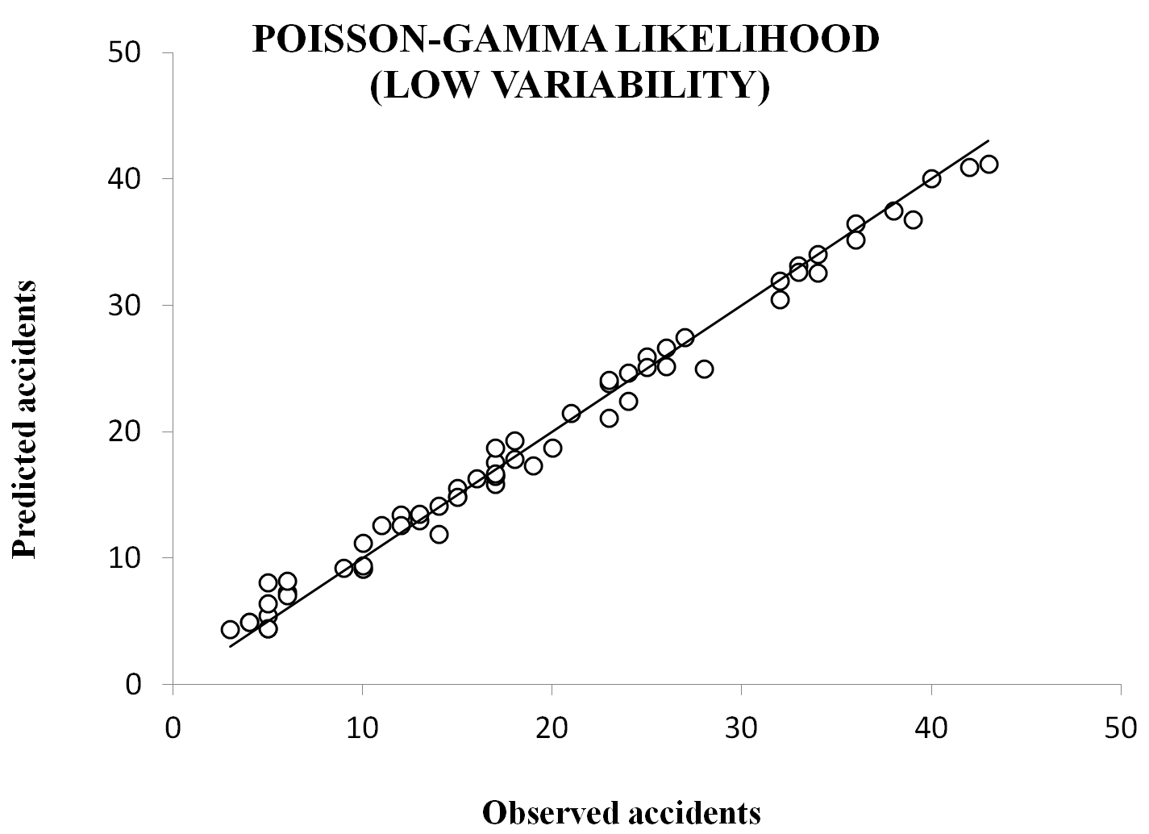
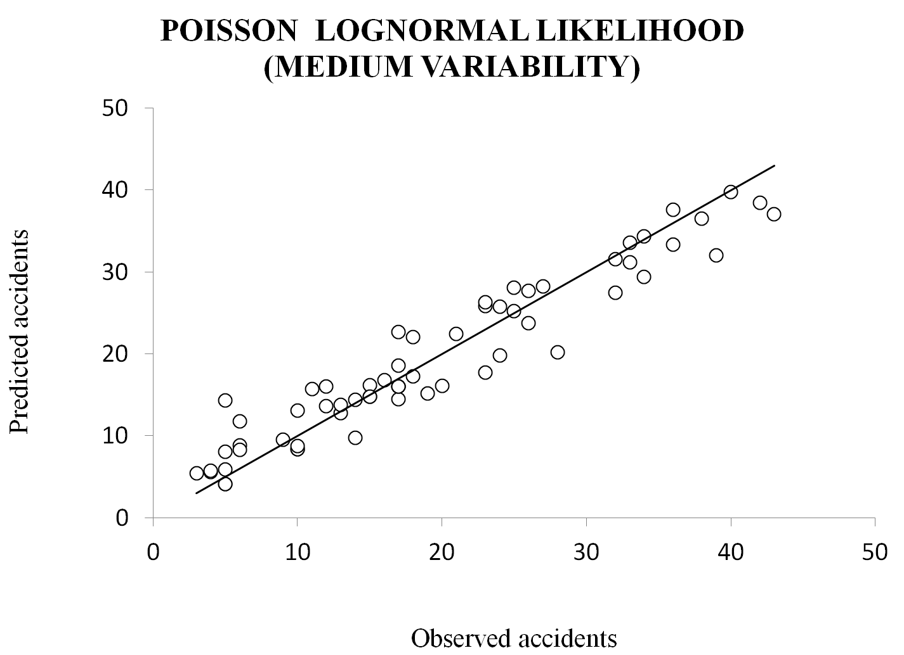
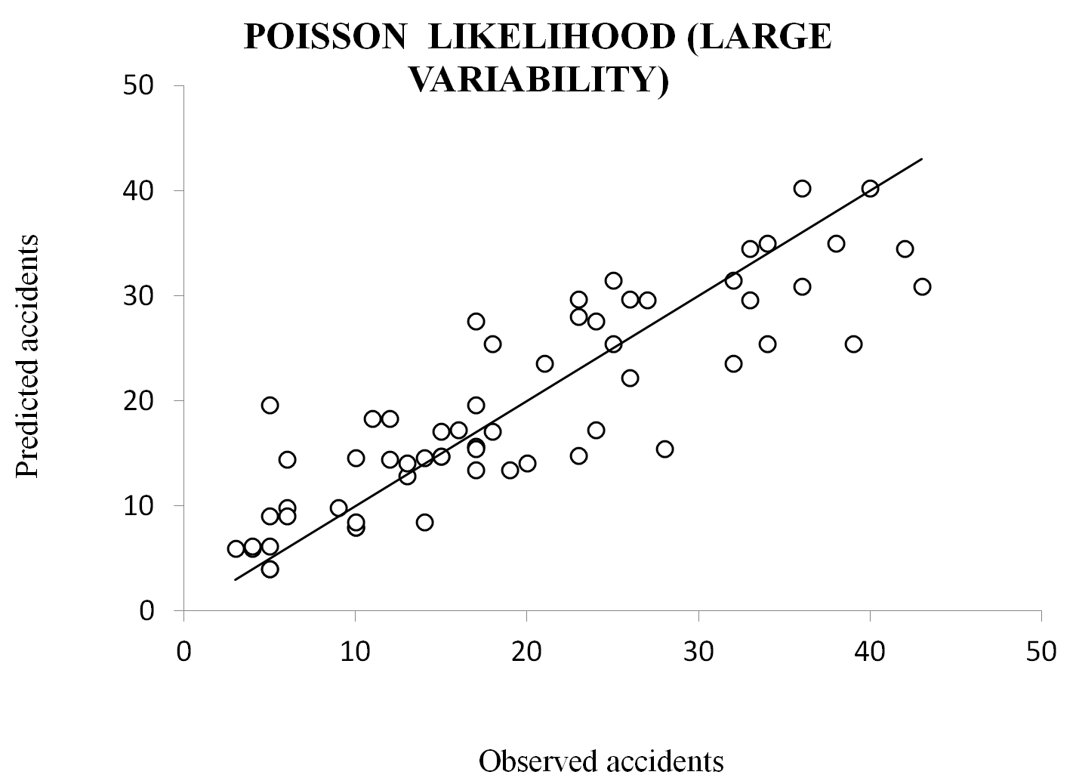 Fig. 1 Observed versus predicted accident frequencies

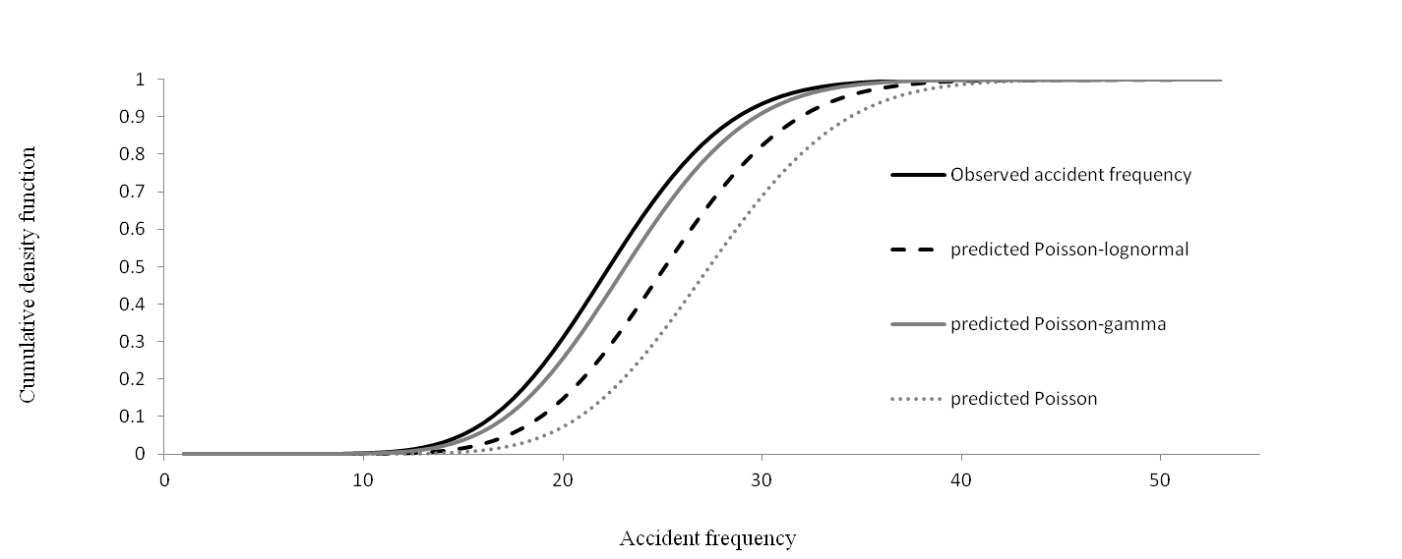
Fig. 2 CDFs based on the observed and the predicted accident frequencies for a typical segment

- Relative Risk outcomes
The results related to the rank of the relative risk estimates are summarized in Tables III and IV. In the Bayesian road safety literature, a typical method to rank sites for hotspot identification is based on θ, the posterior expected accident frequency [30]. In accordance with this method, Table III and IV report the ranks of the highway segments based on the posterior expected accident frequency (θ) per km and the relative risk r. The correlation between these sets of ranks can be examined through the Spearman’s correlation coefficient that is estimated based on the Equation 5.

$s=1- \frac{6\sum{d^{2}}}{n(n^{2}-1)} (5)$

where
s is the Spearman’s coefficient;
d is difference between corresponding ranks;
n is the number of elements to be ranked.

For the Poisson-gamma likelihood the value of the Spearman’s correlation coefficient between the above mentioned sets of statistical ranks is 0.60 (Table III), which is statically significant according to the critical values related to this coefficient. Such a value implies a relatively high positive correlation between these sets of ranks. The Spearman’s coefficient for the Poisson-lognormal likelihood is 0.39 (Table IV).

Besides, for the case study used in this paper, we observed that there is a relationship between the observed accident frequency (normalized per segment length) and r (Fig. 4). This figure shows that as the posterior mean of the accident frequency per km increases, the posterior mean of the relative risk r, generally, increases (Fig. 4). It was also found that there is a positive covariance between the accident rates and r. The results explained in this section support the use of r to identify sites with potential need for further investigations. Additionally, as explained in the section II.D, r can be used to verify the quality or reliability of SPFs. But this verification is not, directly, possible using the posterior θ.

- Conclusions
In the Bayesian paradigm, three different likelihoods were applied to calibrate SPFs; and consequently, predict the accident frequency for 62 divided segments of the Trans-Canada highway in New Brunswick. Total accident frequency (property damage only, injury, and fatality accidents) for a period of 3 years were aggregated and analyzed through MCMC methods using Gibbs sampling. All the independent variables used in the SPFs were found to be statistically significant. Segment Length, AADT, and the density of horizontal curves were the most influential causal factors. Environmental exposure factors (snowfall and rainfall) had a minor effect on the accident frequency for the case study adopted in this paper.

A Bayesian goodness-of-fit measure, DIC, and a series of graphical measures were used to compare each likelihood outcomes. The hierarchical Poisson-gamma model having the smallest DIC value indicated the best fit to the dataset, followed by the Poisson-lognormal, and then the Poisson likelihoods. In addition, the results in terms of model-fitting using DIC were validated with different graphical goodness-of-fit measures. It was demonstrated that the multiplicative random effect r (here, labeled as relative risk) in Poisson mixture models, can be used as an alternative to identify potential hazardous sites and examine the efficiency of the causal factors presented in an SPF. The analysis suggests that sites where the value of r is significantly greater than 1 require more investigation to identify further causal factors. Moreover, these sites may be potential hazardous sites that necessitate the implementation of safety improvement programs.

Since accident consequences may vary drastically by the type of accidents, future research should examine the observed data by severity (e.g., injury or fatal). For this purpose, a wider range of independent variables will be necessary in order to determine the most relevant causal factors related to various severities. Another extension of this research can focus on the application of the methodologies employed in this paper to other road facilities such as intersections.

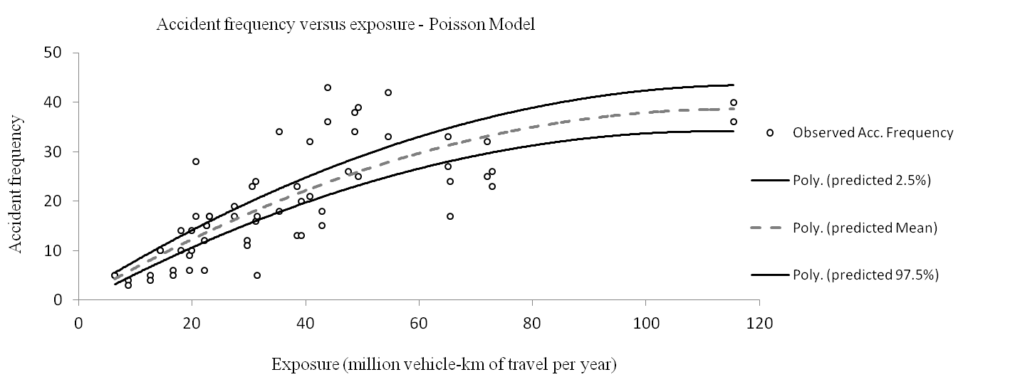
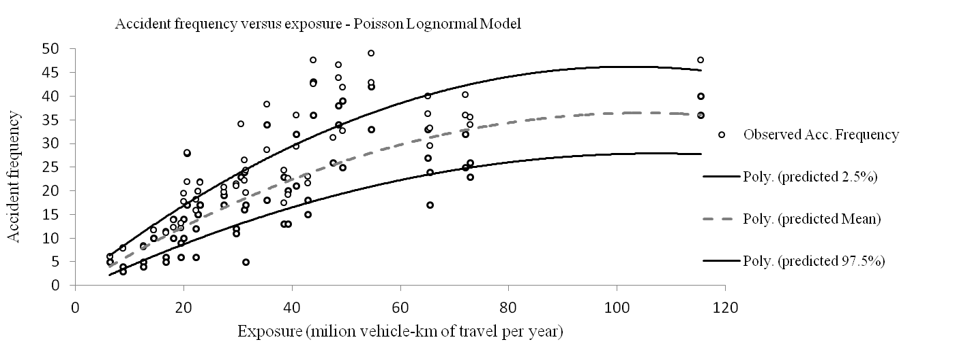
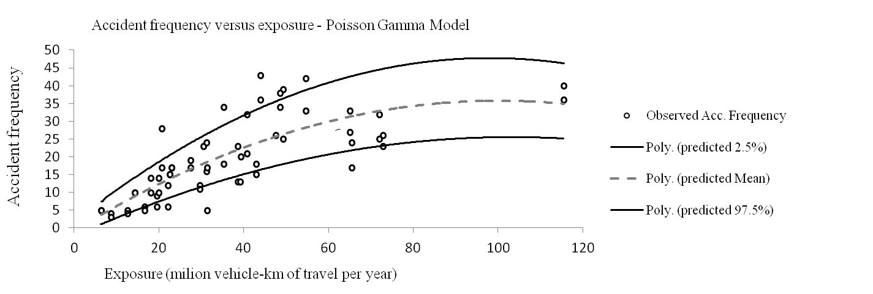
Fig. 3 Accident frequencies versus exposure (vehicle-km of travel per year)

TABLE III
raNK OF SITES BASED ON THE POSTERIOR θ (NORMALIZED PER KM) AND THE POSTERIOR MEAN OF r
(POISSON-GAMMA LIKELIHOOD)

Segment id | Rank of sites  based on the Posterior θ normalized per km | Rank of sites  based on the posterior mean of r | Segment id | Rank of sites  based on the Posterior θ normalized per km | Rank of sites  based on the posterior mean of r
1 | 27 | 47 | 32 | 22 | 42
2 | 1 | 1 | 33 | 12 | 25
3 | 16 | 34 | 34 | 32 | 49
4 | 23 | 30 | 35 | 9 | 23
5 | 28 | 20 | 36 | 17 | 45
6 | 24 | 33 | 37 | 10 | 31
7 | 35 | 55 | 38 | 19 | 46
8 | 6 | 5 | 39 | 62 | 62
9 | 39 | 15 | 40 | 37 | 17
10 | 11 | 2 | 41 | 61 | 61
11 | 20 | 3 | 42 | 53 | 56
12 | 51 | 26 | 43 | 60 | 58
13 | 25 | 29 | 44 | 57 | 59
14 | 8 | 41 | 45 | 45 | 14
15 | 46 | 38 | 46 | 34 | 6
16 | 48 | 36 | 47 | 56 | 50
17 | 59 | 54 | 48 | 50 | 35
18 | 54 | 37 | 49 | 31 | 7
19 | 43 | 11 | 50 | 30 | 8
20 | 44 | 13 | 51 | 2 | 10
21 | 55 | 57 | 52 | 3 | 4
22 | 58 | 51 | 53 | 52 | 27
23 | 49 | 48 | 54 | 33 | 19
24 | 47 | 44 | 55 | 40 | 32
25 | 38 | 18 | 56 | 13 | 16
26 | 42 | 43 | 57 | 4 | 9
27 | 36 | 60 | 58 | 41 | 53
28 | 14 | 40 | 59 | 29 | 21
29 | 26 | 52 | 60 | 15 | 22
30 | 21 | 39 | 61 | 5 | 12
31 | 18 | 28 | 62 | 7 | 24

TABLE IV
raNK OF SITES BASED ON THE POSTERIOR θ (NORMALIZED PER KM) AND THE POSTERIOR MEAN OF r
(POISSON-LOGNORMAL LIKELIHOOD)

Segment id | Rank of sites  based on the Posterior θ normalized per km | Rank of sites  based on the posterior mean of r | Segment id | Rank of sites  based on the Posterior θ normalized per km | Rank of sites  based on the posterior mean of r
1 | 22 | 51 | 32 | 21 | 39
2 | 1 | 1 | 33 | 12 | 25
3 | 15 | 35 | 34 | 29 | 53
4 | 24 | 32 | 35 | 10 | 16
5 | 30 | 20 | 36 | 14 | 45
6 | 25 | 33 | 37 | 8 | 30
7 | 28 | 57 | 38 | 13 | 47
8 | 9 | 3 | 39 | 52 | 62
9 | 39 | 14 | 40 | 40 | 23
10 | 23 | 2 | 41 | 54 | 61
11 | 33 | 7 | 42 | 43 | 50
12 | 55 | 28 | 43 | 62 | 55
13 | 27 | 29 | 44 | 58 | 59
14 | 4 | 37 | 45 | 48 | 15
15 | 46 | 41 | 46 | 44 | 9
16 | 50 | 36 | 47 | 59 | 48
17 | 60 | 52 | 48 | 51 | 34
18 | 57 | 38 | 49 | 37 | 8
19 | 47 | 13 | 50 | 34 | 6
20 | 49 | 17 | 51 | 2 | 10
21 | 53 | 58 | 52 | 3 | 4
22 | 61 | 49 | 53 | 56 | 27
23 | 42 | 46 | 54 | 38 | 19
24 | 45 | 44 | 55 | 36 | 31
25 | 41 | 24 | 56 | 16 | 12
26 | 35 | 43 | 57 | 6 | 5
27 | 26 | 60 | 58 | 32 | 54
28 | 11 | 42 | 59 | 31 | 21
29 | 19 | 56 | 60 | 18 | 18
30 | 17 | 40 | 61 | 5 | 11
31 | 20 | 26 | 62 | 7 | 22

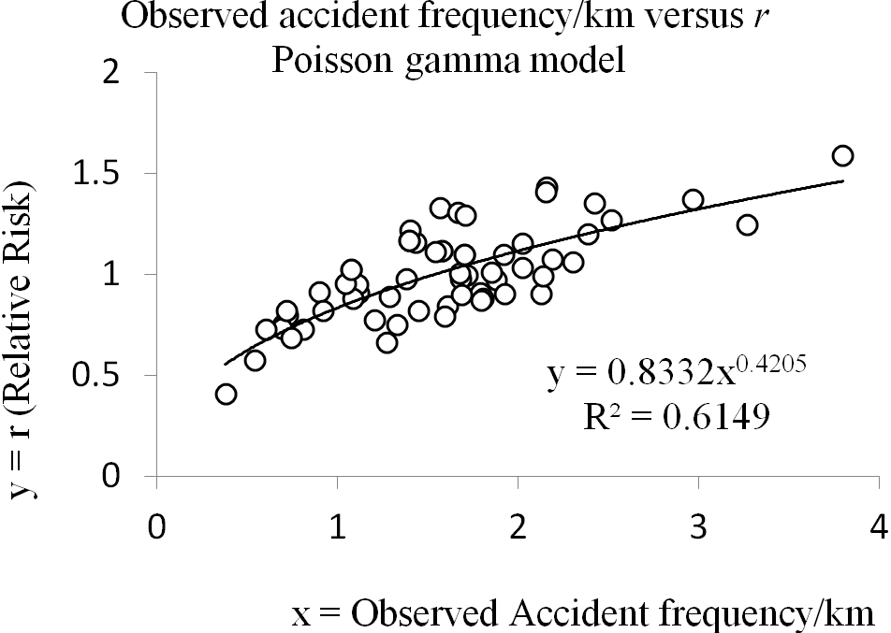
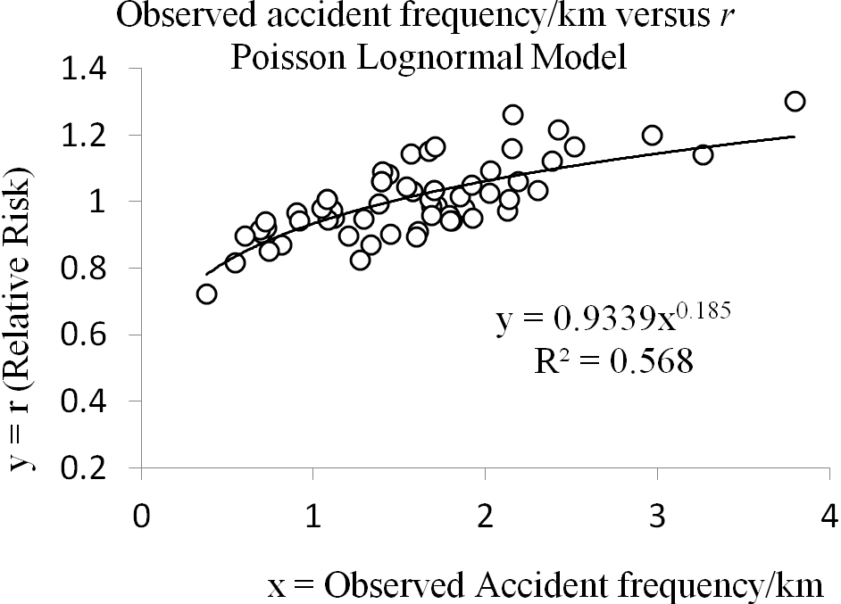
Fig. 4 Observed Accident frequencies per km versus relative risk (r)
REFERENCES
- TAC. 2001. The Canadian Road Safety Audit Guide. Transportation Association of Canada, Ontario, Canada.
- TAC. 2004. Canadian Guide to In-service Road Safety Reviews. Transportation Association of Canada, Ontario, Canada
- TRB. 2004. Road Safety Audits, A Synthesis of Highway Practice. Transportation Research Board, Washington, DC, U.S.
- NAMS. 2006. International Infrastructure Management Manual. New Zealand
- Hauer, E. Observational before-after studies in Road Safety. Elsevier Science Inc, New York. 1997.
- Freitas, N. (1999). Bayesian Methods for Neural Networks. Trinity College, University of Cambridge. PhD Thesis [online]. Available from http://www.cs.ubc.ca/~nando/publications.html [cited January 29, 2012]
- Haas, R. 2001. Reinventing the (Pavement Management) Wheel [online]. Distinguished Lecture Presented At Fifth International Conference On Managing Pavements Seattle, Washington. Available from www.civil.uwaterloo.ca/isap/graphics/haaslecture.pdf
- C-SHRP. 1995. Bayesian Modeling: Joint C-SHRP / Agency Applications [online]. Available from www.cshrp.org/products/csbf-e8.pdf
- Gelman, A. and Hill, J. Data Analysis Using Regression and Multilevel/Hierarchical Models. Cambridge University Press. New York. 2007.
- Gamerman, D., Lopes, H.F. Markov Chain Monte Carlo Stochastic Simulation for Bayesian Inference. 2nd Edition Chapman and Hall/CRC, Taylor Francis Group. Boca Raton, FL. 2006.
- Hong, F., Prozzi, J.,A. (2006). Estimation of Pavement Performance Deterioration Using Bayesian Approach. Journal of Infrastructure Systems, 12: 77- 86
- Mitra, S., Washington, S. On the nature of over-dispersion in motor vehicle crash prediction models. Accident Analysis and Prevention No. 39, 2006, pp. 459–468.
- Lord, D., and Miranda-Moreno, L.F. Effects of low sample mean values and small sample size on the estimation of the fixed dispersion parameter of Poisson-gamma models: A Bayesian Perspective. Safety Science, Vol. 46, No. 5, 2006, pp 751-770.
- El-Basyouny, K., Sayed, T. Safety performance functions with measurement errors in traffic volume. Safety Science, Vol. 48, 2010, pp. 1339–1344.
- Heydecker, B.G., and Wu, J. (2001). Identification of Sites for Accident Remedial Work by Bayesian Statistical Methods: An Example of Uncertain Inference. Advances in Engineering Software. 32, 859-869.
- Anastasopoulos, P., Mannering, F. A note on modeling vehicle accident frequencies with random-parameters count models. Accident Analysis and Prevention Vol. 41, No.1, 2008, pp. 153-159.
- Washington, S., Congdon, P., Karlaftis, M., Mannering, F. Statistical and econometric methods for Transportation Data Analysis. Chapman & Hall/CRC, Boca Raton, FL, 2003.
- Baglivo, J.A. Mathematica laboratories for mathematical statistics: Emphasizing Simulation and Computer Intensive Methods. SIAM-ASA series on statistics and applied probability, SIAM Philadelphia, Alexandria VA, 2005.
- Bedford, T., Cooke, R. Probabilistic risk analysis: foundations and methods. Cambridge University Press, UK, 2001.
- Gelman, A., Carlin, J.B., Stern, H.S., Rubin, D.B. (1995) Bayesian data analysis. Chapman & Hall. London, UK.
- Spiegelhalter, D. J., Best, N. G., Carlin, B. P., & Van der Linde, A. Bayesian measures of model complexity and fit (with discussion). Journal of the Royal Statistical Society, Series B, Vol. 64, No. 4, 2002, pp. 583-616.
- Lawson, A. B. and Williams, F. L. R. (2000) Spatial competing risk modeling with applications in spatial epidemiology. Statistics in Medicine, 19, 17/18, 2451-2468.
- Schlattmann, P., Bohning, D. Mixture models and disease mapping. Statistics in Medicine 1993; 12:1943-1950.
- Conlon, E., Louis, T. Addressing multiple goals evaluating region-specific risk using Bayesian models. In Disease Mapping and Risk Assessment for Public Health, Lawson AB et al. (eds). Wiley: New York, 1989.
- Lord, D., Persaud, B. Accident prediction models with and without trend: application of the generalized estimating equation. In Transportation Research Record, Journal of the Transportation Research Board, No.1717, Washington D.C, 2000, pp 102–108.
- Cheng, W., Washington, S., 2005; Experimental evaluation of hotspot identification methods. Accident Analysis & Prevention, Vol. 37, No. 5, 2005, pp. 870-881.
- Lunn, D.J., Thomas, A., Best, N., and Spiegelhalter, D. WinBUGS -- a Bayesian modeling framework: concepts, structure, and extensibility. Statistics and Computing, No.10. 2000, pp.325-337.
- Brooks and Gelman, 1998; Alternative methods for monitoring convergence of iterative simulations. Journal of Computational and Graphical Statistics. Vol. 7, No.4, 1998, pp.434-455.
- Miranda-Moreno, L.F., Lord, D., Fu, L. Bayesian road safety analysis: incorporation of past experience and effect of hyper-prior choice. Presented at the 87th Annual Meeting of the Transportation Research Board, Washington, DC. 2008.
- Miranda-Moreno, L.F., Labbe, A., Fu, L. (2007) Multiple Bayesian Testing Procedures for Selecting Hazardous Sites. Accident Analysis and Prevention. 39, 1192-1201.

