IDEA: A Collaborative Organizational Design Process Integrating Innovation, Design, Engagement, and Action

Donald W. de Guerre, PhD
Associate Professor and Graduate Program Director
Department of Applied Human Sciences
Concordia University
7141 Sherbrooke St. West VE 225.3
Montreal, Quebec, Canada
don.deguerre@sympatico.ca
Voice: +1 514 848 2424 (2270)
Fax: +1 514 848 2262

Daniel Séguin, MA
Desirable Futures
PO Box 9 Kootenay Bay
British Columbia, V0B 1X0, Canada

Alicia Pace, MA
Pace Consulting
PO Box 9 Kootenay Bay
British Columbia, V0B 1X0, Canada

Noel Burke, MEd
Dean School of Extended Learning
Concordia University
1455 De Maisonneuve Blvd. West
Montreal, Quebec, H3G 1M8, Canada

IDEA: A Collaborative Organizational Design Process Integrating Innovation, Design, Engagement, and Action

Donald W. de Guerre, Daniel Séguin, Alicia Pace, and Noel Burke

Abstract
This paper describes an innovative and successful one-year organization change process. It captures a design-based inquiry that simultaneously applies creative, purposeful, and systemic thinking to a complex set of issues. Three significant findings result from this research. First, this paper discusses how the change process created the necessary and sufficient conditions allowing for the creation of an innovative organizational design that embeds both optimization and innovation. Second, Design Thinking was used to develop a two-day participative design process we have called IDEA, an acronym for integrating innovation, design, engagement, and action. We believe that the IDEA organizational design process is replicable. Third, it describes an emergent and co-created change process. This paper concludes by raising questions for future transformative organizational design efforts.
Keywords: Innovation, Organizational Design, Design Thinking, Organizational Change, Engagement.

Introduction
This paper will describe an innovative and successful one-year organization change process that was challenging and emergent throughout. Grounded in Open Systems Theory (OST(E)) as developed primarily by Fred and Merrelyn Emery (Emery 2000), the action research team also used the theory and practices of Appreciative Inquiry (Watkins, Mohr, et al. 2011) and Design Thinking, particularly IDEO’s Human Centered Design (Brown 2009). In collaborative action research, the process often takes on a life of its own and researchers must collaborate with the researched in what becomes an emergent process. This paper will capture that process and demonstrate why the researchers decided their traditional grounding in OST(E) and its methods was necessary but not sufficient to this case. While the organization was a recent merger of three very different departments in the university, while it is a service-based knowledge work organization with a unique mandate, and while its existence is contentious, none of these factors would necessarily require the researchers to change OST(E) methods. Rather, as we collaboratively explored the intent and requirements with the participants, we jointly decided to develop a unique process. We describe how this occurred in the body of the paper.
Three significant findings result from this research. First, the change process that evolved consisted of four phases that we have called: Connect, Innovate, Design, and Implement. What is unique is that the experience of working together in town hall meetings and temporary teams during the Connect and Innovate phases enacted the organization that needed to be designed and implemented. We believe that work processes and other minor, incremental changes before the Design phase created the necessary and sufficient conditions that enabled innovative design. Second, Design Thinking was used to develop a two-day participative design process we have called IDEA, an acronym for integrating innovation, design, engagement, and action. We believe that the IDEA organizational design process is replicable. Third, the final organizational design is unique and we believe builds Design Thinking and innovative design into the very tapestry of the organizational infrastructure.
The paper is organized in the four following sections; organizational context and contracting for a change process, theoretical grounding and concepts, the change process, and results and discussion. The first section describes the contract with the research site, a knowledge-based organization within a larger system. Next, we review our theoretical grounding with a brief introduction to OST(E) (Emery 2000), a description of our work to incorporate Appreciative Inquiry (Watkins et al. 2011), and an explanation of our understanding of Design Thinking (Brown 2009) and the concepts we incorporated in the IDEA process. In the third section of the paper, we describe the organizational change process, the two-day IDEA design process, and the final organizational design. The final section (Discussion and Conclusions) is devoted to some of our reflections, learning, and questions for future.

Organizational Context and Contract for Change Process

The School of Extended Learning at Concordia University, Montreal
The School of Extended Learning (SEL) at Concordia University in Montreal was founded in March 2006.

The goal of the School of Extended Learning is to become Concordia’s multifaceted service hub for accessing an enriched menu of learning offerings and learning opportunities as well as of new possibilities for customised education and training.

SEL Strategic Plan Exec Summary

Placed on the boundary of Concordia and facing outwards towards the community, it was created as part of Concordia’s 2005-10 Academic Plan. Located on the downtown campus, it is easily accessible and convenient for Montrealers.
Concordia recruited a successful change management leader, Noel Burke, as the new Dean for the School. Previous successes of Noel’s included the introduction of a new educational reform for schools in the province as well as the introduction of Community Learning Centres. His challenge was to develop the School of Extended Learning as an institution linking the resources of the university to the needs of the community using an approach that would either break even or be profitable without adding any new resources. The School was a merger of the previous Continuing Education Department, Student Services, and the Institute for Community Development, each of whom came with existing staff, budgets, and cultures.

Contract with SEL: Goals of the change process and description of action research team
Rather than being pre-determined, the change process was collaboratively co-designed and emergent. Decisions about next steps were made after completing the step just before and decisions were taken by multi-functional process design teams in consultation with all staff members that wanted input. There were actually two AR Team contracts with SEL both of which were for a new organizational model. However, as we describe the process below the reader will see why and how we changed from a normal participative organizational design process to a collaborative, emergent action research process using abductive reasoning.

The action research (AR) team consisted of one professor and two consultants, both of whom were graduates of Concordia’s unique Master of Arts in Human Systems Intervention program. After some initial meetings with the Senior Management Team (SMT), the AR team, grounded in OST(E) and participative design (de Guerre 2003), could easily see that to break through the existing siloed structure, a flexible, adaptive organization of temporary teams was necessary. Staff felt overworked and only able to continue existing course offerings. Decision-making was bottlenecked.
However, it was also clear that a traditional Participative Design Workshop (PDW) would not suffice. A department within a larger organization, SEL did not want to change the design principle and our initial scanning identified that neither did upper management nor the trade unions. The research question became how to create an innovative participative design process that engaged all SEL staff in a learning and change process to deliver a temporary team-based democratic organizational structure and process. While the outcome was relativity clear for the AR team, a process that would help all of the SEL staff create their own version of a democratic structure and process was necessary. For this we turned to Appreciative Inquiry (Watkins et al. 2011) and Design Thinking (Brown 2009; Martin 2009; Mau in Berger 2009).
The innovation process that emerged followed four main phases: Connect, Innovate, Design, and Implement. What was unique in this process is that the system learned to innovate in temporary teams called “InnoPods.” The InnoPods were cross-functional and, through their involvement in the InnoPods, participants learned to take responsibility, make decisions that mattered and that they had motivated and creative colleagues who wanted to be more involved. Only then were they willing to commit to a participative design process consisting of the collaboratively designed, unique two-day organizational design process described below. The process involved all of the SEL staff and focused on the design of the entire organization. Many organizational design processes begin with process design (input, throughput, and output) and then fit the people into the process. In this case, the people created an ideal organizational model and then tried to figure out how to make it work.
In our process, we reasoned, much as Emery (Emery & Thorsrud 1969) had years before, that people already fully understood their work processes and so did not need to do an analysis. They had learned about each other’s work through the Connect and Innovate phases and they were asked to use their experience as data to prototype a new organizational model. We hypothesize that this Design Thinking approach is very appropriate for complex knowledge work systems where multi-task work flow processes can move in multiple directions and multiple patterns, depending on the unique features of the client being served.
There are many routes to participatively design a new organizational model. There is not one best way. Rather, one must work with the system and adapt to the nature of the work, the culture, and the goal or design challenge. Eventually, all of the bits and pieces need to be covered, although this does not necessarily need to happen in any particular order.
Design Thinking, Appreciative Inquiry, and Participative Design all take a puzzle learning approach to change as opposed to a problem solving, or linear, approach. They all use abductive logic, which we further discuss below. The use of joint innovation process design teams to sort out the next step is a good example of puzzle learning (Emery 1999). Following a brief discussion of the theories we used, we will describe the journey in which we found ourselves involved.

Theoretical Grounding and Concepts

This section will briefly review the key concepts and constructs that we used to guide this action research project. First, from OST(E) are the organizational design principles and the method known as Participative Design. Second, from Appreciative Inquiry is the notion of the art of the positive question and learning from inquiring into strengths as opposed to problems. Finally, from Design Thinking is the design process we used and particularly “rapid iterative prototyping.” Later (in the section describing the process), the reader will see the way in which each theory informed our practice.

Open Systems Theory (OST(E)) and the Participative Design Workshop (PDW)

The version of open systems theory developed primarily by Fred Emery, OST(E),
has two main purposes. The first is to promote and create change toward a
world that is consciously designed by people, and for people, living harmoniously
within their ecological systems, both physical and social. “Socioecology”
captures the notion of people-in-environments. Included within this is the concept
of open, jointly optimized, sociotechnical (and sociopsychological) systems,
optimizing human purposefulness and creativity, and the best options afforded
by changing technologies. Again, these organizational systems are designed by
the people themselves. The second purpose is to develop an internally consistent
conceptual framework or social science, within which each component is
operationally defined and hypotheses are testable so that the knowledge required
to support the first purpose is created. OST(E) develops from integrated theory
and practice where the practice involves important human concerns, societal and
organizational. (Emery 2000 p. 623)

OST(E) was developed and refined in the 1970s following the completion of the research phase testing sociotechnical systems thinking in the Norwegian Industrial Democracy Project. Participative methods were developed for strategic planning to assist with active adaptation and for organization redesign to democratize the workplace and thereby increase productivity and innovation. During the 80s and 90s these methods, called the Search Conference and the Participative Design Workshop, were diffused around the world and tested in many different workplaces, in both the private and public sector. Both the theory and the practice have been continuously refined (Emery and de Guerre 2006). During the first decade of this century de Guerre et al. (2008) demonstrated quantitatively that democratic organizations based on the second design principle (described below) are more effective for human beings and for organizations.
The OST(E) concepts relevant for this paper are the organizational design principles, the six factors for productive human activity, and the PDW (Emery and Thorsrud 1975) The choice of design principle shapes the organization structure and culture, which fundamentally effects human behaviour and, consequently, effects performance. The first design principle (DP1) is called “redundancy of parts” because there are more people than required at any given point in time. Flexibility is achieved by adding or subtracting people as necessary. In DP1 structures, people are treated like replaceable parts. The critical feature of this form of organizing is that the responsibility for coordination and control is not located with the people who are actually doing the work and, therefore, specialized parts to control and coordinate are necessary. This produces a supervisory hierarchy of personal dominance where some have the right and responsibility to tell others what to do and how to do it.
The second design principle (DP2) is called “redundancy of functions” because flexibility is gained by building more skills and knowledge into each individual person than s/he can use at any given point in time. The critical feature of this form of organizing is that responsibility for coordination and control is located with people who are actually doing the work (see Figure 1). As stated by Emery and Devane (2006):

Therefore, DP2 produces a flat hierarchy of functions based on self-managing groups where relationships between all groups, both laterally and vertically entail negotiation between peers. The tool to change an organization design principle from DP1 to DP2 is the Participative Design Workshop (PDW). (p. 421-422)

Fig. 1 about here

In a PDW, participants are briefed on the design principles and their effects. One of the major effects is on the six factors for productive human activity. Well established and extensively researched, they are the intrinsic motivators. These factors are:
- Elbow room (autonomy in decision-making);
- Continual learning, for which there must be (a) the ability to set goals and (b) accurate and timely feedback;
- Variety;
- Mutual support and respect;
- Meaningfulness, which consists of (a) doing work with social value and (b) seeing the whole product or service; and
- A desirable future.

Participants score themselves on the six factors, develop a skills matrix of all the skills required to do the whole task and rate themselves, draw up their existing organizational structure and work flow, and then draw a new DP2 organization. Finally, they examine the practicalities necessary to allow the new self-managing groups to control and coordinate their own work processes.
OST(E) has learnt that before entering into a PDW, it is necessary to have a formal and legal agreement, usually as a letter added to a collective agreement (Emery 1999). However, over the past 20 to 30 years, practitioners in North America have seldom been able to secure such agreements. Consequently, PDWs has been used as an educational workshop and for re-organizations of various kinds, but has not been used to formally and legally change the design principle.
Consequently, in order to discover and create more effective methods to change the design principle from DP1 to DP2, we began a new action research program. This research builds directly on the methods and participative democratic values of OST(E) with the hopes of providing practitioners with a new option.

Appreciative Inquiry and Strength-Based Participative Design
This section will explore early attempts to use OST to inform the Design Phase of the Appreciative Inquiry 5-phase method. While not totally satisfactory, the AR team learned a great deal about the power of the positive question and the need to connect before beginning to innovate. The first stage of this research began in 2008 with an exploration of similarities and differences between OST and Appreciative Inquiry (AI) when a group of OST(E) and AI scholar-practitioners met for three days. The group found some differences but also significant common ground between the two approaches. From that dialogue the authors herein learned about AI as a significant evidence-based inquiry and change process that delivered hard tangible results to organizations and the people who work there. AI practitioners reported wanting to go further and to create formal and legal DP2 organizational structures. The group agreed to further explore the possibilities through some joint projects.
The opportunity for a joint project with Bernard Mohr (www.InnovationPartners.com) came in 2009 and Strength-Based Participative Design was born. However, the design process was less than fully satisfactory (Shendell-Falik et al. 2012). Intended to be a hybrid of AI and PDW, it did not work as planned. A lot of the normal preparations for PDW were skipped with the intent of relying on AI discovery and dream workshops as preparation. The level of commitment to creating multifunctional work teams was never realized due to the energy spent on process redesign and the energy lost due to a union/management conflict that was never adequately addressed. Nevertheless, much was learned. For OST(E) practitioners there were the questions of using “non-deficit based language” and how much “pre-given knowledge” participants needed. OST(E) practitioners observed Asch’s (1952) four conditions, positive affect, and high energy in the design process. The structure of the AI process was DP2 as a result of which we agreed to try again at the next opportunity.
In 2010, the Sociotechnical Systems Roundtable began a new action research program to develop the new STS for the 21st Century. One of the authors attended an STS Discovery Lab three-day meeting and learned about their use of Design Thinking. The notion of observational research and rapid iterative prototyping as well as the use of creative inputs rather than previous research and theory was interesting. We found our opportunity to put all of this together in our next project, but first we needed to learn more about Design Thinking.

Design Thinking & Doing
It was during the 1540s that the word “design” was first introduced. Harrington (2011) describes how it means “to mark out,” from de, which means “out” and signare, which means “to mark.” This suggests both strategic and physical intention, whereby the best designers bring about a tangible output from a strategic intent. The essence of design can therefore be summed-up as the human capacity to plan and produce desired outcomes (Bruce Mau in Berger 2009).
Over the past century, the practice of design has been evolving in response to economic and social environmental shifts. Design emerged from the craft activities of early artisans, which after Germany’s defeat in WWI, created the space for modern product design at the Bauhaus through a surge of radical experimentation in all of the previously suppressed arts. The post-war era saw an economic recovery in most parts of the world that gave way to product design driven more by customer or market-focused approaches. Industrial and individual demands become more complex and so did the necessity for differentiation and performance. This was the start of the ease-of-use influence on product design. By the 1950s, modern industrial design pioneers such as Henry Dreyfuss (2003) were expanding on ease-of-use by incorporating ergonomics into their designs.
Throughout the 70s and 80s, the software industry influenced the practice of design by injecting into it the notion of a User Requirement Definition, which takes a user-centered approach to problem solving as opposed to a system- or developer-centered approach. Later, in the 1980s, command prompt computers gave way to the Graphical User Interface in which companies quickly saw potential worth leveraging. Software designers who knew how to exploit this new system also introduced the User Requirement Definition design methodology. This gave birth to the modern-day user-centered approach in which the design briefing takes into consideration the person who will ultimately use the product or service as the primary focus for the objectives of the design exercise.
At the cusp of the 21st century, two significant trends can be identified: where design skills are being applied and who is actually doing the design work (Burns et al. 2006). Today, design has evolved to encompass a much more expansive scope; the more traditional disciplines of industrial, visual, space, and building design now include fields such as experience, service, and interaction design. The thread that binds them is that each field takes a holistic cross-disciplinary approach that leverages systems thinking to complex human-centered problem solving. Great designers know this in their bones and articulate it in everything they do. They are in a constant state of design thinking and doing.
Design Thinking can be seen as the integrated approach at the core of the design process. Roger Martin (2009) describes this as:

A discipline that uses the designer’s sensibility and methods to match people’s needs with what is technologically feasible and what a viable business strategy can convert into customer value and market opportunities. A person or organization instilled with that discipline is constantly seeking a fruitful balance between reliability and validity, between art and science, between intuition and analytics, and between exploration and exploitation. (p. 62)

This elegant definition suggests that three key attributes are pivotal to the design process:
- Acquire and articulate conceptual clarity about a system’s needs (individual and/or organizational), the market opportunities that exist, and what makes good strategic business sense through observational research and experience;
- Move innovative ideas forward through prototype iterations that leverage new inputs and feedback leading to models that are smart recombinations of their predecessors;
- Thinking and exploration are only beneficial when they move into execution without attachment. Refine, finalize, and implement the prototype currently most effective all the while knowing that one day it will inevitably have to change
Abductive logic is at the heart of Design Thinking and the above attributes (Peirce 1878; Riel 2009). As explained by Emery and Emery (1997):

Peirce demonstrated that there were three forms of logical inference and not just the two, deduction and induction, that were generally supposed. He distinguished between induction as a form of statistical generalization and abduction (retroduction) as a form of inference that yielded `reasonable ex post-facto hypotheses'. He showed (1878) that if we regard the inference as only probably true, not necessarily true, then all syllogisms cannot be reduced to deductive forms (p. 1).

OST(E) also uses abductive logic. Emery suggests that for sound social science to emerge from abduction, it must achieve a clear conception of the particular that is given and then postulate only those hypotheses that if proven true could constitute an adequate explanation of the observed particular (Emery & Emery 1997).
Martin (2009), when discussing Charles Sanders Peirce, suggests that when applied to design, “it is understood that there is no way to prove any new thought, concept, or idea in advance and that all new ideas can only be validated through the unfolding of future events [and] a logical leap of the mind or an inference to the best explanation is required” (p. 25, emphasis added) and this leap of mind must at the same time avoid past false conceptions. Consequently, abductive logic sits between the past-data-driven world of analytical thinking and present intuitive knowing from within a situation as described by Shotter (1993). In this way, abductive logic is located between reliability (to produce consistent, predictable outcomes) and validity (to produce outcomes that meet a desired objective) (Martin 2009).
It becomes obvious that organizations can become stagnant or maladapted to their environment by being stuck in a reliability mentality. They end up running out-dated, yet reliable, processes; structuring themselves in presumably predictable hierarchical models; and attempting to manage innovation instead of creating spaces that allow innovation to flourish. Yet, the future no longer resembles the past and these out-dated business ideas no longer serve today’s organizations.
Creative problem solving of complex issues requires a different way of organizing. To balance administration and invention, a business needs to shift the weighting of its structure, processes, and culture. OST(E) states that type of organization is DP2 (Emery 2008). Martin (2009) suggests that organizations must structurally move away from siloed permanent departments to more flexible models. These models should be containers for temporary teams that flow to project-based work. These multi-disciplinary teams allow the organization to be responsive and adaptive to newly emerging opportunities.
The organization’s processes must then match the new structure to give the people who are doing the work the elbowroom needed to actualize their ideas. Thus, energies and resources should be re-routed away from rigorous planning and strict budget processes, which are applications of inductive and deductive logic that extinguish the possibility of initiatives that cannot produce predictable future outcomes. Therefore, a new organizational culture must also be cultivated. Individuals must be empowered to try out new ideas that don’t necessarily guarantee success. They must be encouraged to fail, but “fail forward.” Management’s role then becomes that of a boundary rider protecting the balance between reliability and validity.
In order to create an organization infused with Design Thinking, the AR team constructed a holistic organization change process that pulled from a variety of the above theories and processes. The approach stemmed primarily from business design (Martin 2009), transformation design (Burns et al. 2006), and human-centered design (Ideo n.d.; Brown 2009) and was intended to address the structural, process, and cultural needs required for creative problem solving of complex issues. In the case of this action research project, the design challenge or purpose of the intervention became to create an organizational model that is service oriented, instils pride, is a great place to work and meets institutional goals.
Table I summarizes the core design elements that the AR team wove into multiple stages of the change process:

 | Element | Description
Structures | Temporary Teams | “InnoPods” (i.e. innovation pods) were task teams with specific required functional outcomes. They also behaved as a mandated transition state organization in which staff experienced an example of the new organizational model.
 | Multi-functional Groups | Group composition in all parts of the process – research, design, and implementation – cut across departments and levels of organizational hierarchy. Through this approach, there is a better chance of coming up with unexpected solutions (Brown 2009). Multi-functional groups are also an application of the second design principle (Emery 1999).
Processes | Observational Research | Research is done from the point of view of the end user. Immersing themselves in context helps staff gain empathy and allows them to simultaneously observe, analyze, and synthesize (Martin 2009).
 | Making Things Visible | Publically sharing visual representation of complex processes and systems was done using flip-chart, storyboards, and post-its in order to catalogue ideas, avoid misinterpretation, and build shared meaning (Emery 1999; Brown 2009; Watkins et al. 2011).
 | Design Challenge | A multi-functional staff team established the concrete design challenge to guide the organization change process. To springboard their thinking, the team looked at challenges and opportunities faced by the organization.
 | Prototyping | In the design workshop, multiple multi-functional groups working in parallel drew prototypes of the organizational model on flip-chart. The idea was not to try to get it right the first time, but to learn incrementally with each iteration. The successful prototype was scaled and implemented.
 | Rapid Iteration | Prototypes were iteratively designed, meaning drawing of the organizational model was repeated several times; each time, the results of one iteration were used as the starting point for the next iteration.
 | Mash-ups | Parallel groups were asked to look for the best of the best in each prototyped organizational model and use this as an input for the next iteration. “Smart recombinations” were created by asking: How can these two seemingly unrelated pieces intelligently fit together?
 | Time-boxing | Many people noticed that they work best with deadlines and concrete timelines. Likewise, an innovation project with a beginning, middle, and end is more likely to keep the team motivated and focused on moving forward (Ideo n.d.).
Cultural Scaffolding | Managing Learning and Change | The AR Team met with Senior Management on a weekly basis to help them work through, and strategize, how to maintain a balance between reliability and validity, support abductive logic amongst staff, and hold space for learning rather than being in control.
 | Failing Forward | This language was introduced early in the change process and eventually accepted. The notion here is to make small incremental changes rather than trying to get it right the first time; prototype, refine, implement, and repeat.
 | User-Centered | The design challenge emphasized employee job satisfaction while maximizing client services, thus making the two key stakeholders’ needs, wants, desires, and limitations the central focus of the organization change process.
 | Experimentation | Look at regular work as an opportunity to try out different methods, concepts, and ways of doing.
 | Interdisciplinary | Bringing people from different backgrounds and departments together in order to solve complex problems.
Table I Design Elements

Collaborative organizational design through multifunctional teams: InnoPods
With these thoughts, ideas, insights, and overlaps of OST(E), AI, and Design Thinking in mind, we continued our collaborative emergent organizational design process. We were in partnership with the learning and innovating of the SMT and the process design team (PDT) as we moved through the process.
We now want to describe a bit of our journey and, in doing so, we realize that we, and all of the participants, received some new creative inputs from our collective reading and insight before each iteration and we note that rapid iterative prototyping occurred both in all of the staff meetings (InnoEvents) and between temporary task teams (InnoPods). Consequently, we apologize in advance for our rather chronological, or linear, description of an active multi-tasked, multi-patterned conversation over time.

The Change Process: Connect, Innovate, Design, Implement
Having completed a series of all staff meetings to embrace SEL’s mission, vision, and values over the first two years of operation, the Senior Management Team developed a holistic, or systemic, view of their organizational structure in November 2009 (Prototype 1). Called the Concentric Management Model, it was presented to staff in February 2010. Shortly after that, we were contacted to begin an organization redesign process that would allow for multi-functionality. We were asked to work with SEL to develop a new inclusive and holistic social architecture. The idea was that while all departments were very busy at particular times of the year, at other times they were not and so new projects could be developed and implemented through the use of temporary teams as staff was available. This seemed to us to require a change of design principle through a simple series of PDWs. However, that is not what happened.
After an initial management review of, and agreement to, the normal set of minimal critical specifications, a process design team (PDT), consisting of staff and managers from across the organization, was formed to co-design the participative design process with the AR team. This team met three times. At the first meeting the team reviewed the elements of OST(E) such as the design principles, the six factors, and PDW that apply to organizational design. Several members of the team said they were already informally acting in participative democratic ways and that regardless of the organizational design, the main issue was that they were understaffed and overworked. In their second meeting, the PDT continued to explore OST(E) and whether they thought a participative design process to change the organizational design principle would be useful for SEL. They were polite and curious but did not show any particular interest in participative design. The research team chose to explore the design principles and six intrinsic motivators in more detail as elements we considered essential, but we accepted that they were not ready to change the design principle. The PDT decided to jointly co-design a new process. A discussion emerged that focused on trying to help us as outsiders and their own managers present understand the degree to which the current staffing levels were unsustainable. There were three positions that were open and not being filled and one person had three acting positions (i.e. was doing three jobs); this was significant in an organization of approximately thirty people. The work was barely getting done, which did not allow any time for meetings (like this one). It was in their third meeting that they determined that before redesigning SEL, the staff needed to connect with each other. It became clear to the research team that members of the PDT had never met each other before and had no idea of what other departments were doing. We realized that the organization was a recent merger of three separate organizations, each with different cultures, and that these different organizational cultures had never really met each other. The team felt that a workshop session in which all staff could meet each other and learn about what they were doing was a necessary first step to enable the organization to engage in a dialogue about developing a new organizational model. The hope was that this workshop would help people shift from seeing oneself as working in a particular department to seeing oneself as working for SEL.
The PDT decided to use a combination of AI and OST(E) to develop a two-day “Discover and Innovate” workshop in the Connect phase of moving towards their new holistic architecture. In this workshop, participants examined what was going on in the world around them, met new people using a paper-based Facebook-type profile, mapped SEL’s generative positive core (core values, strengths, capabilities, and assets) based on paired interviews, and generated opportunities for innovation. Five temporary project teams, called “InnoPods,” were formed to develop recommended innovations. A midsummer town hall meeting allowed InnoPods to share the work they had done so far and receive feedback and helpful suggestions from their peers; they reported their final findings at a Town Hall meeting at the beginning of November. At this meeting, all of the staff agreed to move into the Design phase and a new PDT was formed to develop a two-day organizational design process.

The Two-day IDEA Design Process
The IDEA organizational design process occurred on December 20 and 21, just before the holiday season break. The purpose of the workshop was to learn about, and embed, Design Thinking into SEL; to re-connect as a whole group; and to collectively create a new organizational model for SEL that creates better work experience, more learning, and an increased capacity for actively seeking new opportunities for innovation and growth. Suffice it to say that all participants and the AR team considered the process a success. The resultant new organizational model that embeds Design Thinking and innovation will be described in detail in a later section. For now, we want to continue our narrative description of the journey.
Having completed the Connect and Innovate stages and having collaboratively developed the IDEA process for the design stage, the staff members were ready to design. Before we began the design process we talked about Design Thinking and rapid iterative prototyping. The research team pointed out that a model is just a metaphor of some aspect of reality. All models tell you certain things, and not other things, about that reality. The model is not the reality, but it can be used as a guide to explore and understand that reality. While developing a new organizational model for SEL, we also encouraged people to examine their own mental models.
“Design is the human capacity to plan and to produce desired outcomes” (Mau in Berger 2009, p.3). This definition suggests that we can consciously and purposefully design products, spaces, experiences, communities, organizations, societies… Just about any problem or opportunity can be tackled with Design Thinking. In this case, the design challenge was to create an organizational model that is service oriented, instils pride, is a great place to work, and meets SEL’s institutional goals (see Fig. 2).

Fig. 2 about here

How we are at work is determined by the organizational model. Rather than describing the design principles in a briefing, two organizational models resembling DP1 & DP2 were shown and discussed using photographs depicting various workspaces and their implications for productivity, innovation, and people.
The design process outlined below was followed for the two-day IDEA process.

Fig. 3 about here

Design teams were multi-functional and included people from different disciplinary and educational background. The multi-functional principle is what allows for finding creative solutions to complex problems (Emery 2008).
All design tasks were time boxed. An innovation project with a beginning, middle and end is likely to keep the team motivated and moving forward. Also, new teams were formed at each stage of the process. This allows for the maximum mixing and sharing of ideas and information.
Design is an iterative process. The process was fast-paced, messy, and surfaced personal opinions on how SEL could best be organized to attain its goals. The first rough prototypes were not very elegant, but rapid iterative prototyping in new groups provided the opportunity to find an elegant design that pleased everyone. We planned to continue the process with a model integration team (MIT) after the two-day process. In fact, the MIT had ten models to recombine (mash-up) to make Prototype 4, an integrated model. We will say more about this after our description of the IDEA process.
Since most staff members were present, all parts of the organization and direct relations with all parts of the environment were also present. This allowed the research phase to be observational in that the participants present were assumed to have full knowledge of the system-in-environment and, therefore, be able to collectively reflect it. The first round of observational research was done in five small groups, one for each of those most regularly interacting with a particular stakeholder group (students, institutional partners, university administration, part and full time faculty members, and customized programming clients in the community). A second round of observational research focused on SEL staff experience at work and, finally, a workload map showing high and low activity periods by department was developed.
In the ideate phase, the previously developed design principles, design challenge, and principles of Design Thinking to guide our design work were discussed and modified as required until all were agreed upon. The rationalization of conflict, whereby agreement comes from seeking common ground rather than consensus (Emery 1999), was used when there was disagreement.
Prototype I was then presented by one of the AR team members as a management model that sought innovation, self-management, leading from the middle, and service-based design. It was presented as a meta-model that sought creativity and gave permission to innovate. The Dean of the School then said a few words to build on this presentation and provide the permission and sanction to design an ideal model to meet all the objectives. Small groups then discussed this first prototype and their InnoPod experience in the innovate stage and walked the walls to review the research and design principles. The groups then generated a list of ideas to prototype the next organizational model.
With these ideas in place, we were ready to move to the next phase: develop the ideas, prototype the model, refine the model, and iterate. Each design team did their own developing of their ideas, prototyping and refining their model to be ready for presentation to the whole group, who would make comments about what they thought worked, what they thought needed changing, and any other ideas. These were recorded on yellow post-it notes placed on the model for the next iteration done by a different team.

Fig. 4 about here

Before each iteration the design teams explored creative inputs and imagined ways they might be applied in SEL. These were in the form of YouTube videos, Ted Talks, blogs, or short articles on innovative “out of the box” companies, management, or applications of Design Thinking. Each person in the team explored one video or paper and then discussed each input and noted the key ideas that they imagined they could use in their organizational prototyping.
Consequently, information and knowledge was broadly diffused through all participants and the resulting models/prototypes were creative, colourful, and radically different from bureaucratic organizational structures. For the second and third prototype iterations, the design teams were invited to mash-up the existing models by finding smart recombinations of these existing models, using the new ideas from creative inputs and previous prototypes.
We began a third iteration, but during this iteration, all of the five design teams got stuck and were not able to proceed. When queried, the whole group agreed that they were really happy with their second iteration design. They had collectively created two structural models, two relational models, and a business process model. We formed a model integration team (MIT) representative of the whole system to integrate the best ideas of all models into a new prototype to be explored at the next all staff Town Hall meeting.

Final Design and Implementation
The MIT met three times and developed a new prototype that included the best ideas from each of the ten models developed. The model was based on services provided to clients and activities within each service area. Underlying the services to clients was an administration hub and a relational ring of innovation that was understood as a series of multi-functional task forces (InnoPods) and meetings. They were essentially describing a way of building in an innovation organization that replicated and sustained the change process in which they were currently engaged. This would meet SEL’s requirements for continuous innovation and adaptation.
The resulting model was presented to all of the staff for final agreement on this being the model with which to move forward at this time. There was unanimous consent and a celebratory atmosphere as people realized that they had all participated in changing the organizational model to one they all liked and that would provide a good chance of meeting all of the institutional goals. They suggested that management review the model such they understand their new role and also that management could assign staff members to their new positions within the model.
The management team met and revised the model several times. The MIT integrated model was Prototype 4 and management did three more prototypes, completing with Prototype 7 (which is diagrammed in Figure 5). Management added a leadership ring and changed the services from four to three areas by combining two service areas into one. Then they developed an initial staffing plan and prepared to present their work to all of the staff at a final Town Hall.

Fig. 5 about here

Everyone agreed to name their model the SEL Eco-system because all areas are open and interactive (all lines are dotted to denote this). Both clients and employees can move anywhere in the system. The model shows two common areas and two embedded common functions relating to three activity areas.
The first commons is at the centre and is envisioned as interaction with all stakeholders, all of whom are related to SEL for the purpose of teaching and learning. SEL provides learning services for all kinds of students, organizations, and communities. All of them interact in this common space and enter SEL through the welcome centre, which is the highlighted ring around the stakeholder commons. The second commons is the outer ring. Called the relational ring, it is meant to depict the constant formation and creative destruction of InnoPods and InnoEvents involving all of the SEL staff and sometimes including stakeholders as project team members. It is an area of incubation and ownership as well as creativity and innovation. In the process of trying to carve out time for the work of InnoPods to take place, SEL established a set of benchmarks for the attribution of each person’s time on task. This is referred to as the “7-2-1” distribution, which assumes that 70% of a person’s time will be spent on Primary tasks and duties (as specified in the job description); 20% on Secondary tasks, including InnoPod/InnoEvent work and assisting others in peak times; and 10% on Tertiary activities of personal interest that contribute both to the organization’s goals as well as those of the individual. It is foreseen that the 7-2-1 ratio may vary from person to person dependent on time of year, peak activity periods, and intensity of various work assignments.
The two embedded common functions are leadership and support. Management spends most of its time in the leadership ring functioning as boundary riders and spending most of their time managing University to SEL relations and scanning the environment internationally for new opportunities. However, everyone is a leader at some point in time, either in their activity area teams, cross-functional teams, or InnoPods. An individual staff member may be a member of his or her home activity area team (e.g. student advising), an InnoPod (e.g. to design the welcome centre), and a cross-area support hub team (e.g. finance).
The three activity areas provide SEL services to clients and every staff member has a home activity area and interacts on a regular basis with each of the other activity areas through the support hub, leadership ring, or relational ring. It is for this reason that the activity areas are drawn with open boundaries contacting all the rings from stakeholders to the relational ring and through that to the environment external to SEL.
The model is complete, flexible, and workable. It is also only a prototype that SEL understands will need refinement and iteration as it is stress tested in reality. However, this model is new and requires new ways of working. There are many details to be worked out and much learning of new practices to make it operational.

Results and Discussion

It is premature to say whether or not this participative design process will produce a DP2 organization. That was never the stated intent; we can say that this design process works to connect and engage people across the organization, increases multi-functionality, and allows for more control and coordination of work to be done where the work is performed.
Since SEL is not a standalone entity far from the power of the centre but rather is a faculty embedded within a larger university that constrains the freedom it has to implement its new design, formal and legal DP2 was never the intention. Management is aware of this constraint and is working to develop a transparent co-governance system such that all SEL staff will have the opportunity to help manage the boundary.
We learned a lot in the IDEA process and in using AI as part of the preparation phase. Table II summarizes the main differences between PDW and IDEA processes as two distinct participative approaches to engaging employees to design their own organization.

 | PDW | IDEA Process
Theoretical Grounding | - OST/STS | - OST/STS  - Design Thinking  - Appreciative Inquiry
Theory Inputs | - DP1  - DP2  - 6 factors | - Rapid Iterative Prototyping  - Creative Inputs (Ted Talks, You Tube, RSI Animate Short Case Articles)
Participants | - Natural Work Groups  - Diagonal Slice  - Intact Groups as Design Teams | - Whole System  - Diagonal Slice  - Maximal Mixing of Groups
Agenda | - Briefing 1:  - DP1  - 6 factors  - Skills matrix  - Briefing 2:  - DP2  - Current Org Structure & Workflow  - New Org Structure  - Briefing 3:  - Practicalities | - Introduction  - Research  - Ideate  - Develop  - Iterate  - Prototype  - Refine (Validate)  - Iterate  - Build
Change Process | - Formal and Legal Agreement  - Preparation to Design  - PDWs  - Integration  - Town Hall  - Implement | - Connect  - Innovate  - Design  - Integration  - Area Teams  - Town Hall  - Implement
Design Context | - Organizations and Communities | - Organizations, Communities, Value Realization Networks, Multi-organization Eco-systems
Output | - DP2 Organization Structure | - Multiple Organization Models  - Relational, Spatial, Structural
Table II PDW and IDEA Process

While the PDW uses OST(E) and STS for theoretical grounding, the new IDEA process adds Appreciative Inquiry and Design Thinking. AI raises the question of the extent to which pre-given knowledge should be provided to participants. While participants should not have to recreate the wheel, so to speak, we also want to leave them the maximum area for creativity. The PDW briefings are not prescriptive; they are explicit in their description and absolute in their correctness based on years of research and development.
The new IDEA process does not describe theory or research but offers ideas from OST(E), AI, and Design Thinking. The design principles were presented as pictures of workplaces where people are isolated at their desks and pictures where people are working in groups. These pictures (several were used) were described as different organizational models. How the organizational model influences quality of work life and productivity as well as quality and innovation were all areas that were discussed with participants. There was unanimous agreement that participants wanted to change the SEL organizational model towards one that would be more engaging, more democratic, more collaborative, and less bureaucratic.
Rather than theory, creative inputs were used to spark new thinking, new opportunities, and new possibilities. Once ideas were developed, the next step was to develop a first rough prototype. Missing was any analysis of the existing organization or any theoretical guidelines (design principles and 6 factors) to shape the model that people could design. The consequence we observed was that there were different kinds of Design Thinking. In other words, the participants had the option to decide what a good approach might be for them. One model was a re-design of the office space in order to make it more open and more interactive between clients/students and other stakeholders. Another was a structural model moving from departments to service delivery as the basic unit for design, and a third modeled the process and relationships of the way a user would go through their journey with SEL. Each of these approaches is valid because they came from the people doing the work. Each model contributed to the design thinking that created the prototype they are now implementing. Participants were fully engaged through the entire process and using their own inherent and natural human creativity.
AI also emphasizes the art of the positive question and inquiry-based dialogue. Without the analysis of the existing organization, the focus was entirely on innovating the future and the ideal. People sought to understand ideas and potential models. We observed Ash’s (1952) four conditions for effective communication as people discovered that they had a lot of similarity in how they saw the School and what they wanted for themselves and their stakeholders. Groups entered creative work mode (Bion 1962) first thing in the morning and stayed there throughout the process. Energy, learning, and productivity seemed very high throughout. They connected with the whole and saw SEL as a system that they named an “eco-system” in their final model.
Drawing from Design Thinking, we used the notions of rapid iterative prototyping, failing forward, smart recombination (mash up), and time boxing and we practiced the multi-functional principle as a whole by constantly establishing new multi-functional design teams at each stage of the workshop. This meant that people were building on each other’s ideas as they moved from group to group and brought new ideas each time. The workshop delivered multiple (10) models, each with similar and different ideas. What evolved was a discussion of the whole and it became clear that the whole was designing the whole. Groups would comment on other groups work and state how their model addressed an issue that existed in the previous iteration. We did not observe any differences between management and staff. A stranger would likely not have been able to point out who was the leader.
While Nussbaum (2011) and others have suggested that Design Thinking is just a failed fad, the IDEA process is a truly creative space. Although there are hundreds of different definitions for creativity, a general agreement is that it involves the production of something novel that is useful and has value (Mumford 2003 p.110). Creativity is about recognizing challenges, seeing possibilities, generating ideas, and putting them into practice to solve a particular problem.
The IDEA process delivers creativity because it:
- Leverages relationships and harnesses many forms of intelligence. Creativity emerges out of the tension between different ideas and perspectives coming together to collectively tackle a shared issue (Fabricant 2011).
- Externalizes ideas in a wide variety of forms. Through rapid-iterative prototyping, participants actively see and feel their best ideas emerging and evolving (Fabricant 2011; Brown 2009)
- Creates a container for experimentation. In the rapid-iterative prototyping process, judgment, blame, and criticism are suspended, observation is seen as a key to success, pre-established frameworks and mental models are not imposed, inquiry and diversity are celebrated, and the group has the sense that together they have the collective capacity to solve the problem. Individuals’ voice of judgment is suspended, which allows them to access their deeper creativity (Senge et. al. 2004).
- Jointly holds “the old” and “the new.” The gap between current reality and desirable future is iteratively omnipresent throughout the process, providing participants a source of creative energy (Senge 1990 p.150).
- Stems from meaningful work. Collectively working on a solution that will directly impact everyday work engages creativity. In the IDEA process, participants discover what is meaningful to another by putting ideas, proposals, and issues on the table as prototypes rather than offering them as fully formed recommendations (Wheatley 2005).
The change process for the PDW and the IDEA process are very similar on the generic level. The difference is in the language and the focus of the work. In North America, there is no national bargaining and so formal and legal agreements have to be made at the local level. National unions may block locals from making such an agreement. We do not know of a formal and legal union/management agreement to change the design principle since the 1980s. Consequently, participative design in North America is more of a laissez-faire phenomenon (Trist and Dwyer 1982) and some would say there are no DP2 organizations in North America, just some with pockets of informal DP2. If so, it is time to find new ways to introduce the many benefits of democratic forms of organization. OST(E) is well-researched and very solid, but the way of engaging participants in designing their own workplaces may need to change.
Almost all organizations today have gone some way towards pure DP2. They have teams with some of the work being coordinated at the level at which the work is performed but they often still have supervisors, now called leaders, who can intervene at any time. New technology, the new knowledge work that is dependent on temporary project teams and globalization, has forever changed the nature of work and work organizations. Many organizations today are part of Value Networks (Allee 2008; Ramirez 1999) and, to create new value and meet social responsibilities, many organizations are also part of Business Ecosystems (Moore 2006). The critical design elements in these types of organizations are multi-functional roles and relationships. Value is created through knowledge and roles interacting together on complex inter-organizational issues that no one sector can resolve. New ideas are generated that can then be prototyped by different organizational entities. Designing these new forms of workplace is perhaps more a matter of designing relational entities or dialogical spaces than it is of designing formal and legal structure. This experience of creating a new social infrastructure to introduce new ways of thinking and working convinces us that AI and Design Thinking can add value to the PDW. That organizational structures built from the second design principle (DP2) are required remains obvious. It is how to create them that needs innovation in North America.

Conclusion
This paper reports on a collaborative and, therefore, emergent action research process. When we began this project we did not know that it would become an innovative action research project. We began it as an application of a normal participative organization redesign. However, to meet the needs of the client system, we quickly adapted the traditional process and co-evolved a creative and innovative organizational design process that we think is replicable and perhaps diffusible to other situations.
The process could be easily replicated when an organization is seeking to establish an innovation structure and culture in a complex service environment and when the whole organization is involved through diagonal slice design teams. However, we also learned a lot about Design Thinking and we believe that the IDEA process we developed could also be used for the design of value networks and inter-organizational domains. Embedding Design Thinking (abductive logic and reasoning) deep within traditional organizations would in itself increase organizational agility, flexibility, and capacity for pro-active adaptation in the globally unpredictable social, economic, and ecological environments in which we exist. Cautious analytic (deductive and inductive) reasoning has been invaluable but, today, there is also the need for organizations to understand abductive reasoning.
In hindsight, we can see how Design Thinking and AI not only informed the IDEA process, but also informed the entire change process (connect, innovate, design, implement) and we believe that we stumbled on to something significant as we saw the need to connect and innovate process improvements as preparation for holistic participative organizational design.
Organizations have always needed to optimize existing operations (reliability) and to innovate new products, services, and processes (validity) but, today, there is perhaps a kind of figure/ground reversal. While organizations still need to optimize, particularly in some new knowledge-based organizations, innovation moves to the foreground and optimization is taken for granted. Instead of adding extra-specialized parts (the expert innovators), both the change process and the resulting organizational model that SEL evolved both optimizes and innovates. When the staff is working in area teams and cross-area teams they are optimizing existing offerings. When they are working in InnoPods with stakeholders and potential stakeholders, they are innovating new offerings and all SEL staff has the opportunity to be engaged in any, or all, of these types of teams.
However, operationalizing such a flexible and holistic model changes the very meaning of work. As opposed to having “my job” and “my desk” employees will now become team members. The area teams will be home base and relatively permanent providing optimized services. We predict cross-area teams might exist for a year or so before rotating in and out of the service hub. InnoPods are emergent, temporary, and unpredictable. They will form as opportunities or demands for innovative programs arise. While a staff member will always be in their home area team they will be part time in a cross-area team and/or an innopod. To work in such an organization requires flexibility and adaptability on the part of everyone and entails no less than a new mental model of work and work organization. Whether SEL management and SEL staff can make the shifts required will be seen over the course of the next year or two. This will be the topic of a future paper.
Further research is necessary to stress test and validate this method that we have tentatively named the IDEA design process. We consider it only Prototype 1 and hope that others will mash up and iterate it. A baseline organizational culture and innovation questionnaire before the organizational design and change process with a follow-up questionnaire eighteen months after implementation would establish the extent of change on several dimensions. For our part, in this first experience we have identified that Design Thinking and Appreciative Inquiry can help organizational designers when dealing with the new design context including new technology (web 2.0 and 3.0), networked organizations, and globalization. We look forward to our next opportunity.

Acknowledgements
We would like to thank all of the SEL staff and management for their willingness to engage, to learn, and to change. We learned about Design Thinking and Appreciative Inquiry from many sources, but we would especially like to acknowledge the contribution of Innovation Partners International staff, particularly Bernard Mohr and Bob LaLiberte; Socio-technical System Discovery team members, particularly Doug Austrom, Helen Maupin, and Carolyn Ordowich; and our colleagues at Concordia University who were part of our early learning, particularly Nathalie Fauteux, Susan Newman, and Andrew Trull. Concordia University and The School of Extended Learning supported part of this research.

References
Allee, Verna (2008) Value network analysis and value conversion of tangible and intangible assets. J Int Cap
9(1):5–24
Asch S E (1952) Social psychology. Prentice Hall, New York
Berger W (2009) Glimmer: How design can transform you life, and maybe even the world. Random House Canada, Toronto
Bion WR (1962) Experiences in groups and other papers. Basic Books, New York
Brown T (2009) Change by design: How Design thinking transforms organizations and inspires innovation. Harper Collins, New York
Burns C, Cottam H, Vanstone C, Wihall J (2006) Red paper 02: Transformation design. Design Council, London http://www.designcouncil.org.uk/documents/documents/publications/transformationdesign_designcouncil.pdf. Accessed November 9 2010
de Guerre D W (2003) Variations on the Participative Design Workshop. In: Beyerlein M M, Klein G, Broedling L (eds) The collaborative work systems fieldbook: Strategies for building successful teams., John Wiley & Sons, San Francisco, pp 275-286
de Guerre D W and Emery M (2008) Modern forms of laissez-faire organization. International Academy of Open Systems Theory. www.thelightonthehill.com. Accessed June 10 2011
de Guerre D W, Emery M et al (2008) Structure underlies other organizational determinants of mental health: Recent results confirm early sociotechnical systems research. Syst Pract Action Res 21(8):359-379
Dreyfuss H (2003) Designing for People., Allworth Press, New York
Emery F E, Emery M (1997) Toward a logic of hypotheses: Everyone does research. Concepts and Transform 2(2):119–144
Emery M (1999) Searching: The theory and practice of making cultural change. John Benjamins, Philadelphia
Emery M (2000) The current version of Emery’s Open Systems Theory. Syst. Pract Action Res 13(5):685-703
Emery M (2008) The determinants of creativity and innovation at work. International Institute for Open Systems Theory, Montreal. www.thelightonthehill.com. Accessed June 10 2011
Emery F E, Thorsrud E (1969) Form and content in industrial democracy. Tavistock, London
Emery F E, Thorsrud E (1975). Democracy at work. Martinus Nijhoff, Leiden
Emery M, de Guerre D (2006) Evolutions of Open Systems Theory. In: Holman P, Devane T, Cady S H (eds) The change Handbook: The definitive resource on today’s best methods for engaging whole systems, 2nd edn. Berret-Koehler, San Francisco, pp 24-249
Emery M, Devane T (2006) Participative Design Workshop. In: Holman P, Devane T, Cady S H (eds) The change Handbook: The definitive resource on today’s best methods for engaging whole systems, 2nd edn. Berret-Koehler, San Francisco, pp 419-435
Fabricant R (2011) Frog design: 3 things Wile E. Coyote teaches us about creative intelligence. Fast Company Co. Design April 12, 2011. http://www.fastcodesign.com/1663604/frog-design-3-things-wile-e-coyote-teaches-us-about-creative-intelligence. Accessed September 5 2011
Harrington P (2011) What do we mean by “innovation,” “collaboration” or “design?” Fast Company’s Co. Design. http://www.fastcodesign.com/1663265/what-do-we-mean-by-innovation-collaboration-or-design. Accessed November 10 2009
Ideo (n.d.). Human centered design toolkit. http://www.ideo.com/work/human-centered-design-toolkit. Accessed February 26 2009
Martin R (2009) The design of business: Why Design Thinking is the next competitive advantage. Harvard Business Press, Boston
Moore J F (2006) Business ecosystems and the view from the firm. The Antitrust Bull 51(1): 31
Mumford M D (2003) Where have we been, where are we going? Taking stock in creativity research. Creativity Research Journal 15:107-120
Nussbaum B (2011) Design Thinking is a failed experiment. So what’s next? Fast Company Co. Design April 06, 2011. http://www.fastcodesign.com/1663558/design-thinking-is-a-failed-experiment-so-whats-next. Accessed September 16 2011
Peirce C S (1878) The rules of philosophy. In Konvitz M. Kennedy G (eds.) (1960) The American pragmatists. New American University, New York
Ramirez R (1999) Value co-production: Intellectual origins and implications for practice and research. Strat Mgmt J 20:49-65
Riel J (2009) Why you’ve never heard of Charles Sanders Peirce. In: Martin R (ed) The design of business: Why Design Thinking is the next competitive advantage. Harvard Business Press, Boston p 66
Senge P (1990) The fifth discipline: The art and practice of the learning organization. Doubleday, New York
Senge P M, Scharmer C O, Jaworski J, Flowers B S (2005) Presence: An exploration of profound change in people, organizations and society. Doubleday, New York
Shendell-Falik N, Ide P, Mohr B, Laliberte B, de Guerre D (2012) Bumps in the journey towards a New Care Delivery model. Nurs Admin Q 31(3): 243-252
Shotter J (1993) Cultural politics of everyday life. University of Toronto Press, Toronto
Trist E, Dwyer C (1982) The limits of laissez-faire as a socio-technical change strategy. In: Trist E, Murray H, et al. (eds) (1993) The social engagement of Social Science: A Tavistock Anthology. Vol II (The socio-technical perspective). The University of Pennsylvania Press, Philadelphia
Watkins J M, Mohr B J, Kelly R (2011) Appreciative inquiry: Change at the speed of imagination, 2nd edn. Pfeiffer, New York
Wheatley M (2005) Finding our way: Leadership for uncertain times. Berrett-Koehler Inc., San Francisco

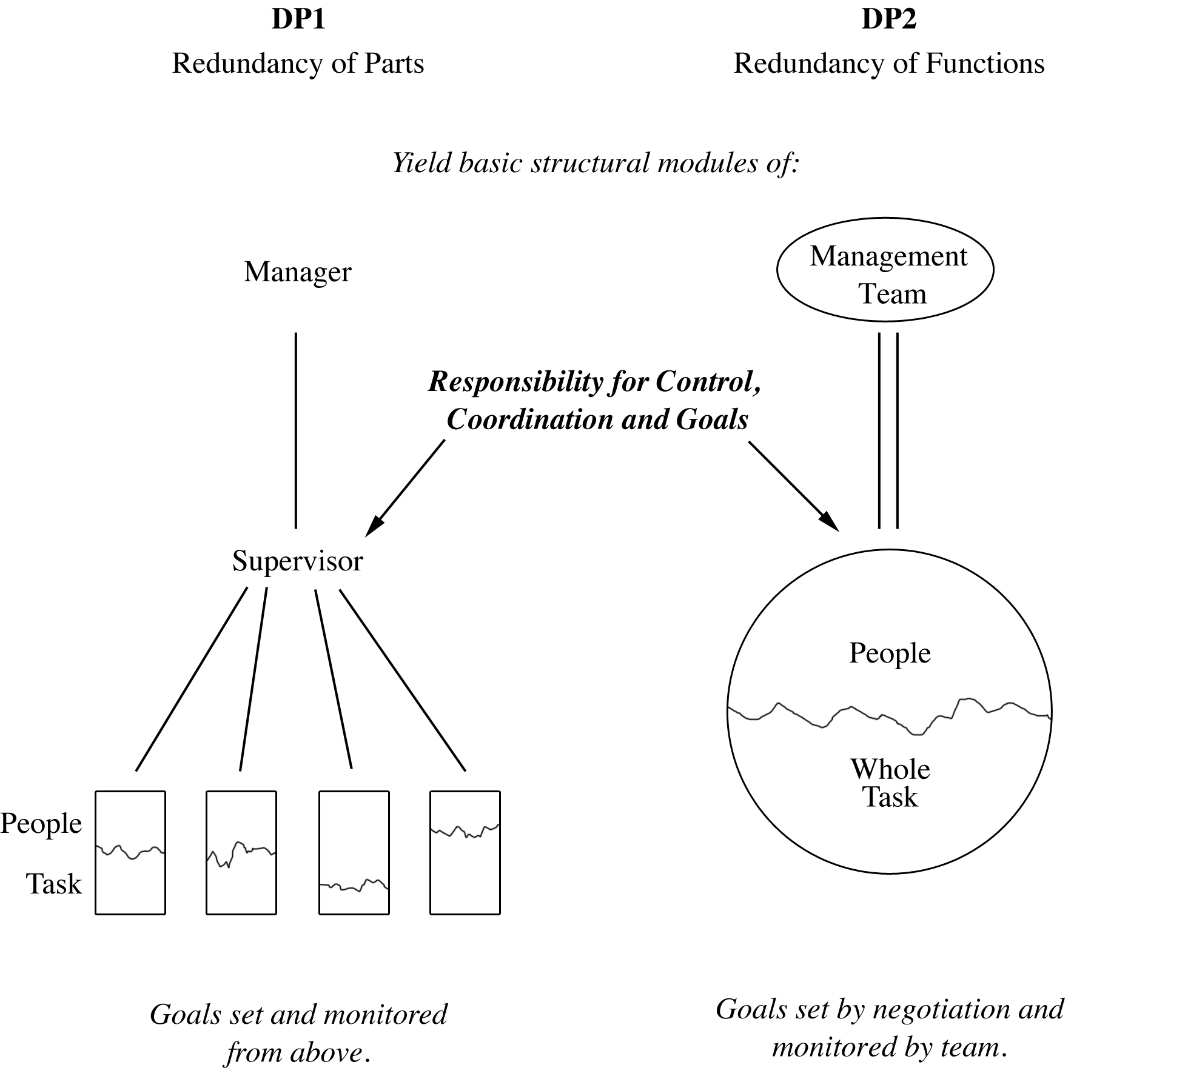
Fig. 1 The Organizational Design Principles (adapted from Emery and Devane 2006)

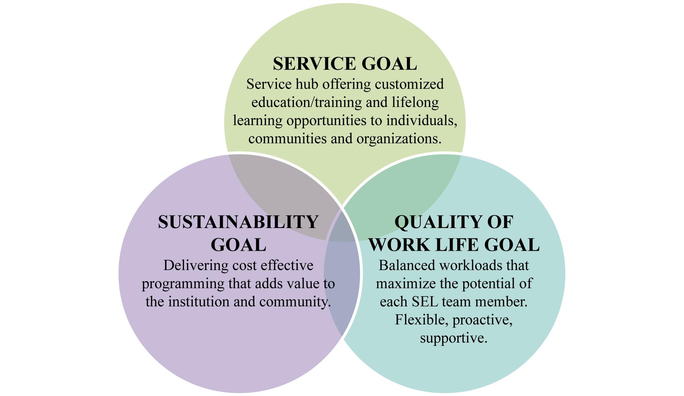 Fig. 2 Institutional Goals for the New Organizational Model
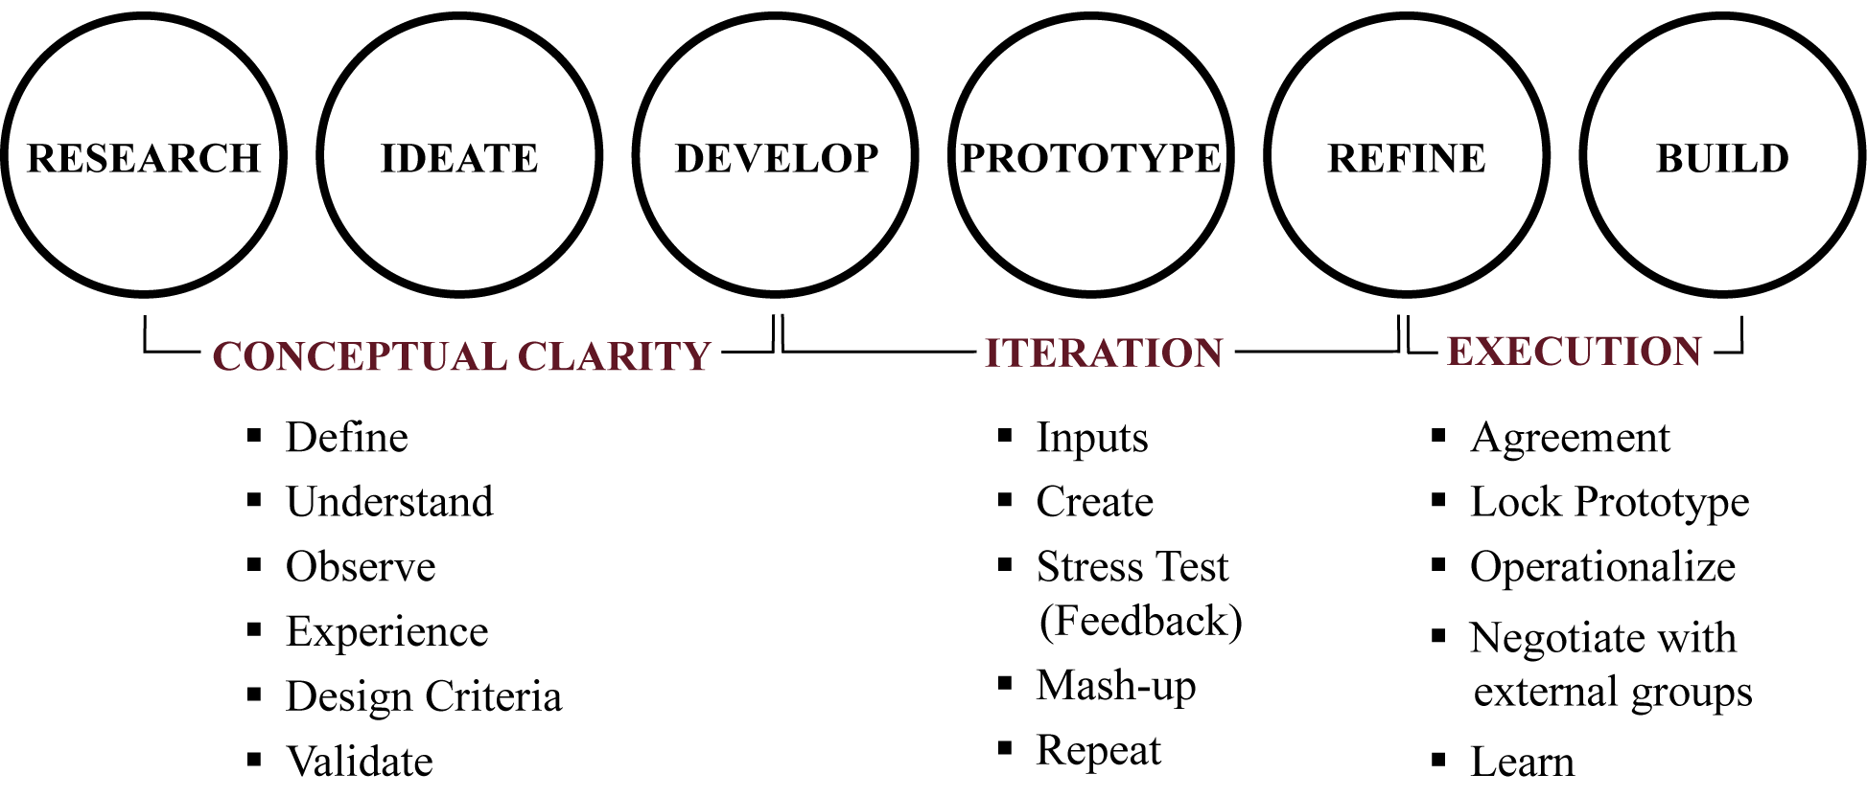
Fig. 3 Design Process (Adapted from www.studio-h.org/curriculum)

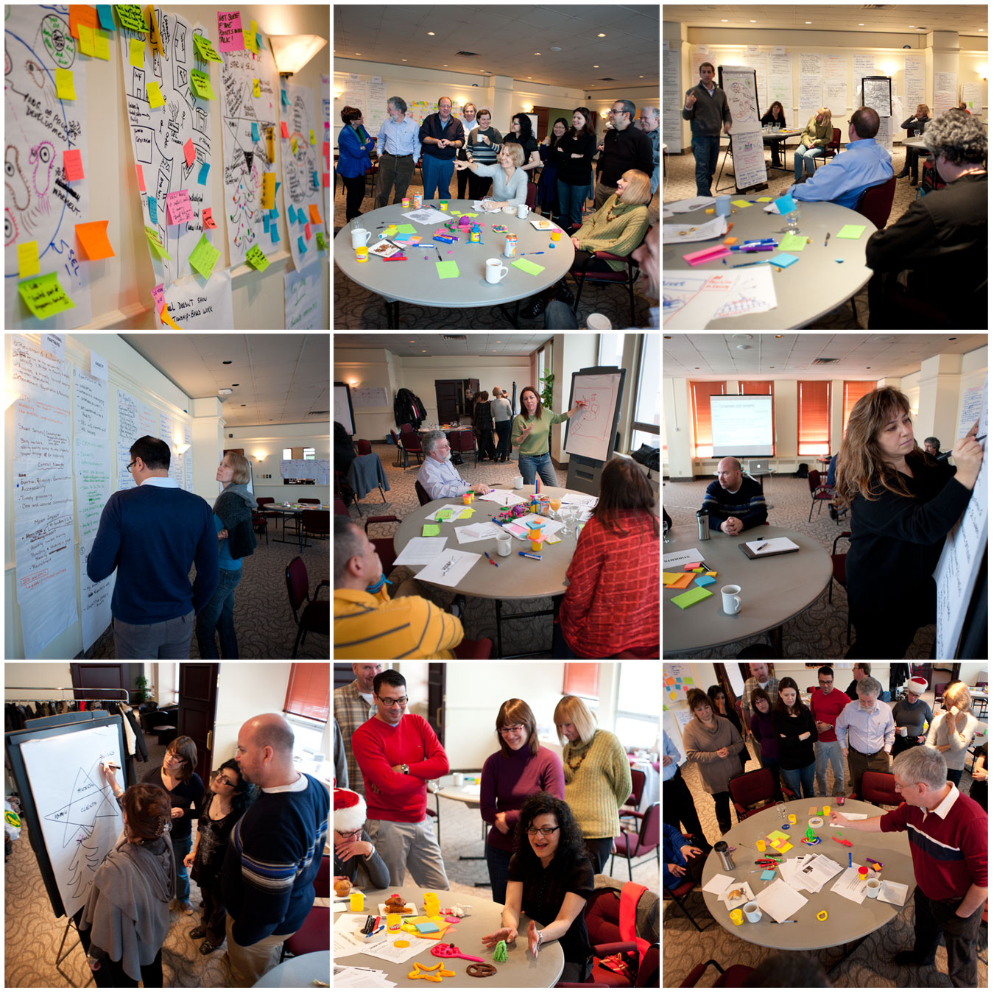
Fig. 4 The designers designing

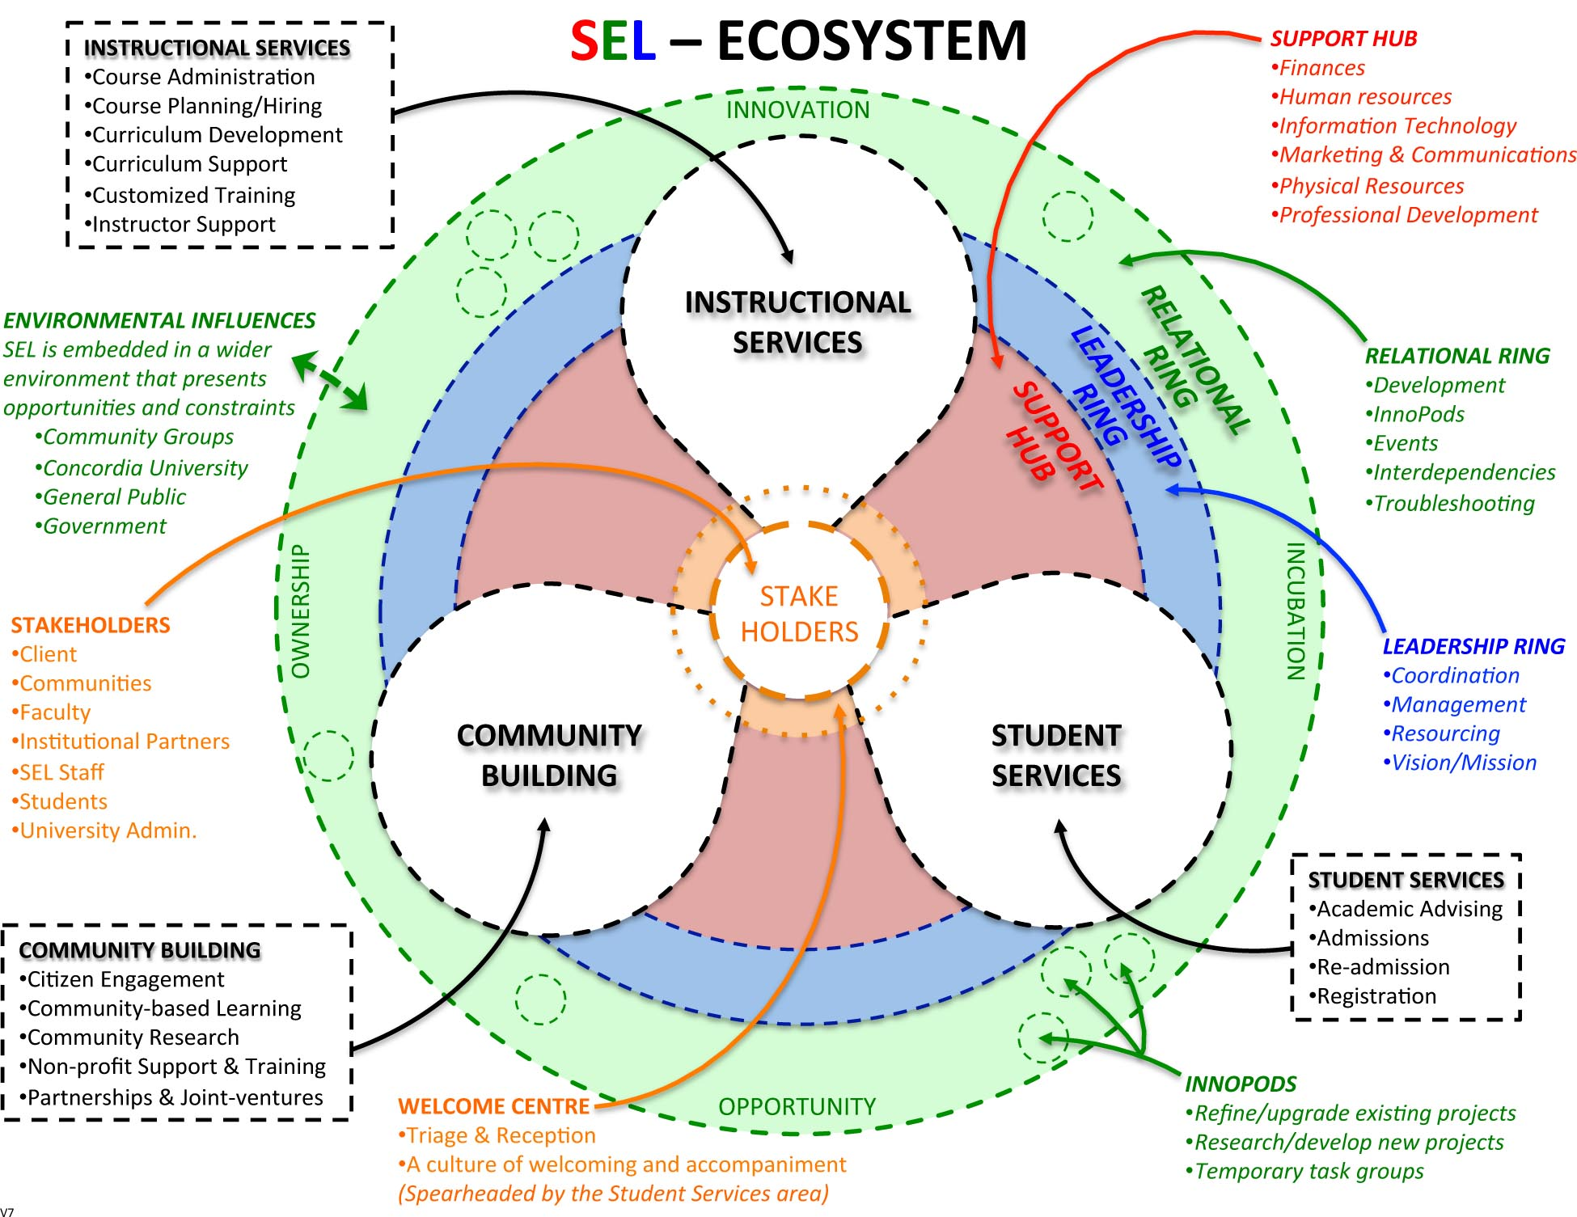
Fig. 5 The Organizational Model (Prototype 7)

A global network of business leaders, researchers, trade unionists, academics, managers, and consultants who share the principles and practices of Socio-technical Systems theory and a common interest in developing more humane and effective organizations. For more information: www.stsroundtable.com
The first modern arts and crafts school.
No loss of job, status, pay or benefits; no design can be imposed; does not violate the collective agreement; maintains or improves service quality. Note that what OST may call minimum critical specifications is like a design briefing.
This was done in order to ensure that existing silos could not re-emerge and that service area teams would not be seen as departments.

