Modeling and validation of a photocatalytic oxidation reactor for indoor environment applications

Lexuan Zhong, Fariborz Haghighat*
Department of Building, Civil and Environmental Engineering
Concordia University, Montreal, Quebec H3G 1M8
Corresponding Author: haghi@bcee.concordia.ca

Abstract
Modern building ventilation design must take into account the health, safety and comfort of the occupants, as well as energy consumption and the environment. The system needs to protect occupants against chemical contaminants from numerous internal sources - office equipment, furniture, building materials, appliances, as well as intentional release. A promising technology which has great potential in this respect is UV photocatalytic oxidation (UV-PCO). Designing a UV-PCO system for a building requires full understanding of its performance, which strongly depends on the UV intensity field, types and concentration levels of reactants, oxygen and moisture levels, temperature, reflectance of duct surfaces, system configuration, orientation, air stream characteristics like temperature, humidity, air velocity and mixing, just to mention a few.
This paper reports the development of a mathematical model for predicting the performance of a honeycomb monolith PCO reactor used in building mechanical ventilation systems. The model is validated by comparing its prediction with experimental data and with the prediction made by an existing model. The influence of several kinetic parameters such as airflow rate, pollutant inlet concentration, light intensity, humidity, and catalyst deactivation has been investigated. The developed model can be used as a practical tool to simulate and optimize a UV-PCO system for application in building mechanical ventilation system.
Keywords: Ultraviolet photocatalytic oxidation, model, irradiance, energy, efficiency, simulation

- Introduction
The needs to provide a healthy, safe and comfortable indoor environment and to reduce building energy consumption have all increased the interest in systems to filter gaseous contaminants from the air. Ultraviolet photocatalytic oxidation (UV-PCO) is a promising technology which has great potential for such an application (Zhong et al. 2010). Such devices use titanium dioxide (a semiconductor) where electron transition from the valence band to the conduction band results from the absorption of light in the near UV range. The subsequent generation of positive holes and their interactions lead to the formation of hydroxyl radicals. These act as powerful oxidizing agents and can be used in the mineralization of organic molecules on the surface of titanium dioxide. In addition, claims have been made with respect to the use of UV-PCO devices in enhanced inactivation rate of microorganism (Wang et al. 2009). However, it must be noted that in case of incomplete oxidation, the pollutants may be transformed into other by-products that can also pose health hazards. There is little reliable information available in the literature about the performance of this system. Although a number of devices such as chemical filtration, UVGI, and UV-PCO are available in the market, no systematic studies have been carried out regarding their comparative performance. In the quest for more successful commercial applications of UV-PCO technology in buildings, more attention is being brought to the modeling and simulation of reactors in order to obtain a more comprehensive and systematic understanding of the UV-PCO system.
Nicolella and Rovatti (1998) proposed a mathematical modeling of monolith reactors, which predicted the rate of chemical reaction and energy transfer. This model provided the distribution of photo flux along the channels, and defined the contributions of thermal and pure photonic effect on the overall rate of conversion. Although enthalpy balance was an innovative aspect in their modeling, they neglected the contribution of molecular diffusion transfer in the mass balance, and therefore their model cannot accurately account for the behaviour of PCO under the case of continuous injection of contaminants.
Changrani and Raupp (2000) presented the development of a two-dimensional heterogeneous convection-reaction model for an annular reticulated monolithic gas-solid photo-reactor. This model was developed on the basis of efficient utilization of UV irradiance, and it evaluated the reaction rate with local volumetric rate of energy absorption (LVREA). The magnitude of LVREA mainly determined the influence of mass transfer when it was a limiting process. At the same time, LVREA was affected by the catalyst loading and porosity of the porous catalyst support. However, this model assumed steady state conditions, which makes it difficult to be applied to practical usage due to the variation of numerous properties, such as the pollutant concentration in the inter-fibres or at the surface of fibres as function of time.
Yang et al. (2004) proposed an improved PCO model based on three main parameters: the average total removing factor, K_{t}, the number of mass transfer units, NTU_{m} and the fractional conversion, ε. This model can be applied to predict the controlling process of a PCO reactor under specific conditions. The controlling process could be mass-transfer-controlled process, reaction-controlled process, or combined-controlled process. The limitation of this model is that the mass conservation equation was constructed only in air-phase and the effect of irradiance on PCO performance was not clearly reflected in their mathematical model.
Developed one-dimensional and two-dimensional models, based respectively on plug flow and laminar flow, are used to study the effect of the key parameters on the performance of an annular reactor (Tomasic et al 2008). Through simulation analysis, they concluded that the inter-phase mass transfer was the dominating process, which determined the behaviour of the annular photocatalytic reactor. Nevertheless, the kinetic rate model they developed does not consider the light intensity and interference effects.
In the past two decades, although different prediction models for PCO reactors have been developed, most of them are not intended for mechanical ventilation applications and cannot correctly simulate the behaviour of a PCO reactor under the conditions encountered in buildings (Vincent et al., 2009; Puma et al., 2009). In addition, most reported models consider mass balance of pollutants in either air-phase or solid-phase (Hossain et al., 1999; Zhang et al., 2003; Lewandowski and Ollis, 2003; Yang et al., 2004; Estivill et al., 2007). Only few models consider pollutants mass balance for both air-phase and solid-phase, and those which take it into account assume a steady state condition (Nicolella and Rovatti, 1998; Changrani and Raupp, 2000; Tomasic et al., 2008).
This paper reports the development of a reliable time-dependent PCO model to simulate an in-duct PCO air cleaner under the conditions relevant to the actual applications. The proposed two-phase model incorporates the influences of properties of light sources and catalyst, reactor geometry, mass transfer parameters, kinetic parameters as well as operational conditions, such as the airflow rate, inlet pollutant concentration, relative humidity, and irradiance. The comprehensive PCO model is then used to analyze the effects of key parameters on PCO performance, to predict the single-pass removal efficiency of the in-duct UV-PCO air cleaners, and to estimate the dominating process between physical interactions and photochemical interactions.
- Model development
Photocataytic degradation of gaseous pollutants is a complex physico-chemical process and the catalytic reaction rate is an essential gauge of the efficiency of UV-PCO system. Simple kinetic models are different order empirical models, which assume the concentrations of reacting species in air as the driving force for reaction. The effects of the rest of aforementioned UV-PCO parameters are lump-summed into a reaction rate constant as well as the order of reaction (Zhang et al., 2003; Yang et al., 2004). In contrast, the models that assume the concentrations of adsorbed species on the catalyst as the driving force can separately account for the effects of pollutant mixture, oxygen and moisture levels, as well as the concentration of reactants. Several studies (Obee, 1996, Chen et al., 2005) applied different forms (e.g., unimolecular with or without interference effects of mixture, and bimolecular) of Langmuir-Hinshelwood (L-H) model, which retains the assumptions underlying the Langmuir adsorption isotherm. L-H model, however, cannot explicitly describe UV irradiation or mass transfer of reactants in the bulk fluid and porous structure of the catalyst. In this research, an L-H model combined with a proper light scattering model and a mass transfer model will be developed to closely reflect the actuality of the photocatalytic reaction.
The considered PCO reactor is integrated into a mechanical ventilation system, and UV lamps with peak wavelengths of UVA, UVB and UVC are positioned in front of and parallel to the filter surface coated with titanium dioxide (TiO₂). The following fundamental mechanisms are considered in the development of in-duct UV-PCO:
- The distribution of photo energy within ducts and interaction between light and matter at the surface of catalyst;
- Convection, diffusion, and boundary transfer of contaminants in the air-phase;
- Adsorption and photocatalytic oxidation reaction on the solid-phase;
- Inter-phase mass transfer of reactant species.

The following assumptions are made in the development of the model:
- Irradiance emitted from UV lamp is constant, stable in the imaged plane of a light source and independent of specified directionality;
- The inner geometries of ducts are identical and inner walls are uniformly irradiated by UV lamps asymmetrically mounted in the duct;
- Absorption, reflection, refraction and diffraction of light by mixed gases are negligible;
- TiO₂ catalysts are uniformly coated at the fibrous support;
- Reflectivity of inner walls is a function of light wavelength, and independent of the light incidence angle;
- Air flow in duct is regarded as ideal plug flow; and
- PCO reaction occurs at the surface of catalyst fibres illuminated with UV-lights.

UV irradiance field model
In this model, the irradiation on the catalyst surface is attributed to two factors: one is the direct photon transmittance from the light source; another is the photons reflected from interior duct walls. In the modeling process the principle of view factor is employed. Using this method, the contributions of irradiation on two parts to TiO₂ surfaces are easily and accurately estimated.
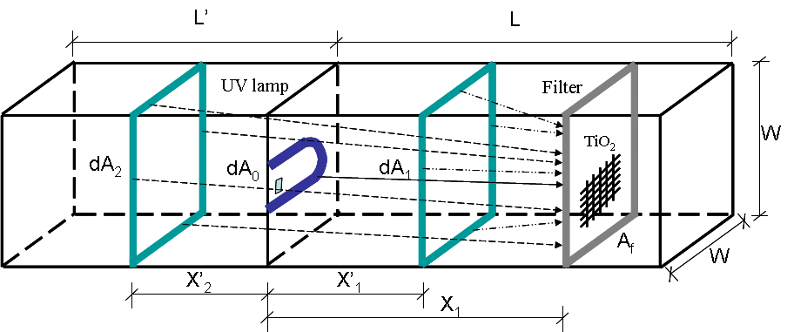
Figure 1 - Schematic diagram of square duct demonstrating the spectral intensity contributions of differential areas to a purification filter with area A_{f}

The mathematical expression of the spectral intensity I_{f}(λ) to the fibrous filter coated with TiO₂ (Figure 1) is determined as follows:
(1)
The first term is the contribution of direct illumination from all the infinitesimal dA₀ area composing the plane of UV light. The remaining terms are the contributions of indirect illumination from adjacent and opposing wall surface on both sides of UV source.
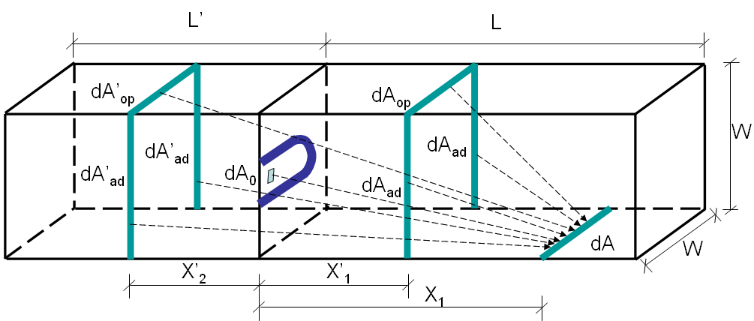
Figure 2 - Schematic diagram of square duct demonstrating the spectral intensity contributions of differential areas to a differential wall strip element dA

The mathematical expression of the spectral intensity I_{w}(λ) to the wall surface (Figure 2) is shown below:
(2)
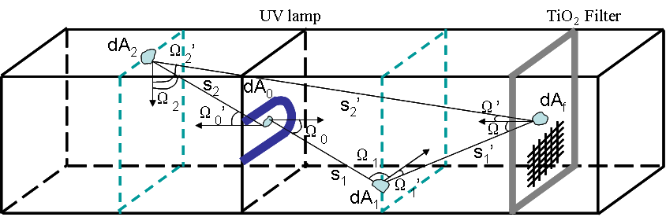
Figure 3 - View factor associated with the radiation heat exchange between two elemental surfaces of area

According to the thermal radiation theory, view factor, F(M,N), is the proportion of all radiation which leaves surface M and strikes surface N. The view factor is geometrically determined (as shown in Figure 3) and mathematically expressed between two elemental areas:
(3)
(4)
(5)
(6)
The standard equations of integral and differential view factors were provided by Siegel and Howell (1992) and Worth et al. (1996) to calculate the view factors on right side of the UV source for a square channel. Similarly, equations of integral and differential view factors on left side of the UV source are derived.
Combined with the spectral power distribution of wavelength provided, the average intensity at the catalyst surface can be subsequently determined through the method of integral weighted mean. The expression is shown as follows:
(7)
Compared with the previously developed irradiance models (Hossain and Raupp, 1998; Hossain and Raupp, 1999; Hossain et al., 1999; Alexiadis, 2006), the advantage of this new UV irradiance model is that the contributions of wall surface on left and right side of UV light are considered, because UV sources are always mounted within a duct of HVAC system. Therefore, this model accurately simulates the actual distribution of UV irradiation in an in-duct air purification system.
Reaction kinetic model
The determination and evaluation of kinetic parameters in photocatalytic reaction rate model is based on the fundamental mechanism of PCO, and is one of the main obstacles for practical application of mathematical model of PCO reaction. The simple representation of photochemical process is:
Based on this mechanism, developed Langmuir-Hinshelwood reaction rate equation is used for modeling the mean PCO reaction rate of species i removal, which is given by
(8)
Considering the irradiance distribution within the catalyst as non-uniform, meaning that the irradiance within the catalyst is smaller than that at the external surface, the effectiveness factor, , of the photocatalyst, defined by Hill (1977), is used to evaluate the mean efficiency of the entire catalyst. Assuming irradiance within the catalyst varies exponentially; the effectiveness factor of the geometry of interest is expressed as:
(9)
Mass balance
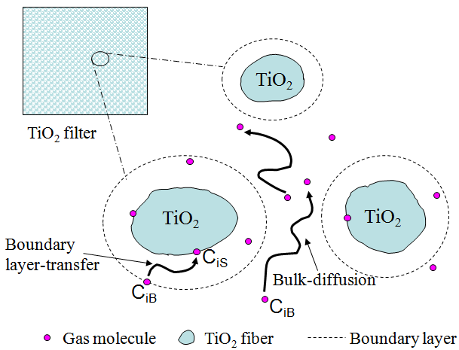
Figure 4 - Schematic diagram of gas molecule transfer in the inter-fiber (air-phase) and at the surface of fibres (solid-phase)

The PCO dynamics of contaminants in fibrous TiO₂ film is described by two equations, one representing the mass balance of the contaminant in the inter-fibre air-phase, and the other representing the mass balance at the surface of catalyst fibres (Figure 4):
(10)
(11)
where the initial and boundary conditions are
at (12)
at (13)
at (14)
- Model implementation
To numerically solve the problem, the TiO₂ film is discretized into n elemental cells connected in series in the airflow direction. Since the fibrous diffusion inside the fibres is not considered, only one fibre element is needed for each film node, and the concentrations C_{B} and C_{S} are assumed to be uniform within a same cell (Figure 5). Each of the film cells was implemented as a mass transport component solving with the Matlab R2009b using finite difference method.

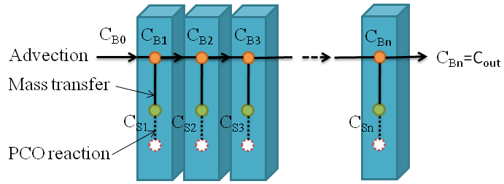
Figure 5 - Discrete representation of TiO₂ filter

The PCO model is then used to simulate photocatalytic oxidation of toluene without intermediates generated. The parameters in the PCO model are summarized in Table 2 (column a). Once these parameters are obtained/estimated from the existing literature (column b), the predicted performance of PCO air cleaners can be evaluated for given values of the operational conditions.
Miyayama et al. (2004) found that the porosity of TiO₂ film was controllable in the range of 30% to 56% by changing trehalose concentration in the dip-coating solution. Ould-Mame et al. (2000) mentioned that the typical values of porosity and turtuosity of TiO₂ film were 0.5 and 3, respectively. These two typical values were also taken in this study. The thickness of TiO₂ film is linearly proportional to deposition time, but photocatalytic activity has nonlinear relationship with the film thickness. The optimum thickness of TiO₂ catalyst film grown by the low-pressure metal-organic chemical vapour deposition is between 3 and 5µm (Jung et al., 2005). In this study we select a film thickness of 5µm.
The method developed by Wilke and Lee (1955) is commonly used to estimate gaseous diffusion coefficients for a wide range of temperatures. The value of 8.6×10⁻⁶m²/s for toluene at room temperature is calculated using Wilke- /Lee’s correlation, that is, the diffusion of gases is a function of temperature, the molecular weight, the collision integral, the pressure, and the characteristic length of molecules.
Votruba et al.,’s (1975) developed Sherwood number (Sh) is used to calculate the interphase mass transfer coefficient, k_{g}:
$Sh=0.705{(Re\frac{D}{L_{f}})}^{0.43}{Sc}^{0.56}$ (15)
where Sc is the Schmidt number and Re is the Reynolds number, D is the characteristic length of fibrous media, and it was taken as 3×10⁻⁷(m). Considering Reynolds number is associated with the airflow rate, Sherwood number is a function of the airflow rate and characteristic length of TiO₂ particle. In addition, Sherwood number integrates the convective mass transfer coefficient in its definition, $Sh=k_{g}D/D_{m}$, then the convective mass transfer coefficient can be determined from the computed Sherwood number. The mass transfer coefficients for the three airflow rates were presented in Table 1.

Table 1 Mass transfer coefficients for different airflow rates
Empirical estimation | Airflow rate (m/s)
 | 0.5 | 1.0 | 1.5
k_{g} (m/s) | 1.39 | 1.87 | 2.23

Kinetic parameters have been evaluated by many researchers, and different results have been reported for different models under various reaction conditions. For example, in literature, various values of reaction rate constant k₀ and absorption coefficient K for toluene with a concentration range from 0.064-98mg/m³ (0.02-26ppm) have been reported. They include 13.388mg/m³·s and 0.0049m³/mg (Bouzaza et al., 2006), 6.77×10⁻⁷mol/m²·s and 0.24m³/mg (Zhang et al., 2007), 0.026 mg/m³·s and 0.0266 m³/mg (Shiraishi and Ishimatsu, 2009), as well as 0.0134 mg/m³·s and 0.66 m³/mg (Sleiman, 2009). It is very hard to compare these values, partly because most of experimental setups and reaction conditions are totally different, partly because the kinetic parameters have different units. In this study, reaction rate coefficient of 1 mg/m³·s and absorption coefficient of 0.24 m³/mg were selected, which are within the range of aforementioned reported values. Obee (1996) investigated the effect of moisture on photo-oxidation of sub-ppm toluene, and obtained the value of 4.9×10⁻⁴m³/mg (0.00036ppm⁻¹) for water absorption coefficient by using the least-squares optimization. We used this value in our simulation.
Taking into account the fact that the irradiance distribution within the catalyst follows exponential decay, the extinction coefficient of catalyst was set to a typical value of 0.3µm⁻¹ (Hill, 1977; Changrani and Raupp, 2000).
In this study, the irradiance at the surface of TiO₂ filter was always greater than 1-2 mW/cm². According to the empirical correlation between the reaction rate and the light intensity (Obee and Brown, 1995), the power exponent value of 0.5 is considered in our simulation.
A value of 0.6m⁻¹, apparent catalyst surface area per unit PCO reactor volume, has been calculated on the basis of known geometrical size of the rectangular PCO reactor (Figure 6). The contaminant concentration, UV irradiance, airflow velocity and relative humidity were assumed to be controllable in the range of 0.038-37.7mg/m³ (0.01-10ppm), 2-20mW/cm², 0.5-1.5m/s (100-300cfm), and 6990-18940 mg/m³ (30-80%), respectively.
Figure 6. Schematic diagram of experimental setup

Table 2 Simulation parameters for UV-PCO tests
Parameters (a) |  | Compound:  Toluene (b)
Catalyst property | TiO₂ film porosity, $ε$ | 0.5
 | TiO₂ film tortuosity factor, $τ$ | 3
 | TiO₂ film thickness, L_{f} | 5µm
Mass transfer | Molecular diffusion coefficient, D_{m} | 8.6×10⁻⁶m²/s
 | Inter-phase mass transfer coefficient, k_{g} | 1.39, 1.87, 2.23m/s
 | Geometric surface area per unit reactor volume, a | 0.6 m⁻¹
UV-PCO reaction | Synthetic kinetic rate coefficient, k₀ | 1 mg /m³∙s
 | Absorption coefficient, K | 0.24 m³/mg
 | Water absorption coefficient, K_{H2O} | 4.9×10⁻⁴m³/mg (0.00036 ppm⁻¹)
 | UV irradiance extinction coefficient, µ | 0.3 µm⁻¹
 | Reaction order with respect to UV light applied, β | 0.5
Operation conditions | Concentration range, C_{in} | 0.038-37.7mg/m³  (0.01-10 ppm)
 | UV irradiance range, I_{f} | 2-20 mW/cm²
 | Velocity range, u_{x} | 0.5-1.5 m/s  (100-300cfm)
 | Humidity, C_{H2O} | 6990-18940 mg/m³  (30-80%)

- Model Validation
To validate the PCO model prediction, simulation results are compared with the prediction made by two-site kinetic model developed by Lewandowski and Ollis (2003). Two-site kinetic model is established on the basis of the presumed presence of two different types of adsorption sites, hydrophobic adsorption sites (type I) and hydrophilic adsorption sites (type II). For the reactant i, it is assumed to be only accessible to hydrophobic adsorption sites (type I). The site balance is given as follows:
(16)
Compared with the PCO model, the two-site kinetic model only considers the mass balance of a reactant at the fibre surface, but gives a more detailed description (including adsorption and desorption) on mass transfer.
Figure 7 compares the PCO model simulation results with both experimental data and the two-site kinetic model simulation results for two cases. Two models provide reasonable fits for experimental data collected during the photocatalytic oxidation of toluene in a single-pass, powder layer PCO reactor under operational conditions of 20 mg/m³ and 30 mg/m³ of feed concentration, 1000 mg/m³ of water vapour concentration and 1×10⁻⁶ m³/s (2cfm) of gas flow rate. In Lewandowski and Ollis (2003), a 100W blacklight was used as a UV energy provider, but no information about the irradiance was provided. So the value of irradiance is the only adjusted parameter in the simulation, and finally 16.5 mW/cm² is found to be a correct value to simulate the trend of the toluene concentration for both cases.
It is worthwhile to mention that in their experimental work, Lewandowski and Ollis (2003) did not turn on UV lights until the adsorption of toluene and water by the regenerated catalyst reached equilibrium. In other words, the first part of the experimental data reflects the adsorption process taking place, whereas the latter part shows the UV-PCO photochemical process being underway. This is the reason for the discrepancy between experimental data and the PCO model predictions at the initial stage. After 60 minutes, however one can see that the exit concentration profile predicted by the PCO model for both cases seems to be more consistent with the experimental data than that predicted by the two-site kinetic model. The good agreement between the predictions from the proposed PCO model and previous experimental results indicates the PCO model can correctly capture the trend of efficiency as a function of time. Hence, the validated model can be applied to describe the behaviour of a PCO for application in the in-duct UV-PCO air cleaners.
(a)
(b)
Figure 7 – Comparison of model prediction with the prediction of two-site kinetic model (Lewandowski and Ollis, 2003) for toluene with inlet concentration of (a) 20mg/m³ (b) 30mg/m³. (Simulation conditions: C_{in}=20mg/m³ and 30mg/m³; C_{H2O}=1000mg/m³; u=0.011m/s; I_{f}=16.5mW/cm²)

- Parametric simulations analysis
The simulation program is then used to predict the reactor behaviour under different operational conditions, as well as to account for the PCO performance changes resulting from the influencing design parameters. Moreover, it can provide information regarding limiting case tests beyond experimental possibilities. For example, it is of great interest to investigate the impact of operational conditions on the PCO efficiency. Figure 8 demonstrates the interrelationships between different influencing elements in the PCO reactor model.
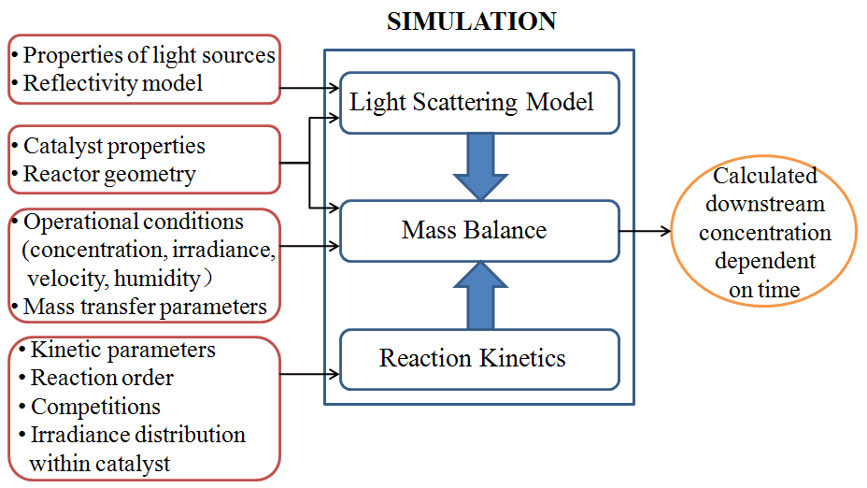
Figure -8 - Structure of simulation program

Effect of airflow rate
Figure 9-a shows the single-pass efficiency decays as function of time. It also shows that as the airflow rate increases, the efficiency drops. In other words, as the air velocity increases, the exposure time to the PCO is so short that the decomposition of VOCs is greatly compromised. More precisely, it means that the PCO reaction time is longer than the residence time and that the pollutants cannot fully participate in PCO reaction. Therefore, the lower the airflow rate, the higher the single-pass efficiency.
Effect of inlet concentration
Figure 9-b shows the simulated result of single-pass efficiency as function of time for various toluene inlet concentrations; this shows that as the inlet concentration decreases the steady-state efficiency increases and the time to reach equilibrium is shorter. Theoretically, the single-pass efficiency can reach one within the first few minutes. Then, it rapidly drops down as time elapses since the active sites at the catalyst surface are gradually blocked by reactants and/or intermediates. This figure also shows that the slopes of all curves before 40 minutes are almost identical. This is due to using the same air velocity for all cases. It should be noted that in this study the change of the reaction rate constant due to gradually deactivated catalyst is not considered, which will be discussed later.

Effect of light intensity
UV irradiance has a pronounce impact on the performance UV-PCO since it determines the number of electron-hole pairs reacting with adsorbed water to form highly reactive hydroxyl radicals. In this study, the UV irradiance can be changed by altering the distance between the UV lights and the catalyst surface, and by changing the numbers of UV lights. Figure 9-c shows the impacts of three levels of UV irradiance on the PCO efficiency. This figure demonstrates that increasing the irradiance increases single-pass efficiency, and to be more specific, that the removal efficiency is nonlinear with UV irradiance. At low light intensity, electron-hole pairs effectively participate in the photochemical reactions, whereas recombination of the electron-hole pairs inhibits the rate of electron transfer at the high light intensity. Thus, not much hydroxyl groups expected are promoted by high irradiance. Hence, the single-pass removal efficiency depends nonlinearly on the light intensity.

Effect of relative humidity
Humidity has a dual role on the performance of UV-PCO system: on one hand it supplies high-activity hydroxyl radicals, and on the other hand it competes with contaminants adsorbed on the catalyst surface. The optimal level of humidity needed in PCO air cleaners is determined by contaminant concentrations. Figure 9-d shows that decreasing the relative humidity leads to the increase of the single-pass efficiency, which indicates that the limiting factor is the adsorptive competition between moistures and pollutants under the case of photocatalytic oxidation of low concentration pollutants. This conclusion was also stated by Zhong et al (2010); they reported that for the low concentration of a single contaminant, the lowest relative humidity is the best condition for PCO.
Effect of catalyst activities
Catalyst deactivation is a common phenomenon reported in previous work (D’Hennezel et al., 1998; Alberici and Jardim, 1997; Ameen and Raupp, 1999). The effect of assumed reaction rate constants on the efficiency of PCO was simulated to study the catalyst with different levels of deactivation. Figure 9-e shows that single-pass efficiency after 25 minutes decreases whenTiO₂ catalyst has lower activity. The efficiency curves in the first 25 minutes have nearly identical slopes because the PCO process at initial stage is mainly controlled by advection and mass transfer, which brings reactants into the catalyst bed. After a certain amount of reactant accumulation at the surface of TiO₂ fibres, PCO reaction is the limiting process which controls all other PCO processes. Therefore, after PCO works for a certain period of time and reaches equilibrium, the single-pass efficiency curve is closer to zero as the reaction rate constant becomes smaller. It should be mentioned that the kinetic rate coefficient, which in this study is assumed to be constant, changes with time.
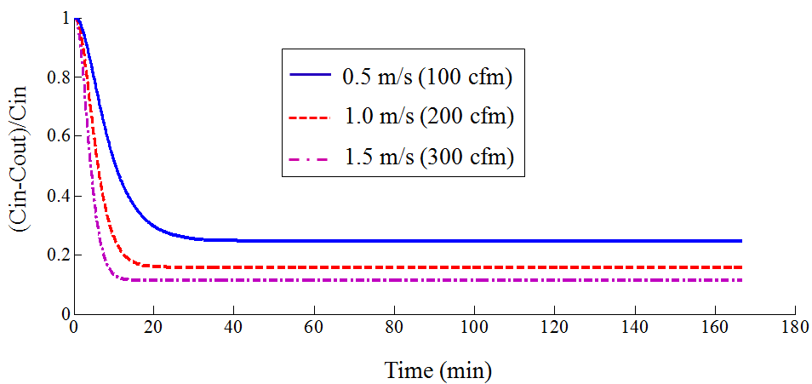
- Simulation conditions: C_{in}=3.77 mg/m³; I_{f}=5mW/cm²; u=0.5, 1.0, 1.5m/s; C_{H2O}=11720mg/m³
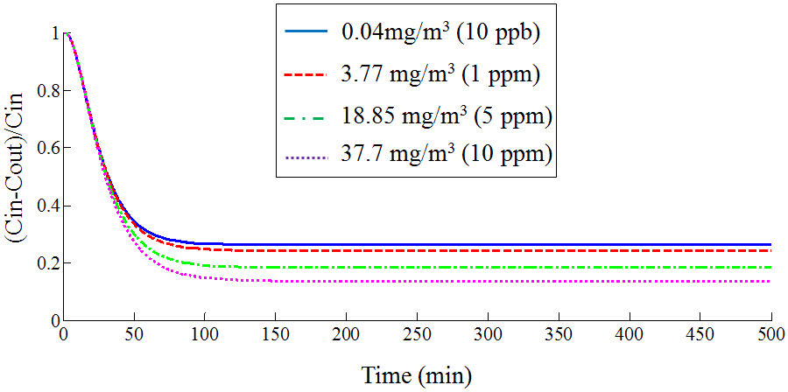
(b) Simulation conditions: C_{in}=0.038, 3.77, 18.85, 37.7mg/m³; I_{f}=5mW/cm²; u=0.5m/s; C_{H2O}=11720mg/m³

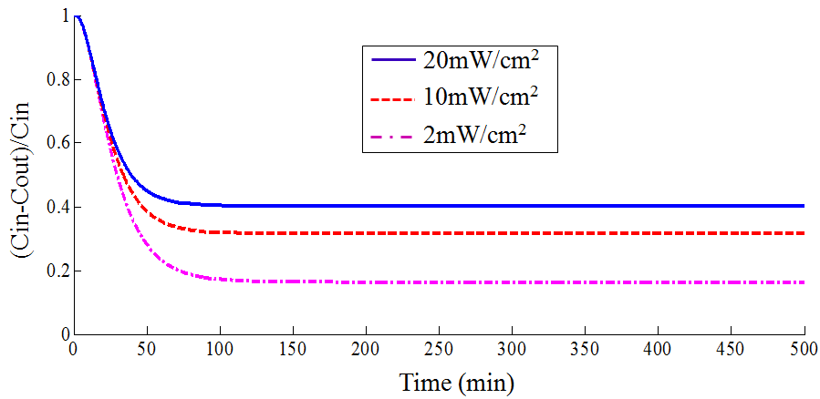
(c) Simulation conditions: C_{in}=3.77mg/m³; I_{f}=2, 10, 20mW/cm²; u=0.5m/s; C_{H2O}=11720mg/m³

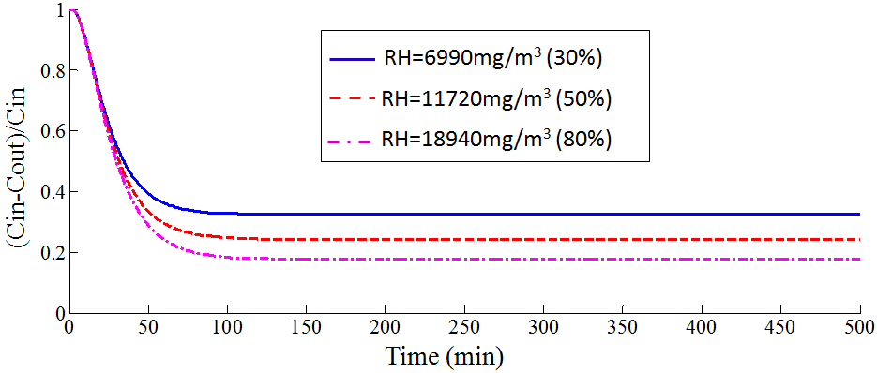
(d) Simulation conditions: C_{in}=3.77mg/m³; I_{f}=5mW/cm²; u=0.5m/s; C_{H2O}=6990, 11720, 18940mg/m³

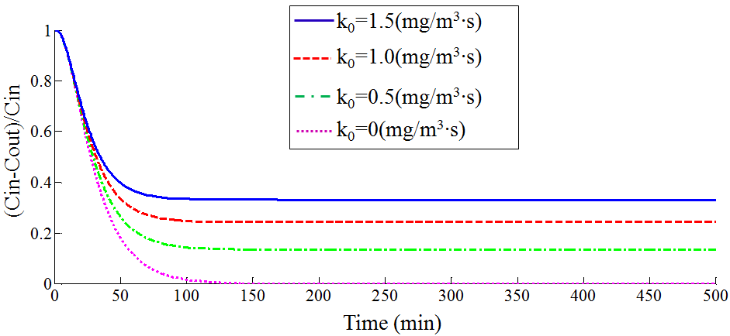
(e) Simulation conditions: C_{in}=3.77mg/m³; I_{f}=5mW/cm²; u=0.5m/s; C_{H2O}=11720mg/m³; k₀=0, 0.5, 1.0, 1.5mg/m³·s
Figure 9 Effects of operating parameters: (a) airflow rate (b) inlet concentration (c) light intensity (d) relative humidity (e) catalyst activities

Limiting cases study
In order to further verify the model prediction, it is used to investigate the impact of limiting cases, which includes zero air velocity, zero reaction rate constant, zero adsorption coefficient, and zero mass transfer coefficient. These limiting cases are beyond the experimental possibility, but they still can be compared with theoretical analysis.
- Zero velocity (u). Airflow is mainly responsible for bringing the reactant into the filter bed. When the velocity is zero, the molecular diffusion is the only mechanism of mass transfer into the surface of catalyst. The order of magnitude of molecular diffusion is about10⁻⁶, which is significantly small. Therefore, only a very small amount of reactants can reach TiO₂ catalyst. Hence, the removal efficiency can remain unity for a long time, as shown in Figure 10.

- Zero reaction rate constant (k₀) and/or zero absorption coefficient (K). In this case, the model is changed to account for the sorption dynamics of contaminants. Figure 10 shows that after the TiO₂ fibres adsorb pollutant molecules for some time and then the fibres have no capacity to hold additional contaminant molecules, the removal efficiency curve will be close to zero due to the breakthrough.

- Zero mass transfer coefficient (k_{g}). Reagent species need to transport through the boundary layer surrounding the catalyst fibres before being absorbed and photochemical reaction takes place. So mass transfer coefficient is an important parameter which determines the number of pollutant molecules reaching the PCO surface and being involved in the reaction. When the mass transfer coefficient is zero, there is no occurrence of external diffusion in the boundary layer and thus no PCO reaction. Therefore, breakthrough happens after the contaminant flow passes through the bed depth, and the removal efficiency also soon drops to zero (Figure 10).
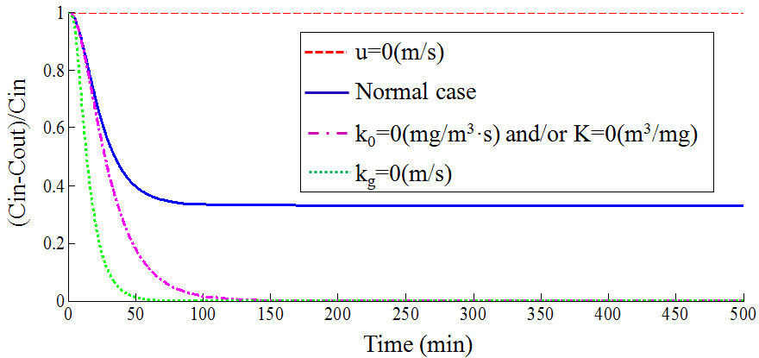
Figure 10 - Single-pass efficiency-time profile modeled under different limiting cases
(Simulation conditions: C_{in}=3.77mg/m³; u=0 and 0.5m/s; I_{f}=5mW/cm²; k₀=0 and 1mg/m³·s; K=0 and 0.24mg/m³; k_{g}=0 and 1.39m/s)

The simulation results for aforementioned extreme cases are presented in Figure 10. It can be observed that the developed model is able to predict correctly the performance of the system for the extreme cases and the prediction follows the theory.

- Conclusions
A Langmuir-Hinshelwood (L-H) model combined with light scattering model as well as mass transfer model is developed and numerically implemented to simulate the performance of a PCO air cleaner commonly used in building HVAC systems. Although a more comprehensive validation needs to be carried out in the near future, the proposed comprehensive PCO model could be a useful tool to simulate and optimize a UV-PCO reactor for scaling-up and design purposes. The main features of this mathematical model are:
- The comprehensive PCO model is developed based on three sub-models: irradiance field model, reaction kinetics model, and mass balance.
- Properties of light sources and catalyst, reactor geometry, mass transfer parameters, kinetic parameters as well as operational conditions determine the performance of PCO air cleaners.
- The model parameters can easily be estimated from real systems.
- The descriptions of mass balance of species at air and solid phase allow the exit concentration at downstream to be computed.
The main advantages of this model in comparison with other models are:
- The model parameters can be measured independently.
- The time-dependent model can predict the single-pass removal efficiency of UV-PCO air cleaners more accurately.
- This model can be used to investigate the effects of key parameters on the performance of PCO.
- Optimization of VOCs removal process in PCO system can be carried out by analysis of the dominating process between physical interactions and photochemical interactions.
In summary, a mathematical model of UV-PCO is developed and the simulation results are in good agreement with the experimental data and with the prediction made by an existing model. The validated model is then used to carry out parametric studies to identify the influencing parameters. The current model is therefore suitable for assessing the behaviour of an in-duct UV-PCO air cleaner. Moreover, the hybrid model based on fundamental principles provides important insights into physical or photochemical processes involved in UV-PCO technology. Future work includes implementing experimental validation and improving modeling methodologies to better reflect the actuality of photocatalytic reactions.

Acknowledgements
The authors would like to express their gratitude to the Natural Sciences and Engineering Research Council of Canada for the financial support through the strategic grant program, and Arvin Haghighat for his valuable inputs.

Notation
English symbols
a geometric surface area per unit reactor volume (1/m)
A area (m²)
C concentration (mg/m³)
D_{m} molecular diffusion coefficient (m²/s)
D characteristic length of fibrous media (m)
F view factor
I UV irradiance (mW/cm²)
K Langmuir’s absorption parameter (m³/mg)
k₀ synthetic kinetic rate coefficient (s⁻¹)
k_{g} inter-phase mass transfer coefficient (m/s)
k_{ads,i} adsorption rate constant for species i on type I sites (atm⁻¹s⁻¹)
k_{des,i} desorption rate constant for species i on type I sites (s⁻¹)
k_{I} reaction rate constant for conversion of species i to a intermediate on
type I sites
L_{f} TiO₂ film thickness (nm)
P distribution function of spectral power
P_{i} partial pressure of species i in reactor (atm)
r PCO reaction rate (mol/m³s)
s length of the connecting line (m)
t time (min)
u velocity (m/s)

Greek letters
β reaction order with respect to UV light applied
ξ stoichiometric coefficient of the compound in the reaction
wall reflectivity (%)
Ω angle
λ wavelength (nm)
porosity of the catalyst
tortuosity of the catalyst
υ air viscosity (m²/s)
effectiveness factor of the photocatalyst
µ UV irradiance extinction coefficient
θ_{i} coverage of species i on type I sites
θ_{S1} coverage of vacancies on type I sites

Dimensionless parameters

Re Reynolds number, $Re=uD/ευ$
Sc Schmidt number, $Sc=υ/D_{m}$
Sh Sherwood number, $Sh=k_{g}D/D_{m}$

Subscripts
0 plane occupied by UV lights
1 duct wall at the right side of UV light
2 duct wall at the left side of UV light
ad adjacent walls
B bulk
f filter
H₂O humidity
i species
in inlet
j intermediates converted from i
min minimum wavelength provided
op opposing wall
out outlet
S sorbed-phase
w wall
x, vector

Superscripts
max maximum wavelength provided

Special symbols
¯ average value

Reference
Alberici, R.M., Jardim, W.E. (1997) Photocatalytic destruction of VOCs in the gas-phase using titanium dioxide, Applied catalysis B-Environmental, 14, 55-68.
Alexiadis, A. (2006) 2-D Radiation Field in Photocatalytic Channels of Square, Rectangular, Equilateral Triangular and Isosceles Triangular Sections. Chemical Engineering Science, 61, 516-525.
Ameen, M.M., Raupp, G.B. (1999) Reversible catalyst deactivation in the photocatalytic oxidation of dilute o-xylene in air, Journal of catalysis, 184, 112-122.
Bouzaza, A., Vallet, C., Laplanche, A. (2006) Photocatalytic degradation of some VOCs in the gas phase using an annular flow reactor – determination of the contribution of mass transfer and chemical reaction steps in the photo-degradation process. Journal of Photochemistry and Photobiology A – Chemistry, 177, 212-217.
Changrani, R. G., Raupp G. B. (2000) Two-dimentional heterogeneous model for a reticulated-foam photocatalytic reactor, AIChE Journal, 46(4), 829-842.
Chen, W., Zhang, J.S., Zhang, Z. (2005) Performance of air cleaners for removing multiple volatile organic compounds in indoor air, ASHRAE Transactions, 1101-1114.
D’Hennezel, O., Pichat P., and Ollis D.F. (1998) Benzene and toluene gas-phase photocatalytic degradation over H2O and HCL pretreated TiO₂: by-products and mechanisms, J.Photochem. Photobiol. A – Chem, 118, 197-204.
Estivill, I.S., Brucato, A., and Puma, G.L. (2007) Two-dimensional modeling of a flat-plate photocatalytic reactor for oxidation of indoor air pollutants. Industrial & Engineering Chemistry Research, 46, 7489-7496.
Hill, CG. (1977) An Introduction to Chemical Engineering Kinetics and Reactor Design. Wiley: New York.
Hossain, M.M. and Raupp G.B. (1998) Radiation Field Modeling in a Photocatalytic Monolith Reactor. Chemical Engineering Science, 53, 3771-3780.
Hossain, M.M. and Raupp G.B. (1999) Polychromatic Radiation Field Model for a Honeycomb Monolith Photocatalytic Reactor. Chemical Engineering Science, 54, 3027-3034.
Hossain, M.M., Raupp G.B., Hay S.O., and Obee T.N. (1999) Three-dimensional developing flow model for photocatalytic monolith reactor. AIChE Journal, 45(6), 1309-1321.
Jung S.C., Kim S.J., Imaishi N., Cho Y.I. (2005) Effect of TiO₂ thin film thickness and specific surface area by low-pressure metal-organic chemical vapour deposition on photocatalytic activities, Applied Catalysis B: Environmental, 55, 253-257.
Lewandowski, M., Ollis D.F. (2003) Extension of a two-site transient kinetic model of TiO2 deactivation during photocatalytic oxidation of aromatics: concentration variations and catalyst regeneration studies, Applied Catalysis B: Environmental 45, 223-238.
Miyayama, M., Takenaka, T., Takata, M., Shinozaki, K.(2004) Preparation of nanoporous TiO₂ film using aqueous sol with trehalose, 23rd Electronics Division Meeting of the Ceramic-Society-of-Japan, OCT 23-24, 2003 Kawasaki, JAPAN. Source: ELECTROCERAMICS IN JAPAN VII, Book Series: KEY ENGINEERING MATERIALS, 269, 87-90.
Nicolella, C., Rovatti, M. (1998) Mathematical modeling of monolith reactors for photocatalytic oxidation of air contaminants, Chemical Engineering Journal, 69, 119-126.
Obee, T.N. (1996) Photooxidation of sub-parts-million toluene and formaldehyde levels on titania using a glass-plate reactor, Environmental Science and Technology, 30, 3578-3584.
Obee, T.N., Brown, R.T. (1995) TiO2 photocatalysis for indoor air applications: effects of humidity and trace contaminant levels on the oxidation rates of formaldehyde, toluene and 1,3-butadiene, Environmental Science and Technology, 29, 1223–1231.
Ould-Mame, S.M., Zahraa, O., Bouchy, M. (2000) Photocatalytic degradation of salicylic acid on fixed TiO₂- kinetic studies, International Journal of Photoenergy, 2, 59-66.
Puma, G.L., Estivill, I.S., Obee, T.N., Hay, S.O. (2009) Kinetics rate model of the photocatalytic oxidation of trichloroethylene in air over TiO₂ thin films, Separation and Purification Technology, 67, 226-232.
Shiraishi F., and Ishimatsu T. (2009) Toluene removal from indoor air using a miniaturized photocatalytic air purifier including a preceding adsorption/desorption unit, Chemical Engineering Science, 64, 2466-2472.
Siegel, R., Howell, J.R. (1992) Thermal Radiation Heat Transfer, 3rd ed. McGraw-Hill, New York.
Sleiman M., Conchon P., Ferronato C., and Chovelon J.M. (2009) Photocatalytic oxidation of toluene at indoor air levels (ppbv): TTowards a better assessment of conversion, reaction intermediates and mineralization, Applied Catalysis B: Environmental, 86, 159-165.
Tomasic, v., Jovic, F., Gomzi, Z. (2008) Photocatalytic oxidation of toluene in the gas phase: Modeling an annular photocatalytic reactor, Catalysis Today, 137, 350-356.
Vincent, G., Marquaire, P.M., Zahraa, O. (2009) Photocatalytic degradation of gaseous 1-propanol using an annular reactor: Kinetic modeling and pathways, Journal of Hazardous Materials, 161, 1173-1181.
Votruba, J., Sinkule J., Hlavacek, V., Skrivanek. (1975) Heat and mass transfer in honeycomb catalysis II, Chemical Engineering Science, 30, 201-206.
Wang, B., Mortazavi, R. and Haghighat, F. (2009) Evaluation of Modeling and Measurement Techniques of Ultraviolet Germicidal Irradiation Effectiveness – Towards Design of Immune Buildings Indoor and Built Environment, 18, 101-112.
Wilke, C.R., Lee, C.Y. (1955) Estimation of diffusion coefficients for gases and vapors. Industrial Engineering Chemistry, 47, 1253–1257.
Worth, D.J., Spence, A., and Crumpton, P.I. (1996) Radiative Exchange between Square Parallel Channels in a Concentric Monolith Structure. International Journal of Heat Mass Transfer, 39(7), 1463.
Yang. R., Zhang. Y.P., Zhao, R.Y. (2004) An improved model for analyzing the performance of photocatalytic oxidation reactors in removing volatile organic compounds and its application, Journal of the air & waste management association, 54, 1516-1524.
Zhang, Y.P., Yang, R., and Zhao, R.Y. (2003) A model for analyzing the performance of photocatalytic air cleaner in removing volatile organic compounds. Atmospheric Environment, 37, 3395-3399.
Zhang, Y.P., Yang R., Xu Q.J. and Mo J.H. (2007) Characteristics of photocatalytic oxidation of toluene, benzene, and their mixture, Air & Waste Management Association, 57, 94-101.
Zhong, L., Haghighat, F., Blondeau, P., Kozinski, J. (2010) Modeling and Physical Interpretation of Photocatalytic Oxidation Efficiency in Indoor Air Applications, Building and Environment, 45, 2689-2697.

