Container Freight Rates and Economic Distance: a new perspective on the world map

Elisabeth Gouvernal, Research Director, SPLOTT, IFSTTAR University of Marne La Vallée, France, elisabeth.gouvernal@inrets.fr

Brian Slack, Concordia University, Montreal Canada H3Y 1H9. slack@alcor.concordia.ca

Introduction

Transport costs represent an important subject for maritime transport studies. Costs have been shown to be a major issue in shaping in inter-port competition, regional accessibility and modal competition [1, 2]. Maritime transport costs are made up of a number of separate elements, including ocean freight rates, insurance costs, port charges, terminal storage and handling, and land distribution costs. In the academic literature the recent focus has been on shipping costs [3,4,], terminal costs [2, 5,6] and inland distribution costs [7]. Despite the significant extent of this literature, there has been much less attention paid to freight rates. There is much evidence of the structure and scale of shipping costs, but how these relate to actual freight rates charged is less clear. This paper seeks to redress this imbalance to some degree. The objective is to explore how container freight rates vary globally and regionally and over time. This is achieved in part by considering freight rates as a measure of economic distance. Unlike absolute distance which is invariant between locations, economic distance is a relative measure, but like absolute distance it can be mapped. In this paper the geographical distribution for a set of rates from markets around the world to the ports of the Northern Range of Europe is mapped. This cartographic representation provides a unique opportunity to explore the spatial arrangement of markets while providing a number of insights into the spatial structure of rates during a period of considerable change. The paper goes on discuss this spatial structure in the context of three issues that have been raised in the literature: the relationships between rates and physical distance; the role of market conditions and rates; and, the relationships between rates and economic development. From this examination, questions are raised involving long held assumptions about distance and rates, competition and pricing, and rates and economic development.

Container Freight Rates

Transport economists have contributed greatly to understanding how freight rates are determined in theory [8, 9,]. Rates are seen to depend on supply factors, such as the availability and capacity of different transport modes and their operating costs, and the demand, such as the volume of goods to be transported. We know much less on how rates are arranged and distributed spatially in reality. In part this is due to the confidential nature of rates, especially for liner shipping, but also their complexity. There have been a few studies that have provided a partial indication of container freight rates at a regional level for specific dates [10], but there are few if any comprehensive global studies of container rates. Certainly, trade journals [11] and consultants [12] produce comparative rates for many of the major trade lanes on a quarterly basis over several years (see Figure 1). As useful as these values may be, they mask inherent differences in the data used. For example, the quarterly data in Containerisation International are averages for major markets, with no indication as to how variance in the rates is distributed between periods, and the extent to which differences in rates between ports in the same range are structured (rates charged to different customers in the same market differ widely) (See figure 1). The Drewry data is equally aggregated and averaged based largely on data from freight forwarders, the customers of the shipping lines.

Insert figure 1 about here

In practice container rates are quoted by the carriers as the price per box, with the rate, Freight All Kinds (FAK), not being theoretically based on what is in the container. Since the introduction of the container FAK tariffs have hidden a complex reality: the rates vary by customer even for the same destination, and are frequently determined by the importance of the customer to the shipping line and the total volumes being shipped for this destination. This reality makes it extremely difficult to apply the average values that are published. In addition, container freight rates in practice comprise a charge per TEU as well as a set of surcharges that may be higher than the rates negotiated with the shipping lines [13]. The existing literature does not always make this distinction clear.

In reality, shipping lines sell space on ships using a tariff grid for each port of call. It is differentiated according to the type of container, 20ft, 40ft, refrigerated etc. These grids were established by the conferences, and their members are supposed to apply them across the board. In 2008, the block exemption of the conferences serving Europe was lifted by the EU, and now the grids for the European trades are set by each carrier, resulting in a supposedly differential rate structure.
The grids provide a sort of “official tariff”. However, there has always been a great deal of latitude in dealing with large-volume customers, for whom a separate grid is established. These major accounts are typically major industrial enterprises, large importers and distributors, and major freight forwarders. The special grids differ for each of these clients, because their freight-slot purchases are different. In the case of the company providing the data used here the rates offered the forwarders are revised every quarter, which allows the carriers to adjust the rates fairly frequently in response to market conditions. For the shippers, however, rates are fixed for twelve month periods, typically. Terms of volume commitment exist only in American contracts in the case of this company. The rates quoted to the major customers are for full containers. The issue of repositioning empty containers is not charged directly to customers since it is a cost problem for the carriers alone. In cases where repositioning is a significant cost factor, this carriers levy a ‘traffic imbalance’ surcharge per full container [13].

Data sources for this study

The freight rates employed in this paper were provided by one of the top three global container shipping lines. The rates used are those charged to some of the largest forwarders. While the rates accorded to these major customers may be lower by 10-25% than the grid of rates charged to other customers, the size of the forwarders and their importance in European trades means that they account for a very large percentage of traffic carried by the carrier. In addition, the fact the same type of client is being used means that that variations in rates are not due to the quality of the client. It thus ensures a high degree of consistency in the rates between the reporting periods.

The rates were collected for the month of June 2007, 2008, and 2009. Because freight rates vary throughout the year it was decided to select the rates for one month. June was chosen because it represents a month in between the slow period of the early spring, and before the traffic peaks of the fall. The three years selected are significant particularly because it includes June 2007 which was just prior to the onset of the world economic crisis, and the two following years that were marked by significant impacts of the crisis. It also covered the end of the conference system in October 2008.

Although rates for both imports and exports were collected, this study focuses on the imports to Europe. The original data set comprised rates in either dollars or euros, depending on the market and for 20ft (TEU) and 40 ft (FEU) containers. Here, the rates are standardized in euros, the rates being converted at the exchange rates for June 1 of each of the years in question. Only FEU container rates are used. The resultant data are contained in table 1.

Insert table 1 about here

Freight rates and relative distance

It is very evident from table 1 that there are considerable differences in the rates between ranges and this has significant consequences for how economic space is structured. One method to depict this economic surface is to map it. This paper begins by providing a unique perspective of the spatial structure of the world as organized by freight rates as a measure of economic distance. The distinctions between physical and economic distance will be clearly revealed. Since the table indicates also important temporal shifts in freight rates, mapping the changes for the three years will help clarify their spatial dynamics. In this section of the paper two aspects of the geography of freight rates are presented, one in terms of spatial patterns, the second in terms of temporal change. These descriptions form a base upon which analysis and discussion of the shifts is provided.

Spatial distributions in relative space

Much of the understanding of spatial relations in the Sciences and among the general population, be it at the local, national or global scales, has been fixed in a Euclidian space that is based on absolute distances. Cartography, the means of representing of space, is overwhelmingly founded on this construct. Everyone is familiar with the world shown in Atlases where the only differences between maps are based on scale, or which projection is used because of the impossibility of depicting the spherical earth on a two-dimensional surface.

Other metrics, however, involving relative distance measures, such as time, have been shown to be useful indicators of spatial structure [14]. This is particularly evident with regards transportation. Transport improvements have shorted the time taken to travel between places, and as a result there has been a significant shrinkage of space. Cities that were weeks away from others in the days of sail or stagecoaches are now hours apart. Telecommunications have shrunk the map of the world still further. The impacts of this shrinkage have been profound globally. International trade has exploded, supply chains have been extended, innovations are spread rapidly, and banking and finance has become global [15]. Time-space shrinkage is regarded as the basis of contemporary globalization by theoreticians such as David Harvey [16], and has led to a great debate about the impacts. Research has demonstrated, however, that space-time compression is unequal, with many parts of the world not sharing the time benefits of transport and telecommunications systems [15]. Isochronic maps have been developed in a number of fields to portray this type of relative distance, and which in structure and appearance are vastly different from those based on absolute distances [17]. Spatial inequality is seen as a basic factor in regional disparities and underdevelopment [18]

Freight rates can be considered also a measure of relative economic distance. They represent the costs of overcoming physical distance separating shippers and customers. However, unlike the metric of time, mapping economic distance as indicated by freight rates is undeveloped, particularly on a large scale. Even in such spatially-focused disciplines such as Regional Science or Economic Geography spatial patterns of rates are greatly simplified and are assumed to be shaped largely by relationships with distance [19]. Thus the Weberian construct of isotims and isodapanes which has shaped early industrial location theory, are largely distance-based [20].

Here, with the extensive data set available it is possible to produce maps that indicate the locations of the maritime ranges in economic space. The maps provide a preliminary but revealing indication of the uneven spatial distribution of container freight rates and serve to isolate a number of key questions.

Map design and construction was achieved by grouping together ports in the same maritime range. The 12 regions identified are then located on an equidistant map based on a grid comprising 500 euro distance bands. North America had to be excluded because of the unique structure of the rates which include land transport costs as all-in rates, and the data set received for 2007 did not include rates for Africa, the Middle East and Central America. The ranges considered are shown in dark shading but their size and shape are exactly the same as they possess in absolute space. Their relative positions are based on the average rate applied to the ports in each region (the ports are located as dots). The degree of displacement in economic space from their actual location in absolute space is revealed. The locations where they are plotted are correct for their economic distances from Northern Europe, but for the sake of clarity (frequently Australia and China would overlap) the vector in which they are positioned may not conform to the exact orientation from the Northern Range.

Changes in relative space

Three strikingly different representations are indicated by the maps for 2007, 2008 and 2009.

2007

June 2007 was just prior to the onset of the global financial crisis and the economic recession that followed. World trade was booming and shipping lines were profiting from the market growth, seeking to add still further capacity in order to exploit markets that seemed to be expanding continually.

The map of 2007 (see figure 2) contains the least number of ranges, because of data non-availability. It reveals significant discordances between the relative and absolute locations of those ranges for which data are available. The bull markets of China, Korea, Japan and South-East Asia appear relatively further away from Northern Europe than their geographical locations suggest, and the South Asia and Eastern Mediterranean ranges repeat this pattern. On the other hand, the South American ranges appear to be located in relative space close to their absolute locations. Only Australia is indicated as being relatively closer to Europe than in reality.

Insert figure 2 about here

2008

2008 was marked by the real onset of the global crisis (see figure 3). Of the ranges mapped in the previous year, the Eastern Mediterranean (on the map referred to as the Levant) and South East Asia ranges have moved closer to their locations in absolute space, and the East Coast South America range maintained a spatial accordance in both absolute and relative space. China and Japan have moved somewhat closer to their absolute locations, but Korea has been drawn significantly closer to Europe than the previous year. Australia maintains its relative proximity, while South Asia and the West Coast of South America ranges have moved significantly further away in relative space. Of the three new markets, the Middle East and West Africa are significantly further away from the Northern Range in economic space, but Central America is the opposite, being much closer relatively to Europe.

Insert figure 3 about here

2009

By June 2009 the economic crisis was in full spate. A combination of traffic declines and additional capacity helped transform economic space (see figure 4). Strong centripetal forces seem to be pulling most ranges closer to Europe than before. All the ranges in East, South East and South Asia, Australia, Mexico in varying degrees are closer to Europe in relative space. Indeed, Japan appears to be close to Europe’s doorstep! Central America and the Middle East are now somewhat further away from Europe relatively, while the West Coast of South America appears to be almost off the map in relative space!

Insert figure 4 about here

Temporal variability

It is clear from the previous descriptions that there are differences in the spatial configuration and change from one range to the next. Some of these differences are indicated in further detail in figures 5 and 6.

The markets of East and South East Asia generated the largest traffic volumes to Europe and incurred some of the highest freight rates in 2007. Thereafter, however the rates plummeted (see figure 5). Even here, two distinct trends are evident. In the case of China and Japan the trend of the decline over the three years was continual. However, for the other two ranges, South East Asia (including Singapore, Malaysia, Indonesia and the Philippines) and Korea, the rate of decline was very pronounced between 2007 and 2008. On the other hand their rates stabilised somewhat in 2009.

Insert figure 5 about here

There are several ranges whose relative locations with other ranges have remained more stable throughout the period. Australia, as the maps indicated, occupies a location relatively close to Europe throughout, and its freight rates have not shifted significantly over the three years. This can be clearly seen in figure 6. The Eastern Mediterranean, Middle East, East Coast South America and West Africa ranges also exhibit much less volatility than those in East and South East Asia.

Insert figure 6 about here

There are two aberrant cases. South Asia presents a trajectory that is a hybrid; its rates increased moderately between 2007 and 2008, but fell significantly from 2008 to 2009, at a rate of decline comparable to the trend of China and Japan. West Coast South America exhibits a unique trend line, with a very strong increase in freight rates from 2008-2009.

Analysis and relationships

There is an old saying that a map is worth a thousand words. Figures 2, 3, and 4 reveal a great deal about the geography of freight rates, and in the text some of the most important trends have been noted. It is beyond the scope of one paper to explain all the changes the maps reveal. Rather, the mapping results are employed to re-visit some of the more important relationships with freight rates that have received attention in the academic literature and to analyse some of the consequences of these relationships.

Distance

Freight rates as a measure of economic distance reveal a spatial pattern in figures 2, 3, and 4 that distorts the absolute space typical of Atlases. Yet physical distance has long been claimed as being related to transport costs. Freight rates are presumed to increase because the greater the distance travelled the more fuel will be consumed and the fewer voyages per year will be possible. Text books graph the relation between rates and distance as a set of step-like or quasi-linear curves [19], and the gravity model is frequently employed as the model of choice to analyse spatial flows. In the absence of true transport costs, distance has often been substituted as a surrogate in quantitative analyses [5, 21].

Distance as a factor has received particular attention in international trade studies and maritime transport. Most of the studies treat transport or shipping costs rather than freight rates alone. For example, it has been claimed that increasing transport costs by 10% reduces trade volumes by 20% [2], while a doubling of absolute distance increases transport costs by 20% [21].

In recent years, however, several studies have refuted these claims. For example, a 2010 study produced by the OECD indicates that many factors influence transport costs and that “the aggregate effect of distance on transport costs is, to say the least, complex.” [22]. Another study has concluded that “Theorists should re-evaluate the role of distance in trade models and refrain from using distance as a proxy for transport costs.”[23]. The pendulum in recent years appears to be moving away from recognising the importance of distance in transport cost studies.

There has been much less research on the effect of distance on freight rates. One of the few is a study on shipping in the Caribbean [10]. Using freight rates for one month provided by a carrier the authors indicate that distance accounts for only 20% of the statistical variance in freight rates. On the other hand, the study indicates that several other factors have statistically significant relationships with freight rates, including transhipment versus direct services, the number of competing carriers, an index of liner shipping connectivity, transit time, and port infrastructure endowment in the importing and exporting countries.

In the present study the maps indicate a degree of discordance between relative and absolute space. Differences appear in all three years, but it would appear that the years of the recession (2008 and 2009) exhibit the largest discrepancies. This perception is somewhat confirmed by simple correlation, where a statistically significant result suggests that nearly half the variance in freight rates is accounted for by distance in 2007. In contrast the other two years indicate no relationship at all (see table 2). The collapse of freight rates in several major markets in 2008 and 2009 has clearly impacted on the significance of physical distance, and suggests that other factors have become much more important.

Insert table 2 about here

It is evident that the debate in the broader literature over distance/costs is not really applicable to this study. Freight rates represent only one component of transport costs. Some of the other components of transport costs are non-spatially determined, such as landside port costs and efficiency, so it should be no surprise that the evidence of relationships with distance should be so inconclusive. In the case of freight rates, the lower strength of correlation with distance in the Caribbean study, at least compared with the 2007 results here, could be due to the fact that half the freight rates between port pairs in that sample involved transshipment, where potentially higher costs are incurred [10]. In this study nearly only 25 per cent of the destinations involved transshipment and that when the carriers own feeder services are used there are no differences in freight rates compared to the rates quoted for direct services.

This paper has considered distance and freight rates as two different measures of distance, one absolute, and the other relative. The evidence presented indicates that relative metrics are inevitably more dynamic and spatially uneven. Although not evaluated here other relative distance factors may be equally related to absolute distance. For example, transit times influence slot costs, and will be reflected in some degree to the rates charged. If the evidence for the link between physical distance and freight rates is inconclusive, market conditions can be expected to play an even more important direct influence. In the following section the relationship between rates and markets are considered.

Market conditions

Economists have long connected market conditions with freight rates. The equilibrium price in shipping markets is where the availability and quantity of freight to be carried is equal to the supply of shipping provided by the carriers [9]. Market conditions certainly appear to have played an important role in accounting for the considerable spatial shifts that were the result of high volatility in rates. It is significant that the most volatile of markets between 2007 and 2009 were the largest. For example, in 2007, Asian markets were significantly further away from Northern Europe than their absolute location would suggest, while by 2009 they were among the closest to Europe.

The evidence indicates that carriers charged high rates in many of the trade lanes with Asia because of the size of the trade flow in periods of economic prosperity, as in 2007. The very high rates appear in fact to be beyond theoretical equilibrium values during periods of high demand in these markets. Companies appear to have sought to maximise revenues (and profits) in the strong markets, despite competition. Stopford provides a slot cost estimate of $360 for an 11,000 TEU vessel on the Europe-Asia trade, indicating very high levels of profitability on that route in 2009 [8] based on the rates presented here. However, competition and lowering demand forced the companies to lower their rates to levels that fell in some cases to be below cost. For example, rates from China to Northern Europe fell from 2,300 euros per FEU in 2007 to 212 euros in 2009. The fall in rates greatly exceeded the drop in traffic, estimated to be around 20% less than 2007 totals.

On the other hand, the ranges exhibiting the greatest stability tend to be niche markets, that is to say markets that are small that generate smaller numbers of containers. Thus, for Australia, Eastern Mediterranean and Middle East ranges, West Africa and Central America, the difference in rates for the ports in the range is less than 400 euros over the period per FEU. Indeed, in the case of Mexico and the West Coast of South America rates actually increased. Yet it is in these markets where there are fewer carriers and therefore less competition where in theory oligopolistic pricing could be applied.

It is difficult to test the relationship between market size and freight rates with any degree of precision, mainly because the available surrogate data are so imprecise. One possible independent variable was applied: annual container traffic by range for each of the three years. The results are somewhat similar to those with distance (see table 2). Only in 2007 is there a statistically significant relationship, and the other years indicate no correlation. It suggests that the disproportionate decline in freight rates involving the largest markets has distorted patterns during the recession. It must be recognized, however, that the surrogate value is very imprecise. The actual number of containers shipped between each market is not available, as the data set employed is based on total traffic for each range as a whole, and does not separate European Northern Range shipments in particular.

Some evidence for oligopolistic pricing may be obtained by examining round trip rates. Carriers in preparing to negotiate with major clients over rates base their slot calculations on their costs for the round trip. Thus the relationship between import and export freight rates must be considered. A comparable data set for imports and exports involving the ports of East and South East Asia for the same three years was compiled (see table 3). It reveals expected variations in rates over the three years, but whereas import rates for these markets have declined spectacularly from 2007 to 2009, export rates, while smaller, have actually increased during the same period. A complete reversal of trends is evident, when import rates to Europe are high, export rates are low, and conversely when import rates fall, export rates are at their highest. In 2009, the decline in import rates has brought them closer to the export rates.

Insert table 3 about here

These observations add weight to the hypothesis presented above: when the demand in certain markets is large and growing, the shipping lines are able to charge very high rates and achieve high profitability, which in 2006 and 2007 the carriers were turning into placing new orders for ships to expand their capacities. However, faced with a decline in the demand for Asian imports into Europe, rates collapsed on this one segment of a service, and the carriers raised rates somewhat on the return leg to compensate. The problem is that volumes are not well balanced on the Europe-Asia trades with imports still being much greater than exports. Thus, increasing freight rates from Europe could not compensate the losses on the import trade during the economic crisis. The shipping lines were selling under their breakeven point.

For the other markets which we have called ‘niche’ not only is more stability evident in general (see table 3), but there is greater balance in rates between the import and export trades. We suggest that because these markets are smaller, they have been less prone to massive swings in freight rates. The two exceptions to this observation are ECSA in 2007, and WCSA in 2009 (see the next section).

Economic space and development

The mapping exercise and the subsequent discussions permit some insights to be drawn on the question of freight rates and economic development. The lead author’s previous research experience in developing markets focusing on costs [24, 25] and the broader literature detailing difficulties developing countries face in accessing export markets [2] led to an examination of the role of freight rates as a barrier to economic development. This is at the basis of claims that lesser developed economies have a freight rate disadvantage with major advanced nations, since the rates on the outbound leg from the developed markets are lower than those on the return voyage from the developing countries [26].

The evidence appears to support this contention, at least during the boom year of 2007. European exporters did possess a transport cost advantage over the emerging markets. The theoretical literature [8] and the data presented in this paper provide an answer. If the market is working then small economies should be more expensive to serve than larger ones, if the trade volumes are small. In most of the examples in Table 3 the imbalance of rates between inbound and outbound shipments from Europe is due to the large inflow of goods imported from Asian markets to Europe during the economic boom and ECSA throughout. As suggested in the previous section, the carriers have sought to maximize revenues, despite the presence of large numbers of competitors in the market. Table 3 indicates that the advantage possessed by European exporters was not maintained in 2009, however.

Insert table 3 about here

The evidence from the WCSA is more ambiguous, with no clear pattern over the three years. However, the considerable spike in import rates in 2009 of WCSA is due to the rapid growth in the region’s exports to Europe. Based on port data for the port of Rotterdam, container exports in 2009 from WCSA to the port were 410 per cent higher than imports.

Earlier work in West Africa revealed that even in 1996 Asia was closer to Europe than Africa in terms of economic distance partly because of differences in vessel scale economies [25]. The issue of scale economies in container shipping has become even more important factor in recent years [1, 27]. Economies of scale are very significant, and in the last ten years the carriers have been engaged in a massive upscaling of their fleets. The larger (and newer) vessels not only carry more boxes than smaller vessels but they are more fuel efficient and their operating costs are relatively lower. Thus, the slot costs of deploying large vessels are extremely advantageous, especially where voyages are long [1]. It is for this reason that all the major carriers have been deploying their largest vessels on the Europe-Asia trade routes. The smaller vessels are retained on the thinner trade lanes, and this results in higher rates because of their higher slot costs. This relationship is confirmed when vessel size is correlated with freight rates in 2009 (see table 2). This is the only statistically significant correlation obtained for 2009, and reveals a strong inverse relationship with freight rates.

A further shipping factor influencing economic development is frequency of service. This has been cited in several studies as a barrier to development [10, 22]. Less frequent services limit shippers’ choices. While this is seen as a corollary of competition, the discussion in the above section suggested that there are several ambiguities in the effect of competition on price, but there is strong evidence in the literature that lack of competition has an important impact on choice and service frequency.

In conclusion, the extent to which freight rates act as a barrier of trade and economic development appears questionable. Many developing countries, such as Philippines, Pakistan, India and even China appear not to be constrained by rate differentials with European exporters. The Latin American markets do not indicate a consistent pattern in favour of one or the other. However, it must be remembered that freight rates represent only one component of transport costs, and port inefficiencies, poor hinterland connections may weigh much more heavily in some developing markets.

Conclusions

This paper has focused on freight rates provided by a major global carrier. As indicated, the rates employed possess a high degree of consistency, because they apply to the same category of customer for the same equivalent month over the three years. This cannot be claimed for other available sources of freight rates that are either composite values, based on averages, or may or may not include surcharges. Although this paper has examined the rates of one major carrier only and on the European trades in particular the EU regulations are seeking to promote rate competition between shipping lines, overall these differences among the global carriers is not that great, since they compete in the same markets and in many trade lanes they cooperate in various forms from slot shares, to joint services.

Freight rates are more than the costs shippers have to pay to move their containers. They represent a factor that helps define and structure spatial relationships. This paper has displayed this dimension in the context of the world market being convulsed by rapid change. Economic space as defined by economic distance is shown to be highly variable from one year to the next. The largest markets appear to be located in relative space far from their absolute locations during periods of growth, as the carriers impose almost monopolistic pricing in a competitive market. A 10-20% drop in traffic draws these larger markets much closer to the European Northern Range in relative space. Thus China which in 2007 in relative space is located in the Antarctic Ocean, in 2009 is in Central Siberia! Such spatial shifts are shown to be less pronounced in many of the smaller markets. Australia, for example is shown to be persistently closer to the Northern Range in relative space than it appears in absolute space. West Africa maintains the same stable relationship over the two years for which data are available, albeit at a greater distance from its absolute location.

As a measure of economic distance therefore freight rates give rise to spatial patterns that are distinct from how the world is arranged using absolute distance. Comparing relative distance and absolute distance helps confirm what some academic literature suggests that physical distance is an imperfect surrogate for actual freight rates.

It could be claimed that the three years of freight rates that forms the basis of this paper are atypical. It is true that the depth of the global recession following the boom of the mid-2000s was exceptional. However, figure 1 suggests that choosing a ‘typical’ period in container shipping might be very difficult, and that cyclical and punctual changes are to be expected.

While market size plays a role in determining freight rates (as indicated by economic theory) a consideration of the resulting spatial patterns suggests that this role is contradictory. In the largest markets where competition is greatest, the carriers have been able to impose very high freight rates during a period of growth. On the other hand the global economic crisis had a catastrophic effect in the major trade lanes, resulting in the shipping lines offering freight rates that were below cost, and producing the enormous shrinkage in relative space noted above. One factor that appears significantly related to the changes is vessel size and scale economies. In periods of high demand the capacity of mega-ships provides the ability to move large quantities of containers at prices that exceed costs by a wide margin. During periods of low demand the costs per slot work in the carriers’ favour too because of operational efficiencies.

Evidence is presented that developed economies have a rate advantage over developing economies since inbound rates to Europe are higher than what European exporters pay to access those markets. This is clearly a function of demand and competition. The trend is most pronounced in 2007 when the European demand was great, and significant trade imbalances with many developing countries existed. What is also evident is that the trend reversed itself in 2009 at the bottom of the European recession when Asian exporters in particular had a rate advantage. Does this constitute a barrier to development? In the context of Asia and South America the differences between inbound and outbound rates does not.

Further study might explain why certain markets seem to resist the patterns of the industry in general. For example, why do Australia-Europe rates vary so little, and why are they persistently lower than many markets much closer to Europe? Is this case an aberration unique to this carrier? A further line of research would be to conduct an analysis centred on rates between other major ranges and markets around the world, for example on the US or China. How consistent are the spatial patterns of freight rates centred on those markets? The hypothesis that carriers achieved virtual oligopolistic pricing in a competitive market requires further confirmation and explanation. Similarly, the empirical evidence of return rates indicates that the carriers have been raising rates on return voyages in markets where the outbound rates had fallen most. Is this related to actual traffic growth on the return voyages, or is it as hypothesised a strategy to offset some of the losses incurred on the outbound voyages?

References

[1] NOTTEBOOM, T. 2004. Container Shipping and Ports: an overview. Review of Network Economics 3, 86-106.

[2] LIMAO, N., VENABLES, A.J. 2001. Infrastructure, geographical disadvantage,
transport costs and trade. The World Bank Economic Review, 15(3): 451-479

[3] HUMMELS, D. 1999. Towards a Geography of Trade Costs. GTAP Working Papers, 17. Purdue University.

[4] WILMSMEIER, G., HOFFMAN, J. AND SANCHEZ, R.J., 2006. The Impact of Port Charges on International Maritime Transport Costs. In K. Cullinane and W. Talley, Port Economics. (Amsterdam:Elsevier), 117-140.

[5] SANCHEZ, R., HOFFMAN, J., MICCO, A., PIZZOLITTO, SGUT,G. AND WILMSMEIER, G. 2003. Port Efficiency and International Trade. Maritime Economics and Logistics, 5, 199-218.

[6] HARALAMBIDES, H.E., CARIOU. P. AND BENACCHIO, M. 2002. Costs, Benefits and Pricing of Dedicated Container Terminals. International Journal of Maritime Economics, 4, 21-34.

[7] NG, K. Y. A. 2009. The Spatial Characteristics of Inland Transport Terminals: evidence from Southern India. Journal of Transport Geography, 17, 346-356

[8] STOPFORD, M 2009 Maritime Economics. (London: Lloyds Press)

[9] LUN, Y.H.V. , Lai, K-H., and Cheng, T.C.E. (2010). Shipping and Logistics Management. (London: Springer).

[10] WILMSMIEIR, G. and HOFFMAN, J. 2008. Liner Shipping Connectivity and Port Infrastructure as Determinants of Freight Rates in the Caribbean Maritime Economics and Logistics, 10, 130-151.

[11] CONTAINERISATION INTERNATIONAL. Monthly, (Informa: London)

[12] DREWRY. Container Market Review, Annual, (Drewry Consulting:London).

[13] SLACK, B. AND GOUVERNAL E. 2011. Container Freight Rates and Surcharges. Journal of Transport Geography (under review).

[14] KNOWLES, R. 2006. Transport shaping space: differential collapse in time–space. Journal of Transport Geography, 15, 407-425.

[15] DICKEN, P. 2007. Global Shift, mapping the changing contours of the global economy. (New York: Guildford Press).

[16] HARVEY, D. 1989. The Condition of Modernity. (Oxford:Blackwell).

[17] VICKERMAN, R., SPIEKERMANN, K., and WEGENER, M. 1998. Accessibility and Economic Development in Europe. Regional Studies, 33.1, 1-15.

[18] WARF, B. 2008 Time-Space Compression: Historical Geographies (New York:Taylor & Francis).

[19] RODRIGUE, J-P, COMTOIS, C. and SLACK, B. 2009. The Geography of Transport Systems. (London: Routledge).

[20] ISARD, W. 1998. Methods of Interregional and Regional Analysis. (Aldershot: Guildford Press).

[21] MICO, A.and PEREZ, N. 2002. Determinants of maritime transport costs. Inter-American Development Bank ,Working Paper No. 441.

[22] OECD, 2011. Clarifying Trade Costs in Maritime Transport. Trade and Agriculture Directorate, TAD/TC/WP(2008)10/FINAL.

[23] CLARK D.P. 2007. Distance, Production and Trade. Journal of International Trade & Economic Development 16, 359 – 371.

[24] GOUVERNAL,E., GUILBAULT, M. and RIZET, C. 1997. Politiques de transport et compétitivité, (Paris :Hermès)
[25] GOUVERNAL, E. 1997 Le monde redessiné par les coûts de la ligne régulière. In: Politiques de transport maritime et portuaire et compétitivité (Paris :Hermès)

[26] REDDING, S. AND VENABLES, A.J. 2003. Economic Geography and International Inequality. Journal of International Economics 62, 53-82.

[27] CULLINANE, K. and KHANNA, M. 2000. Economies of Scale in large containerships: optimal size and geographical implications. Journal of Transport Geography 8, 181-195.

figure 1 Container Freight Rates, 1993-2009 (Containerisation International)

 | 2007 | 2008 | 2009
East Coast South America (ECSA) | 1,325 | 1,425 | 1,225
West Coast South America WCSA) | 1,267 | 1,166 | 2500
China | 2,235 | 1,287 | 212
South East Asia (SEAsia) | 2,235 | 826 | 588
Japan | 1,788 | 1,288 | 353
Korea | 2,086 | 547 | 565
Eastern Mediterranean (EMed) | 683 | 383 | 300
Middle east (MEast) |  | 1,159 | 777
South Asia (SAsia) | 1,192 | 1,481 | 476
Mexico |  | 322 | 494
Australia | 1,267 | 1,095 | 1,130
West Africa (WAf) |  | 1,260 | 1,209

table 1 Average freight rates for imports, European Northern Range, 2007, 2008, 2009 (in Euros)

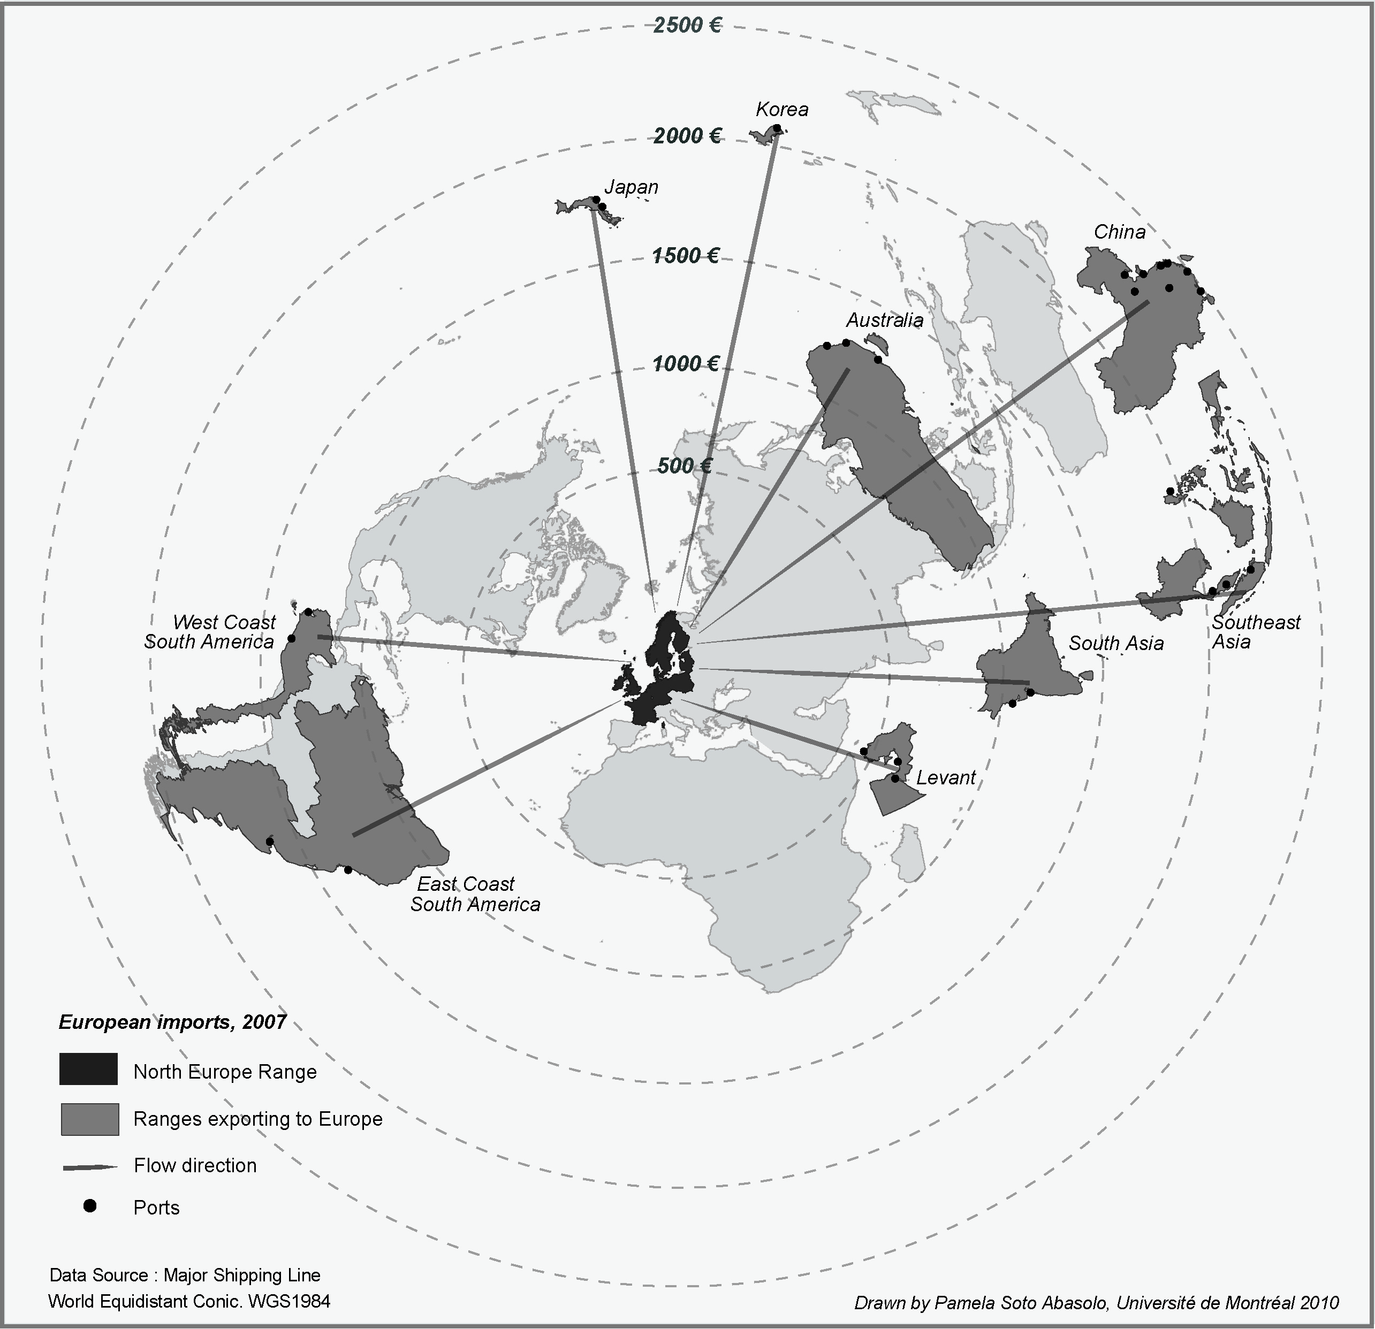
figure 2 Economic Distance (container freight rates) June 2007

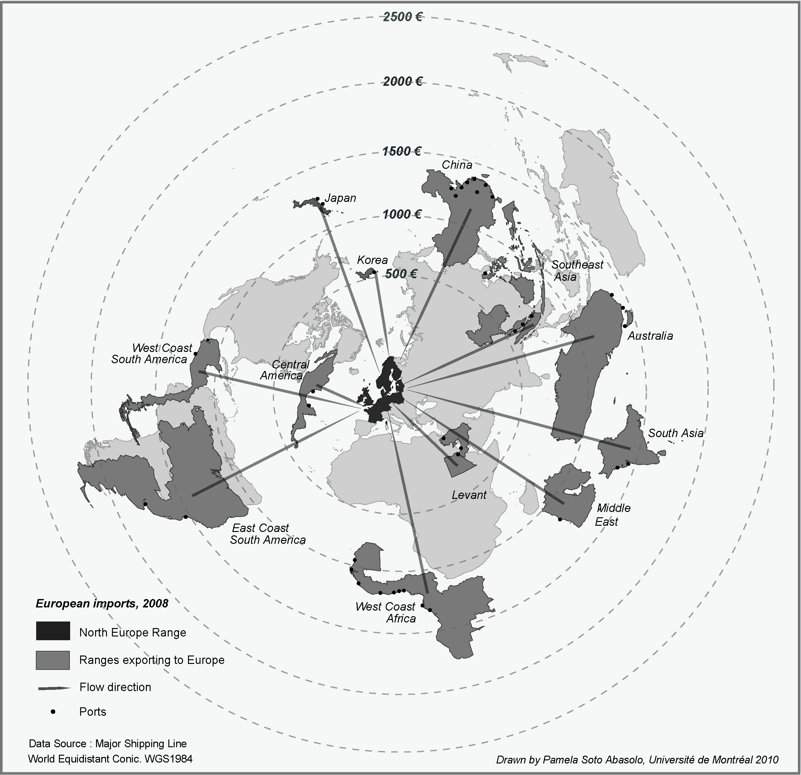
figure 3 Economic Distance (container freight rates) June 2008

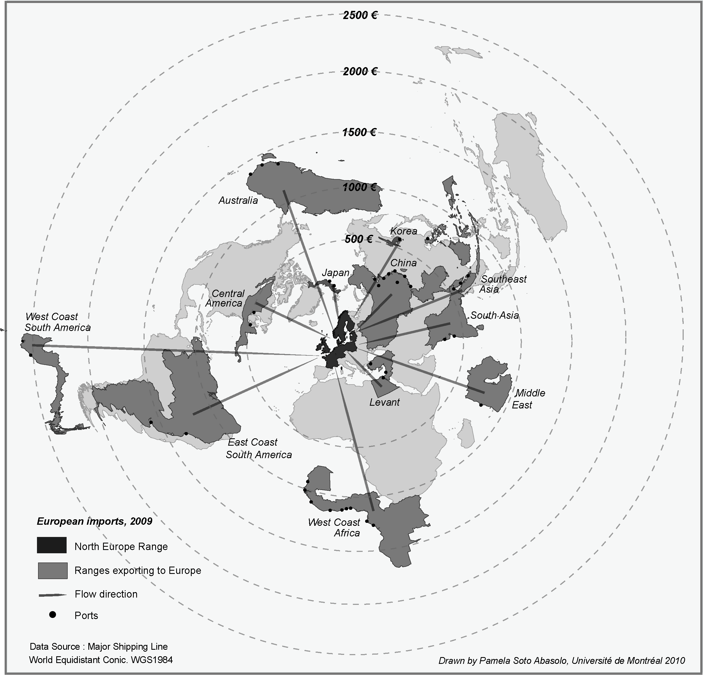
figure 4 Economic Distance (container freight rates) June 2009

figure 5 East and South East Asia Trends in import rates to Europe, 2007-9 (in Euros).

figure 6 Trends in import rates from niche markets to Europe, 2007-2009 (in euros)

 |  | 2,007 | 2008 | 2,009
distance |  | 0.705087* | 0.166355 | -0.21651
traffic |  | 0.716612* | 0.161374 | -0.34098
size of largest vessel na na -0.65394*

* p-value significant at <.005

table 2 Correlations between rates and distance, traffic by country and size of the largest vessel

2007 2008 2009
 | imports |  | exports |  |  |  | imports |  | exports |  |  |  | imports |  | exports
China | 2,235 |  | 82 |  |  |  | 1,287 |  | 129 |  |  |  | 212 |  | 441
SEAsia | 2,235 |  | 172 |  |  |  | 826 |  | 278 |  |  |  | 588 |  | 591
Japan | 1,788 |  | 112 |  |  |  | 1,288 |  | 193 |  |  |  | 353 |  | 477
Korea | 2,086 |  | 82 |  |  |  | 547 |  | 129 |  |  |  | 565 |  | 441
Australia |  | 1,267 |  | 1,788 |  |  |  | 1,095 |  | 1,159 |  |  |  | 1,130 |  | 1,483
ECSA |  | 1,325 |  | 200 |  |  |  | 1,425 |  | 1,300 |  |  |  | 1,225 |  | 650
WCSA |  | 1,267 |  | 1,400 |  |  |  | 1,166 |  | 1,400 |  |  |  | 2500 |  | 800

table 3 Northern Range European Import and Export freight rates for selected markets (in €)

Care must be taken in interpreting these results. The export rates for Far East destinations in 2009 only, included three surcharges: Terminal handling costs, Bunker adjustment factor, and Currency adjustment factor. If these surcharges had been removed, the base rates would have been negative! [13]

