Wind effects on the performance of solar collectors on rectangular flat roofs: A wind tunnel study
Dimitrios I. Ladas, Theodore Stathopoulos, Efstratios Dimitrios Rounis
Centre for Zero Energy Building Studies, Concordia University, 1455 De Maisonneuve Blvd. W., H3G 1M8, Montreal, Quebec, Canada
Keywords: wind effects; solar collectors; local flow distributions; thermal performance
Abstract
Wind induced convection is the main cause of heat loss for roof-mounted solar collectors. In this study the importance of using the actual wind velocity distributions over the whole roof area, instead of a commonly assumed single velocity of a reference location, is addressed through experimental measurements and numerical assessment of the performance of solar collectors placed on different locations over the roof of a typical rectangular building. The measurements were carried out at the Boundary Layer Wind Tunnel of Concordia University, for nine different locations on the roof, three different wind directions and cases concerning both an isolated building and a building with surroundings of various configurations. For the isolated building case, it was found that local velocities on different roof locations may vary more than 60% and the effect of these differences on the performance of solar collectors placed on these locations was assessed. In an attempt to generalize the results, 17 different surrounding configurations were considered. For a typical day in Montreal (with 4 m/s – 7 m/s average wind speed), it was found that the thermal gains between solar collectors at different locations over the same roof could vary up to 21%.
1. Introduction
Solar thermal systems are an efficient means of fulfilling the building’s heat demand, or a considerable part of it, reducing CO₂ emissions, while being a durable sustainable technology with an expected life span of 20-30 years (Buker & Riffat, 2015). The various types of flat plate solar collectors, as well as design techniques used to enhance their thermal performance, in terms of reducing thermal losses to the environment, have been extensively reviewed (Suman et al, 2015; Michael et al, 2015). Apart from design enhancement (fins, double glazing, etc.), thermal losses to the environment can be further reduced by strategic placement of the collectors, according to the local wind velocity distributions of the installation area, in the case of this study, the building roof.
The main objective of this study is to investigate the effects of wind on the performance of solar collectors placed on roofs, by measuring the velocity distributions over different locations of the same roof and translating the effect of these local velocity distributions numerically into convective heat losses. The common practice is to assume a uniform wind velocity, as measured at a reference location, over the whole roof area. However, the building configuration, the wind direction and the building surroundings highly affect the velocity distributions over the roof. This is expected to result in different convective heat losses, depending on the location of the collector, and therefore varying thermal performance.
Flat-plate solar collectors (Fig.1) are mainly used for domestic hot water and space heating. They consist of an absorber plate that absorbs solar irradiation and turns it into heat, which is in turn passed to a circulating fluid inside the collector. Apart from the absorber, the rest of the collector is well insulated to prevent heat losses as much as possible. Since the absorber, which may or may not be glazed, is in direct contact with the environment, it constitutes the main factor of heat loss due to natural or wind-induced convection. More specifics on the solar collectors’ features are given by Kalogirou (2004).
In the present study, the importance of using the actual velocity distributions corresponding to different locations on a roof, as opposed to a single reference velocity, is investigated experimentally and numerically. The effect of surrounding buildings has also been taken into account.
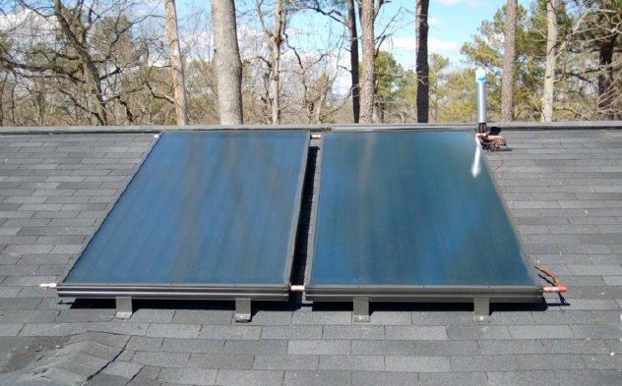
Figure 1: Roof-mounted, flat-plate solar collector.
2. Aerodynamics of wind around buildings’
2.1 Wind around buildings
Figure 2 shows a typical vortex formation for the basic case of perpendicular wind approaching an isolated rectangular “bluff body”, in this case a building, as described in Woo et al (1977). This is the most common case of air flow around a building, with air coming to a halt at the stagnation point and then being redirected to the edges of the building, where it separates. At the points of separation, the wind accelerates and flow recirculation areas of high turbulence/vorticity are formed. This basic case is described in detail in the wind engineering literature (Kim et al, 2003; Yakhot et al, 2006; Lim & Castro, 2009) and provides the fundamental case for experimental measurements.
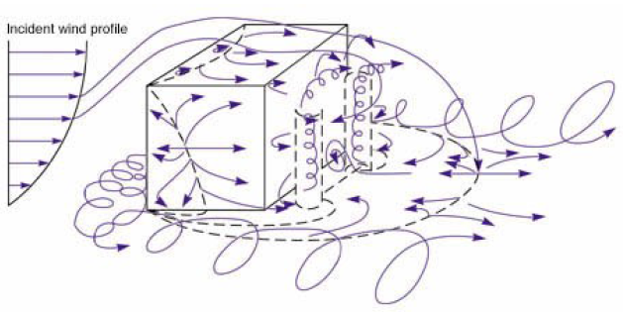
Figure 2: Three dimensional wind flow around a rectangular body (Woo et al, 1977); modified.
However, this is rarely the case in real conditions, since the presence of nearby structures highly influences the flow distributions around the building of interest. Two common effects that nearby structures may cause are the down-washing effect and the channeling effect. In urban settings the flow fields around neighboring buildings interact, forming a very complex flow field.
2.2 Wind-induced Convective Heat Transfer Coefficients (CHTC)
The main cooling effect of wind on the collector is convective heat transfer occurring on the top side of the collector, which may be exposed or glazed. This convection can be either natural, for still or low velocity wind, or forced, for medium to high velocity wind.
The distribution of wind velocities over the roof area of a building is affected by various parameters such as the building shape, the direction of wind, wind speed, turbulence intensity and the presence of surrounding obstacles (Karava et al, 2011, Karava et al, 2012), and is in most cases non-uniform. In order to assess accurately the convective losses from a collector, the actual velocity distributions need to be known and, thus, the most appropriate location for a collector may be chosen.
Numerous studies have been performed in the past to establish a relationship for the wind induced heat transfer coefficient, h_{w}, and a reference wind velocity, V_{loc,} for flat plate solar collectors, including wind tunnel studies (Jürges,1924; Watmuff et al, 1977; Sparrow et al, 1979; Kind et al, 1983; Shakerin, 1987), full scale studies (Sturrock, 1971; Test et al, 1981; Kumar et al, 1997; Sharples & Charlesworth, 1998; Hagishima & Tanimoto, 2003; Kummar & Mullick, 2010), analytical studies (Sartori, 2006) and CFD (Emmel et al, 2007; Blocken et al, 2009; Montazeri et al, 2015; Defraeye et al, 2010; Liu et al, 2013). Palyvos (2008) and Mirsadeghi et al (2013) have provided an extensive review of the wind-induced convective heat transfer coefficients. Figure 3 presents several of these relationships for the wind induced heat transfer coefficient for 0º wind. The linearity between the local wind velocity and the wind-induced CHTC is apparent in almost all cases. However, there are considerable differences between the results of each study, posing a great difficulty in the choice of the appropriate correlation for each case and this is because wind induced CHTC are normally determined through experimentation due to their dependence on the factors stated above.
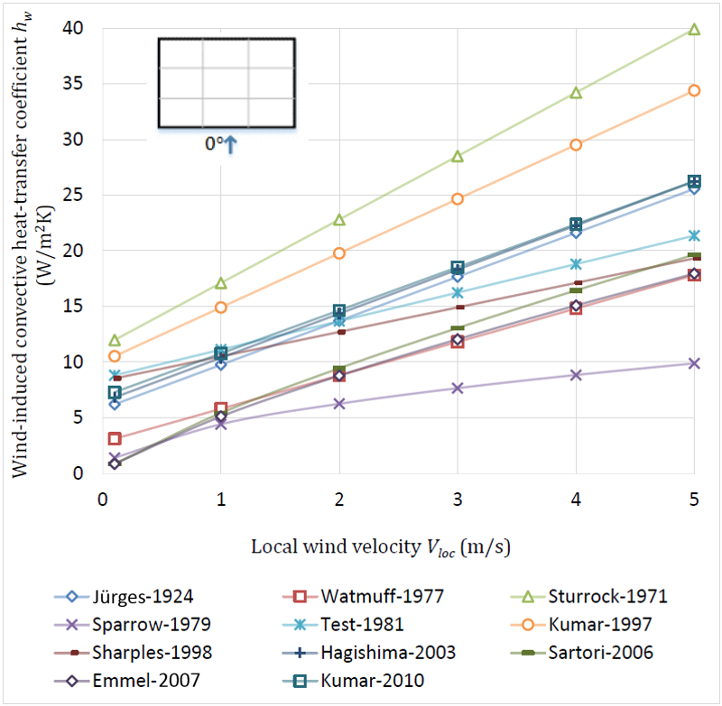
Figure 3: Comparison of h_{w} correlations of cited studies for 0º wind.
In this study, h_{w} was calculated numerically, by applying the velocity distributions measured to one of the established analytical modes. The model chosen for the development of equations 1-8 (Table 1), for a solar collector with a 45º tilt on top of a building and assuming south orientation, was that of Sharples & Charlesworth (1998), who provided correlations for various angles of incidence at intervals of 45º. Although these correlations were developed for a building with a pitched roof (35º), the results for 0º wind direction lie within the range of values of wind-driven CHTC for the same direction given by studies performed on flat roofs (Test et al, 1981; Kummar & Mallick, 2010; Hagishima & Tanimoto, 2003) and it is assumed that the behavior for the rest of the studied angles will be similar. Moreover, the study takes into consideration the natural convection phenomena that are dominant during low wind velocities. These regression equations are considered the most practical to adopt for the current study and since they are functions of wind incidence, they are expected to provide the most accurate results.

Wind Incidence Angle (deg) | Regression Equations for h_{w} (W/m²K)
0 | 2.2V_{loc}+8.3 | (1)
45 | 2.6V_{loc}+7.9 | (2)
90 | 3.3V_{loc}+6.5 | (3)
135 | 2.2V_{loc}+7.9 | (4)
180 | 1.3V_{loc}+8.3 | (5)
-135 | 2.3V_{loc}+7.8 | (6)
-90 | 2.2V_{loc}+11.9 | (7)
-45 | 3.9V_{loc}+6.0 | (8)
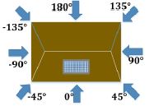
Table 1: Regression equations of h_{w} and V_{loc} by wind incidence angle (Sharples & Charlesworth, 1998).
3. Methodology
3.1 Experimental procedure
The velocity measurements were carried out at the Boundary Layer Wind Tunnel of Concordia University, which is an open-circuit (12.2 m x 1.8 m) wind tunnel, with a suspended roof that allows a variable height between 1.4 m and 1.8 m. A 1.21 m diameter turntable is installed in the downstream section, upon which models can be placed and tested at for different wind directions. Also, models can be moved up and down, changing the models’ height. The wind tunnel’s centrifugal blower can produce speeds from 3 m/s to 14 m/s. Velocity measurements were performed with a Cobra probe, a flow measurement device which can measure and resolve local static pressure and all three components of wind velocity. The Cobra probe moves inside the wind tunnel with the help of a three-dimensional transverse system.
As dictated by the similarity parameters of the particular wind tunnel installation (Stathopoulos, 1984), a scale of 1:400 was adopted. A wooden model [25 cm (length) x 15 cm (width) x 1.5 cm (height)] was constructed in this scale and a second roof height of 7.5 cm was also tested as a separate case. The roof of the model was divided into 9 equal rectangles, the centers of which represent the location of the collectors (Fig. 4).
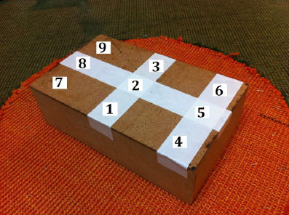
Figure 4: Building model at 1:400 scale.
The building model was set on the turntable and was oriented according to the assumed wind direction of each experiment. The local velocity measurements, V_{loc}, were taken with the Cobra probe over each location to a corresponding height of 2 m (0.5 cm), where a typical commercial solar collector would be located. The wind tunnel operated at a speed of 14 m/s, while the velocity readings were recorded for 30 seconds each, at a sampling frequency of 1000 Hz.
The cases studied were divided into two groups, one dealing with the isolated building in open field exposure, with a flow exponent α=0.13 and a roughness length, Z_{o}, equal to about 2 cm, and the other group dealing with the building set among various configurations of surrounding structures, since it was recognized that in urban areas, nearby surroundings would highly influence the velocity distributions. In order to get an idea about the trends of the influence of wind, an envelope approach was considered, starting by specific proximities of one or two buildings and then moving to more complex urban terrains. Therefore, several scenarios were created, including one or two adjacent buildings with varying heights, set at different locations relative to the subject, as well as actual city environments.
Figure 5 shows the two cases of an isolated building (6 m and 30 m height) that were studied for three wind directions (0º, 45º and 90º).
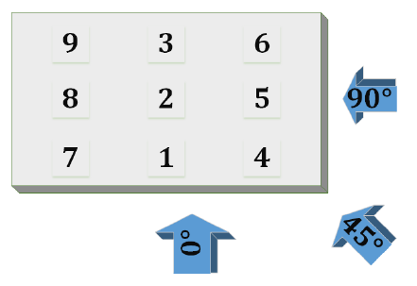
Figure 5: Isolated model (Cases 1 and 2) and wind directions considered.
Figures 6 through 8 present the cases with surroundings, indicating the adjacent buildings relative positions, as well as the direction of wind considered. Figure 9 demonstrates the two cases with urban settings that were also considered, namely, one with city settings and average building heights similar to the test subject (30 m) and one set in downtown Montreal (average building height: 80 m).
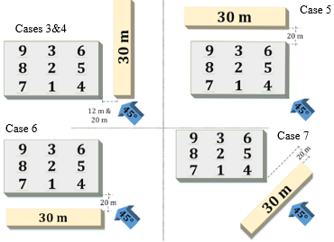
Figure 6: Setup configurations with a 30 m high adjacent building (Cases 3-7).
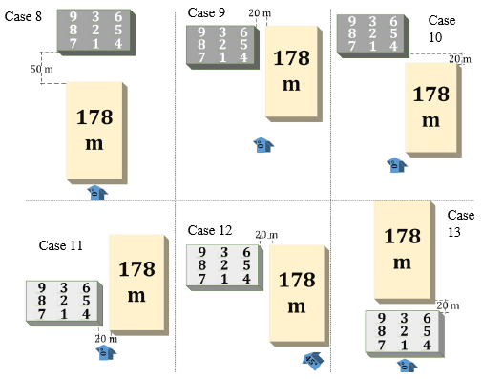
Figure 7: Setup configurations with a 178 m high adjacent building (Cases 8-13).
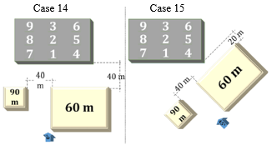
Figure8: Setup configurations with two adjacent buildings, 90 m and 60 m (Cases 14-15).

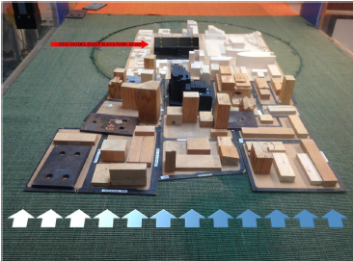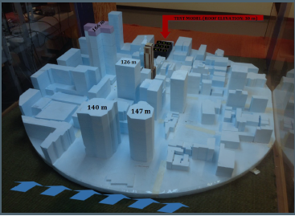
Figure 9: High model (30 m) with city surroundings (Case 16) and in downtown Montreal (Case 17).

Table 2 summarizes the 17 cases of wind tunnel measurements.
Case | Target building height (m) | Adjacent building 1 height (m) | Adjacent building 2 height (m) | Wind direction (deg)
1 | 6 |  |  | 0, 45, 90
2 | 30 |  |  | 0, 45, 90
3-7 | 6 | 30 |  | 45
8-10 | 30 | 178 |  | 0
11-13 | 6 | 178 |  | 0, 45
14, 15 | 30 | 90 | 60 | 0, 45
16 | 30 | city surroundings (avg. building height: 30 m) |  | 0
17 | 30 | downtown Montreal (avg. building height: 80 m) |  | 0
Table 2: Cases of the isolated building and building with surroundings, studied in the wind tunnel.
3.2 Thermal modeling
The performance of a single-glazed, water-based collector was carried out using the heat transfer model of Duffie & Beckman (2006), for N-glazed collectors (N=1 glazing).
Several assumptions were made in order to further simplify the numerical solution of the model:
- The amount of solar radiation absorbed by the glass cover is negligible.
- The glass is opaque to infrared radiation and the heat flow is one-dimensional.
- The ambient temperature is assumed to be the same at the front and the back of the collector.
According to Duffie & Beckman (2006) the thermal performance of the collector is modeled as the useful energy gain, q_{u}, per collector area Ac, expressed as:
q_{u}=F_{R}[S-U_{L}(T_{i}-T_{a})] (9)
where T_{i} and T_{a} are the inlet and ambient temperatures respectively, F_{R} is the collector heat removal factor which relates the actual useful energy of the collector to the useful gain if the whole collector surface were at the cooling fluid temperature, S is the solar radiation absorbed by the collector plate and U_{L} is the overall collector loss coefficient. U_{L} consists of all the losses that take place during the collector’s use and includes the top-loss coefficient U_{t}, the bottom-loss coefficient U_{b} and the edge loss coefficient U_{e} (equation 10).
U_{L}=U_{t}+U_{b}+U_{e} (10)
The top-loss coefficient expresses the heat escaped through the top cover of the solar collector due to convection and radiation between the glazing and the absorber plate. In this model, an empirical equation developed by Klein (1979) is used:
(11)
where:
- N is the number of glass covers
- ε_{g} is the glass emittance (dimensionless)
- ε_{p} is the plate emittance (dimensionless)
- T_{pm} is the mean-plate temperature (K)
- h_{w} is the wind induced heat transfer coefficient (W/m²K)
- f=(1+0.089h_{w}-0.1166h_{w}ε_{p})(1+0.07866N) the wind factor (W/m²K)
- C=520(1-0.000051β_{w}²) the collector tilt factor (deg)
- β_{w} is the collector tilt (deg)
- e=0.430(1-100/T_{pm}) the mean plate temperature factor
- σ=5.67*10-8 W/m²K⁴ the Stefan-Boltzmann constant
The bottom loss coefficient expresses the thermal energy escaping from the back of the collector and is a function of the collector’s insulation thermal conductivity k_{i} (W/mK) and the insulation layer thickness L_{t} (m):
(12)
The edge-loss coefficient refers to the thermal energy escaping from the edges of the collector. It is assumed that the edge insulation has the same thickness as the bottom insulation and therefore the losses from the edges can be measured by using one-dimensional heat flow around the perimeter of the whole system. The coefficient becomes a function of the edge insulation thickness e_{t} (m) and the collector thickness C_{t} (m):
(13)
Where:
- P is the collector perimeter (m); and
- A_{c} is the collector area (m²)
The efficiency of the collector, η, was defined as the ratio of the thermal energy gains, q_{u}, over the total incident solar radiation (calculated hourly, depending on the incident solar radiation), I_{T}:
(14)
4. Results and discussion
4.1 Velocity distributions
The experiments were repeated three times for each group of cases, in order to identify the error of the measurements. The standard deviation of each measurement was normalized by the mean value above each location, producing an average error of 5.8% for the first group of measurements (isolated case) and 6.7% for the second (configurations with surroundings). The measured velocity and turbulence intensity profiles are demonstrated in Figure 10.
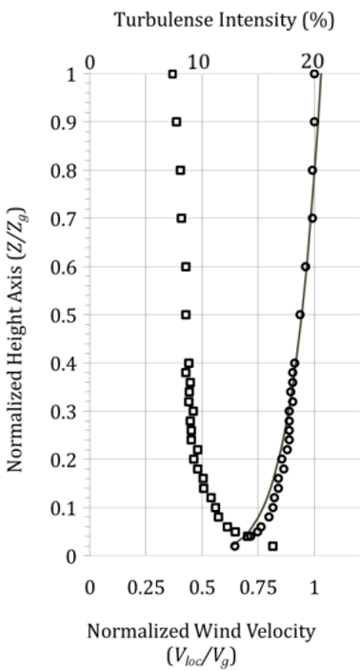
Figure 10: Experimental velocity and turbulence intensity profiles.
The local velocities are plotted over the roof area in the form of velocity coefficients, defined as the ratio V_{loc}/V_{g}. V_{loc} is the local velocity measured over each location (0.5 cm above the surface), while V_{g} is the wind speed at gradient height. The gradient height Z_{g} is defined as the height at which the wind velocity is no more affected by the terrain roughness. For this study, the gradient height was located 60 cm above the wind tunnel surface and the gradient velocity was 14 m/s. The results presented here are organized according to the two main groups of measurements: the isolated building and the cases with surroundings.
Isolated building
The V_{loc}/V_{g} contours for case 1 of the isolated building (6 m building) over the roof area and for the three wind directions are shown in Figure 11. It should be noted that although a symmetric distribution would be expected for the case of 0º wind direction on the roof, the flow field on a horizontal plane produced by the Concordia University Boundary Layer Wind Tunnel is not perfectly symmetric. This has been addressed to by Stathopoulos (1984) and is considered as part of the experimental error during the measurements.
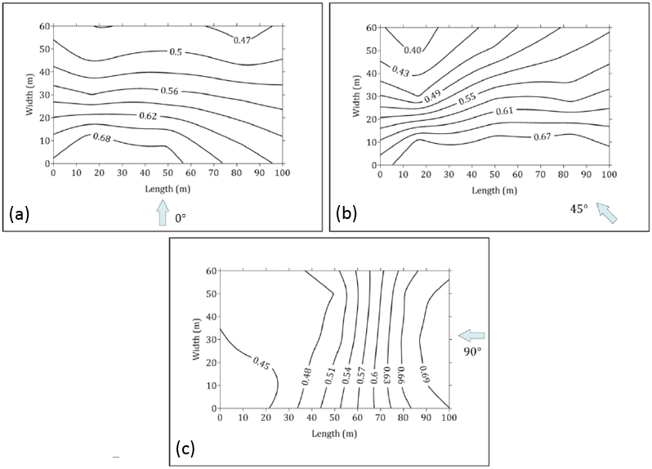
Figure 11: V_{loc}/V_{g} contours for the 6 m high isolated building (Case 1) for (a) 0º, (b) 45º and (c) 90º angle of attack.
Due to the separation of the wind flow and resulting acceleration at the front edges of the building, the velocities on the roof are generally higher above the windward area. Measurement results show that the highest differences between the minimum and maximum local velocities recorded, were produced for an oncoming wind with 45º angle of incidence. In particular, the ratio between maximum and minimum velocities measured over the roof area for the 45º angle of incidence was 1.75.
The velocity coefficients for the second case (30 m building, see Appendix) were about 20%-30% higher than the first, due to the fact that the measurements take place at a higher location, in accordance with the power law.
Building with surroundings
As expected, the experiments showed that the mean wind speed reaching the building in a developed area would be lower than in the case of an isolated building. However, the complex flow patterns produced due to the presence of nearby surroundings could produce higher than anticipated local velocities over the roof of the target building. The following section presents the most critical of the cases studied in the wind tunnel. All other cases tested have been included in an Appendix.
The highest differences in local velocities from the second group of experiments (cases with surroundings) were recorded when a 30 m obstructing structure was placed across the front right corner of the 6 m high target building (Fig. 12a).

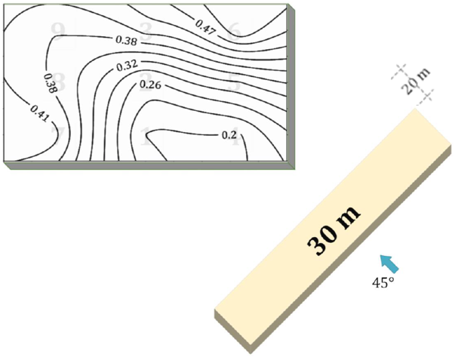
Figure 12: V_{loc}/V_{g} contours with a 30 m high upstream building and wind direction of 45º (Case7).
The wind flow is apparently blocked by the 30 m building resulting to lower local velocities at the windward locations than the leeward. This is due to the separation of the flow at the edges of the taller building and the reattachment of it at the leeward side of the target building. The ratio of maximum to minimum local velocity for this case was found to be 2.7.
For an adjacent building 178 m high, the case that produced the highest differences was the one with the tall building set behind the leeward area of the target building – see Fig. 13. In this case the flow was redirected downwards by the larger building, resulting to a down-washing effect. The lowest velocity coefficients were measured at the leeward part of the roof closest to the larger building. The ratio of maximum to minimum local velocity for this case was found to be 2.1.
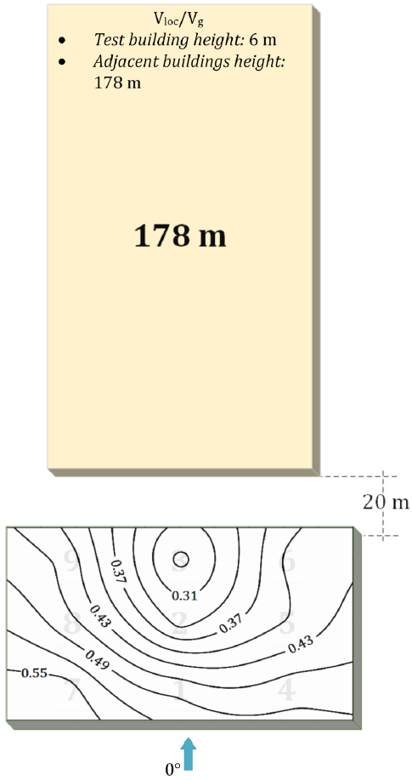
Figure 13: V_{loc}/V_{g} contours with a 178 m high adjacent building set downstream the target building (Case 13).

Case 15 of the second group deals with two buildings, parallel to each other, set across the front right corner of the target building and the velocity contours of the case are shown in Fig. 14. The velocity coefficients measured in this case were considerably lower due to the blockage to the wind flow by the two larger buildings. However, a channeling effect was observed, with the highest values appearing at the locations closer to the opening created by the two obstructing buildings. The ratio of maximum over minimum local velocity above the roof was found to be 2.3.
Finally, the case of the urban setting produced low velocities over the roof of the target building, compared to the rest of the cases tested. The differences in this case between local velocities were smaller with a maximum to minimum local velocity ratio of 1.6 (Figure 15). In general the velocity coefficients are 30% to 50% lower than the isolated case, with the roof location closer to the blocking structures having the lowest velocities of all the other parts of the roof. For the cases 15 and 16, the blockage ratio was less than 3% and 5%, respectively.

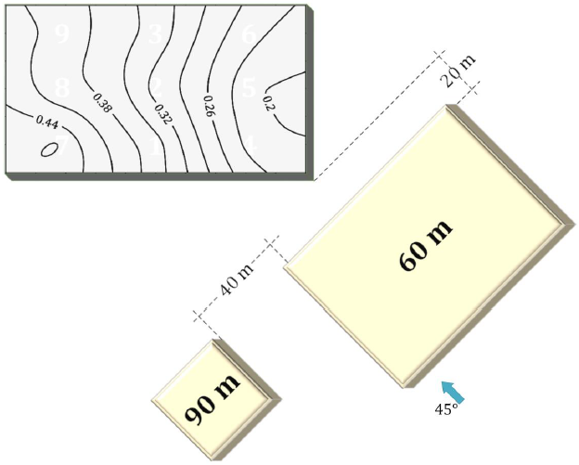
Figure 14: V_{loc}/V_{g} contours with two adjacent upstream buildings (channeling effect) (Case 15).
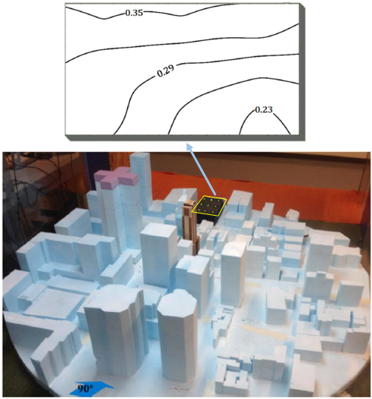
Figure 15: V_{loc}/V_{g} in downtown Montreal area (Case 17).
For analysis using full-scale velocities, the local velocity V_{loc} for any location above the roof of the building can be calculated by multiplying the corresponding velocity coefficient by the gradient velocity.
4.2 Thermal performance of the collectors
The local velocities observed through the cases investigated need to be quantified in terms of convective effects, in order to evaluate the performance of solar collectors placed on different locations of the roof. The daily thermal gains, q_{u} (W/m²), and efficiency, η (%), of the solar collector were calculated numerically with the use of equations 9 and 14. For each group of tests, the conditions were chosen to be the same for comparative reasons. The conditions chosen were those of a typical sunny day and are the following:
- The hourly values of direct and diffuse solar irradiation were taken from a typical meteorological file for Montreal in EnergyPlus Simulation Software (U.S. Department of Energy, 2014) and converted to incident irradiation on collectors at 45º pitch, according to standard solar tracking calculations.
- The ambient temperature was assumed to be T_{a}=20ºC, for typical Montreal summer conditions.
The conditions mentioned above are the same for all cases. The varying parameters of the calculations are the wind velocity and direction and, as a result, the convective effect on the solar panels.
Results for the isolated building
Figure 16a presents the total energy gains of the collector at each separate location for a windy day (Vg=40m/s) and 0º angle of incidence of oncoming wind and Figure 16b shows the corresponding daily efficiency for the two extreme cases of maximum and minimum thermal gains.
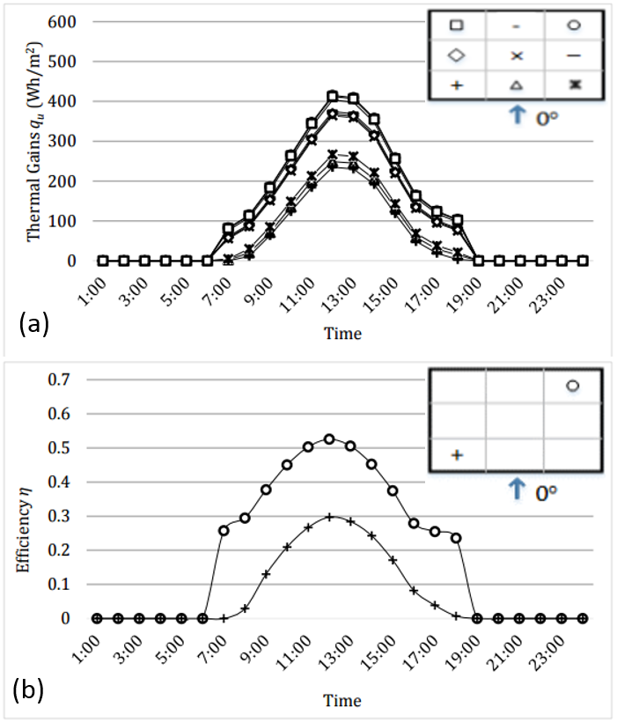
Figure 16: (a) Thermal gains during very windy day for the isolated building (6 m) and 0º wind (Case 1), (b) corresponding thermal efficiency of collector.
Clearly the most beneficial location for the placement of collectors is the leeward side of the roof, where the convectional cooling is minimal. The ratio of maximum over minimum daily thermal gains (and equivalent efficiency) for this case is 2.36. Similar results were found for the 30 m high building. The results corresponding for the angle of attack of 45º, which produced the highest difference in local velocities, are presented in Figure 17. It is clear that there is a considerable difference in the thermal gains of a collector placed in the windward edge, as opposed to one placed at the leeward corner.
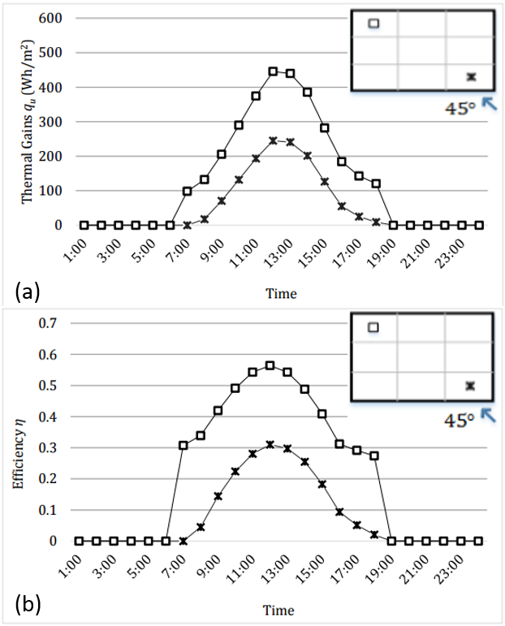
Figure 17: (a) Thermal gains during very windy day for the isolated building (6 m) and 45º wind (Case 1), (b) corresponding thermal efficiency of collector.
Figure 18 shows the ratio of maximum over minimum potential daily energy gains for the roof mounted collectors are presented in respect to gradient wind velocity, for 0º and 45º angle of attack. It must be noted that the conditions assumed for the analysis above were for comparison purposes and may not be realistic. A typical day in Montreal was also considered, with weather data taken from the Government of Canada. In this instance the wind velocities averaged between 4 m/s and 7 m/s (at the collector height), while the direction was not constant.
Figure 19shows that even for these regular conditions the ratio of maximum over minimum daily thermal gains and efficiency is 1.21 for the collectors placed in the most and the least favorable location.
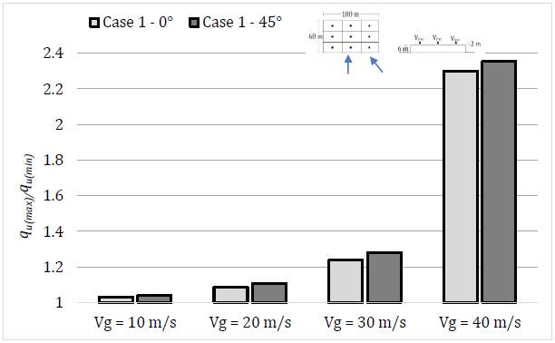
Figure 18: Ratio of maximum over minimum daily thermal gains on roof for an isolated building (6 m) for 0º and 45º wind.
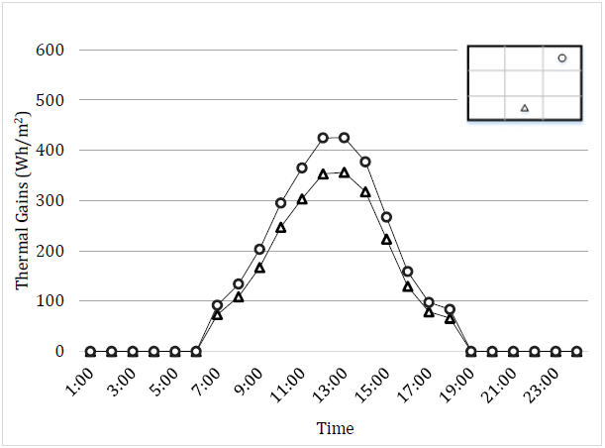
Figure 19: Thermal energy gains during typical day –all wind directions- (Case 1).
Results for the second group (cases with surroundings)
The ratios of maximum over minimum potential daily thermal energy gains for a solar collector mounted above the roof in respect to the gradient wind velocity for the cases with surrounding structures are summed in Figure 20. The potential thermal energy gains ratio between the best and worst location was found to be 1.94 for case 14 (from the group of measurements with surroundings).
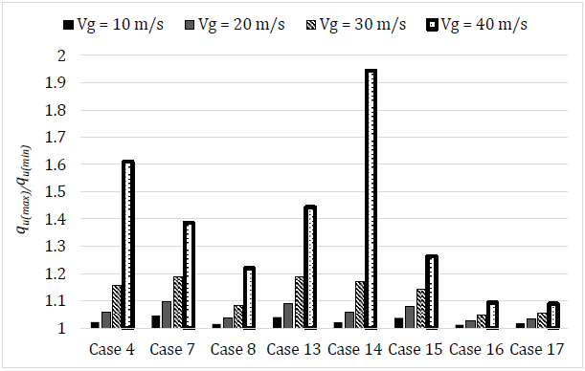
Figure 20: Ratio of maximum over minimum daily thermal energy gains for cases with surroundings.
5. Summary and conclusions
The primary goal of this study was to highlight the significance of using actual wind velocity distributions, as opposed to a commonly used single velocity value, measured at a reference point, when studying the performance of solar thermal collectors mounted on building roofs. Through the experimental procedure of this study, it was demonstrated that the differences in wind velocities on various locations over the same roof may have a substantial effect on the performance of solar collectors.
Two sets of experiments were performed under various angles of incidence and varying building height in a wind tunnel facility, one dealing with an isolated building and the other with the target building set among various configurations of surrounding structures. The main conclusions of this study are summarized as follows:
For the isolated building:
- Measured wind velocity distributions on building roofs showed that the ratio between maximum and minimum local velocities can be as high as 1.75 due to phenomena driven by the building geometry and wind directionality. Local velocities at the leeward part of the roof were found to be considerably lower than the windward part.
- Through a numerical model developed for a single glazed solar collector, it was found that there was more than 20% difference in the solar gains and corresponding thermal efficiency for a collector placed in the leeward rather than the windward part of the roof.
For the cases with surrounding structures:
- The differences in local roof velocities may vary up to more than 60%, while flow patterns are governed by the geometry and relative location of neighboring buildings.
- In general, the average wind velocities on the roof can be approximately 50% lower as compared to the case of the isolated building. However, the presence of a very high structure near the target building may cause 20%-30% higher velocities than those of the isolated case.
This study was performed on a generic rectangular building, however, it provides an insight of the trends of wind influence for a wide range of proximity elements and wind directions.

Acknowledgements
The authors would like to acknowledge the support of the Natural Sciences and Engineering Research Council of Canada (NSERC) through a research discovery grant to the second author, as well as through the Smart Net-zero Energy Buildings Strategic Research Network (SNEBRN). Furthermore, the authors are grateful to Professor Bert Blocken, member of the journal’s Editorial Board, who kindly agreed to be Acting Editor and handled the review process outside the EVISE system, since the Editor is a co-author.

References

Blocken, B., Defraeye, T., Derome, D., Carmeliet, J, (2009) High-resolution CFD simulations for forced convective heat transfer coefficients at the facade of a low-rise building. Build. Environ. 44, 2396–2412.

Buker, M., Riffat, S. (2015). Building integrated solar thermal collectors – A review. Renewable and Sustainable Energy Reviews 51, 327-346.

Defraeye, D., Blocken, B., Carmeliet, J. (2010). CFD analysis of convective heat transfer at the surfaces of a cube immersed in a turbulent boundary layer. Int. J. Heat Mass Transf. 53, 297–308.

Duffie, J., Beckman, W. (2006). Solar Engineering of Thermal Processes. 3rd ed. New York: Wiley Interscience.

Emmel, M. G., Abadie, M. O., Mendes, N. (2007). New External Convective Heat-Transfer Coefficient Correlations for Isolated Low-Rise Buildings. Energy and Buildings 39, 335-342.

Hagishima, A., Tanimoto, J. (2003). Field Measurements for Estimating the Convective Heat-Transfer Coefficient at Building Surfaces. Building and Environment 38, 873-881.

Jürges, W. (1924). Der Wärmeübergang an einer ebenen Wand. Beihefte zum Gesundheits-Ingenieur, 1227-1249.

Kalogirou, S. (2004). Solar-Thermal Collectors and Applications. Progress in Energy and Combustion Science 30, 231-295.

Karava, P., Jubayer, C. M., Savory, E. (2011). Numerical Modelling of Forced Convective Heat Transfer from the Inclined Windward Roof of an Isolated Low-Rise Building with Application to Photovoltaic/Thermal Systems. Applied Thermal Engineering 31, 1950-1963.

Karava, P., Jubayer C.M., Savory, E., Li, S. (2012). Effect of incident flow conditions on convective heat transfer from the inclined windward roof of a low-rise building with the application to photovoltaic-thermal systems. Journal of Wind Engineering and Industrial Aerodynamics 104, 428–438.

Kim, K. C., Ji, H. S., Seong, S. H. (2003). Flow Structure Around a 3-D Rectangular Prism in a Turbulent Boundary Layer. Journal of Wind Engineering and Industrial Aerodynamics 91, 653–669.

Klein, S. A. (1979). Calculation of Flat-Plate Loss Coefficients. Solar Energy 17 (79).

Kumar, S., Mullick, S. C. (2010). Wind Heat-Transfer Coefficient in Solar Collectors in Outdoor Conditions. Solar Energy 84, 956-963.

Kumar, S., Sharma, V. B., Kandpal, T., Mullick, S. C. (1997). Wind-Induced Heat Losses from Outer Cover of Solar Collectors. Renewable Energy 10(4), 613-616.

Lim, H., Castro, I.P. (2009). Flow Around a Cube in a Turbulent Boundary Layer: LES and Experiment. Journal of Wind Engineering and Industrial Aerodynamics 97, 96-109.

Liu, J., Srebric, J., Yu, N. (2013). Numerical simulation of convective heat transfer coefficients at the external surfaces of building arrays immersed in a turbulent boundary layer, Int. J. Heat Mass Transf. 61, 209–225

Michael, S., S, I., Goic, R. (2015). Flat plate solar photovoltaic-thermal (PV/T) systems: A reference guide. Renewable and Sustainable Energy Reviews 51, 62-88.

Mirsadeghi, M., Cóstola, D., Blocken, B., Hensen, J.L.M. (2013). Review of external convective heat transfer coefficient models in building energy simulation programs: Implementation and uncertainty, Appl. Therm. Eng. 56, 134–151.

Montazeri, H., Blocken, B., Derome, D., Carmeliet, J., Hensen, J.L.M. (2015). CFD analysis of forced convective heat transfer coefficients at windward building facades: Influence of building geometry, J. Wind Eng. Ind. Aerodyn. 146 (2015) 102–116.

Palyvos, J.A. (2008). A survey of wind convection coefficient correlations for building envelope energy systems’ modeling, Appl. Therm. Eng. 28, 801–808.

Sartori, E. (2006). Convection Coefficient for Forced Air Flow over Flat Surfaces. Solar Energy 80, 1063-1071.

Sharples, S., Charlesworth, P. S. (1998). Full-Scale Measurements of Wind-Induced Convective Heat Transfer from a Roof-Mounted Flat-Plate Solar Collector. Solar Energy 62(2), 69-77.

Sparrow, E. M., Ramsey, J. W., Mass, E. A. (1979). Effect of Finite Width on Heat Transfer and Fluid Flow about an Inclined Rectangular Plate. Transactions of the ASME, Journal of Heat Transfer, Volume 101, 199-204.

Stathopoulos, T. (1984). Design and fabrication of a wind tunnel for building aerodynamics. Journal of Wind Engineering and Industrial Aerodynamics 16, 361-376.

Sturrock, N. S. (1971). Localised Boundary Layer Heat Transfer from External Building Surfaces. Ph.D. Thesis. University of Liverpool: s.n.

Suman, S., Khan, M., Pathak, M. (2015). Performance enhancement of solar collectors. Renewable and Sustainable Energy Reviews 49, 192-210.

Test, F. L., Lessmann, R. C., Johary, A. (1981). Heat Transfer during Wind Flow over Rectangular Bodies in the Natural Environment. Transactions of the ASME, Journal of Heat Transfer, Volume 103, 262-267.

U.S. Department of Energy (2014). EnergyPlus Energy Simulation Software. [Online] Available at: http://apps1.eere.energy.gov/buildings/energyplus/.

Watmuff, J. H., Charters, W. W. S., Proctor, D. (1977). Solar and Wind-induced External Coefficients for Solar Collectors. Int. Revue d' Hellio-technique 2, 56.

Woo, H. G. C., Peterka, J. A., Cermak, J. E. (1977). Wind Tunnel Measurements in the Wakes of Structrures, s.l.: NASA Contractor Rep. NASA CR~2806.

Yakhot, A., Liu, H. & Nikitin, N. (2006). Turbulent Flow Around a Wall-Mounted Cube: A Direct Numerical Simulation. International Journal of Heat and Fluid Flow 27, 994-1009.

APPENDIX
This Appendix includes contour plots of wind velocity coefficients for the rest of the studied cases, i.e. Cases 2, 3, 4, 5, 6, 8, 9, 10, 11, 12, 14, 16.

Case 2 (30 m high isolated building)
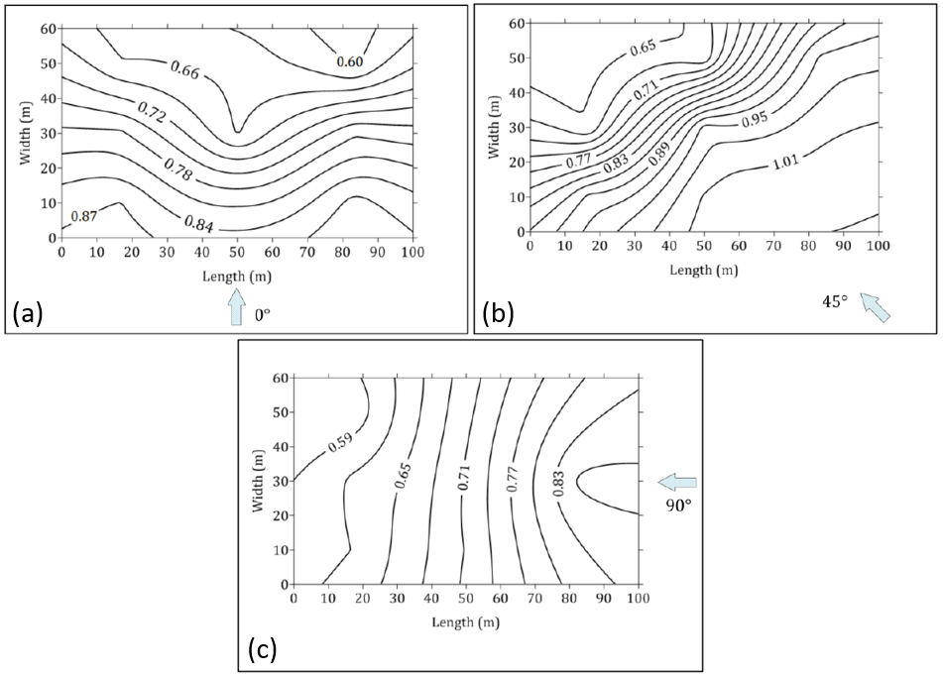

Case 3
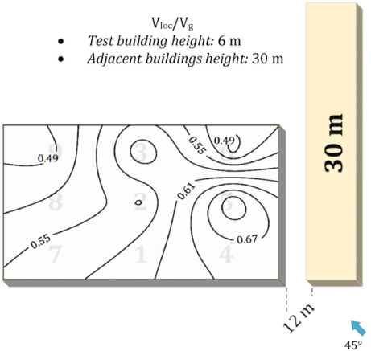

Case 4
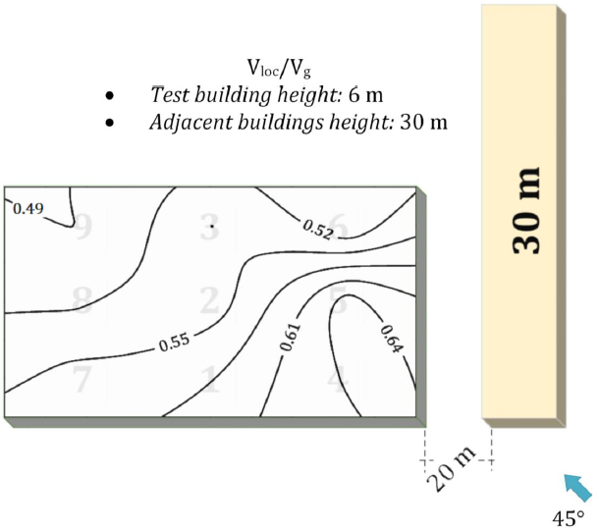

Case 5
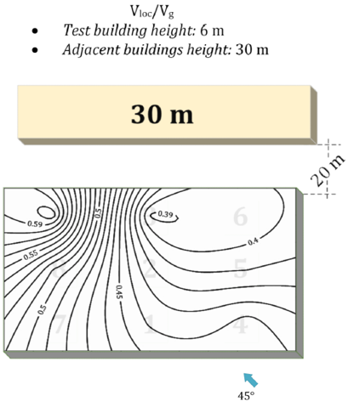

Case 6
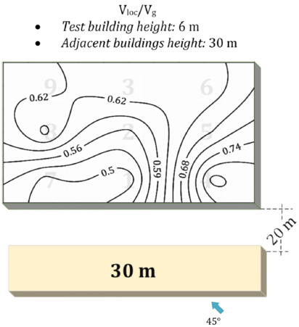
Case 8
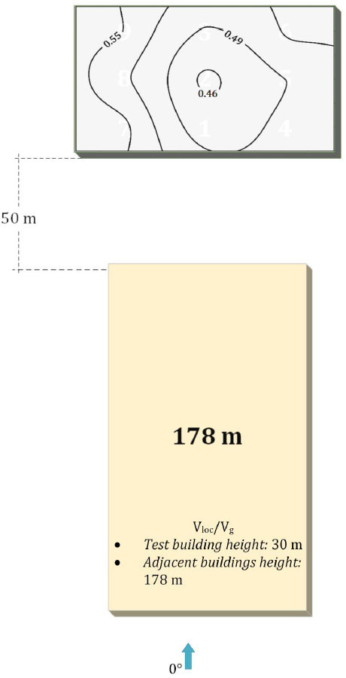

Case 9
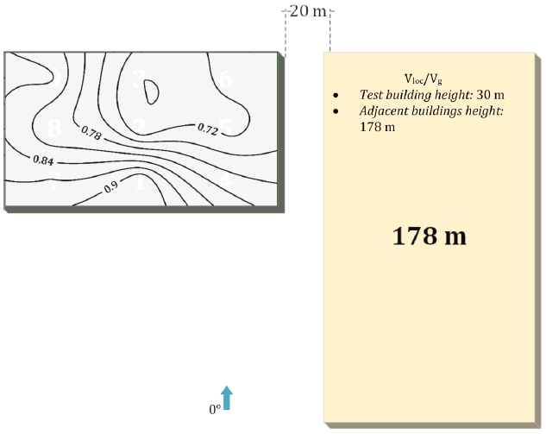

Case 10
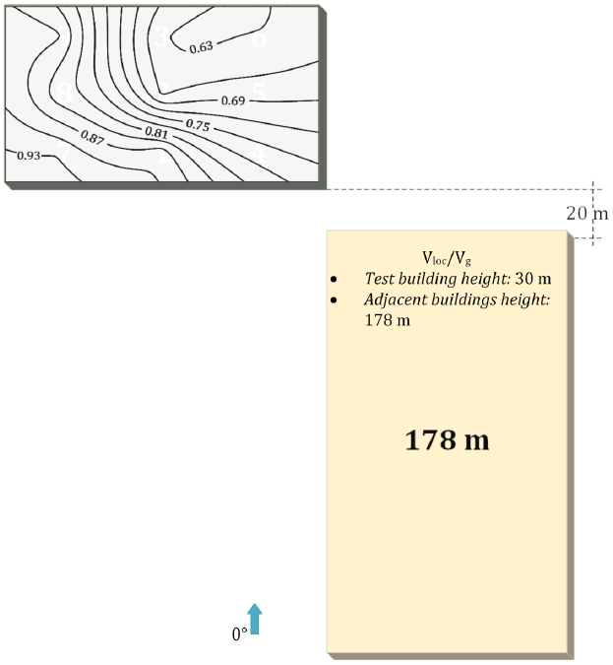

Case 11
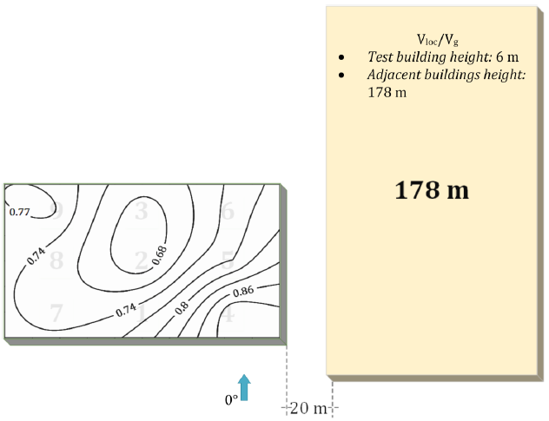

Case 12
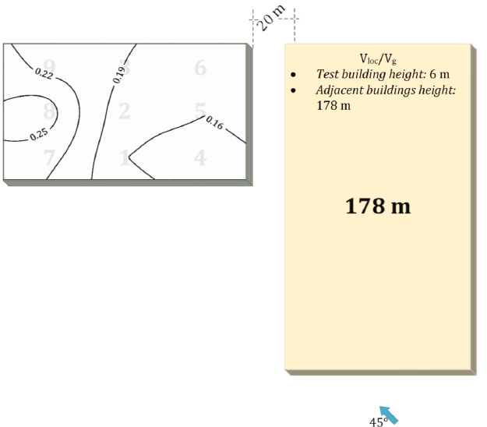

Case 14
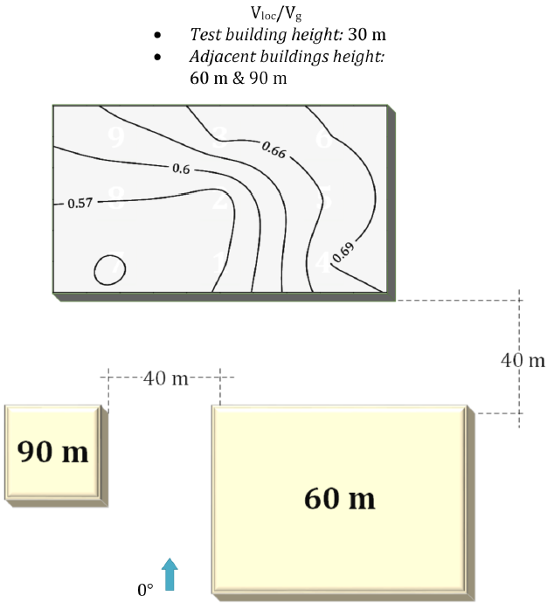

Case 16
