Characterizing the structural formation of epoxy-amine networks: the effect of monomer geometry
Keroles B. Riad, Rolf Schmidt, Alexandre A. Arnold, Rolf Wuthrich, Paula M. Wood-Adams

Abstract
We develop an approach for quantifying cure that applies thermodynamic modelling to interpret DSC data that is consistent with solid state NMR. The effect of elements of monomer geometry, such as the angle between functional groups and the distance between them, on curing of epoxy-amine thermosets is explored experimentally using this new technique. The effect of the angle between functional groups on the glass transition temperature of the final cured network is significant. The effect of spacing between functional groups is masked by the rigidity of the spacer. Our approach to interpreting DSC data allows us to detect processes that would have been missed otherwise. This is exemplified by the observation of slow exothermic deterioration reaction occurring well below the TGA measured thermal degradation temperature. Our NMR results indicate that significant etherification occurs at 140°C, unlike the commonly held belief that it is insignificant at such low temperatures.

1. Introduction
Epoxy-related applications are widespread and include adhesives^{1,2}, composites³ and stereo-lithography 3D printing⁴. However, epoxy systems are particularly difficult to characterise due to their complex network structures resulting from gelation (occurring after a third of functional groups react⁹), cross-linking and side reactions⁵, and the variation of reactivity, mobility⁷ and steric hindrance⁶ as the structure evolves.
Monomer geometry acts as an architectural precursor⁷ for network topology. The evolving network eventually prevents unreacted functional groups from meeting, at a state called the “topological limit”⁷. Two theoretical approaches to describing epoxy systems are consistent with experiments: the lattice simulations reviewed by Oleinik⁶ and the tree-like approach of Dušek⁷ (inspired by Flory^{8,9}). The lattice simulations relate topological parameters to T_{g} and yield stress⁶, emphasizing the importance of monomer geometry on curing and final network properties.
The literature exploring effects of monomer architecture is rich but still incomplete. Dušek reviews many architectures, including star-like and hyperbranched⁷ molecules. Kim et al.¹⁰ show that bulkier curing agents increase conversion rates. Studies applying theoretical and experimental analysis show that increasing the length of the curing agent molecule between functional groups decreases T_{g}¹¹. These works consider monomers with multiple geometric differences, including the angle, and length between functional groups and the degrees of freedom of the molecule. Studying each of these geometric differences separately could enrich our understanding of these systems. Here, we study two elements: the angle and the length between functional groups varied without changing the degrees of freedom of the molecule. This is a starting point to understanding those elements of monomer geometry.
The cure of epoxy systems can be characterised by techniques such as titration¹², NIR¹³, sol-gel analysis¹⁴ and differential scanning calorimetry (DSC). With DSC data we typically infer percentage of cure via the heat emitted during the exothermic curing⁵. The measured heats are routinely referenced to the maximum experimentally observed heat which is assumed to represent 100% cure^{4,5}. This reference implies that all functional groups have reacted when the experimental maximum heat is achieved. However, it is very likely that unreacted functional groups will remain in the network after reaching the topological limit. We develop an approach to calculate a more accurate percentage of cure referenced to the theoretical maximum heat that would be released if all functional groups were to react.

2. Experimental
2.1 Materials
Resorcinol diglycidyl ether (>96%), o-phenylene diamine (99.5%), m-phenylene diamine (99.9%) and p-phenylene diamine (99%) from Sigma Aldrich; Benzidine (95%) from Toronto Research Chemicals Inc. and dichloromethane (DCM) (99.5%) from Caledon are used without further purification. Resorcinol diglycidyl ether, initially semi-crystalline, is melted at 50ºC and cooled to room temperature prior to use. Diamines are manually ground into fine powder using a mortar and pestle. Figure 1 shows the chemical structures of the reagents.
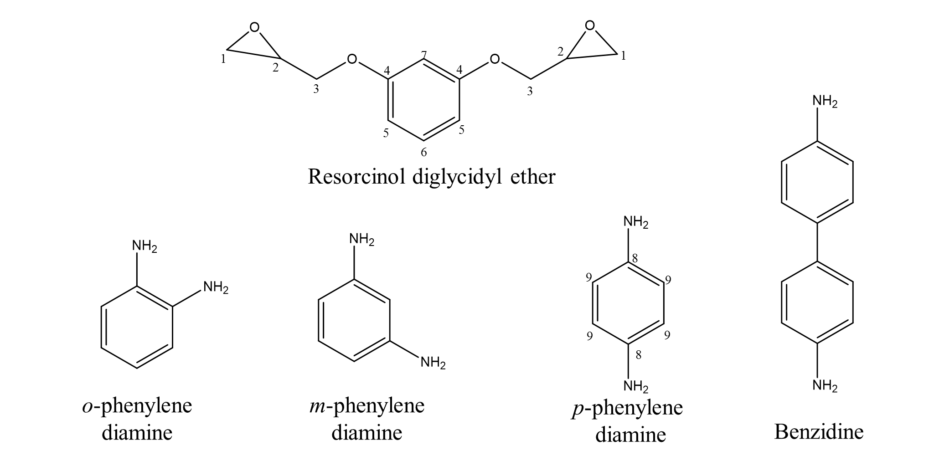
Figure 1. Reagents
2.2 Mixture preparation
Each mixture weighs 1.5 grams in total with a 1:1 molar ratio of epoxide to NH. The epoxy and amine monomers are dissolved separately in DCM (0.5 mL and 4 mL of DCM respectively) in 20 mL vials. The two solutions are combined and stirred for 10 minutes. The mixture is transferred to a 250 mL beaker and placed under 600 mmHg vacuum for 30 minutes to evaporate the DCM.

2.3 DSC observation of curing
DSC experiments are performed on 5-10 mg samples in hermetically sealed pans using a TA Q10 DSC referenced to an empty pan and repeated a minimum of 3 times. Isothermal curing at 140°C is performed followed in some instances by isothermal post curing at a higher temperature. The DSC is heated to 140°C and then the sample cell is loaded and allowed to cure for 2 hours. The T_{g} is then measured by ramping at 5°C/min between 100°C and 200°C. For experiments with post curing, the 140°C curing procedure is first executed without T_{g} measurement and then the sample is removed. The DSC is then heated to T_{g140°C} +100°C. Here, T_{g140°C} is the T_{g} of another sample of the same mixture previously measured after the curing process at 140°C. Finally, the cell is returned to the DSC and post cured for 10 hours. The final T_{g} is measured by ramping at 5°C/min between 100°C and the post curing temperature.

2.4 Thermogravimetric Analysis (TGA)
TGA experiments are conducted to ensure that post cure temperatures are lower than those for thermal degradation. The TGA samples, 20 mg each, are cured isothermally for 2 hours in an open platinum pan at 140°C and under nitrogen inside a TA Q50 TGA. The temperature is then ramped at 20°C/min up to 1000°C to determine the thermal degradation temperature at which weight loss occurs. The lowest degradation temperature among all systems is 300°C, well above the highest post curing temperature.

2.5 Nuclear magnetic resonance (NMR) experiments
NMR samples are prepared using an epoxy/p-phenylene diamine mixture. About 0.5 g of the mixture is transferred to an open platinum pan and then cured isothermally at 140°C for 2 hours under nitrogen in TA Q50 TGA. The resulting solid film is manually ground using a mortar and submitted to solid-state NMR analysis. After analysis, the same sample is post cured at 223°C for 10 hours and once again submitted to NMR analysis.

All spectra are recorded on a Bruker Avance III HD operating at a frequency of 400.03 MHz for ¹H and 100.60 MHz for ¹³C using a double resonance 4 mm magic-angle spinning (MAS) probe and a spinning frequency of 12.5 kHz. In order to make peak integration more quantitative, cross-polarization was avoided and all spectra were recorded using a single 3.33 μs long 90° pulse with 85 kHz TPPM ¹H decoupling during acquisition. The recycle delay is set to 30 s and the acquisition time to 15 ms. Spectra were externally referenced with respect to TMS at 0 ppm by setting the downfield peak of adamantane to 38.23 ppm. The spectra were processed using MNova (Mestrelab Research S.L., Santiago de Compostela, Spain).

2.6 Data reporting
Results are reported with 90% confidence limits (error bars) to account for the number of repeats unless mentioned otherwise. Significance is judged using 90% confidence two tailed t-tests except for NMR data as they were not repeated.

3. Methodology
To explore the effects of angle between functional groups, three epoxy-amine systems are studied where the curing agent is either o-phenylene diamine, m-phenylene diamine or p-phenylene diamine. The angle between functional groups in these diamines is 60°, 120° and 180°, respectively. In addition to the geometric difference, there are other differences between the systems including nucleophilicity¹⁶ and solvent effects¹⁵. We separate the two classes of factors using a two-step experiment: curing at a low temperature and post curing at a higher temperature. The effect of steric hindrance may be significant enough to be observed in the initial curing step. We assume that factors such as nucleophilicity and solvent have similar effects on the reaction during cure and post cure. The network topology is expected to affect our observations only during post curing when the topological limit is approached.
We post cure at T_{g140°C} +100 °C to minimize the difference between the initial molecular mobilities in the systems^{19,20}. This ensures that all systems start under the same mobility conditions and have approximately the same rates of polymeric configurational rearrangements and monomer diffusion²¹, as described by the WLF equation²². Therefore, any observed differences in T_{g} between post cured systems can be attributed to the different angles between amine groups.
We studied an additional benzidine system to observe the effect of the monomer length. This system is compared to that with p-phenylene diamine. Benzidine is longer than p-phenylene diamine. The overall monomer rigidity is the similar because they have a similar number of degrees of freedom. In this way, we study the effect of length without changing the rigidity of the curing agent.

3.1 Calculation of percentage cure
An approach based on the molar heat of the amine-epoxy reaction at a given curing temperature is introduced to obtain accurate measurements of percent of cure. The molar heat of reaction, h_{T}, is calculated from the standard heat of formation, h₀, at 25°C (-120.3 kJ/mol) and the molar heat capacity, C_{p}, (0.01513 kJ/mol K)¹⁷ as shown in Equation 1.
$h_{T}=h_{0}+C_{p}∆T$ (1)
The theoretical total heat, $H_{max, T_{cure}}$, that would be emitted per gram of mixture if all functional groups were to react at the curing temperature, $T_{cure}$ is calculated using Equation 2:
$H_{max,T_{cure}}=n_{i}h_{T_{cure}}$ (2)
where n_{i} is the initial number of moles of the limiting functional group per gram of mixture. The percent of cure, $α_{T_{cure}}$, can then be estimated using Equation 3:
$α_{T_{cure}}=\frac{H_{m,T_{cure}}}{H_{max,T_{cure}}}$ (3)
Here, $H_{m,T_{cure}}$, is the total heat measured by the DSC per gram of mixture during cure. This is also used to calculate the number of moles of the limiting functional group that have reacted per gram of mixture, $n_{r,T_{cure}}$, according to Equation 4:
$n_{r,T_{cure}}={n_{i}×α}_{T_{cure}}$ (4)
Similarly, Equations 5,6 and 7 are used to calculate the theoretical total heat, $H_{max,T_{post cure}}$, that would be emitted per gram mixture if all remaining functional groups were to react at the post curing temperature, $T_{post cure}$, the percent of cure due to post curing, $α_{T_{post cure}}$, and the number of moles of the limiting functional groups that have reacted during post cure per gram mixture, $n_{r,T_{post cure}}$respectively:
$H_{max,T_{post cure}}=\left(n_{i}-n_{r,T_{cure}}\right)h_{T_{post cure}}$ (5)
$α_{T_{post cure}}=\frac{H_{m,T_{post cure}}}{H_{max, T_{post cure}}}$ (6)
$n_{r,T_{post cure}}={\left(n_{i}-n_{r,T_{cure}}\right)α}_{T_{post cure}}$ (7)
Here, $H_{m,T_{post cure}}$ is the total heat measured by the DSC per gram of mixture during post curing at $T_{post cure}$ and $\left(n_{i}-n_{r,T_{cure}}\right)$ is the number of moles of the limiting functional group that are left unreacted after the first curing process per gram of mixture.
Finally, the ultimate percent of cure,$α_{u}$, is calculated using Equation 8:
$α_{u}=\frac{n_{r,T_{cure}}+n_{r,T_{post cure}}}{n_{i}}$ (8)
Each amine-epoxy reaction leads to an epoxy molecule bonded to an N-H group as shown in Figure 2 for resorcinol diglycidyl ether reacting with p-phenylene diamine. In this analysis we assume that no etherification occurs, which is believed to be reasonable for a curing temperature of 140°C^{17,18}.
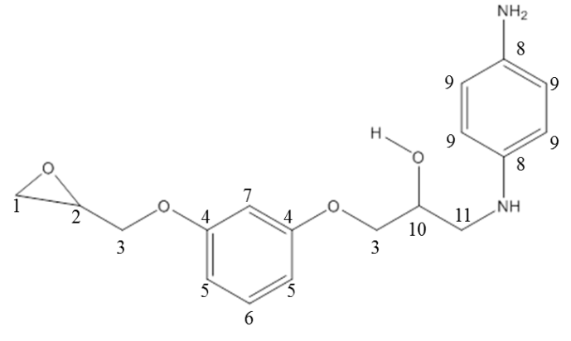

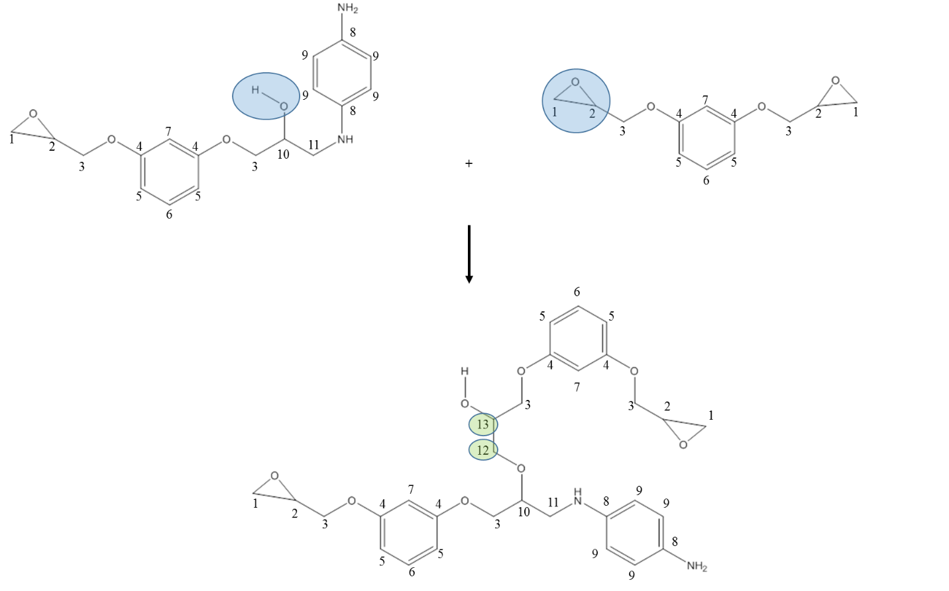

(b)

Figure 2. (a) The product of epoxy reacting with p-phenylene diamine. (b) Etherification

4. Results and Discussion
An example of the DSC traces for cure and post cure are shown in Figure 3 a and b respectively. As explained previously the areas under these curves are used in the calculations of percent of cure (Equations 3 and 6).
(a) (b)
Figure 3. Example DSC traces of: (a) curing at 140°C and (b) post curing of the same sample, resorcinol diglycidyl etherand o-phenylene diamine at 229°C. The total heat is the area between the curve and the baseline.

4.1 DSC results

Table 1 summarizes the results of all DSC experiments. The maximum curing rate at 140°C increases with the angle between the amine functional group. This makes sense because steric hindrance is highest when functional groups are closest to each other as in o-phenylene diamine and lowest when they are furthest apart as in p-phenylene diamine. After curing, the o, m and p-phenylene diamine systems all have a percent of cure of ~70% and a T_{g} of ~125°C. We assume that steric hindrance and nucleophilicity affect the curing rate most significantly during post cure as well.

After post curing at T_{g140°C} +100 °C, where the systems with isomeric monomers are at or very close to their topological limits, the differences between their T_{g} are much more significant than those differences between the same systems after only cure. This indicates that the angle between functional groups has a significant effect on the network properties close to the topological limit.

Table 1: Summary of study of geometric factors, angle and distance between amine functional groups*
 |  | Cure at 140°C |  |  |  | Post cure at Tg140°C +100°C
Material and angle between amine groups (°) |  | $α_{T}$(%) | $$n_{r,T_{cure}}$$  (mole/g mixture) | Max. curing rate  (mol/g· min) | T_{g} (°C) | $α_{U}$(%) | $$n_{r,T_{post cure}}$$  (mol/g mixture) | T_{g} (°C)
o-phenylene diamine | 60 | 71  (69-73) | 0.0051  (0.0050-0.0052) | 0.0010  (0.0009, 0.0012) | 129  (117-141) | 82  (80-84) | 0.0009  (0.0004-0.0014) | 113  (108-118)
m-phenylene diamine | 120 | 73  (69-77) | 0.0052  (0.0050- 0.0055) | 0.0022  (0.0020, 0.0023) | 125  (122-128) | 97  (84-109) | 0.0019  (0.0013-0.0024) | 131  (121-141)
p-phenylene diamine | 180 | 67  (61-73) | 0.0048  (0.0044-0.0052) | 0.0070  (0.0060, 0.0090) | 123  (117-129) | 106  (93-119) | 0.0025  (0.0019-0.0032) | 148  (135-160)
Benzidine | 180 | 76  (73-79) | 0.0048  (0.0046-0.0050) | 0.0011  (0.0010-0.0012) | 154  (148-160) | 110  (99-121) | 0.0020  (0.0010-0.0030) | 175  (158-191)
*Values inside parentheses are 90% confidence limits of means

The p-phenylene diamine and benzidine systems illustrate the effect of monomer length. Percentage of cure on a mass basis is not useful for comparing these two systems as the two curing agents have different molecular weights. Therefore, we make the comparison on a molar basis using the η_{r} parameters. Both systems have the same number of moles of amine-epoxy reaction per gram of sample after curing and after post curing. Here, a mole of reaction is where one mole of epoxide groups react with one mole of NH groups. Note that the monomer molecular weight also affects Tg. The T_{g} of the benzidine system is higher than the p-phenylene diamine system after curing and after post curing. The conclusions of previous studies¹¹ may indicate that systems with the shorter monomer, p-phenylene diamine would have a higher T_{g}, if those conclusions are generalized.
Note that there are two types of components in the networked systems: rigid benzene rings and flexible chains. There are more benzene rings in the benzidine system compared to that in the p-phenylene diamine system. This means that the benzidine system has a larger rigid fraction leading to a higher T_{g} than that of the p-phenylene diamine system. Also, the packing density in the benzidine system is likely lower than in the p-phenylene diamine system due to the increase in length. Thus, there are two competing effects on T_{g} as the monomer length increases in this case: the increased rigid fraction and the decreased packing density. Soni et al¹¹ increased monomer length by increasing flexible chain length. In that case, the increased flexible fraction lead to the observed decrease in T_{g}. Considering both the observations of the current study and those of Soni et al¹¹ we can conclude that length certainly affects packing in an unambiguous way, but its effect on T_{g} may be primarily determined by the rigidity of the units.
Further, we compare T_{g} after cure and after post cure in Table 1. T_{g} increases after post curing for all systems with the exception of that of the o-phenylene diamine system which decreases from 129°C to 113°C during post curing. This indicates that the network is deteriorating in the post curing process. The apparent percent of cure of the p-phenylene diamine, m-phenylene diamine and benzidine systems are higher than 100% after post curing, implying that more heat is emitted than can be accounted for by the curing reaction. Including etherification in our analysis does not explain the excess heat since one mole of etherification emits less heat than one mole of amine-epoxy reaction.¹⁷ That is to say that if all epoxide groups left react with alcohol groups instead of amine groups, less heat will be emitted contrary to the excess heat observed. To explore further, a benzidine system is post cured for a much longer time showing a decrease in T_{g} from 175 (10)°C after 10 hours of post cure to 158°C after post cure for only 34h. Also, the “apparent” percent of cure increases from 110 (7)% after 10 hours of post cure to 136% after post cure for only 34h. These results indicate that an exothermic network deterioration process occurs during post curing leading to erroneously high values for percent of cure and unexpectedly low values of T_{g}.
For the benzidine system, post curing results in a higher T_{g} than only curing, meaning that on the face of it one might expect nothing unusual to be happening. In other DSC approaches to determine percent of cure, the measured heat is referenced to the maximum heat obtained. Our approach, which references the theoretical heat of reaction, allows us to unambiguously capture the network deterioration process.

4.2 Solid state NMR results
NMR analysis investigates which reactions are occurring during cure and post cure and verifies our DSC method for determining percent of cure. NMR measurements are conducted on the epoxy monomer, the p-phenylene diamine, and the cured and post cured samples. Table 2 shows the resulting chemical shifts and corresponding assignments.
Table 2: NMR chemical shifts of reactant material, epoxy and p-phenylene diamine and resulting networks after curing at 140°C and post curing at 223°C
 | Epoxy (ppm) | p-phenylene diamine (ppm) | 140°C cured sample (ppm) | Area  (cured sample) * | 223°C post cured sample (ppm)
C₁ | 44.63 | - | Missing | - | Missing
C₂ | 50.2 | - | 47.8 | 0.09 | 48.72
C₃ | 68.93 | - | 69.4 | 1 | 69.43
C₄ | 159.8 | - | 159.7 | 0.18 | 159.56
C₅ | 107.4 | - | 111 | 0.34 | 111
C₆ | 130.13 | - | 130 | 0.19 | 129.7
C₇ | 101.9 | - | 103.8 | 0.27 | 104.41
C₈ | - | 138.5 | 140.3 | 0.18 | 140.87
C₉ | - | 116.63 | 117 | 0.41 | 119.65
C₁₀ | - | - | 69.4 | 1 | 69.43
C₁₁ | - | - | 54.5 | 0.15 | 54.67
C₁₂ | - | - | 69.4 | 1 | 69.43
C₁₃ | - | - | 69.4 | 1 | 69.43
X₁ | - | - | - | - | 146.65
X₂ | - | - | - | - | 12.04
* Values are normalized with respect to the C3.
The carbons are numbered in Figures 1 and 2 and assigned according to the literature^{23,24,25} for resorcinol diglycidyl ether, p-phenylene diamine and their reaction products. We assume that the C₁ and C₂ chemical shifts are merged somewhere in the middle of their respective chemical shifts in the cured and post cured samples. Two unassigned shifts, X₁ and X_{2,} that cannot be associated with the curing reactions, appear only in the post cured samples. These shifts fall in the regions of aromatics and aliphatics respectively supporting the hypothesis that another reaction is occurring during post curing as indicated by our DSC calculations and the bimodal DSC trace (Figure 3b). This degradation reaction may differ from thermal degradation observed with TGA at 300°C (well above post curing temperatures) and would not likely have been associated with a degradation reaction in DSC studies using the conventional approach to calculating percent of cure.
Percent of cure is calculated from NMR spectra using peak areas which depend on the concentration of the carbons corresponding to those shifts. Below, $C_{i}$ is the area associated with carbon i.
$Initial epoxide concentration ∝C_{4}=C_{5}={2C}_{6}=2C_{7}$ (9)
$Initial N-H amine concentration∝C_{9}={2C}_{8}$ (10)
$Unreacted epoxide concentration∝{{Peak}_{47.8}}/2$ (11)
$C-N formed due to amine-epoxy reaction concentration∝C_{11}$ (12)
$\%epoxy cure=\left(1-\frac{unreacted epoxy}{initial epoxide}\right)×100\%$ (13)
$\%amine-epoxy reaction=\left(\frac{C-N formed due to amine-epoxy reaction}{initial N-H concentration}\right)×100\%$ (14)
$\%Etherification=\%epoxy cure-\%amine-epoxy reaction$ (15)
Percent of cure (Table 3) is calculated with reference to each separate shift in Equations 9 and 10 to obtain the average and standard deviation. Note that the unreacted epoxy concentration is proportional to half of the area of the shift at 47.8 because the area of C₁ equals that of C₂.
Table 3: NMR calculations of percentages of cure*
Average area corresponding to epoxide concentration | Average area corresponding to N-H concentration | Epoxy percentage of cure (%) | Amine percentage of cure (%) | Etherification (%)
0.36 (0.15) | 0.34 (0.09) | 85 (7) | 45 (13) | 39 (11)
*Values inside round brackets are standard deviations

Based on the data in Table 3 we observe that the average areas representing epoxide concentration and N-H concentration are similar within experimental uncertainty, consistent with the 1:1 molar ratio of the mixtures. The NMR-calculated percent of cure, 85 (7)%, is not far from the DSC-calculated percent of cure, 67 (6)% considering the uncertainty. However, the DSC value is lower because of the inherent assumption that etherification is insignificant while clearly, 39 (11)% of etherification is significant. Since this result differs from the literature^{17,18}, an additional analysis of the NMR data is performed using the shift at 69.4 ppm. This shift includes carbons 3, 10, 12 and 13. The etherification percentage can be derived from C₁₂ which also equals to C₁₃ and calculated as follows:
$OH-epoxy reaction concentration∝\frac{{Area}_{69}-C_{3}-C_{10}}{2}$ (16)
$C_{3}=Average initial epoxide concentration$ (17)
$C_{10}=C_{11}$ (18)
$\%etherification=\left(\frac{OH-epoxy reaction}{initial epoxide}\right)×100\%$ (19)
Accordingly, etherification is 68 (27)% which does not contradict the data in Table 3 considering uncertainty. Further, the heat of reaction approach is used to back-calculate how much heat would be emitted due to the amine-epoxy reaction and etherification, if they occur according to the NMR-calculated percentages in Table 3. Table 4 compares the calculated heats with that measured by DSC. The NMR-back-calculated-heat does not contradict the raw heat data measured with DSC.
Table 4: Comparison between heat emitted according to NMR and DSC*
NMR |  |  | DSC
Heat emitted from amine (J/g sample) | Heat emitted from etherification (J/g sample) | Total heat emitted (J/g sample) | Average Heat (J/g sample)
391 (109) | 290 (84) | 681 (138) | 573 (59)
*Values inside round brackets are standard deviations

4. Conclusion
Several challenges of studying the effects of monomer geometry on thermosetting experimentally are addressed here. The complexity of the system is simplified by separating the geometric or topological factors from the other effects using a two-step experiment: curing and post curing. Steric hindrance, nucleophilicty and solvent effects affect the curing rate much more significantly than T_{g} and the percent of cure after the first step. They are assumed to have the same effects during post curing. Geometric effects are only expected to be measurable close to the topological limit during post curing. A WLF approach is used to keep initial mobility effects similar in all systems during post curing. We conclude that the observed differences between the three systems in their network properties close to the topological limit are due to the angle between functional groups.
It is more difficult to study the effect of length as a geometric variable because the rigid and flexible fractions of the monomers have a critical role. Increasing the length either comes with an increase in the rigid fraction, increasing T_{g}, or an increase in the flexible fraction, decreasing T_{g}. Increasing the length also reduces the packing density which decreases T_{g}. It appears to be difficult to separate all other effects to explore this experimentally. Studies of the networks at the topological limit will provide a more detailed understanding of the effect of monomer geometry on the final network properties and a useful model for the design of epoxy-based materials.
The approach used to calculate the percent of cure based on the theoretical heat of reaction leads to the association of the observed extra processes to a degradation reaction that might have otherwise been missed or not associated with a degradation reaction. Eventually, this work may lead to an understanding of the nature of the degradation as well as allowing the exact determination of curing conditions under which such networks could reach the topological limit. More significantly, the proposed approach of using heats of reaction is consistent with NMR analysis. Finally, we show that there is significant etherification in our systems even at temperature as low as 140°C.

Bibliography
1. Park Y, Lim D, Kim H, Park D, Sung I. International Journal of Adhesion and Adhesives 2009;29(7):710-717. doi:http://dx.doi.org/10.1016/j.ijadhadh.2009.02.001.
2. Montarnal D, Capelot M, Tournilhac F, Leibler L. Science 2011;334(6058):965-968. doi:http://dx.doi.org/10.1126/science.1212648.
3. Kuilla T, Bhadra S, Yao D, Kim NH, Bose S, Lee JH. Progress in Polymer Science 2010;35(11):1350-1375. doi:http://dx.doi.org/10.1016/j.progpolymsci.2010.07.005.
4. Esposito Corcione C, Greco A, Maffezzoli. A Journal of Applied Polymer Science 2004;92(6):3484-3491. doi:http://dx.doi.org/10.1002/app.20347.
5. Sbirrazzuoli N, Mititelu-Mija A, Vincent L, Alzina C. Thermochimica Acta 2006;447(2):167-177. doi:http://dx.doi.org/10.1016/j.tca.2006.06.005.
6. Oleinik EF. Epoxy-aromatic Amine Networks in the Glassy State Structure and Properties. In: - Dušek K, editor. - Epoxy Resins and Composites IV. : - Springer Berlin Heidelberg, 1986. pp. 49-99.
7. Dušek K, Dušková-Smrčková M. Progress in Polymer Science 2000;25(9):1215-1260. doi:http://dx.doi.org/10.1016/S0079-6700(00)00028-9.
8. Dušek K. Polymer Bulletin 2007;58(1):321-338. doi:http://dx.doi.org/10.1007/s00289-006-0671-7.
9. Flory PJ. Principles of polymer chemistry. Ithaca [u.a.]: Cornell Univ. Press, 1992.
10. Kim WG, Lee JY. Polymer 2002;43(21):5713-5722. doi:http://dx.doi.org/10.1016/S0032-3861(02)00444-5.
11. Soni NJ, Lin P, Khare R. Polymer, 2012;53(4):1015-1019. doi:http://dx.doi.org/10.1016/j.polymer.2011.12.051.
12. Flory PJ. Journal of the American Chemical Society 1941;63(11):3083-3090. doi:http://dx.doi.org/10.1021/ja01856a061.
13. Sahagun CM, Morgan SE. ACS Applied Materials & Interfaces 2012;4(2):564-572. doi:http://dx.doi.org/10.1021/am201515y.
14. Arridge RGC, Speake JH. Polymer 1972;13(9):443-449. doi:http://dx.doi.org/10.1016/0032-3861(72)90111-5.
15. Hofer K, Johari GP. Macromolecules 1991;24(17):4978-4980. doi:http://dx.doi.org/10.1021/ma00017a039.
16. Ehlers J, Rondan NG, Huynh LK, Pham H, Marks M, Truong TN. Macromolecules 2007;40(12):4370-4377. doi:http://dx.doi.org/10.1021/ma070423m.
17. Swier S, Van Mele B. Journal of Polymer Science Part B: Polymer Physics 2003;41(6):594-608. doi:http://dx.doi.org/10.1002/polb.10413.
18. Mijovic J, Wijaya J. Polymer 1994;35(12):2683-2686. doi:http://dx.doi.org/10.1016/0032-3861(94)90400-6.
19. Bueche F. The Journal of chemical physics 1954;22:603-609. doi:http://dx.doi.org/10.1063/1.1740133.
20. Rouse Jr PE. The Journal of chemical physics 1953;21:1272-1280. doi:http://dx.doi.org/10.1063/1.1699180.
21. Wise CW, Cook WD, Goodwin AA. Polymer 1997;38(13):3251-3261. doi:http://dx.doi.org/10.1016/S0032-3861(96)00882-8.
22. Williams ML, Landel RF, Ferry JD. Journal of the American Chemical Society 1955;77(14):3701-3707. doi:http://dx.doi.org/10.1021/ja01619a008.
23. Ergozhin EE, Chalov AK, Iskakova RA, Klepikova SG, Solomin VA. Russian Journal of Applied Chemistry 2002;75(1):102-105. doi:http://dx.doi.org/10.1023/A:1015533326940.
24. Ngono‐Ravache Y, Foray M, Bardet M. Polymers for Advanced Technologies 2001;12(9):515-523. doi:http://dx.doi.org/10.1002/pat.112.
25. SDBSWeb : http://sdbs.riodb.aist.go.jp (National Institute of Advanced Industrial Science and Technology, Nov 20, 2012)

