Photo-Polymerization Using Metal Oxide Semiconducting Nanoparticles for Epoxy-Based Coatings and Patterned Films
Keroles B. Riadª, Alexandre A. Arnold^{b}, Jerome P. Claverie^{c}, Suong V. Hoa^{d}, Paula M. Wood-Adamsª*
ª Laboratory for the Physics of Advanced Materials, Department of Chemical and Material Engineering, Concordia University, Canada.
^{b} Department of Chemistry, Université du Québec à Montreal (UQAM), Canada
^{c} Department of Chemistry, Université de Sherbrooke, Canada
^{d} Concordia Center for Composites, Department of Mechanical, Industrial and Aerospace Engineering, Concordia University, Canada.

Keywords: Polymers, Photo-polymerization, Nanotechnology, Catalysis, Electrochemistry.
Abstract: Photo-polymerization is fundamental to many applications such as printed circuit board manufacturing, dentistry, coating, and stereolithography 3D-printing. However, the current organic cationic initiators are toxic, expensive and difficult to tune with respect to the wavelength of light required for the initiation of the photo-polymerization. Different applications require different wavelengths of light to initiate photo-polymerization. Thus, the ability to tune initiators is sought after. Here, we show that metal oxide semiconducting nanoparticles photo-polymerize epoxy via an oxidation reaction that we monitor using FTIR, NMR and titration techniques. Careful selection of metal oxide semiconducting materials with the desired band-gap energy controls the wavelength of light to which this class of epoxy photo-initiators respond. Additionally, those semiconducting nanoparticles are cheaper and less toxic relative to their commercial counterparts. Finally, semiconducting nanoparticles are standard materials with well-known syntheses offering a wide-range of readily available options. Our findings introduce a new class of epoxy photo-initiators that could impact industrial applications that rely on photo-polymerization, as well as nanocomposites where photo-induced reactions during use are undesirable.
1. Introduction
A vast array of high-impact applications that makes use of photopolymerization has been arising ever since Kodac developed the first synthetic photo-polymer, polyvinyl cinnamate, as a photoresist in printing plates., These applications include the manufacturing of printed circuit boards, photocurable coatings, and stereolithography 3D printing.²,,, The reason photopolymerization is catching so much attention is because it can be preferable to heat polymerization because it is less unpleasant relative to heat in dentistry applications, and requires low energy and no solvents.² However, controlling the critical wavelength required to trigger the photopolymerization reaction remains an area of needed research.
Photo-polymerization mechanisms are generally classified in two categories: free-radical and cationic. In the former, free-radicals are produced during photo-initiation whereas in the latter, the initiator is photo-decomposed to generate cationic species and, ultimately, protons that ring-open reactive species such as epoxide groups. The radical photo-initiation of acrylic monomers and resins has been extensively investigated using a variety of initiators including semiconducting nanoparticles.,, In this work, we are interested in the photo-polymerization of epoxy, which requires a cationic initiator. Onium salts, first developed by Crivello, are the most commonly used cationic initiators.⁶ Equation 1 and 2⁶ show an example of a cationic photopolymerization mechanism, described by Yagci et al.⁶, where protons open up the epoxide rings and initiate polymerization. The focus of most past studies of cationic initiators are on shifting the light wavelength to which the photo-initiator is sensitive.^{6,}
${Ph}_{2}I^{+}{{PF}_{6}}^{-}\underset{→}{hν}{Ph}_{2}I^{+^{*}}+{Ph}^{*}+{PF_{6}}^{-}$ [1]
${Ph}_{2}I^{+^{*}}+RH→PhI^{*}+R+H^{+}$ [2]
Equations 1 and 2 are reproduced from ref 6. Copyright 2010 American Chemical Society.
The principles of oxidation and reduction¹² via semiconductors were implemented when Fujishima and Honda first demonstrated the splitting of water with solar light using a semiconducting plate. In this application, the water is oxidized by the photo-generated holes, to generate O₂, and protons which are reduced by the photo-generated electrons to form H₂ gas. Semiconductors are also able to oxidize alcohols to ketones, and produce protons.^{,8} Equations 3 and 4⁸ show a typical alcohol oxidation reaction by a semiconducting material producing protons as described by Hoffman et al.⁸
$ZnO+hν→{h_{vb}}^{+}{{+e}_{cb}}^{-}$ [3]
$ROH+{h_{vb}}^{+}→{ROH}^{*}+H^{+}$ [4]
Equations 3 and 4 are reproduced from ref 8. Copyright 1992 American Chemical Society.
Here, we demonstrate the ability of semiconducting nanoparticles to photo-polymerize epoxy. In our reaction, semiconducting nanoparticles oxidize alcohol and produce protons that then open epoxide rings and initiate polymerization (Scheme 1). The electrons generated by exciting the semiconducting nanoparticles are scavenged by Oxygen. In fact, electron scavenging by oxygen is critical in the alcohol oxidation surface reactions of transition metals through chemisorption mechanisms.
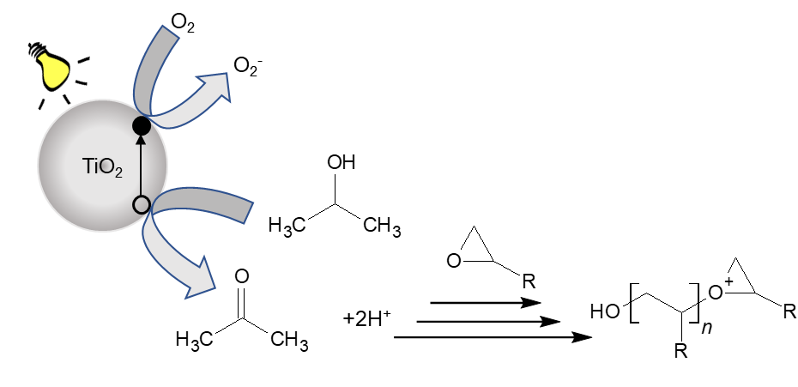
Scheme 1. Proposed mechanism for the photo-polymerization of epoxy in the presence of isopropanol using semiconducting nanoparticles.
Semiconducting nanoparticles are a tunable, cheaper, less toxic, and easier to synthesize alternative to the current commercial cationic organic initiators. Chung et al demonstrated the versatility of semiconducting nanoparticles by creating PbS coated ZnO quantum dots exhibiting the highest certified efficiency of 8.55%. Such efficiency is achieved by band gab energy engineering where the energy levels are tuned in such a way where the excited electron is essentially blocked from recombining with the hole. There is a wide variety of standard applicable metal oxide semiconducting nanoparticles with a range of band gap energies that include visible or deep UV regions such as copper oxide and tin oxide, respectively. We focus on P25 TiO₂ in our work as it is among the best photo-catalysts available commercially. We also use ZnO nanoparticles to generalize our conclusions. Both P25 TiO₂ and ZnO are standard materials with well-known synthesis processes and well investigated properties including quantum yields,.
2. Experimental Section
2.1 Materials
The materials used for the experiments are epoxy monomers (1-4 cyclohexane dimethanol diglycidyl ether, mixture of cis and trans- technical grade), isopropanol (99.5%), xylene (reagent grade), 1-phenethyl alcohol (98%), methyl viologen dichloride hydrate (MV) (98%), commercial organic cationic initiator (bis (4-methylphenyl) iodonium hexafluorophosphate (98%)), P25 TiO₂ nanoparticles (25 nm, 50 m²/g, anatase:rutile = 87:13), hydrogen bromide solution in acetic acid (33 wt%), toluene (99.8%), methanol (99.9%), 2-ethylhexanoic acid (2-EHA) (99%), and crystal violet indicator. These are obtained from Sigma Aldrich and used as-received. In some experiments, cyclohexene oxide (98%) is used as the epoxy monomer which is also obtained from Sigma Aldrich and used as received. Zinc 2-ethylhexanoate is obtained from Strem Chemicals and used as-obtained. Pure anatase TiO₂ (23 nm, 91 m²/g) is purchased from mkNANO. ZnO nanoparticles are synthesized via flame spray pyrolysis using a 4/8 flame as described by Güntner et al. The synthesized ZnO particles have a hexagonal zincite crystal structure with a crystal size of 29 nm (XRD), and a specific surface area of 39 m²/g (Nitrogen adsorption).
2.3 Epoxy photo-polymerization
Mixtures (1.5 g) consisting of epoxy monomer, alcohol (isopropanol, 1-phenethyl alcohol), MV and nanoparticles (P25 TiO₂, ZnO) are stirred overnight and sonicated for 30 minutes with a Misonix sonicator 3000 (5 seconds on, 20 seconds off). The exact compositions of the mixtures are specified in the results section. In some control samples, MV and/or nanoparticles are excluded. The mixtures are blade coated on microscope slides to make films that are radiated in a UVP (CL-1000L- 365 nm) photo-chamber with a light intensity of 4 mW/cm² at the surface of the samples. Scheme 2 outlines this sample preparation procedure.
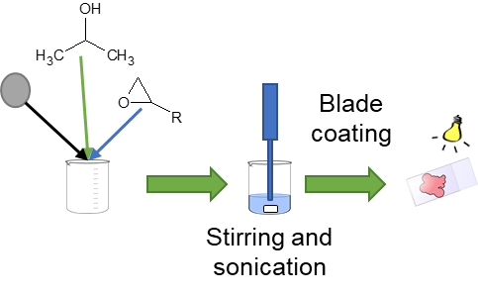
Scheme 2. Sample preparation.
2.4 Reaction Monitoring
Liquid-state NMR experiments are done on cyclohexene oxide. Solid-state NMR experiments are done on samples initially consisting of monofunctional epoxy monomer, cyclohexene oxide, and isopropanol (5 wt%), polymerized by either a commercial organic cationic initiator or P25 TiO₂ (5 wt%) after 50 hours of UV radiation.
All spectra are recorded on a Bruker Avance III HD spectrometer operating at ¹³C Larmor frequency of 150.87 MHz using a double resonance BBFO 5 mm probe for liquids and a Varian 3.2 mm BIO-MAS probe for solids. ¹³C spectra of the soluble samples are acquired with NOE enhancement during the recycle delays. 16384 transients are added with 1 s acquisition time a spectral width of 234 ppm and a recycle delay of 2 s. The ¹³C spectra of the solid samples are obtained at a Magic-Angle spinning frequency of 15 kHz using 1.5 ms cross-polarization at radio-frequency fields of 60 and 75 kHz for ¹H and ¹³C respectively, a recycle delay of 5 s, an acquisition time of 20 ms during which high-power ¹H TPPM decoupling is applied at a radio-frequency field of 75 kHz. The spectral width is 300 ppm, and 8192 transients are accumulated.
The reaction is monitored using FTIR and titration. Fourier transform infrared (FTIR) spectroscopy (NEXUS in ATR mode) is conducted with 64 scans at 1 cm⁻¹ resolution between 600 cm⁻¹ and 4000 cm⁻¹. Titration is performed according to ASTM-D1652-97. During the titration, HBr solution (c = 0.5 mol/L) is used for data points with lower polymerization, and HBr solution (c = 0.06 mol/L) for the later points with higher degree of polymerization.
2.5 Nanoparticle Dispersion
An SEM investigation of the films is done once using a Quanta 200F (FEI, now: Thermo Fisher Scientific), operated in low vacuum mode (P(H2O) = 40 Pa) at an acceleration voltage U = 20 kV to ensure proper dispersion. Images are recorded with back-scattered electrons. Figure 1 shows SEM images of photo-polymerized films containing P25 TiO₂. Image analysis of the most agglomerated particles seen with SEM show an average agglomerated particle size to be 238 ± 10 nm. The largest agglomeration size observed is 254 nm. Sample size is 20 measurements of the largest agglomerations per image (total measurements = 40). The agglomerate particle size of P25 TiO₂ dispersed in water measured by DLS is about 350 nm. Thus, we assess that the P25 TiO₂ particles are well dispersed in our system.

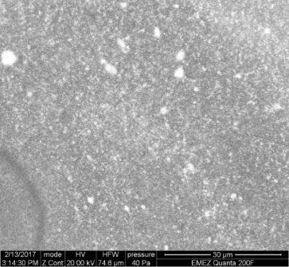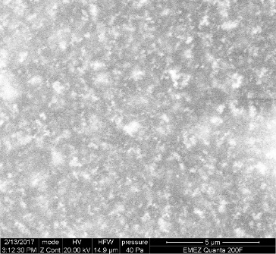
5 µm
30 µm
Figure 1. SEM images of a photo-polymerized film of a mixture containing epoxy, isopropanol (5 wt%), and P25 TiO₂ (5 wt%). The film was irradiated for 150 hours. Image analysis demonstrates that the agglomerated particle size is 238 ± 10 nm. Maximum agglomeration size is 254 nm. Sample size is 20 measurements of the largest agglomerations per image (total measurements = 40).
3. Results and discussion
3.1 Polymerization Verification
Figure 2a shows liquid state ¹³C NMR of the cyclohexene oxide monomer as received, showing a clear shift at 51.7 ppm that corresponds to epoxide rings. Figures 3b and c show solid state ¹³C NMR of the polymerized cyclohexene oxide showing the methylene carbons at 20-33 ppm, and methine carbons at 68-90 ppm. In general, the NMR spectra of the sample polymerized with the commercial cationic organic initiator (Figure 2b) and with the P25 TiO₂ (Figure 2c) have the same general shape indicating that the polymer synthesized using P25 TiO₂ is very similar to that synthesized using the commercial organic cationic initiator.
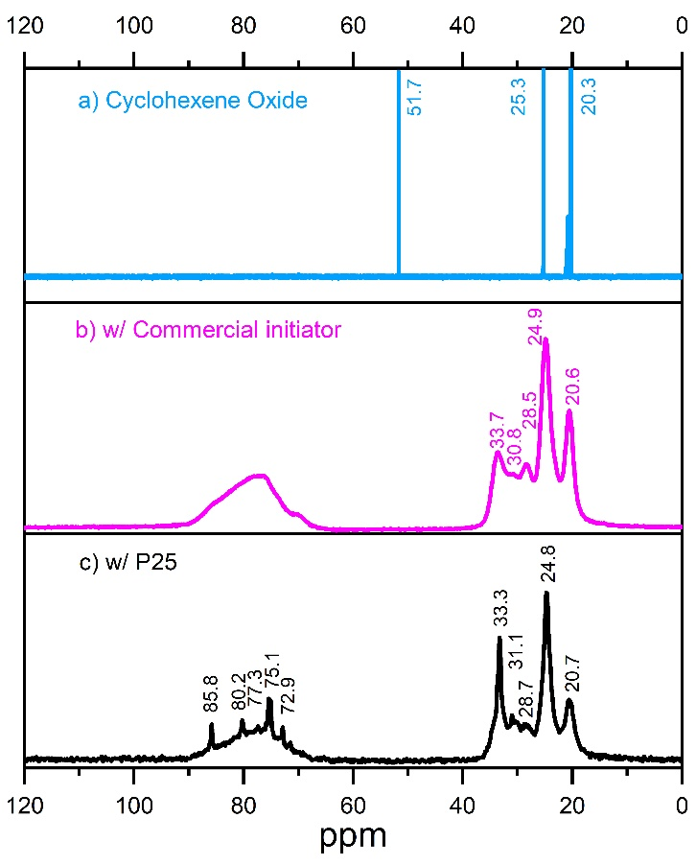
Figure 2. 13C NMR of a) cyclohexene oxide monomer (top, sky blue), b) sample cured with commercial cationic organic initiator (middle, magenta), and c) sample cured with P25 TiO2 (bottom, black).
The broad peak observed in Figure 2b between 70 and 90 ppm is the result of multiple overlapping peaks which cannot be resolved. The breadth of these peaks is most probably a consequence of the large molecular weight and low mobility of the species to which they are associated. This broad chemical shift distribution between 70 and 90 ppm is also observed in Figure 2c in addition to a few sharper chemical shifts at 72.9, 75.2, 80.2, 85.8 ppm. This indicates that the sample polymerized with P25 TiO₂ consists of two populations: a low mobility one with high molecular weight, and a high mobility population with low molecular weight. The presence of high mobility molecules in samples polymerized with P25 TiO₂ is further supported by our observation that it cross-polarizes less efficiently than the sample polymerized with the commercial cationic organic initiator.
We observe that the chemical shift at 51.7 ppm corresponding to the carbons in the epoxide ring disappears after radiation in Figures 2b and c in comparison with Figure 2a, confirming the epoxy consumption predicted by the proposed reaction mechanism in Scheme 1. A chemical shift at ~175 ppm, corresponding to ketones, can be observed in the single pulse experiments (Figure S1) of the sample cured with P25 TiO₂. This peak at 175 ppm confirms ketone formation due to alcohol oxidation predicted by the proposed reaction mechanism in Scheme 1.
3.2 Monitoring of Reaction Kinetics
We use FTIR spectroscopy to monitor photo-polymerization as is the convention. In Figure 3 we show the effect of initiator presence/type and UV radiation exposure on the FTIR spectrum of the reaction mixtures.
The system does not polymerize in the absence of light, as shown by the identical spectra of samples before and after one month stored in the dark (Figures 3a and b). Further, the system does not polymerize in the absence of an initiator even after extensive radiation (Figure 3c). On the other hand, we observe polymerization in the presence of both light and semiconducting nanoparticles, P25 TiO₂ (Figure 3e) or ZnO (Figure 3f), evidenced by the decrease of the epoxide peak at 910 cm⁻¹, consistent with C¹³ NMR observations (Figure 2c). We further observe a large peak at 1717 cm⁻¹ in the systems photo-polymerized with semiconducting nanoparticles, P25 TiO₂ or ZnO, (Figures 3e and f) but not with the commercial initiator (Figure 3d). This peak corresponds to the ketone stretch predicted by Scheme 1, consistent with C¹³ NMR single pulse experiments (supplementary information). Finally, we observe an increase in ether bonds further indicating polymerizations in systems initiated by semiconducting nanoparticles, P25 TiO₂ or ZnO, (Figures 3e and f).
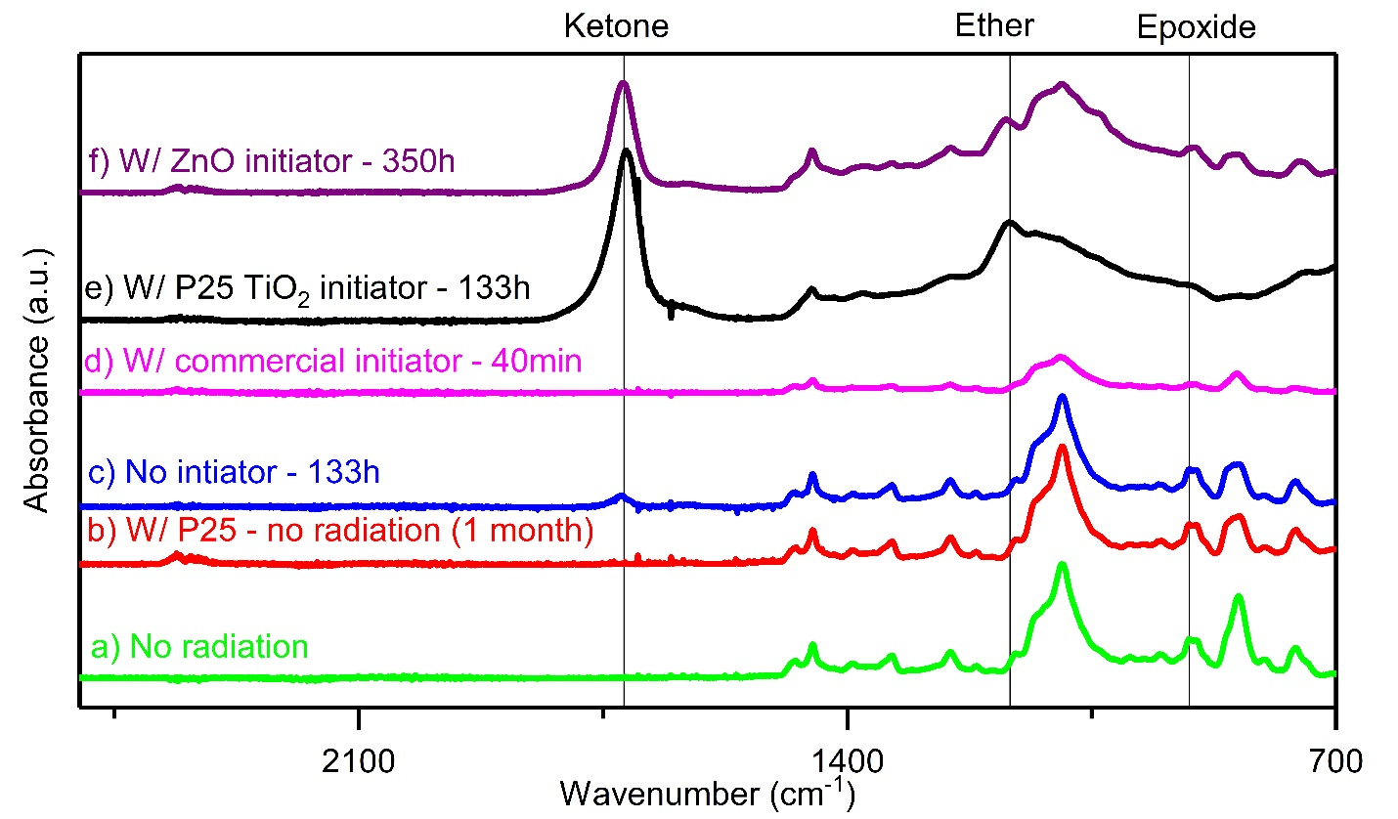
Figure 3. FTIR spectra of systems with epoxy and isopropanol (5 wt%) a) not radiated (bottom, green), b) with P25 TiO₂ (5 wt%) and no radiation (second from the bottom, red), c) radiated for 133h (third from the bottom, blue), d) with commercial initiator (5 wt%) radiated for 40 minutes (fourth from bottom, magenta), e) with P25 TiO₂ (5 wt%) radiated for 133h (fifth from the bottom, black), and f) with ZnO radiated for 350h (top, purple).
In Figure 4, we validate our FTIR quantification using chemical titration. The kinetics of epoxy consumption is monitored via the epoxide peak at 910 cm⁻¹ (black squares). Chemical titration (green squares) of the epoxide group by HBr according to ASTM-D1652-97 validates the FTIR measurements and C¹³ NMR observations, all indicating the consumption of epoxy over radiation time.
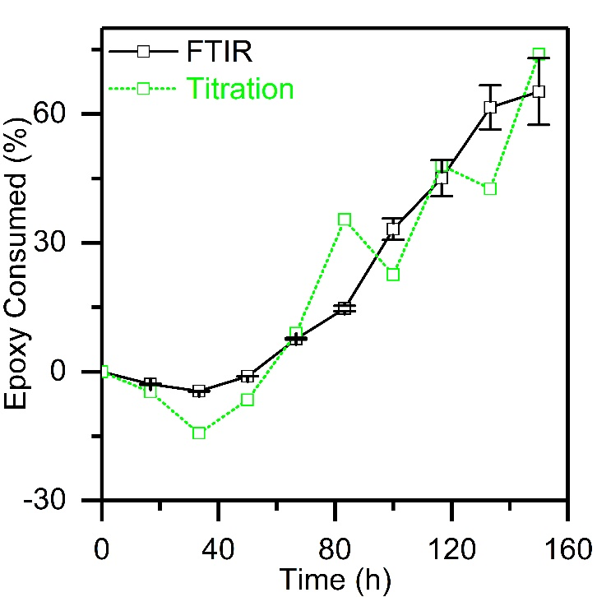
Figure 4. Titration (dotted green line with squares) confirmation of FTIR results (Solid black line with squares). Systems contain epoxy, isopropanol (5 wt%) and P25 TiO2 (5 wt%). Error bars indicate 90% confidence limits on the mean of 18 measurements for all t >0.
We monitor reaction kinetics by following the formation of ketones (Figure 5a), the consumption of epoxide (Figure 5b), and the formation of ethers (Figure 5c) via FTIR peaks at 1717, 1167, and 910 cm⁻¹ respectively for all systems (Figure 3).
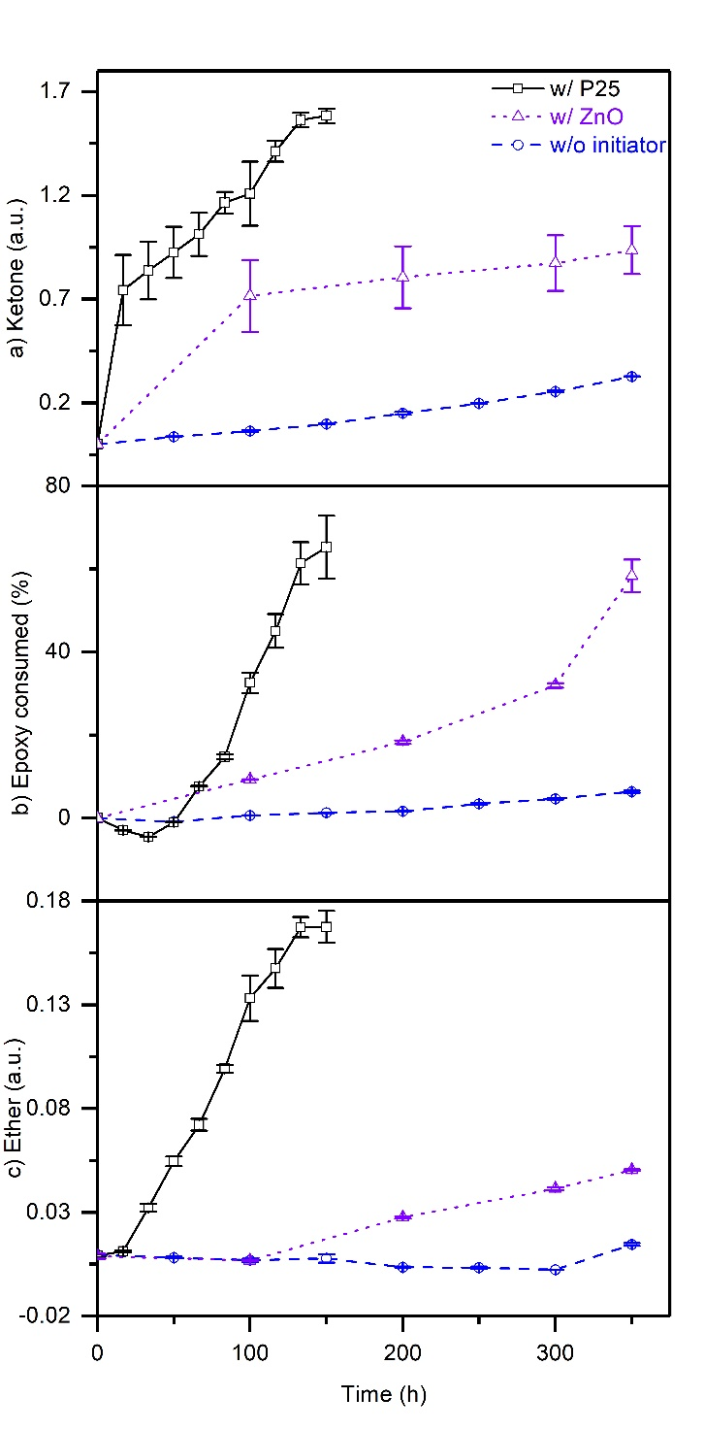
Figure 5. Reaction Kinetics: a) ketone formation (FTIR peak at ~1700 cm⁻¹), b) epoxy consumption (FTIR peak at ~ 910 cm⁻¹), and c) ether formation (FTIR peak at ~1167 cm⁻¹). Base composition: epoxy and isopropanol (5 wt%). Systems contain base composition (dashed line with blue circles); base composition with P25 TiO₂ (solid line with black squares) or ZnO (dotted line with purple triangles). All peak areas are normalized relative to the aliphatic peak area (2800-3000 cm⁻¹). Error bars indicate 90% confidence limits on the mean of 18 measurements for all t >0. Note that the horizontal axis is the same for all three graphs.
The control sample, without initiators, shows no sign of reaction in any of the three indicators. Systems with semiconducting nanoparticles, P25 TiO₂ or ZnO, show significant formation of ketones (Figure 5a), consistent with alcohol oxidation in Scheme 1 and C¹³ NMR single pulse experiments (supplementary information). Furthermore, we observe epoxy consumption (Figure 5b), and ether formation (Figure 5c), in both cases, consistent with epoxy polymerization in Scheme 1, and C¹³ NMR observations (Figure 2c). The reaction is much slower when ZnO is used than when TiO₂ is used, consistent with the literature indicating that TiO₂ is a more efficient photo-catalyst than ZnO. While P25 TiO₂ is used here because it is known to be the superior catalyst, we also use ZnO nanoparticles to generalize our conclusions to metal oxide semiconducting nanoparticles. An apparent induction period in epoxide consumption is observed in samples initiated by P25 TiO₂ (Figure 5b). This induction period has been observed and attributed to the formation of a secondary oxonium ion by Crivello.
Finally, another control experiment is conducted using P25 TiO₂ coated with 2-EHA using a procedure similar to what is reported in the literature (Figure S2). Coated P25 TiO₂ are inferior initiators to uncoated P25 TiO₂. This detrimental effect of nanoparticle coating indicates that our observations are of a surface reaction.
To speed up the reaction kinetics, we conducted a preliminary investigation of the effects of various system composition parameters including type and concentration of alcohol and TiO₂, and the concentration of electron scavenger. Figure 6 compares the reaction kinetics of the improved composition as compared to that of the original. The improved composition consumes 70% of the epoxy after 33 hours, which is 5 times faster than the 150 hours it took for the original composition. We note that in a process such as stereolithography the power intensity used would be several orders of magnitude higher than what is used in this study. This of course would lead to a faster reaction. Nonetheless, there remains a great deal of improvement to the reaction rate needed before it is implemented in a practical process. Parameters such as the semiconducting nanoparticle band gap energy and light wavelength should be explored to improve reaction kinetics because it is already well established that a good match between semiconducting nanoparticle band gap energy and light wavelength is critical in catalytic applications. We note that titania has been found to increase the glass transition temperature and modulus of epoxy. It has also been found that the modulus and yield strength of titania-epoxy composites are highest at 5 titania wt% and decrease at higher loadings due to the creation of microcracks.
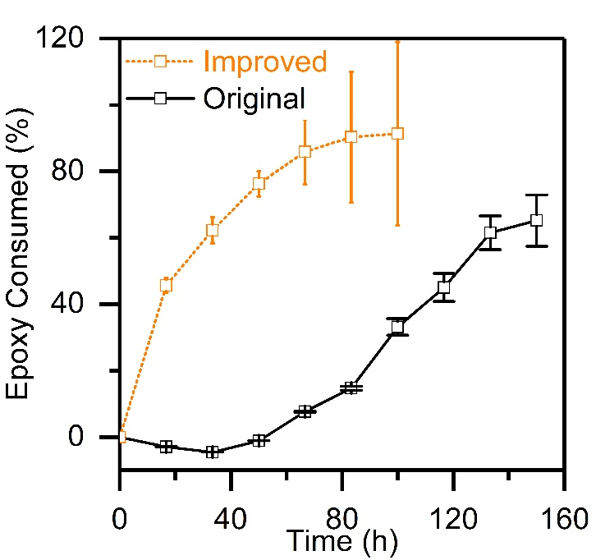
Figure 6. Composition improvement. The original system (solid black line) contains epoxy, isopropanol (5 wt%), and P25₂ (5 wt%). The improved system (dotted orange line) contains epoxy, 1-phenethyl alcohol (10 wt%), MV (0.5 wt%), and pure anatase TiO₂ (25 wt%). Error bars indicate 90% confidence limits on the mean of 18 measurements for all t >0.
3.3 Film Characterization
We evaluate the physical properties of the films to confirm that the film is polymerized. We conducted a swelling experiment where we left a film (thin film of the improved system from Figure 6, 483h of radiation) immersed in a beaker of acetone for 24 hours. The film showed no visible changes in its appearance and no weight loss. On the other hand, an unpolymerized film of the same composition completely dissolved in acetone after 5 minutes. These swelling experiments indicate that the polymerized epoxy film is cross-linked.
4. Conclusions
We demonstrate that semiconducting nanoparticles can initiate epoxy photo-polymerization. Considering the myriad of semiconducting heterogeneous photo-catalysts, this work opens a new class of epoxy photo-initiators.
Another immediate implication of our findings is that epoxy/TiO₂ nanocomposites are likely to suffer from photo-instability because the band gap energy of TiO₂ is within the solar spectrum, and thus it will initiate the reactions reported here whenever exposed to sunlight. Such instability of epoxy/TiO₂ nanocomposites has been reported,, but not previously related to the occurrence of the reactions reported here.

ASSOCIATED CONTENT
Supporting Information. The following files are available free of charge.
Figure S1. Single pulse C¹³ NMR experiments (PDF)
Figure S2. Effect of particle coating (PDF)

AUTHOR INFORMATION
Corresponding Author
Email: Paula.Wood-Adams@concordia.ca (P.M.W)
Author Contributions
The manuscript was written through contributions of all authors. All authors have given approval to the final version of the manuscript.
Funding Sources
We gratefully acknowledge NSERC and Concordia University for funding.
ACKNOWLEDGMENT
We thank Professor Sotiris E. Pratsinis and Dr. Karsten Wegner for their hospitality in the Particle Technology Laboratory (ETHZ), invaluable insights and help with FSP. We also thank Dr. Frank Krumeich (ETHZ) for the SEM images.
REFERENCES

Leubner, W.; Albert, S.; Unruh, C. Light-Sensitive Polymers for Making Printing Plates. Eastman Kodac Co, assignee. Patent US2861058. November 18, 1958.
Peiffer, R. Applications of Photopolymer Technology in Photopolymerization Fundamentals and Applications, American Chemical Society: Washington, DC, 1997:1-14.
Barraud, J.; Gervat, S.; Ratovelmanana, V.; Boutevin, B.; Parisi, J.; Cahuzac, A.; Jocteur, R. Polymer Material of the Polyurethane Acrylate Type for Coating an Optical Fiber or for an Optical Fiber Tape. Alcatel Cable, assignee. Patent US5567794. October 22, 1996.
Jones, N. Nature. Three-dimensional printers are opening up new worlds to research. 2012,487, 22-23.
D’Aveni, R. The 3-D printing revolution. Harvard Business Review. May, 2015; Features.
Yagci, Y.; Jockusch, S.; and Turro, N. Photoinitiated polymerization: advances, challenges, and opportunities. Macromolecules., 2010, 43, 6245-260.
Jubsilp, C.; Takeichi, T.; Rimdusit, S. Polymerization Kinetics in Handbook of Benzoxazine Resins. 2011: 157-174.
Hoffman, A.; Yee, H.; Mills, G.; Hoffmann, M. Photoinitiated polymerization of methyl methacrylate using Q-sized ZnO colloids. J. Phys. Chem., 1992, 96, 5540-5546
Stroyuk, A.; Granchak, V.; Korzhak, A.; Kuchmii, S. Photoinitiation of buthylmethacrylate polymerization by colloidal semiconductor nanoparticles. J. Photochem. Photobiol. A., 2004, 162, 339-351.
Zhang, J.; Huang, Y.; Jin, X.; Nazartchouk, A.; Liu, M.; Tong, X.; Jiang, Y.; Ni, L.; Sun, S.; Sang, Y.; Liu, H.; Razzari, L.; Vetrone, F.; Claverie, J. Plasmon enhanced upconverting core@trible-shell nanoparticles as recyclable panchromatic initiators (blue to infrared) for radical polymerization. Nanoscale Horiz., 2019, 4, 907-917.
Crivello, J. The discovery and development of onium salt cationic photoinitiators. J. Polym. Sci., Part A: Polym Chem., 1999, 37, 4241-4254.
Crivello, J.; Liu, S. Photoinitiated cationic polymerization of epoxy alcohol monomers. J. Polym. Sci., Part A: Polym Chem., 2000, 38, 389-401.
Xiao, P.; Zhang, J.; Dumur, F.; Tehfe, M.; Morlet-Savary, F.; Graff, B.; Gigmes, D.; Fouassier, J.; Lalevee, J. Visible light sensitive photoinitiating systems: recent progress in cationic and radical photopolymerization reactions under soft conditions. Prog. Polym. Sci., 2015, 41, 32-66.
Fujishima, A.; Honda, K. Electrochemical photolysis of water at a semiconductor electrode. Nature., 1972, 238, 37-38.
Hoffmann, M.; Martin, S.; Choi, W.; Bahneman, D. Environmental applications of semiconductor photocatalysis. Chem rev., 1995, 95, 69-96.
Xiao, L.; Green, A.; Haque, S.; Mills, A.; Durrant, J. Light-driven oxygen scavenging by titania/polymer nanocomposite films. J. Photochem. Photobiol., Part A: Chem., 2004, 162, 253-259.
Ilyas, M.; Sadiq, M. Kinetics of Heterogeneous Solvent‐free Liquid Phase Oxidation of Alcohol Using ZrO2 Catalyst with Molecular Oxygen. Chin. J. Chem., 2008, 26, 941-946.
Chuang, C.; Brown, P.; Bulovic, V.; Bawendi, M. Improved performance and stability in quantum dot solar cells through band alignment engineering. Nat. Mat., 2014, 13, 796-801.
Ohtani, B.; Prieto-Mahaney, O.; Li, D.; Abe, R. What is Degussa (Evonik) P25? Crystalline Composition Analysis, Reconstruction from Isolated Pure Particles and Photocatalytic Activity Test. J. Photochem. Photobiol., Part A: Chem., 2010, 216, 179-182.
Emeline, A.; Smirnova, L.; Kuzmin, G.; Basov, L.; Serpone, N. Spectral dependence of quantum yields in gas-solid heterogeneous photosystems: influence of anatase/rutile content on photostimulated adsorption of dioxygen and dihydrogen on titania. J Photochem. Photobiol. Part A: Chem. 2002, 148, 97-102.
Fu, Y.; Du, X.; Kulinich, S.; Qiu, J.; Qin, W.; Li, R.; Sun, J.; Liu, J. Stable aqueous dispersion of ZnO quantum dots with strong blue emission via simple solution route. JACS., 2007, 129, 16029-16033.
Güntner, A.; Pineau, N.; Chie, D.; Krumeich, F.; Pratsinis, S. Selective Sensing of Isoprene by Ti-doped ZnO for Breath Diagnostics. J. Mat. Chem. B., 2016, 4, 5358-5366.
Yahiaoui, A.; Belbachir, M.; Soutif, J.; Fontaine, L. Synthesis and structural analyses of poly (1,2- cyclohexene oxide over solid acid catalyst. Mat. Lett., 2005, 48, 759-767.
Crivello, J.; Liu, Saohsi. Photoinitiated cationic polymerization of epoxy alcohol monomers. J. Polym. Sci. Part A., 2000, 38, 389-401.
González, M.; Cabanelas, J.; Baselga, J. Applications of FTIR on Epoxy Resins – Identification, Monitoring the Curing Process, Phase Separation and Water Uptake in Infrared Spectroscopy – Materials Science, Engineering and Technology. 2012: 261-284.
Neppolian, B.; Sakthivel, S.; Arabindoo, B.; Palanichamy, M.; Murugesan, V. Degradation of Textile Due by Solar Light Using TiO₂ and ZnO Photocatalysts. J. Enviorn. Sci. Health A., 1999, 34, 1829-1838.
Crivello, J. Cationic Potopolymerization of Alkyl Glycidyl Ethers. J. Polym. Sci. Part A: Polym. Chem., 2006, 44, 3036-3052.
Lin, Y.; Chu, T.; Li, S.; Chuang, C.; Chang, C.; Su, W.; Chang, C.; Chu, M.; Chen, C. Interfacial nanostructuring on the performance of polymer/TiO₂ nanorod bulk heterojunction solar cells. JACS, 2009, 131, 3644-3649.
Kočí, K.; Obalová, L.; Matĕjová, L.; Plachá, D.; Lacný, Z.; Jirkovský, J.; Šolcová, O. Effect of TiO₂ particle size on the photocatalytic reduction of CO₂. Appl. Catal. B: Environ., 2009, 89, 494-502.
Morselli, D.; Bondioli, F.; Sangermano, M.; Messori, M. Photo-cured epoxy networks reinforced with TiO₂ in-situ generated by means of non-hydrolytic sol-gel process. Polymer, 2012, 53, 283-290.
Rubab, Z.; Adzal, A.; Siddiqi, H.; Saeed, S. Preparation, characterization, and enhanced thermal and mechanical properties of epoxy-titania composites. Scientific World Journal, 2014, 515739.
Mikhailov, M.; Li, C.; Neshchimenko, V. Optical property degradation of titanium dioxide micro- and nanopowders under irradiation. Nucl. Instrum. Methods. Phys. Res. B, 2014, 333, 52-57.
Mikhailov, M.; Yuryev, S.; Remnev, G.; Sazonov, R.; Kholodanaya, G.; Ponomarev, D. Effect of temperature on radiation resistance of TiO₂ powders during heating and modification by SiO₂ nanoparticles. Nucl. Instrum. Methods. Phys. Res. B, 2014, 336, 96-101.
Mikhailov, M.; Li, Chundong.; Neshchimenko, V. Optical property degradation of titanium dioxide micro- and nanopowders under irradiation. Nucl. Instrum. Methods. Phys. Res. B, 2014, 333, 52-57. For Table of Contents Only

