Mapping the Skin and the Guts of Stories – A Dialogue Between Geolocated and Dislocated Cartographies

Élise Olmedo & Sébastien Caquard

Abstract
This paper calls for a genuine dialogue between geolocated and dislocated cartographies, between Euclidean and coordinates free maps, between conventional and alternative mapping practices. This dialogue was made necessary by the challenges faced by mapping rich, complex and sometimes extremely difficult stories: the life stories of Rwandan exiles. By mapping two of these stories using both a geolocated mapping tool (i.e. Atlascine) and a dislocated mapping approach (i.e. sensibility mapping) we reflect on their respective potential and limits. Both approaches work well together due to their common respect for the integrity of the stories, and commitment to making the mapping process as transparent as possible. However, using them in parallel also unveils their differences and their complementarity. Geolocated maps tend to perform stories as geographic databases. They focus on what is explicit, geolocatable, on what is expressed, on the textual surface, on these stories’ skins. On the other hand, sensibility mapping performs the text as an entry point to the inner parts of these stories. Freed from any Euclidean constraints, sensibility maps engage more deeply with the intimate and personal dimensions of these stories, with what the storyteller might try to express despite the difficulty of verbalizing it, with their guts. The dialogue between both cartographic approaches highlights the vital complementarity of these approaches to map not only what is said in the lines of these stories, but what is also hidden between these lines.

Keywords: Mapping stories; Sensibility mapping; Atlascine; Cartographic dialogue; Art maps; Emotion; Geoweb; Exile; Rwanda

RÉSUMÉ
Cet article propose un dialogue entre la cartographie géolocalisée et la cartographie sensible, entre les cartes euclidiennes et les cartes libérées de toutes coordonnées géographiques, entre les pratiques cartographiques conventionnelles et alternatives. Ce dialogue a été rendu nécessaire par les nombreux défis que présentent la mise en cartes de récits riches, complexes et parfois extrêmement chargés émotionnellement : les récits de vie d’exilés rwandais. En cartographiant deux de ces récits à l’aide d’un logiciel de cartographie géolocalisée – Atlascine – et d’une série de cartes sensibles, nous avons été amenés à réfléchir aux potentiels et limites de ces approches. Ces deux approches ont en commun de respecter l’intégrité des récits représentés, ainsi que de reconnaitre l’importance de rendre le processus cartographique le plus transparent possible. Néanmoins, leur utilisation en parallèle révèle leurs différences ainsi que leurs complémentarités. Les cartes géolocalisées ont tendance à traiter et performer les récits comme des bases de données géographiques. Elles sont adaptées pour représenter ce qui est explicite, ce qui est exprimé, géolocalisable, c’est-à-dire ce qui se situe à la surface textuelle de ces récits, au niveau de leur épiderme. En revanche, la cartographie sensible tend à aborder le texte comme une entrée dans ces récits, dans leurs profondeurs, dans leurs entrailles. Libérées de toute contrainte euclidienne, les cartes sensibles performent et révèlent les dimensions plus intimes et personnelles de ces histoires, sans se départir du point de vue des porteurs de récits pour qui certaines choses peuvent être difficiles à exprimer. Le dialogue entre ces deux approches cartographiques met en évidence leur complémentarité indispensable pour cartographier non seulement ce qui se dit dans les récits, mais aussi ce qui y est enfoui.

Mots clés : cartographie de récits, cartographie sensible, Atlascine, dialogue cartographique, cartes artistiques, émotions, géoweb, exil, Rwanda

Introduction
Contemporary cartography is increasingly open to the interaction between different forms of spatial expressions. A mapping project doesn’t have to position itself anymore as either a scientific or an artistic one; it can be both. This rapprochement between what has largely been considered the two ends of the cartographic spectrum. On the one hand, it has been encouraged by the fascination exercised by maps in the arts and in the humanities as a powerful mean for creative expression and political statements. On the other, by the growing recognition in the social sciences - and in geography in particular - of the potential of art maps and creative mapping practices to expand our understanding of our relationships to places. A variety of scholars have called for this rapprochement (e.g. Casti 2015; Hawkins 2013; 2019; Lo Presti 2018; Caquard et al. 2019; Della Dora 2020) and has materialized in a range of geohumanities and deep mapping projects as well as in art map experiments and activist mapping endeavors (see below). In some of these projects, the hierarchy between what can be called geolocated and dislocated forms of mapping has been somehow blurred, opening up new spaces for a genuine dialogue between them.
Before engaging in this dialogue, let’s clarify what we mean by geolocated and dislocated forms of mapping. Geolocated cartography in our books refers to “conventional” cartography exemplified by Euclidean or Cartesian maps: maps that are mathematically associated to portions of the earth through geographic coordinates. These maps follow the historical lineage of topographic and thematic maps and include all the maps produced with Geographic Information Systems (GIS) as well as with online mapping services such as Google Maps, Openstreetmap and ArcGIS online. Dislocated mapping can be broadly considered “coordinate free mapping”. Less common, it encompasses alternative forms of maps dissociated from the Euclidean space to focus on other connections to places. To do so, they often revisit the cartographic standards as illustrated in examples from art maps (Harmon 2009; Wood 2010), inductive visualization (Knowles, Westerveld, and Strom 2015) or sensibility mapping (Volvey 2012; Olmedo 2015). Some of these dislocated maps have moved outside academia to reach a larger audience. They appear in books, exhibits, museums, digital media as well as public spaces (see examples in Solnit 2010; Pinder 2013; DeGraff and Harmon 2015; Besse and Tiberghien 2017; Reddleman 2018; Duxbury, Garrett-Petts and Longley 2019). This growing popularity within and beyond academia opens the possibility for a genuine dialogue with conventional cartography; a dialogue based on listening, consideration, exchange and openness to learning from one another.
In this paper, we propose to engage a dialogue between one particular type of dislocated mapping practice (i.e. “Sensibility mapping”) and one form of geolocated cartography (i.e. “Atlascine mapping”). This dialogue has been made necessary by the cartographic challenge we have faced: mapping the life stories of Rwandan exiles. The responsibility of mapping such complex, rich and sensitive types of stories requires careful attention and an openness to diverse perspectives. It also requires an ongoing dialogue between Western academic mapmakers and storytellers of Rwandan origin, between those who see the stories as cartographic and research material and those for whom these stories are central to their life and to their legacy. Beyond this dialogue, is a conversation between two academic mapmakers who have different but complementary ways of envisioning spatial representations. This conversation aims to help each of us reflect on our own mapping practices to constantly try to improve them by opening them to other ways of approaching places, stories and data visually.
In the next section, we will review the current status of the relationships between dislocated and geolocated maps, differentiating between the terms hybridization and association. We will then present the two mapping approaches developed to map the life stories of Rwandan exiles and discuss how these two approaches have been mobilized for this project. The final section will reflect on how this dialogue has contributed to our understanding of the ways different mapping practices perform the skin and the guts of stories.

- Hybridizing and associating geolocated and dislocated maps
A growing number of projects have integrated artistic dimensions into conventional cartographic practices and vice-versa to produce what can be called hybrid geolocated-dislocated mapping projects. These projects have taken different forms to reach multiple goals. Alternative mapmaking practices have explored the potential of cutting, painting, erasing, redrawing, knitting, and sewing existing Euclidean maps for aesthetic purposes, as well as for advancing more social and political agendas (Harmon 2009; Littman 2011; Kollektiv Orangotango+ 2018). For instance, the artist Kathleen Vaughan (2020) has made a very large fabric map using Google Maps as spatial reference, on top of which she displayed stories illustrating the devastating consequences of two centuries of human industrial activities on the neighborhood of Pointe-Saint-Charles in Montreal (Canada). In Port Said (Egypt), designer and geographer Nermin Elsherif (2018) organized a four-day collaborative mapping workshop with citizens, artists, activists and researchers to produce a map of personal stories related to the city. In the same vein as the “Memory Map project of New-York City” led by Jake Barton and Nancy Nowacek at the beginning of the 21st century (Krygier 2006), the Port Said map was made of a network of colored threads connecting places on the Euclidean map with short stories written by the participants on post-its. In this collaborative mapping project, the network of strings connecting personal stories to places was then partially covering the geolocated map of the city in an attempt to replace and “challenge the official representation of depicted spaces” and “defy the normative format of maps” (Elsherif 2018, 253-254). This type of hybridization between geolocated and dislocated maps has been done in a range of participatory mapping projects, not only to facilitate a conversation about various experiences of places, but also to keep on reflecting upon the insidious and prevalent power of the Euclidean map in the way we engage with the world. Cartographic hybridization has also taken advantage of the extended potential of the digital environment for mixing media and experiences. For instance, the award-winning “Refugee Republic" project has combined interactivity with hand-drawn Euclidean maps, photos and animation techniques to expose the everyday life in a Syrian refugee camp in northern Iraq (https://refugeerepublic.submarinechannel.com/).
Anne Knowles, Levi Westerveld and colleagues have explored this hybridization of dislocated and geolocated maps. Confronted with the challenge of representing Holocaust experiences that are often spatially vague and multi-scalar, they have developed different concepts, methods and practices such as inductive visualization (Knowles, Westerveld, and Strom 2015). For instance, they combine the Euclidean geography to follow the displacement of two survivors of the Holocaust across eastern Europe, with the memories of significant personal and intimate places shared by these survivors such as a cattle car, a synagogue, a barrack, a shower or even a pocket (Westerveld and Knowles 2018).
In more recent work, Westerveld and Knowles (2020) argue for “non-coordinate means of mapping” into Geographic Information Systems (GIS) (p. 1). They propose a topological GIS that focuses primarily on relationships rather than Euclidean locations. Relationships are indeed central in testimonies and stories: relationships between people, between people and places, and between people, places and displacement. With this proposition, they aim to reverse the priorities of geospatial data structures. In the conventional GIS model, the Euclidean structure is a requirement. In this proposed model, it becomes an option that can be mobilized when it is relevant to represent certain phenomenon. Although this proposition remains purely conceptual at the moment, it clearly illustrates the ongoing reflection on the necessity of finding better ways of combining geolocated and dislocated forms of spatial data structures and spatial expressions. These different examples also illustrate that this hybridization process is independent of the media and the technology mobilized to achieve it.
The hybridization of dislocated and geolocated cartography is nothing new. The 16th century map known as the Codex Quetzalecatzi illustrates: “On the one hand, […] a traditional Aztec cartographic history with its composition and design showing Nahuatl hieroglyphics, and typical illustrations. On the other hand, it also shows churches, Spanish place names, and other images suggesting a community adapting to Spanish rule” (Hessler 2017, para. 4). Indigenous communities have developed skills and strategies over the centuries to hybridize imposed Western mapping practices with their own perspectives on lands and territories (Pearce and Louis 2008; Pearce 2014; Lucchesi 2018; Mansilla and Melin Pehuen 2020), demonstrating their capacity to produce new forms of spatial expressions that expand their own ways of representing their relationships with other beings and with the world in general.
Not only have these Indigenous mapping projects hybridized Indigenous and Western forms of spatial expressions, but they have also mobilized both of them in parallel; they have “associated” them. They have associated oral stories, songs and wampum belts with their Euclidean cartographic counterparts to reach out to Western audiences. For instance, in a 1987 trial that took place in the Supreme Court of British Columbia (Canada), two First Nations - the Wet'suwet'en and the Gitxsan – used their oral traditions (including songs) to express their ancestral relationships to their territories, as well cartesian cartographic translations of this knowledge to communicate their territorial claims to the court (Sparke 1998).
This type of association between geolocated and dislocated mapping practices expands the possibilities of expressing our relationships with places. This is illustrated by the “Anti-eviction mapping project” (Maharawal and McElroy 2018). In this project, Euclidean animated maps of evictions overtime in the San Francisco Bay Area (and later on in other cities) are associated with more creative forms of spatial expressions such as a painted mural and choreographic performances (Maharawal and McElroy 2018). Such dislocated mapping practices aim to better express the human consequences of these evictions. The association of both approaches can then become highly tactical with different forms of expression being mobilized for different forms of political actions and social endeavours. For instance, the geolocated map displaying the number of evictions is not just a way of locating events, it is also a very powerful way of communicating the spread and the scale of this phenomenon to a broad audience. The dislocated forms of spatial expression produced in this project can be mobilized to better voice the impacts of these evictions on the bodies, the individuals, the families and the communities. They may also be therapeutic since they offer a space to express the trauma experienced in relation to eviction and build a support network for the community of people who experienced it.
The choice between cartographic hybridization (i.e. geolocated and dislocated forms are merged into a common cartographic outcome) and cartographic association (i.e. geolocated and dislocated forms remain distinct but are both used in parallel) is often not planned and emerges from a dialogue based on the resources available for the project, the background of the mapmakers, the expectations of the communities involved or the agenda of the project leaders. The dialogue engaged in this paper is based on the association between one form of geolocated cartography and one form of dislocated mapping.

- Anatomy of the Dialoguers
The “Atlas of Rwandan Life Stories” is situated at the crossroad between two research projects: the Montreal Life Stories Project (2008-2012), an oral history endeavour, in which hundreds of life stories of exiles and refugees from all over the world living in Montreal at the time have been videotaped and archived at the Center for Oral History and Digital Storytelling (COHDS) (High 2014); and “The Mapping (Life) Stories Project”, a research endeavour that started in 2013 to explore the multiple theoretical, methodological, technological, ethical and cartographic aspects of mapping life stories. One of the outcomes of this project was the development of the open-source mapping platform named Atlascine followed by the design of a series of sensibility maps of these stories.

The geolocated dialogueuer: Atlascine
Since its first version in 2009, Atlascine has been envisioned as an experimental platform dedicated to implementing and testing ideas emerging from critical cartography and confronting them to mapping practices. Atlascine was first used to map cinematographic stories (i.e. where the actions of films unfold) (Caquard and Fiset 2014). Since 2013, this application has been re-designed to map a broader range of stories, including life stories of exiles (see Caquard and Dimitrovas 2017). In its most recent version, Atlascine mobilizes the power of Euclidean maps to visually synthesize the spatial structures of these stories (e.g. events associated to places described in these stories). It also utilises the potential of interactive maps to navigate within and between these stories through places. The maps in Atlascine are geocoded since they use an Euclidean structure combined with geolocated cartographic symbols to reveal spatial patterns associated to these stories. On the other hand, the multiple entry points these maps offer to listen to these stories are highly unconventional.
In the “Atlas of Rwandan Life Stories”, 21 stories collected in the context of the Montreal Life Stories Project have been tagged and mapped with Atlascine. Tagging is the core function in the latest version of Atlascine (4.0) since it defines what sections of the stories will be mapped and how. Tagging is done directly in the web browser and can be changed easily by anyone with the proper authorization. Two types of tags can be added: theme tags (e.g. genocide, violence, forced migration, resistance, identity and exile) and place tags that are associated with geographic coordinates (e.g. “Rwanda”, “Kibuye”, “Université de Butare”). These place tags serve to geolocate the tagged section of the story on the map using tree rings symbols and to color them based on the theme tags. The user can then click on each tree ring and listen to the associated story segment. These tags then serve as spatial and thematic anchors enabling the navigation between the map and the story, between places and associated moments of the story. All the tags can be changed, added or removed by anyone with the credentials (i.e. a password). As a result, the map is not envisioned as the final output of the process, but rather as an intermediary step that can be modified at will to study these stories and listen to them.

The dislocated dialoguer: Sensibility Mapping
“Cartographie sensible” or sensibility mapping is a method that aims to identify and reveal important aspects of stories such as the emotions hidden in the nuances of experiences, memories and remembering (Volvey 2012; Olmedo 2015; Gaujal 2019). Sensibility mapping emerged a few decades ago from a heterogeneous ensemble of alternative mapping projects and primarily from artistic cartographies. It has been shaped by feminist theories arguing that the personal, emotional and intimate aspects of life and society are highly political (Bondi, Davidson and Smith 2005; Pile 2020). It engages with racial, class and gendered normativities that are core in feminist studies.
Sensibility mapping uses a range of creative techniques dedicated to remaining as close as possible to the story, while keeping some distance from the Euclidean world. These coordinate-free maps become highly influenced by context (of the story and the mapping process) and appear to challenge the cartographic norms metaphorically and figuratively. Sensibility mapping aims to revisit particular moments of the oral or written story that have been identified through a very close listening/reading approach. This approach engages deeply with the experiences it represents and requires careful consideration of every cartographic decision, such as the material selected to represent the story, the choice of the media, colours, shapes and legend.
In the context of mapping life stories of Rwandan exiles, sensibility mapping was done manually on paper, using a pen and paint (watercolour and pastel), to visually interpret the narrator’s perspective, sensibilities and emotions. These maps focus on key moments of each story, with potentially important emotional dimensions that could either be clearly expressed or unconsciously revealed. The mapping mode is based on the principles of notation and experimentation reviving somehow an old cartographic approach inherited from pre-Euclidian forms of mapping (i.e “itinerary maps”), currently reemployed by a handful of artist-cartographers to annotate specific data about emotions and memories of places (Olmedo 2015). The development of this practice of mapping annotation has been investigated especially in France during the last decade (Olmedo 2015), where underground urban artists have explored alternative ways for writing and sensing places.
Sensibility mapping in this research was mobilized to develop an original perspective to the stories inspired from this singular way of artistic mapping. After identifying the key moments of the story, the mapmaker attempts to draw them, following their organization, including the accidents and the turnarounds. The last step consists of finalizing the design to create an appropriate visual atmosphere. Beyond the elements that are represented on the sensibility map, this process includes the ethical challenges of dealing with sensible stories and the struggles to position ourselves relative to stories that are not ours and vis-a-vis the storytellers who own and share them.

- The perspectives of the dialoguers
In the context of the “Atlas of Rwandan Life Stories” produced with Atlascine we have defined different themes of interest to map. These themes emerged from our listening of the stories as well as from the different interactions we had over the years with members of “Page Rwanda”, the Montreal based association that represents the parents and friends of the victims of the 1994 genocide of the Tutsis of Rwanda. The initial goal of this project was to map emotions associated to places in these stories. However, after several attempts, we had to give up that goal: it was too complex to qualify emotions that are often implicit, nuanced and so personal in a systematic way across this series of stories. The introduction of sensibility mapping to the project offered a different perspective on that aspect since it brought the possibility of mapping in-depth certain emotional moments. The identification of the important moments to map was facilitated by Atlascine and its capacity to synthesize each story spatially. The application offered the possibility to go back and forth in the story, identify places and topics, and finally allow the granular level work to begin on the conditions of the story’s elicitation. The results obtained with both methods were shared on different occasions with the Rwandan community, particularly with Emmanuelle Kayiganwa and Emmanuel Habimana.
Emmanuelle Kayiganwa’s story is the story of a Rwandan Tutsi woman who had a happy childhood before being forced to leave her parents when she was 11 due to educational discriminations against the Tutsis. A few years later, in 1973, she was forced to leave her country to escape a wave of extreme ethnic violence against the Tutsis and to seek refuge in Burundi. It is the story of a young woman who spent more than 20 years of her adult life moving between Rwanda, Burundi and Zaire (i.e. Democratic Republic of Congo) fleeing violence and then the genocide of the Rwandan Tutsis, to arrive in Montreal at the end of the year 1994.
Emmanuel Habimana’s story is the story of a Hutu male who left Rwanda to study in Belgium and then moved to Canada in 1980 when he was about 30, long before the 1994 genocide. It is the story of someone who witnessed violence against the Tutsis during his childhood in Rwanda in the 1960s and experienced the 1994 genocide from far away while being deeply affected by this traumatic event. It is also the story of an individual who developed close relationships with the association “Page-Rwanda” over the years.

The Atlascine perspective on these stories
The Atlascine map of Emmanuelle Kayiganwa’s life story synthesizes quite well the main themes she discussed in her story (see Figure 1). The circles representing the theme exile are dominant in the first part of her story (pink), followed by family and work (blue), and then later on violence (red), genocide (dark grey) and finally post-genocide (grey) mentioned at length in the second part of the narrative. This map also clearly identifies the main places that have structured Emmanuelle Kayiganwa’s life story, such as Nyamata and Kabuga in Rwanda, Bukavu in the Democratic Republic of Congo (DRC), Bujumbura in Burundi and Montreal in Canada. All these places appear with larger symbols, some of them associated with clear themes. For instance, Bujumbura is associated with exile and genocide, while Nyamata is mostly associated with genocide and post-genocide.
Figure 1. Story of Emmanuelle Kayiganwa mapped with Atlascine (zoom on Rwanda and Burundi). Both cities of Bukavu (East) and Bujumbura (South) seem to have about the same importance in the story (i.e. symbols of the same size on the map), but Bukavu is mainly associated with memories of genocide (dark grey) and post- genocide (lighter grey), while Bujumbura (South) is associated with stories of exile (pink) and genocide (dark grey). The map is accessible online here: https://rs-atlascine.concordia.ca/rwanda/index.html?module=module.stories

The Atlascine map of Emmanuel Habimana’s story synthesizes the spatial structure of his life as a child raised between two places: Rukondo, where his parents lived, and Karama where he was sent when he was only a few years old to live with his grandmother (see Figure 2). He came back to live with his parents in Rukondo only when he was 14-15 years old. The map calls attention to the association between places and memories such as the early waves of ethnic violence that he witnessed as a child in the 1960s while living in Karama. This map also highlights certain sections of the story such as the ethnic tensions Emmanuel Habimana experienced while being a student in Louvain (Belgium), and different acts of resistance led by others during the genocide (in yellow on the map). Montreal and Trois-Rivières appear later in the story and are mostly related to exile, and certain personal aspects such as friendship and family. The city of Trois-Rivières in Quebec is also highly associated with the genocide - which is explained by the fact that Emmanuel Habimana was already living in Trois-Rivières in 1994 when the genocide was devastating his country.
Overall, these Atlascine maps do well what geolocated maps usually do well: synthesize complex spatial information to enable the emergence of spatial structures. They lay out the geographic specificities of the story with its different spatial densities and intensities. They reveal the skin of these stories, its variations in thickness, its asperities and its apertures that invite for a more in-depth exploration.
Figure 2. Story of Emmanuel Habimana mapped with Atlascine (zoom on Southern Rwanda). In the center of the map, the district of Rukondo, where Emmanuel Habimana lived the first few years of his life with his parents, is associated with family (blue), while the nearby district of Karama is mainly associated to violence (red): this is where Emmanuel Habimana was living in the early 1960’s when he witnessed episodes of ethnic violence against the Tutsis. The map is accessible online here:
https://rs-atlascine.concordia.ca/rwanda/index.html?module=module.stories

The sensibility mapping perspective on these stories
The first step of the sensibility mapping approach was to identify key moments in the story of Emmanuelle Kayiganwa. Although this process could be done with a close listening of the story, in our case it was facilitated by the Atlascine maps. These maps helped us identify three segments of particular interest in this story that were then mapped more deeply. The first sensibility map represents the story segment of Emmanuelle Kayiganwa leaving her parents when she was 11 to continue her education in Nyanza and Kigali to escape educational discrimination against the Tutsis. This segment is mapped as a non-linear path determined by political and increasingly violent events (see Figure 3). The second map represents her description of the different places she experienced during her exile, including her visit to Nyamata, right before her departure to Canada. This is where her parents were deported, and this is also where a mass killing occurred during the 1994 genocide. Her description of coming back to Nyamata is highly emotional. These memories have been represented on the map through the metaphor of human guts. The storyteller's journey is represented as a digestive tract that tightens more and more until a kernel falls off of it. This kernel then comes back to the base of the digestive tract, where another episode of her life starts (see Figure 4).
The third map explores the particular moment of Emmanuelle Kayiganwa’s story when she returns to Nyamata in July 1994 while the genocide is ending. The map represents her visit to the church of Nyamata where thousands of people have been killed including members of her family, and the absolute impossibility for her to find any traces of her mother among all the remains. Based on her description, this sensibility map aims to include her way of expressing these extremely painful memories as much as possible. For instance, she mentioned that while arriving at the church she saw what she thought were tree leaves on the ground, but once she got closer, she realized that they were human scalp skins. This was the only description of the victims she gave; this description was integrated metaphorically in the sensibility map with the drawing of tree leaves (see Figure 5). Through metaphors extracted from the story, the map seeks to render how difficult it is for the storyteller to tell the horror that happened at the church of Nyamata, where Tutsi people found refuge before being massacred. This very personal and contextualized interpretation emphasizes the sequence of elicitation. The mapping here is less about what is said and more about how it is said.
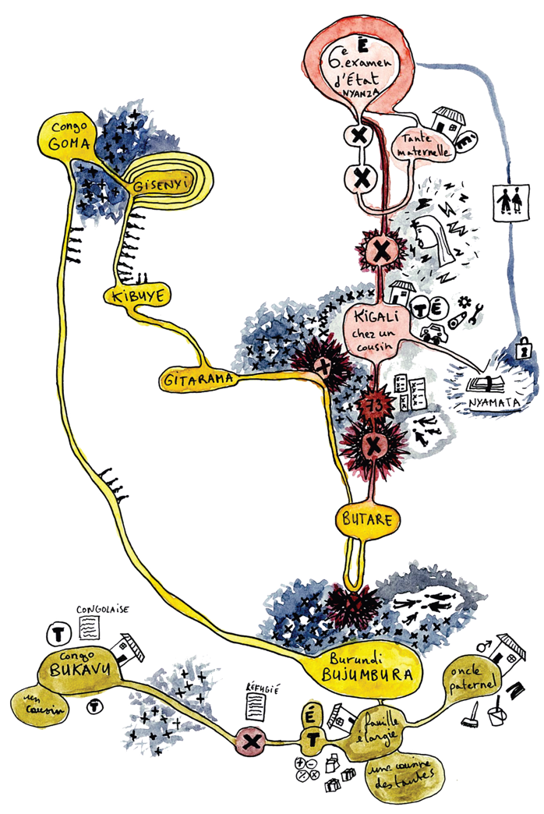 | 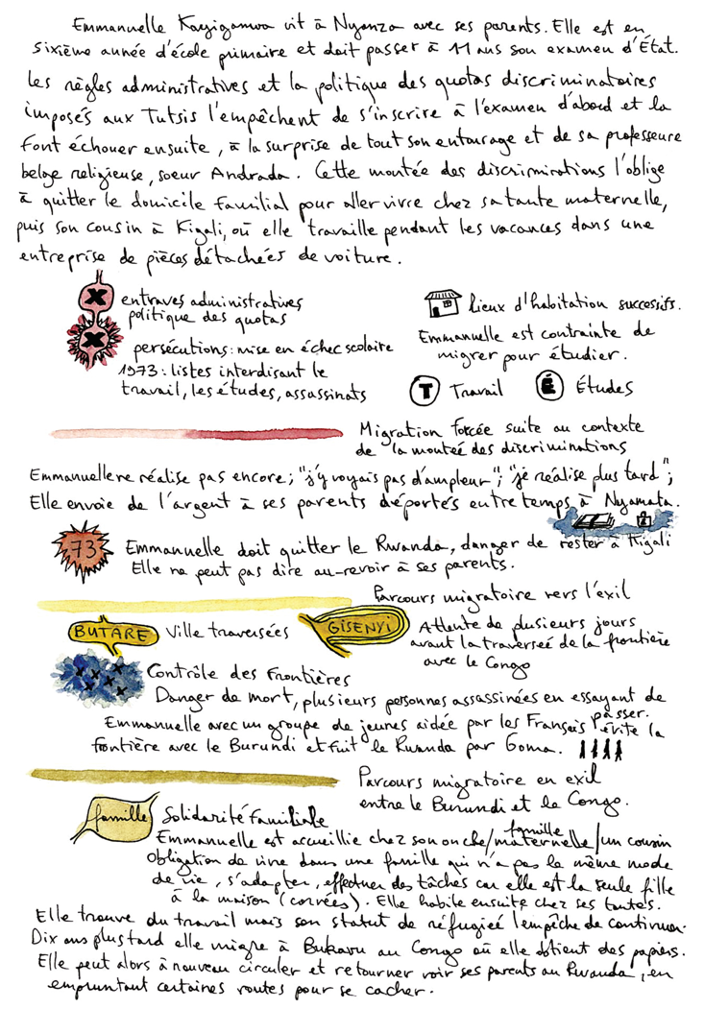
Figure 3. This sensibility map of Emmanuelle Kayiganwa represents the places of forced displacement she experienced when she was a teenager forced to live in exile in Rwanda, Burundi and Congo. The map also represents the rise of discriminations against the Tutsis as described by Emmanuelle Kayiganwa in her life story. The excerpt of the story mapped is accessible online here, from 0:17:31 to 0:31:24: https://rs-atlascine.concordia.ca/rwanda/index.html?module=module.stories

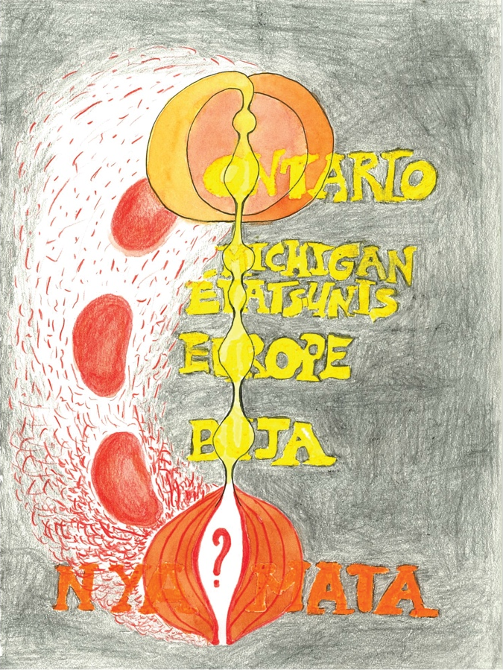 | 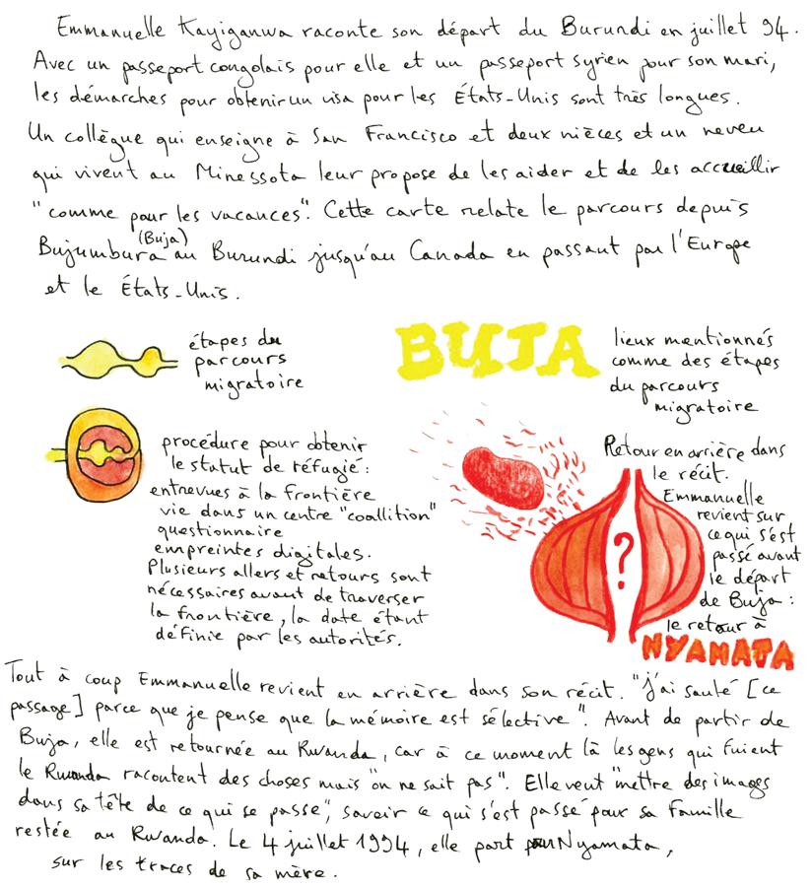
Figure 4. This sensibility map expresses the process to come back to things difficult to tell, cartographically seen as a digestion process. Emmanuelle Kayiganwa indeed narrates the steps of her emigration to North America (USA and then Canada) before coming back in the story to the memories of the genocide, another major part of her life. The excerpt of the story mapped is accessible online here, from 1: 25:25 to 1:29:49: https://rs-atlascine.concordia.ca/rwanda/index.html?module=module.stories

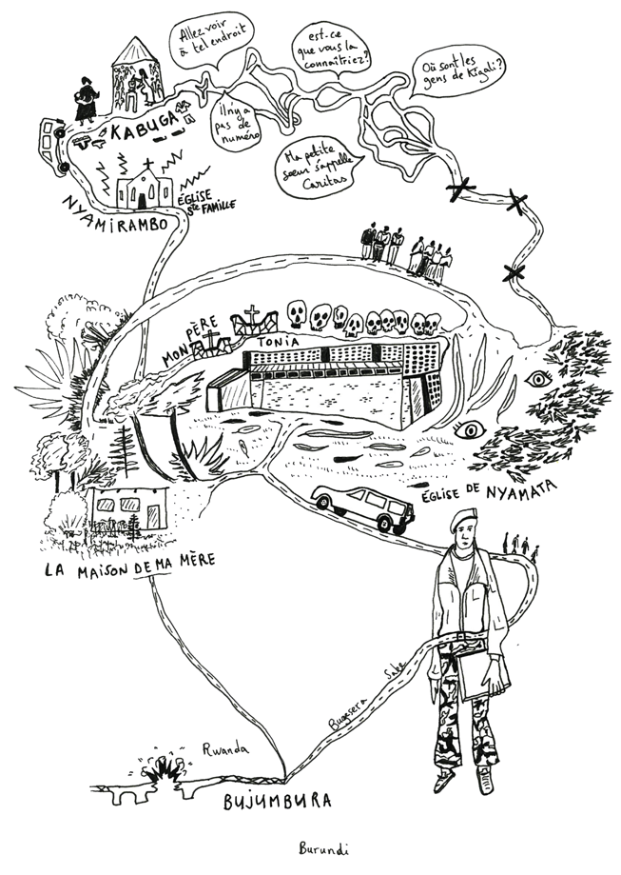 | 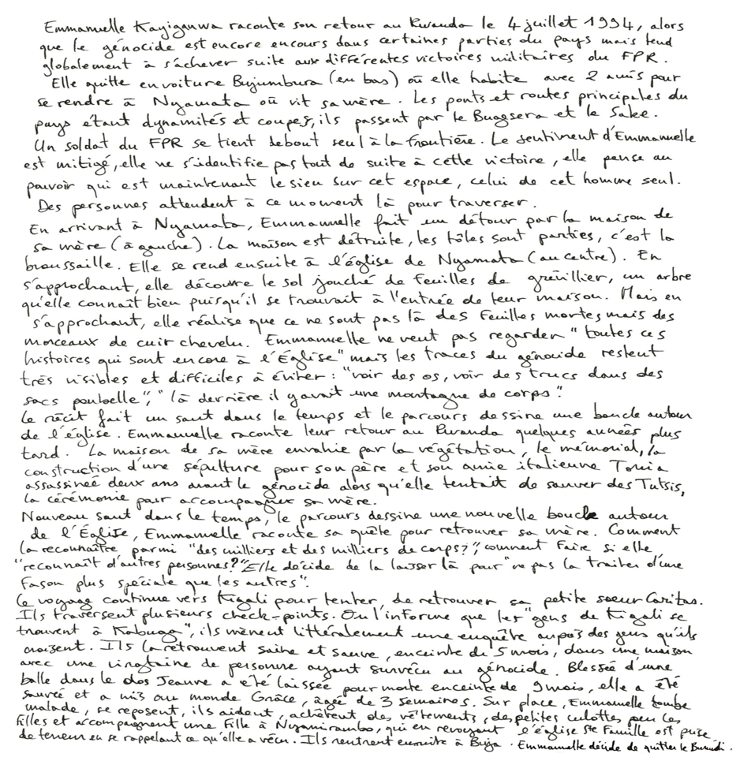
Figure 5. This sensibility map retells her anxious memories of her trip back to Nyamata right at the end of the genocide in July 1994. The map presents the different places she went through during this road-trip in the East of Rwanda: her mother’s house, the church (genocide’s place), Kigali and Kabuga looking for her sister Caritas who survived the genocide. The excerpt of the story mapped is accessible online here, from 1:29:49 to 1:53:12: https://rs-atlascine.concordia.ca/rwanda/index.html?module=module.stories

The life story of Emmanuel Habimana has also been represented with a series of three sensibility maps. The first map has been inspired by the first segment of the story that focuses on his childhood. This map does not include any proper noun place names such as Rukondo or Karama, but several common nouns which mainly refer to both the people and the places where they lived (e.g. Grandmother, mother, father, neighbors). This map also represents the personal journey between different people and places associated to them (e.g. “lieu sûr” or “safe place”). These places and people are anchor points in the map that is organized around a central loop between the grandmother and the parents (see Figure 6).
The second sensibility map is also structured around a loop, but this one is temporal; it connects dates with important personal events, such as the death of Emmanuel Habimana’s parents (see Figure 7). The 1994 genocide is associated to a place - the parish of Cyanika where Emmanuel Habimana’s family is originally from - and to previous waves of violence he witnessed as a child in the early 1960s. The genocide is central here, just like the death of his mother. This event was particularly difficult for him since he was far from her, and unable to return to Rwanda to perform funeral rituals for her. Quebec also appears on the map, but on the top right corner which demonstrates the complete disconnect of this map from any Euclidean geography. Here again, geography is conveyed through the connection between places, dates, events and people, rather than through geolocation. In this segment, Emmanuel Habimana connects the wave of violence against the Tutsis that happened at the beginning of the 1990s with various memories of similar violent events he remembers as a child. These recurring episodes of violence are represented on the map through a loop. This sensibility map insists on the repetition of history rather than on the exact dates and locations of these episodes.
Finally, the third sensibility map represents Emmanuel Habimana’s trips back to Rwanda (see Figure 8). It is also a circular map, but that time it is structured around specific places (i.e. Butare, the Kigali Memorial, and Gikongoro) aligned in the center with some key dates (1960, 1964) and a few people (i.e. “Calixte”, “ma fille”). Here again the location of the places are entirely disconnected from any Euclidean structures, and the emphasis is on revealing the connections between people, places and events over time.
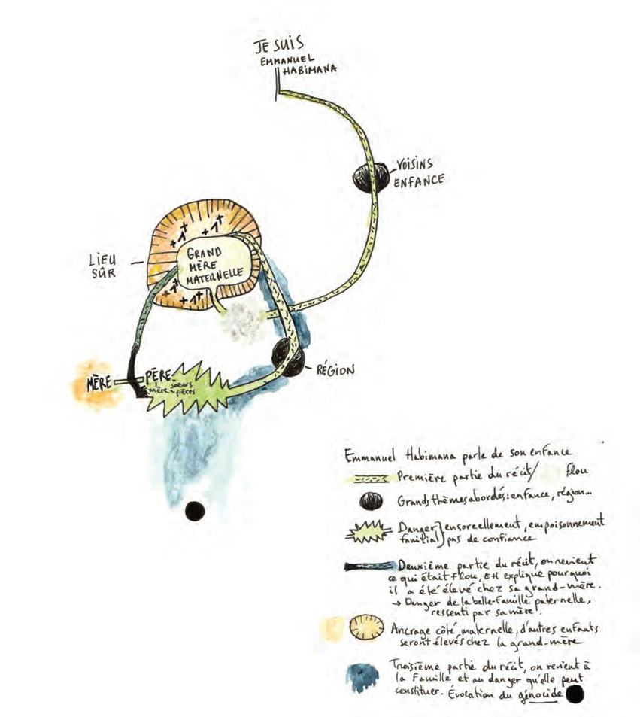
Figure 6. This sensibility map has been inspired by the beginning of the story of Emmanuel Habimana, when he talks about his childhood. The map described the different persons close to him (e.g. Mother, father and grand-mother) as well as the places associated to these persons. The excerpt of the story mapped is accessible online here, from 0:00:00 to 0:10:11: https://rs-atlascine.concordia.ca/rwanda/index.html?module=module.stories

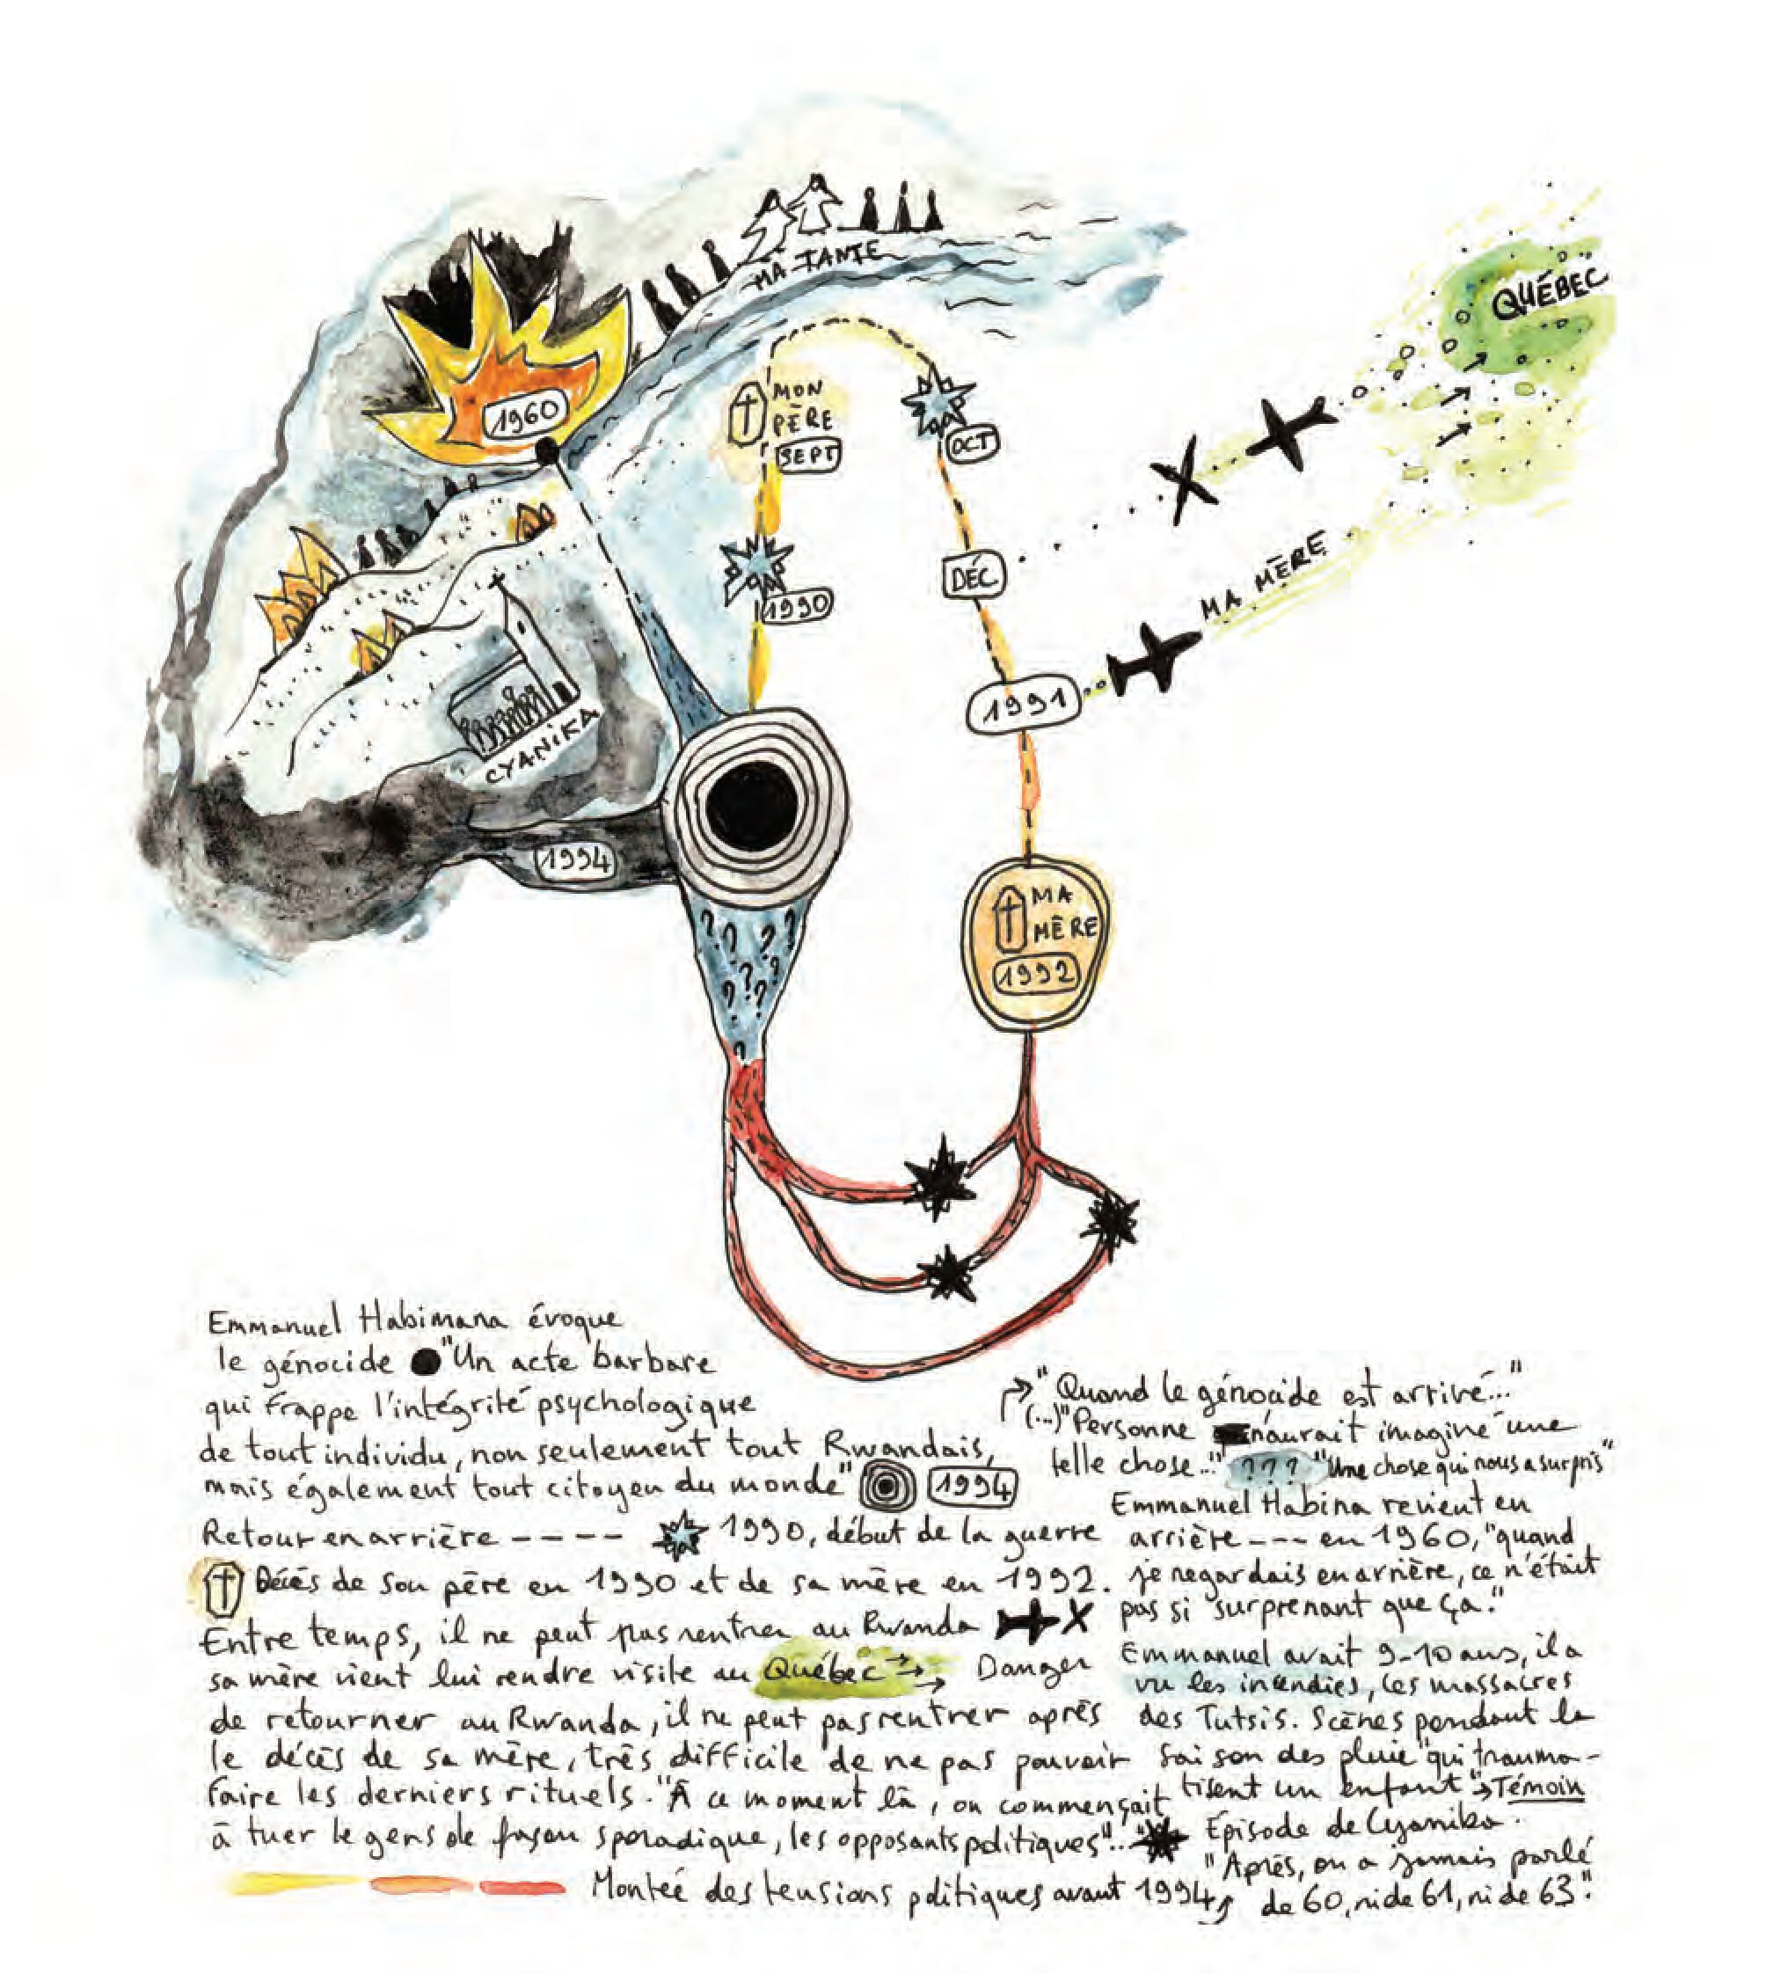
Figure 7. On this sensibility map of Emmanuel Habimana, the evocation of the genocide (in the center of the map) is circular and combined with the story of his relationship with Rwanda. Two episodes are intertwined: the memory of Tutsis’ massacre in the Rukarara river and the beginning of the 1990’s when he was forced to stay in Trois-Rivière due to the political tensions in Rwanda. The excerpt of the story mapped is accessible online here, from 1:30:44 to 1:47:01: https://rs-atlascine.concordia.ca/rwanda/index.html?module=module.stories

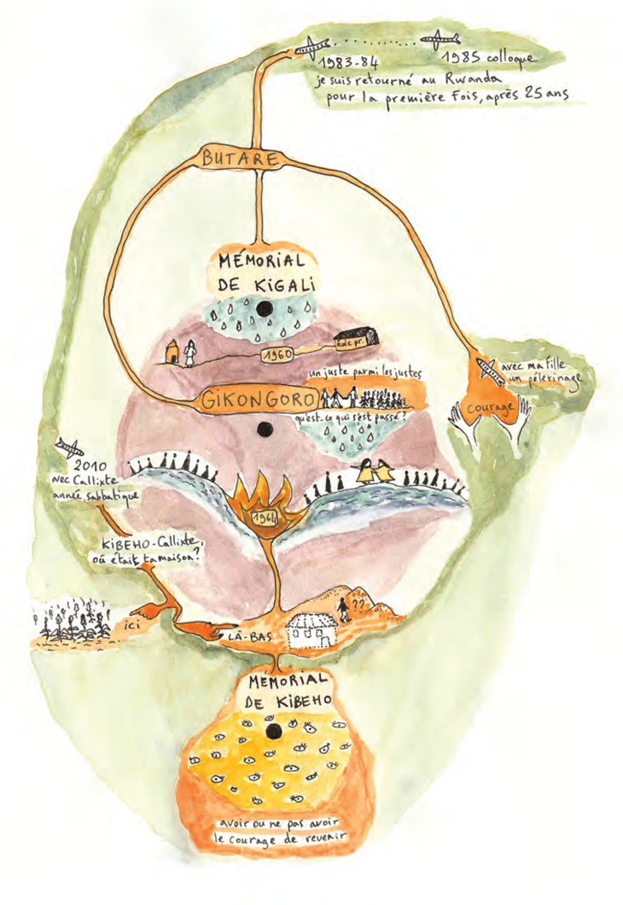 | 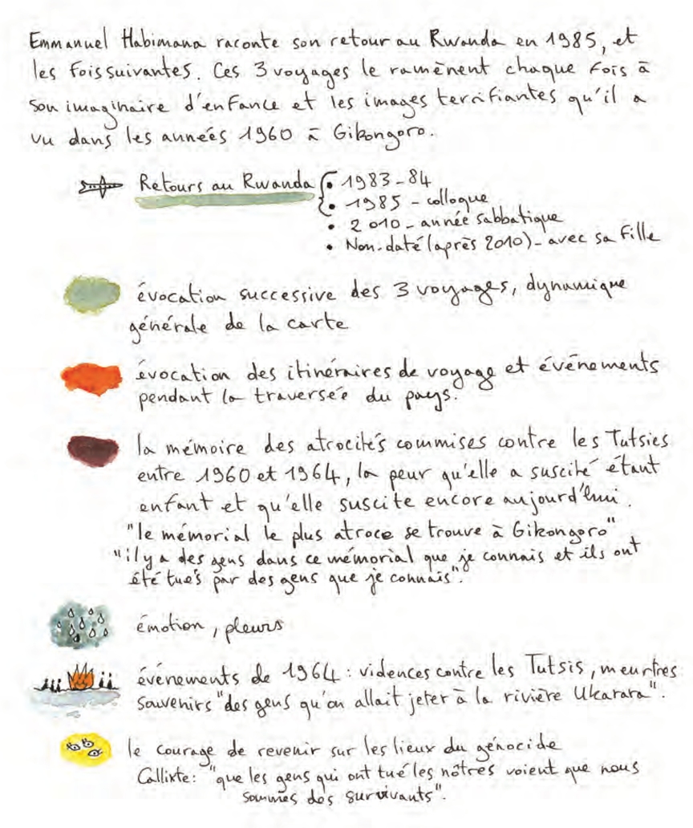
Figure 8. This sensibility map describes Emmanuel Habimana’s return to Rwanda and his apprehension to come back to his native region because of his fear to discover what happened during the genocide. It took him three different trips to be able to finally go back to Gikongoro. The excerpt of the story mapped is accessible online here, from 2:06:16 to 2:14:46: https://rs-atlascine.concordia.ca/rwanda/index.html?module=module.stories

4. Performing Stories with Geolocated and Dislocated Maps
Performativity can be defined as a focus on the ways things are produced and the effects of these production processes (Austin 1970; Butler 2006). The production processes of objects, places, environments and practices have subsequent impacts on other objects, places, environments and practices, and therefore on our actions and by extension on lived experiences. For example, life stories perform memories of events and these performances might have an impact on the storytellers, on people mentioned in these stories and on their relationships with these people. Mapping these stories is also a way of performing the stories, the people and the events. In cartography, the idea of the performativity of the map, our interaction with it, and its implication on the world, emerged from critical cartography. It involved shifting from the “study of maps as objects to a more comprehensive (and potentially interdisciplinary) study of mapping as practice, the knowledge it deploys, and the political field of its operations” (Crampton 2009, 840). Performative mapping focuses on the mapping process and its consequences, both on the realities and the material mapped. In our case, this material is made of stories.
Both cartographic approaches presented in this paper perform stories differently, mainly because they operate on two different levels. Atlascine map operates at the interface between the story and the Euclidean world. It builds bridges between these two “worlds”. These bridges hold on the assumption that stories can be approached as geographic databases and mapped systematically. Like geolocated maps in general, Atlascine maps tends to smooth out the roughness of stories (and data in general). It does so by putting all the moments of a story with different levels of intensity and importance at the same visual level: the level of the cartographic symbol. It flattens the stories and makes them look clear and well organized spatially. Although this levelling process can be criticized for undermining the complexity of stories, it can also be seen as an opportunity to make the story more accessible as a whole. Emmanuelle Kayiganwa noticed that the Atlascine map and its abstract cartographic symbols might help communicate traumatic experiences to a general audience by making these experiences more abstract and less tangible (Caquard et al. 2019). Atlascine performs stories as primarily spatial databases that can be mobilized and searched at will to access the story. This application - and geolocated maps in general - performs stories and data by normalizing them and smoothing them out (see Figure 9). They scan their surface made of letters, words and sentences, and turn it into something that can be retrieved, tagged, counted, measured, located, compared and mapped at will. Atlascine maps, as an illustration of geolocated maps, focus on the surface level of the stories, on their skins.
Sensibility mapping builds a bridge but on a different level: it bridges the story with memory. It relies not only on the words told but also on the ones that were not, the gaps, the missing parts, and the interstices within these stories. It helps to reveal what are considered important aspects of the stories that have been buried, intentionally or not, by the geolocated map or by the storytellers themselves. It is a process of revealing the roughness of stories and identifying the gems within them. This requires digging them out and making them stand out. Sensibility mapping performs the story as a visual expression of a human experience with emotions, contradictions, silences and traumas. It brings to the fore rougher aspects of stories that the storyteller may not even emphasize (see Figure 10). Consequently, it is highly selective in terms of what it reveals and what remains hidden. This selective process is guided by the commitment to reveal the inner parts of a story that might be essential but may remain untold or difficult to see with Euclidian mapping approaches, its guts.
The geolocated maps in this project helped to understand the overall surficial geography of the stories relying on a common frame of reference which allowed comparisons to be made between stories. These geolocated maps perform the stories as collective geospatial databases of testimonies that are made broadly available online. They can treat a large corpus of stories in an egalitarian manner. While they mainly map the surface of these stories, they can help identify some apertures in the story skin. Sensibility maps are more personal and intimate and operate at the story’s subcutaneous level. They tap into the embodied aspects of an experience to speak about sensations, feelings and relationships. They perform the stories as selected entry points to these dimensions. They can be considered a form of deep mapping of particular moments in a story. Since they are unconventional in their form, they also require a commitment from the map user to engage with them and to make sense of them. They perform the stories as ways to access individual and collective intimacies. The sensibility maps based on Emmanuelle Kayiganwa's story were compiled into a paper atlas (see Figure 11), and only one copy of this atlas was printed and given to her. This unique object was received with much appreciation and was described by Emmanuelle Kayiganwa as a legacy to her children who were very young during the 1994 genocide (2020, personal communication). Sensibility maps are one way to perform stories as intimate and collective legacies. They are also a way to develop strong and intimate relationships between the storyteller and the mapmaker.
Figure 9. The smoothing process of Atlascine. The important memory of the morning of April 7, 1994 in Emmanuelle Kayiganwa’s story is represented with another concentric circle around Bukavu. The map is accessible online here: https://rs-atlascine.concordia.ca/rwanda/index.html?module=module.stories
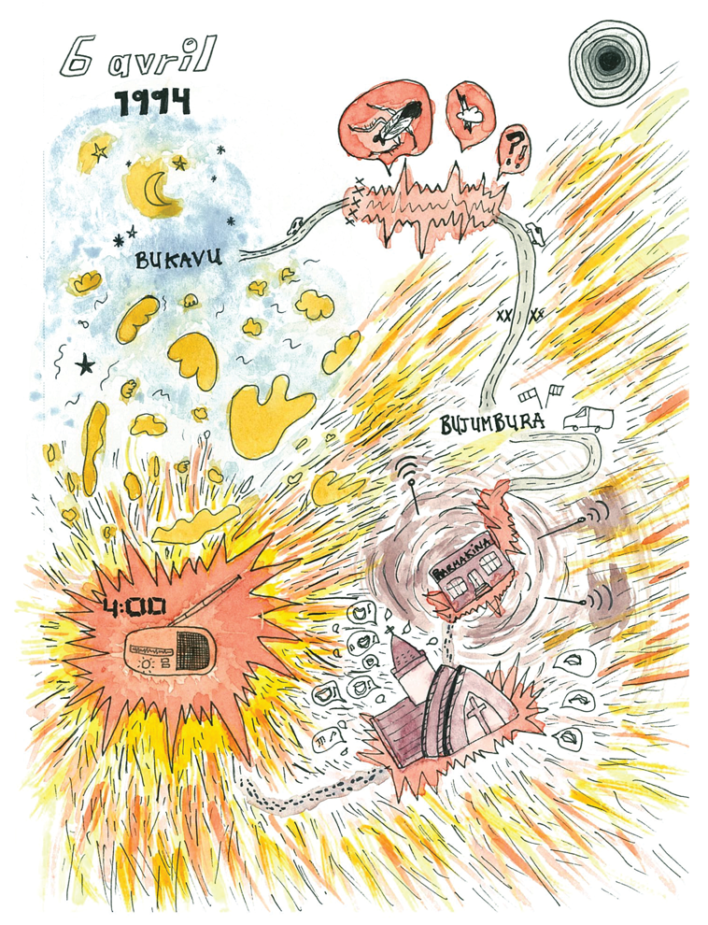 | 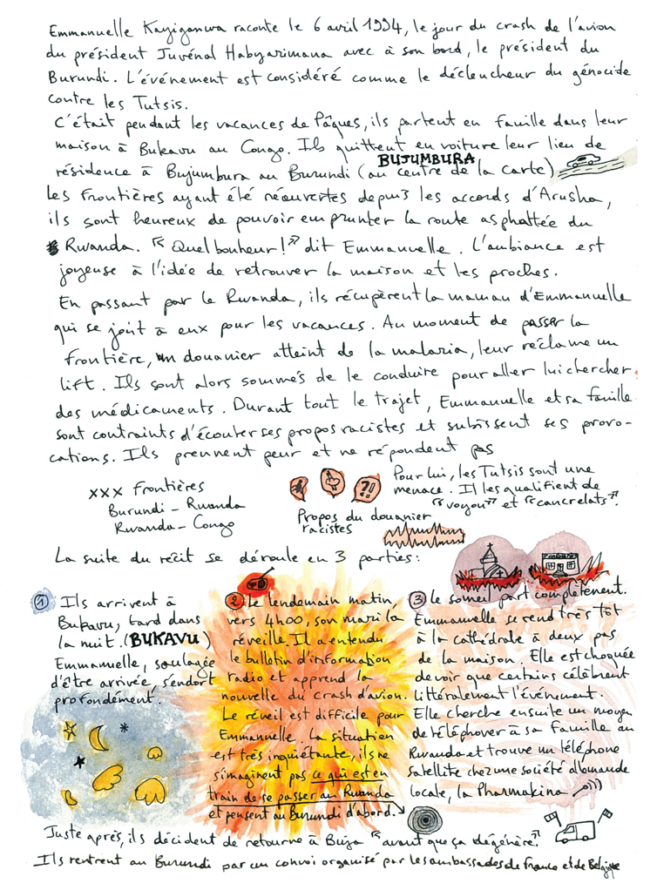
Figure 10. Final map of the morning of April 7, 1994 in Emmanuelle Kayiganwa’s story. This map only focuses on the story through an emotional perspective. The document highlights the intense feeling experienced at the moment of the radio news received early on the morning and describes the following actions of Emmanuelle during this day (going to the church, finding a phone to get news from her family, gathering with friends...).
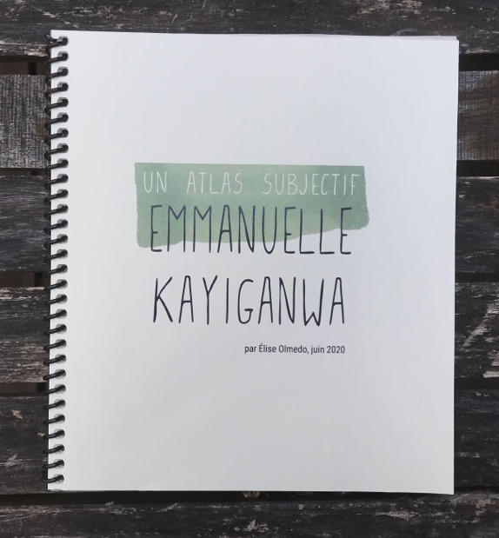 | 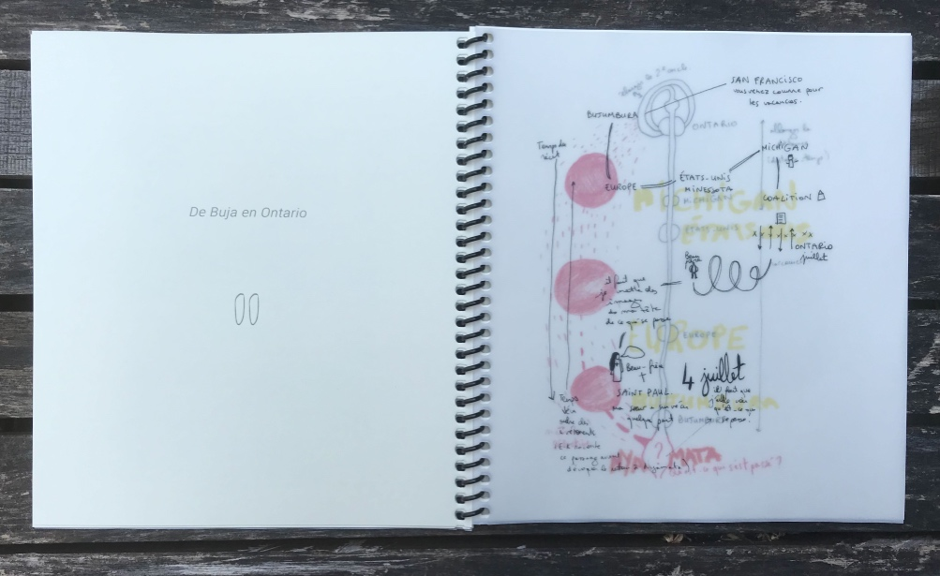
Figure 11. Pictures of the auto-edited subjective atlas provided to the storyteller. On the left, atlas cover. On the right, the superposition of different preparatory sketches for the third map of the atlas, printed on a transparent paper.

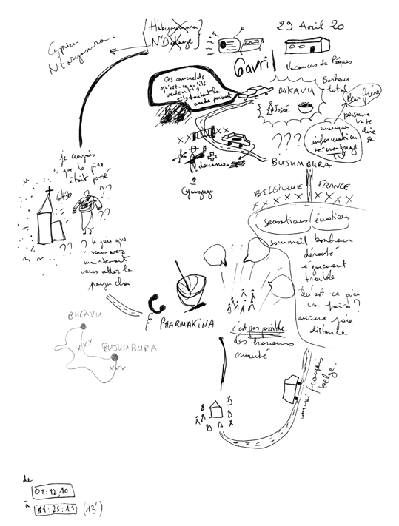 | 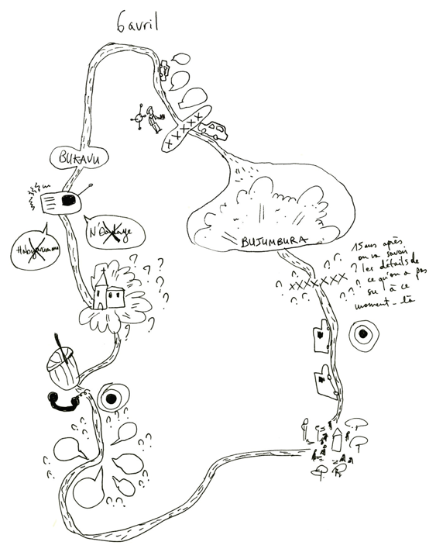 | 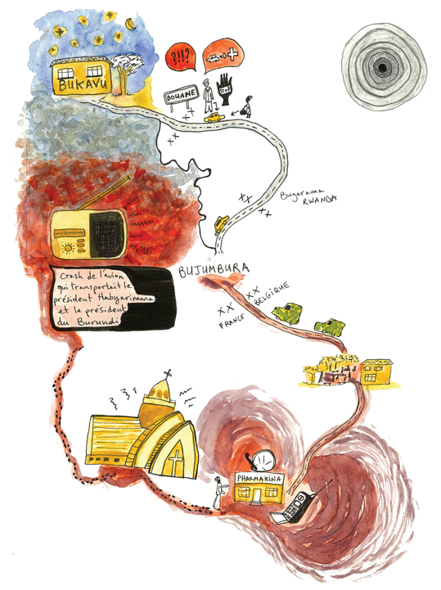
Figure 12. The deepening process of sensibility mapping. The important memory of the morning of April 7, 1994 in Emmanuelle Kayiganwa’s story has been the object of several hand-drawn maps. The details of the description and the underlying emotions held in the narrative are tracked in a process to reach the guts of the story. The excerpt of the story mapped is accessible online here, from 1:29:49 to 1:53:12: https://rs-atlascine.concordia.ca/rwanda/index.html?module=module.stories

Conclusion
The dialogue engaged throughout this project between geolocated and dislocated cartographies enabled us to identify some commonalities and differences between these two approaches. Both share a deep respect for a highly sensitive mapped material, for the stories of the genocide, for the storytellers who suffered from it. This respect translates into the practice of sharing the map with the storytellers throughout the entire process and making this process as transparent as possible. This transparency is essential to acknowledge the positionality and the subjectivity of both the storytellers and the mapmakers. In sensibility mapping, the mapping process is revealed through the presentation of the multiple sketches that have led to the production of each sensibility map and are included in the final version of the printed atlas (see Figure 12). In Atlascine, the mapping process is revealed by making the tagging process as transparent as possible, by always showing the map and the story side by side and by preserving the integrity of each story. Besides these commonalities in approaching stories, both methods produce maps that are very different not only in terms of how they look but also in terms of what they bring forth and how they do it.
Atlascine projects the stories onto the Euclidean space to help revealing their spatial structures, while sensibility mapping looks at their inner parts to expose their own sense of place to our sight. Atlascine maps are technologically dependant, while sensibility maps are technologically free. Atlascine maps are multiple and duplicable, while sensibility maps are unique pieces of map-art. Atlascine maps tend to simplify these stories, while sensibility mapping tends to complexify them. Atlascine maps focus on the explicit and the mentioned, while sensibility maps rely also on what cannot be clearly expressed with words. Atlascine maps perform stories in a standardized way with universal ambitions (i.e. making them accessible to a large audience), while sensibility mapping performs them as personal and intimate memories and legacies. Atlascine maps scan the entire surface of the stories, while sensibility maps explore them in-depth by selecting fragments. Atlascine maps focus on the skins of stories, while sensibility maps focus on their guts. This body metaphor is a recurring motif in cartography (Rossetto 2019); throughout this dialogue, we expanded it to the cartographic material, the data, the stories.
Overall, these differences clearly demonstrate the complementarity of both approaches to map stories. In the next phase of this project, we plan to explore different ways of combining both series of maps. Atlascine maps and sensibility maps could be associated or hybridized in different ways such as through printed atlases, exhibitions, cartographic animations, art performances, hypermedia creations and collective and interactive installations. Whatever the form they take, these integrations might be envisioned as ways of expanding and exposing the geographies of these stories, embracing the fact that aspects of these geographies might remain blurry given their complexity. The maps that we produced aim to reflect and expose this complexity. These maps do not pretend to be self-explanatory and are certainly not self-generated. They require constant navigation between the maps and the stories, listening to these stories repeatedly, exchanging with storytellers, and always remaining open for new encounters somewhere during this back and forth.

Acknowledgment
We are especially grateful to Emmanuelle Kayiganwa and Emmanuel Habimana for sharing their stories, as well as to the association Page Rwanda for being supportive of this mapping project. Thank you to Léa Denieul for text editing, as well as to Emory Shaw, Sepideh Shahamati, and Jessica Babikian for contributing to the Atlas of Rwandan Life Stories. Atlascine was developed in collaboration with the Geomatics and Cartographic Research Center (GCRC) at Carleton University. This project was supported by CANARIE Canada [RS303] and the Social Sciences and Humanities Research Council of Canada (SSHRC) [435-2016-1178 and a Banting Postdoctoral Fellowship].

Bibliography
Austin, John Langshaw. 1970. Quand dire c'est faire. Paris: Éditions du Seuil.
Besse, Jean-Marc, Tiberghien, Gilles A. 2017. Opérations cartographiques. Paris, École nationale supérieure de paysage, Actes Sud.
Bondi, Liz, Davidson, Joyce, and Smith, Mike. 2005. Emotional geographies. Burlington, V.T: Ashgate publishing.
Butler, Judith. 2006. Gender trouble. London: Routledge.
Caquard, Sebastien, and Jean-Pierre Fiset. 2014. “How Can We Map Stories? A Cybercartographic Application for Narrative Cartography.” Journal of Maps 10 (1): 18–25. https://doi.org/10.1080/17445647.2013.847387.
Caquard, Sébastien, Shaw, Emory, Alavez, José, and Dimitrovas, Stefanie. 2019. “Mapping Memories of Exiles: Combining Conventional and Alternative Cartographic Approaches.” In Memoryscape Handbook, ed., Sarah De Nardi, Hilary Orange, Eerika Koskinen-Koivisto, Danielle Drozdzewski and Steven High, , 52-66. Routledge.
Caquard, Sébastien and Dimitrovas, Stefanie. 2017. “Story Maps & Co. The state of the art of online narrative cartography.”, M@ppemonde 121, 1-31. https://doi.org/10.4000/mappemonde.3386
Casti, Emanuela, Taylor, D.R, Fraser. 2015. Reflexive cartography. A new perspective in mapping. Elsevier.
Crampton, Jeremy W. 2009. “Cartography: Performative, Participatory, Political.” Progress in Human Geography 33 (6): 840–48. https://doi.org/10.1177/0309132508105000.
Della Dora, Veronica. 2020. The Mantle of the Earth: Genelogies of a Geographical Metaphor, University of Chicago Press.
DeGraff, Andrew, and Daniel Harmon. 2015. Plotted: A Literary Atlas. San Francisco, CA: Pulp/Zest Books.
Duxbury, Nancy, Garrett-Petts, W.F., Longley, Alys. 2019. Artistic Approaches to Cultural Mapping. Activating Imaginaries and Means of Knowing. London: Routledge.
Elsherif, Nermin. 2018. “Visualizing the Counter-Narratives of Port Said: An Experiment of Mapping Social History.” In This is Not an Atlas: A Global Collection of Counter-Cartographies, ed. kollektiv orangotango+, 252-57. Transcript Verlag.
Gaujal, Sophie. 2019. “La cartographie sensible et participative comme levier d’apprentissage de la géographie.” VertigO - la revue électronique en sciences de l'environnement 19 (1). https://doi.org/10.4000/vertigo.24604
Harmon, Katharine. 2009. The Map as Art: Contemporary Artists Explore Cartography. Princeton Architectural Press.
Hawkins, Harriet.. 2013. For Creative Geographies: Geographies, Visual Arts and the Making of Worlds. London: Routledge.
Hawkins, Harriet. 2019. “Geography’s Creative (Re)Turn: Toward a Critical Framework.” Progress in Human Geography 43 (6): 963–84. https://doi.org/10.1177/0309132518804341. Hessler, John. 2017. “The Codex Quetzalecatzin Comes to the Library of Congress | Worlds Revealed: Geography & Maps at The Library Of Congress.” Webpage. November 21, 2017. Available at //blogs.loc.gov/maps/2017/11/the-codex-quetzelecatzin/.
High, Steven. 2014. Oral History at the Crossroads: Sharing Life Stories of Survival and Displacement. Vancouver: UBC Press.
Krygier, John. 2006. “Jake Barton’s Performance Maps: An Essay.” Cartographic Perspectives 53: 41–50.
Kollektiv Orangotango+. 2018, This is not an Atlas. Transcript Verlag.
Knowles, Anne Kelly, Levi Westerveld, and Laura Strom. 2015. “Inductive Visualization: A Humanistic Alternative to GIS.” GeoHumanities 1 (2): 233–65. https://doi.org/10.1080/2373566X.2015.1108831.Littman, Ariane. 2011. “Wounded Land.” Available at http://www.ariane-littman.com/docs/wounded_land/01_wounded_land_2009-2010.html.
Lucchesi, Annita Hetoevėhotohke’e. 2018. “‘Indians Don’t Make Maps’: Indigenous Cartographic Traditions and Innovations.” American Indian Culture and Research Journal 42 (3): 11–26. https://doi.org/10.17953/aicrj.42.3.lucchesi.
Lo Presti, Laura. 2018. “Maps in/out of place. Charting alternative ways of looking and experimenting with cartography and GIS.” Journal of Research and Didactics in Geography 1(7): 105–119. https://doi.org/10.4458/0623-07
Maharawal, Manissa M., and Erin McElroy. 2018. “The Anti-Eviction Mapping Project: Counter
Mapping and Oral History toward Bay Area Housing Justice.” Annals of the American Association of Geographers 108 (2): 380–89. https://doi.org/10.1080/24694452.2017.1365583.
Mansilla, Pablo and Melin, Pehuen. 2020. “Mapuche Cartography: Defending Ixofillmogen.” In Radical Cartographies: Participatory Mapmaking from Latin America, ed. Sletto B., J. Bryan, A. Wagner and C. Hale, 81-96. Austin: University of Texas Press, 2020.
Olmedo, Élise. 2015. “Cartographie sensible. Tracer une géographie du vécu par la recherche-création.” Thèse de doctorat, Université Paris 1 Panthéon Sorbonne.
Pearce, Margaret Wickens, and Renee Pualani Louis. 2008. “Mapping Indigenous Depth of Place.” American Indian Culture & Research Journal 32 (3): 107–26.
https://doi.org/10.3138/carto.47.2.77 Pearce, Margaret Wickens. 2014. “The Last Piece Is You.” The Cartographic Journal 51 (2): 107–22. https://doi.org/10.1179/1743277414Y.0000000078.
Pile, Steve. 2010. “Emotions and Affect in Recent Human Geography.” Transactions of the Institute of British Geographers, New Series, 35, no. 1 (): 5-20. https://doi.org/10.1111/j.1475-5661.2009.00368.xPinder, David. 2013. Visions of the City: Utopianism, Power and Politics in Twentieth Century Urbanism. London: Routledge.
Reddleman, Claire. 2018. Cartographic Abstraction in Contemporary Art Seeing with Maps. London: Routledge.
Rossetto, Tania. 2019. “The skin of the map: Viewing cartography through tactile empathy.”, Environment and Planning D: Society and Space 37 (1): 83-103. https://doi.org/10.1177/0263775818786251Solnit, Rebecca. 2010. Infinite City: A San Francisco Atlas. Berkeley: University of California Press..
Sparke, M. 1998. “A Map That Roared and an Original Atlas: Canada, Cartography, and the Narration of Nation.” Annals of the Association of American Geographers 83 (8): 463–95. https://doi.org/10.1111/0004-5608.00109
Vaughan, Kathleen. 2020. You are here. Vous êtes ici. Montreal: Mc Clure Gallery.
Volvey, Anne. 2012. “Transitionnelles géographies : sur le terrain de la créativité artistique et scientifique.” Mémoire d’Habilitation à diriger des recherches, Université Lumière Lyon 2.
Knowles, Anne & Westerveld, Levi & Strom, Laura. 2015. “Inductive Visualization: A Humanistic Alternative to GIS.” GeoHumanities. 1. 1-33. https://doi.org/10.1080/2373566X.2015.1108831
Westerveld, Levi, and Anne Kelly Knowles. 2018. “I Was There.” Available at https://visionscarto.net/i-was-there.
Westerveld, L., and A. K. Knowles. 2020. “Loosening the Grid: Topology as the Basis for a More Inclusive GIS.” International Journal of Geographical Information Science 0 (0): 1–20. https://doi.org/10.1080/13658816.2020.1856854.
Wood, Denis. 2010. Rethinking the Power of Maps. New York: The Guilford Press.

