An Analysis of Direct Reciprocal Borrowing Among Québec University Libraries

Joanna C. Duy
Concordia University Libraries

Vincent Larivière
Université de Montréal

Address correspondence to : Joanna Duy, Head, Access Services, Vanier Library 7141 Sherbrooke St. West, Montreal, QC, Canada H4B 1R6
E-mail: Joanna.duy@concordia.ca

Abstract

An analysis of Québec academic libraries’ direct reciprocal borrowing statistics from 2005 to 2010 reveals that the physical distance separating universities plays an important role in determining the amount of direct reciprocal borrowing activity conducted between institutions. Significant statistical correlations were also seen between the amount of direct reciprocal borrowing/lending as well as institution size and library collection size. Given their proximity, Montréal-area libraries have a higher ratio of direct reciprocal borrowing activity compared to interlibrary loan consortial borrowing activity, whereas libraries located outside of Montréal have higher interlibrary loan activity compared to direct reciprocal borrowing. It was found that institutions’ net lender and borrower status can shift depending on whether one is looking at direct reciprocal borrowing versus interlibrary loan activity. An exploratory social network analysis of direct reciprocal borrowing amongst Québec academic libraries was performed, and it affirmed the important role of physical distance in determining direct reciprocal borrowing activity. Language may also play a role in affecting the amount of direct reciprocal borrowing.

Keywords: direct reciprocal borrowing; resource sharing; library cooperation; library consortia; academic libraries; statistics; distance; correlation; collection size; interlibrary loan; institution size

Introduction
While there is much focus in today’s academic libraries on our ever-expanding digital collections, management of library print collections on campus will continue to be a key issue, especially as libraries are asked to justify space allocations for print collections given declining circulation statistics. Libraries have also historically tried to find ways to lower the costs of resource sharing. Thus, cost-effective resource sharing initiatives and consortial storage facilities will likely become ever more important to librarians and their administrators.
Resource sharing initiatives can be viewed on a cost-based spectrum, with Interlibrary Loan (ILL), shared consortial catalogs, and direct reciprocal borrowing occupying different places on the spectrum. In traditional ILL services, the borrowing and lending libraries, usually via their ILL departments, mediate the exchange of materials on behalf of the user. Jackson (2004) showed that these mediated ILL services are expensive, and cost the institutions that participated in the study an average $17.50 USD per borrowing transaction. An increase in automation levels among ILL operations since 2004, however, is likely to have reduced this cost, and a more recent (though smaller scale) study of ILL borrowing costs suggests that the average cost for a borrowing transaction for the US libraries participating in that study is now closer to $10 USD (Leon & Kress, 2012). The consortial shared catalog model, in which libraries at different institutions share a catalog (often managed by a consortium) and users order materials directly through that catalog as opposed to an ILL system, was referred to in recent study as a “circ-to-circ” operation (Leon & Kress, 2012); these requests are unmediated, processed through a circulation-based system as opposed to an ILL system, and often filled by staff in a circulation department. The recent study by Leon and Kress (2012) found the average net cost of this kind of borrowing transaction for institutions participating in the study to be $3.85.
Yet another type of resource sharing is direct reciprocal borrowing (DRB) and lending (DRL), in which users obtain a special borrowing card (alternatively, the home library card may be used) that allows them to go to another library, take the materials they need from the shelves, and check them out. This type of resource sharing is barely mediated at all by library staff and, although we know of no studies that have assessed the costs of DRB (sometimes called direct consortial borrowing), it is likely the least costly of all inter-library services. The Conférence des recteurs et des principaux des universités du Québec (CREPUQ) is a consortium of 18 academic institutions in the province of Québec, Canada. Seven of these institutions are located in the city of Montréal, which, according to Statistics Canada (2011a) is Canada’s second largest city with a population of approximately 1.6 million, and over 3.8 million when surrounding municipalities are included (Statistics Canada, 2011b). CREPUQ participates in a Canada-wide agreement, the Canadian University Reciprocal Borrowing Agreement (CURBA), which began in 2002, and which allows primary users from any university library in Canada to borrow materials in person from any other academic library in Canada (Canadian University Reciprocal Borrowing Agreement, 2012). The CURBA agreement pertains to members of all four of Canada’s university library consortia: the Council for Atlantic University Libraries (CAUL), the Ontario Council of University Libraries (OCUL), the Council of Prairie and Pacific University Libraries (COPPUL) and CREPUQ. Privileges accorded to undergraduates were included in the initial CURBA agreement for most participating consortia; however, members of the CREPUQ consortium did not allow routine DRB by undergraduates until 2008. CREPUQ still does not allow undergraduate users from libraries outside of CREPUQ to borrow from their member libraries.
Borrowing privileges can vary by institution but for graduate students and faculty they are normally equivalent to privileges accorded to undergraduate, extramural, community or students at the lending institution. Borrowing privileges for undergraduates can also vary by institution; in the CREPUQ consortium, undergraduates are allowed to borrow three items for fourteen days, with no renewal (CREPUQ, 2010). Borrowed materials may be returned to the institution where the item was borrowed or the user’s home institution. In addition to offering DRB, all CREPUQ libraries offer ILL borrowing services to their students and faculty (and in some cases, staff members); most offer free borrowing of returnable items.
The CREPUQ is the only academic library consortium of the four participating in the CURBA agreement that keeps detailed statistics on the amount of DRB/L that takes place between institutions. In addition, the Canadian Association of Research Libraries (CARL) does not collect separate DRB statistics as part of their annual statistics collection. The CREPUQ data thus provides a unique opportunity to better understand DRB/L activity within a consortium. This paper aims to provide the first analysis of DRB/L across Québec universities in order to determine a) what is the amount of DRB/L occurring in CREPUQ, and how does it relate to the amount of ILL activity among CREPUQ libraries; b) is there a relationship between physical distance between institutions and the amount of DRB/L between those institutions; c) is there a relationship between a library’s collection size and institution size and the amount of DRB/L and; d) what can social network analysis tell us about DRB/L patterns among CREPUQ libraries?

Literature Review
The phenomenon of DRB/L started in the 1960’s and 70’s and gained momentum in the 1980’s and 1990’s as library budgets failed to keep pace with collection needs. Numerous consortia in the United States reported the formation of new agreements that allowed users from one library to borrow materials in person from another library. The benefits of DRB were summarized by Cram (1995):
The simplest, most effective form of resource sharing is reciprocal borrowing. Wherever we have the figures, reciprocal borrowings constitute a much larger proportion of use than interlibrary loans. There are no forms to be completed, no postage and handling charges to be budgeted for or recovered, and only a fraction of the staff time required by interlibrary loans… the costs connected with it are tiny relative to any consideration of interlibrary loan volume and cost. (p. 72)

Despite the advantages of DRB/L, Davis (2005) noted that “we know little about reciprocal borrowing activity within and between states” (p. 26). He notes that “the concept of reciprocal borrowing is still commingled with interlibrary loan services” (p. 26). Indeed, ILL practitioners often define reciprocal borrowing as being agreements between two ILL operations to provide materials for free or at lower cost and/or higher priority (Heiney & Lilla, 1998; Jackson, 1994; Williams, 2008). Davis, however, defined reciprocal borrowing as “an arrangement between libraries that allows registered library patrons to borrow materials from libraries other than their home library” (p. 2). A 2004 American Library Association (ALA) Office for Research and Statistics survey revealed that 50% of respondents reported statewide direct reciprocal borrowing agreements between all library types, and 33% had multistate reciprocal borrowing programs (Davis, 2005).
Little quantitative research has been done on DRB/L. Ellison (1993) reported DRB/L statistics for Wayne State University, a member of the Southeastern Michigan League of Libraries (SEMLOL) between 1991 and 1992, and argued that net lenders need to be compensated for their contributions to DRB/L initiatives. However, the quantitative analysis was limited to two years’ worth of data specific to Wayne State and did not look at DRB/L patterns with other institutions.
Although it makes intuitive sense that the amount of DRB/L in academic libraries would be related to the physical distance between libraries, we have not identified any recent studies examining this relationship, although it is assumed to exist (Ballard, 1990). The effect of distance on use of public libraries has been well documented, however (see the 1981 review by Palmer) and a recent study by Park (2011) found that distance from patron’s homes to the public library was a determining factor for library use. A survey of public library users in the North Suburban Library System, Illinois, by Kies (1993) found that the geographic location of libraries was the second most common reason why users visited a library different from their own (the most common reason was perceived better collections).
Social network analysis is a type of analysis that, despite its name, does not refer to online social network sites such as Facebook and LinkedIn. Rather, it is “an approach and set of techniques applied to the study of the relational aspects of networks... Once network data are gathered, a visual representation of the network configuration provides the means to analyze the structural properties...” (Schultz-Jones, 2009; p. 595). It is used in the social sciences, as well as other disciplines, as a means to visualize and understand relationships between individuals, groups or organizations in a system. Although little-used by library researchers, a recent review of social network analysis in information science noted that “the opportunities for social network analysis research in library specific contexts remain outstanding” (Schultz-Jones, 2009; p. 621). In this study, we will explore the use of social network analysis as a tool to better understand DRB/L patterns within the CREPUQ consortium.

Methods
A list of the 18 institutions comprising CREPUQ, along with institutional abbreviations and physical addresses taken from their websites, is given in Table 1. Direct reciprocal borrowing data were obtained from CREPUQ’s Statistiques générales des bibliothèques universitaires québecoises (CREPUQ, 2012), using Table 24 for the years 2005-06, 2006-07, 2007-08, 2008-09, and Table 25 for 2009-10. The average amount of borrowing, lending or a total of the two (depending on the analysis), for the five year period, was used, unless the figures were being compared with ILL activity, in which case a three year average (2007-10) was used. Some institutions were missing data (specifically Sherbrooke, for 2005-06; ENAP for 2005-06 and 2006-07; INRS for 2006-07; UQAT for 2008-09 and 2009-10, UQO for 2008-09, UQTR for 2008-09 and 2009-10, UQAM for 2009-10) and averages were therefore calculated over a smaller number of years. In cases where data were being analyzed by institutional pairings, if one institution was missing data, no data was entered for that pair for that year.
In the CREPUQ’s DRB statistics, transactions between the Université de Montréal, HEC and École Polytechnique were considered as inter-campus borrowing, since the three institutions are physically very close and are administratively linked. However, the three have separate library catalogs, and direct borrowing and lending activity occurring between each of these three institutions and all other CREPUQ institutions was reported separately for each in the statistics. For the purposes of this study, therefore, we considered transactions between the three institutions as direct reciprocal borrowing transactions. (Note, however, that users from any of the three institutions who wish to borrow materials from other institutions in the triad need only to use their regular student/faculty/staff ID card, as opposed to a CREPUQ card, which is required for direct reciprocal borrowing between all other CREPUQ institutions).
The number of Full-Time Equivalent (FTE) students was taken from the CREPUQ statistics document (2012; Table 4) as were library collection sizes (Table 14 for all years except for 2009-10 which was taken from Table 15). The library collection size is a count of physical materials and includes monographs, periodicals as well as media materials. The total amount of circulation (initial loans of all material types, including reserves and audio-visual materials, and renewals) was taken from the same document (Table 20 for all years except for 2009-10 which was taken from Table 21).
Interlibrary Loan statistics were obtained from CREPUQ COLOMBO Statistiques annuelles document for the years 2007-10. Specifically, the “Emprunts - Partenaires CREPUQ – Documents reçus - Prêts” tables were used, which indicate the number of loaned returnables as opposed to the number of requests received. Averages were used for the three years. The data in the reports were generated from the ILL software used by CREPUQ: OCLC’s Virtual Document Exchange (VDX); the name of the public ILL system interface is COLOMBO. Since most CREPUQ institutions only started using VDX as their ILL management software in 2006 or 2007, earlier statistics were not available.
A physical address for each of the 18 CREPUQ institutions was obtained by looking at the institution’s home page or their Contact Us (or equivalent) web page. Google Maps was then used to determine the distance between institutions using the shortest driving option which measures the road distance in kilometers. Several CREPUQ institutions have more than one campus (for example, Concordia University, McGill University, Université de Montréal, UQO, UQAT, TELUQ and INRS), and the institutional address for the largest campus was used where there was an obvious difference between “main” and “satellite” campuses. However, there were two institutions where there is either no physical campus to speak of (TELUQ, a primarily online institution), or the various campuses are fairly equal in size (the INRS, with institutes in Québec City, Montréal, Varennes and Laval), and it was not possible to assign a single physical address. These institutions were therefore not included in the part of the study where physical distances were used.
SPSS and Excel were used for statistical calculations and to create charts. The Pearson Correlation Coefficient was used for correlation analysis. UCInet and NetDraw were used to create the network diagram as part of the social network analysis. The centrality of each institution in the network of DRB/L was assessed using the betweeness centrality (Freeman, 1979) which takes into account the relative importance of each node (i.e., each university in the complete network) rather than only counting its number of links with other nodes.

Results and Discussion
General Observations
The average amount of DRB done per institution by all 18 CREPUQ institutions from 2005-10 was 6049 items, and the average amount of ILL done between CREPUQ institutions from 2007-2010 was 1754 items. It is perhaps worth noting here that the total number of items lent and borrowed for all institutions will always equal each other. For example, if Institution A lends 100 items to Institution B, and Institution B lends 200 items to Institution A, the total amount of lending between the two is 300 and the total amount of borrowing is also 300. The ILL transactions reported on in this study only include transactions for returnable materials among CREPUQ institutions – ILL activity with other libraries in Canada or internationally, or ILL borrowing of non-returnable materials, are not included in this study.
Figure 1 indicates the total circulation, DRB and ILL activity for CREPUQ libraries. Total circulation of physical materials in CREPUQ libraries declined by an average of 20% from 2005-2010. DRB declined more sharply, with a 27% decrease over the same five year period. Most institutions experienced a peak in DRB activity in 2006-07, and activity decreased sharply after that time, despite the fact that CREPUQ introduced a new policy allowing undergraduates to participate in DRB starting June 1, 2008 (CREPUQ, 2010); prior to that, undergraduates had to obtain special permission to borrow directly from other CREPUQ libraries. One factor that may have contributed to the decrease in DRB/L after 2006-07 may be the introduction of the automated Interlibrary Loan VDX system, which was introduced to many CREPUQ libraries in 2006-2007, and which allows patrons to search other library catalogs and easily order the materials they need. ILL activity among CREPUQ libraries, while not as high in quantity as the other two services, rose by 8% from 2007 to 2010, and again this may be due to the implementation of the VDX software. It should be noted that seven institutions were missing at least one year’s worth of DRB data for this analysis (Université de Sherbrooke, ENAP, INRS, UQAT, UQO, UQTR, UQAM) and thus the total activity levels are under-reported; with the exception of Université de Sherbrooke and UQAM, however, most of these institutions are relatively small with lower activity levels.

Direct Reciprocal Borrowing and Interlibrary Loan
An average of 7160 items were borrowed per year per library in CREPUQ through both DRB and ILL during the years 2007-10. Of that, an average of 24.5% were ILL transactions and 75.5% were DRB transactions. When institutions were compared to see how much ILL versus DRB was done, an obvious pattern emerged: Montréal libraries do a much higher percentage of DRB compared to ILL, and non-Montréal libraries do more ILL compared to DRB (see Figure 2). Specifically, while ILL accounts for 14% of Montréal universities’ interlending activities, it accounts for 64% of interlending activities of universities outside Montréal. The opposite trend is observed for DRB, which represents 86% of Montréal universities’ interlending activities, compared to 36% for universities located outside Montréal. TELUQ and INRS were not included in either category because their multi-campus/primarily online nature made it difficult to assign them as Montréal or non-Montréal libraries.
Because a large proportion of Montréal-based libraries’ resource sharing needs are met by users who take advantage of DRB, their home institutions are likely spared the cost of processing many ILL borrowing transactions. The cost savings may be significant for large institutions: users from Concordia University in Montréal, for example, did an average of 15,361 DRB transactions per year from 2005-2010; if those transactions had been done via ILL (at a cost of $10 to $17.50 per transaction) the extra cost would have been significant. Institutions outside of Montréal that want to reduce spending on resource sharing may therefore wish to consider lower cost models or special agreements with other institutions.
Table 2 shows the lending to borrowing ratios for both DRB and ILL (based on average activity from 2007-2010) for each CREPUQ institution as well as their collection size per FTE student. While the majority of institutions maintained their net borrower/lender status regardless of the type of resource sharing transaction activity examined, six institutions had different net lender/borrower statuses for DRB versus ILL. For example, Concordia University and HEC were both net lenders in DRB activity (at 1.12 and 1.10, respectively; the ratio shows they were actually fairly balanced in terms of lending and borrowing) but were net borrowers for ILL (0.59 and 0.85, respectively). It may be that these two institutions, perhaps because of their locations, have external users who frequently use their libraries as study spaces, and this may encourage DRB use of their collections. Four other institutions (École Polytechnique, UQAM, ENAP and ETS) showed the opposite pattern – they were net borrowers in DRB activity (with lending to borrowing ratios of 0.27, 0.21, 0.16 and 0.34, respectively, indicating clearly higher levels of borrowing), but they were all net lenders in ILL activity (ratios of 1.44, 2.09, 1.18 and 1.20, respectively). Three of the four institutions are relatively specialized (École Polytechnique is engineering-focused, ENAP centers on public administration, and ETS on technology), and these institutions’ collections may thus be more in demand by scholars doing in-depth research using ILL, as compared with undergraduates who may take advantage of more general resources in other nearby libraries using DRB. Interestingly, the measure of collection size per FTE does not appear to have a consistent effect on net borrower or lender status for either DRB or ILL. Indeed, other studies have shown that users at libraries with larger collections actually do more ILL borrowing than those at institutions with smaller library collections (Costello & Duffy, 1990; Duy & Larivière, 2012; Paustian, 1981; Williams & Woolwine, 2011).
Unfortunately, no data was available on the status of DRB users compared to ILL users for CREPUQ and little has been written on which user groups make use of DRB compared to other resource sharing services. Historically, there has been “a prevailing notion that undergraduate needs are usually so immediate that interlibrary loans cannot effectively serve them” (Prabha and O’Neill, 2001, p. 332). It has also often been assumed that undergraduate students “are not as selective or evaluative as graduate students and faculty in choosing material… they will accept what is readily available “here” rather than pursue what is “elsewhere”” (Foote and Person, 1995, p. 71) partly because of class assignment deadlines. Whether these assumptions still hold true is debatable, given, in part, the increase in faculty-led undergraduate research projects at many universities (Guterman, 2007); indeed, an OhioLINK study found that undergraduate use of their shared catalog ordering service was much higher than anticipated (Prabha and O’Neill, 2001) which suggests that local collections may not always suffice for undergraduates. Given that undergraduates can obtain materials themselves quickly through DRB from local libraries, with no requirement for navigating an ILL system or waiting for materials to arrive, it is likely that they may well be heavy users of DRB.
It is perhaps worth noting here that while DRB/L activity per institution is directed by user preference - which can be influenced by issues such as distance from the user’s residence or home institution - the choice of which institution will fill an ILL request is much more system-driven. The VDX ILL system within CREPUQ automatically creates a rota of potential lending institutions for each ILL request, and it creates the rota randomly (with the exception of placing one major lender consistently at the bottom of the list to help reduce their number of lending transactions). While borrowing institutions are able to manually adjust the rota, this practice is discouraged.

Correlation Between Total Items Borrowed/Lent, Institution Size and Collection Size
Significant positive Pearson correlations were seen between the average amount of DRB activity (2005-10) and the number of FTE students at an institution, as well as the institution’s library collection size. The correlation between FTE students and DRB activity was found to be 0.797 (p<0.01, N=18); a significant positive correlation between these factors makes intuitive sense: the larger an institution’s student population, the more DRB that is likely to occur. The correlation of 0.637 (p<0.01, N=18), which was seen between library collection size and amount of DRB, is more counter-intuitive, however, because one would assume that users at libraries with large collections would not need to do as much DRB from other libraries. However, this type of positive correlation has also been seen for ILL borrowing in other studies (Costello & Duffy, 1990; Duy & Larivière, 2012; Paustian, 1981; Williams & Woolwine, 2011).
Significant positive correlations were also seen between DRL activity and the institution’s number of FTE students and library collection size; specifically, a correlation of 0.738 (p<0.01, N=18) was found between DRL and number of FTE students and a correlation of 0.828 (p<0.01, N=18) was found between DRL and collection size. Both of these correlations make intuitive sense; for example, the larger an institution’s physical library collection size, the more likely they are to do direct reciprocal lending. Again, this correlation has been found in other studies (Costello & Duffy, 1990; Paustian, 1981; Williams & Woolwine, 2011). The correlation between library collection size and amount of DRL could also be driving the correlation between number of FTE students and amount of DRL, as larger institutions are likely have larger library collections which results in more lending.
Effect of Distance on the Amount of Direct Reciprocal Borrowing
For 16 CREPUQ institutions (excluding TELUQ and INRS due to their decentralized nature), the total amount of reciprocal borrowing and lending with each of the other CREPUQ institutions was averaged between 2005-2010, and this number was plotted as a function of the distance between the two institutions (see Figures 3 and 4). Montréal-area institutions show a very predictable logarithmic relationship, where institutions located within a few kilometers of each other have much higher reciprocal borrowing activity, and the amount of reciprocal borrowing reduces drastically as the distance increases to more than a few kilometers (Figure 3). The pattern is less clear for institutions outside Montréal but, even for these universities, very little DRB/L is done with institutions that are geographically distant (Figure 4). On the whole, these results indicate the importance of distance as a factor in determining the amount of DRB/L done in CREPUQ libraries.

Social Network Analysis
Social network analysis is a tool that is rarely used to study libraries – although it is often used in information science (Otte & Rousseau, 2002) - but it offers much potential in helping us understand both the flow of information and organizational relationships between libraries. Knoke & Yang (2008) note that “Relations reflect emergent dimensions of complex social systems that cannot be captured by simply summing or averaging its members’ attributes. Structural relations can influence both individual behaviors and systemic performances in ways not reducible to actor characteristics” (p. 7). Our analysis here helps to visualize the patterns of direct reciprocal borrowing occurring within the network of CREPUQ libraries (Figure 5). The total amount of direct reciprocal borrowing and lending done between libraries is represented by the thickness of the lines joining pairs of institutions; thick lines indicate a higher amount of total borrowing and lending while thin lines indicate a lower amount. The size of the arrow reflects the amount of borrowing or lending done (for example, it can be seen that McGill University lends much more to Concordia University than Concordia does to McGill).
The analysis underscores the importance of distance in terms of the quantity of direct borrowing and lending done between institutions as we see that Montréal-area institutions have much thicker ties between them than do institutions outside of Montréal, even larger institutions such as Université Laval. It also shows that Montréal institutions are at the center of the network, and that most institutions outside of Montréal are at the periphery of the network. The size of each institution’s square (node) reflects its “importance” in the network, as measured by its betweeness centrality. This indicator shows that the most important institutions in the network are Université de Montréal, UQAM, McGill University, Université de Sherbrooke and Université Laval. Interestingly, this represents most (but not all) of the largest CREPUQ universities, and almost all of these institutions have medical and law schools.
Francophone institutions are indicated with a burgundy node and anglophone institutions with a blue node. Although McGill is an anglophone institution in a francophone province, it is a central player in terms of supplying other institutions’ users with materials via reciprocal borrowing, likely because it has the largest collection in the consortium. Users at McGill do not, however, use other universities’ materials (via DRB) as much. McGill users who engage in DRB borrow the most from Concordia University, which is the other English-language university in Montréal. It is highly likely that language plays a role in explaining this trend; it is not surprising that there is more borrowing done between the two large Anglophone universities. Distance also likely plays a large role, as McGill and Concordia are geographically very close to each other.
Limitations and Future Study
There are several limitations to this study. For example, the decision was made to disregard the issue of satellite campuses (except in the case of INRS and TELUQ, who were not included in analyses that used physical distance measures). The CREPUQ statistics do not break down how much DRB/L was done at satellite versus main campuses, so we don’t know exactly what role the satellite campuses and their physical locations played in DRB/L activity.
This study only looked at institutional addresses, however,we have no idea where the patrons involved in these DRB activities live, or how close their home address is to either their home institution or the library where they took part in DRB, which likely plays a large role (Kies, 1993, Palmer, 1981; Park, 2011). Incorporating this information into a study would be more time consuming and require more data from CREPUQ institutions, but is probably feasible as each institution has a record for their DRB patrons which likely includes an address. Looking at issues of accessibility by public transport (for example, proximity to a metro station) may also shed light on DRB use.
This study did not contain any breakdown of use by user type; it would be interesting to determine which user groups make use of DRB most often, and how that compares to ILL use by different groups.
This study also did not account for all types of resource sharing at CREPUQ institutions – for example, DRB/L statistics outside of CREPUQ were not included (for example, the amount of borrowing done by members of other Canadian consortia such as the Ontario Council of University Libraries). Nor did it include ILL activity outside of CREPUQ. In addition, sharing of electronic resources (for example by walk-in users from one CREPUQ institution that may come to use a database at another CREPUQ library as guests) – which is likely to account for an increasing proportion of collection sharing - was also not examined.

Conclusion
The results of this study should help shed light on the interplay between different resource sharing activities within an academic library consortium, and the role that physical location plays in such activities. Our analysis shows that, among CREPUQ libraries, distance between libraries is a key factor affecting DRB/L activity levels. Libraries within Montréal are more likely to have a higher level of DRB activity between CREPUQ partners compared to ILL activity, and this almost certainly has resulted in cost savings for these institutions. We also found that institution size and library collection size correlate significantly with the amount of DRB/L.
Acknowledgements
The authors wish to thank CREPUQ for allowing us to use their library statistics, as well as Valerie Mayman (McGill University) for her insightful comments on the manuscript.

Table 1
The 18 institutions comprising the Conférence des recteurs et principaux des universités du Québec (CREPUQ)
Institution Name | City or Town
Bishop's University | Sherbrooke, QC
Concordia University | Montréal, QC
McGill University | Montréal QC
Université de Montréal | Montréal, QC
Hautes Études Commerciales (HEC) | Montréal QC
École Polytechnique de Montréal | Montréal, QC
Université de Sherbrooke | Sherbrooke, QC
Université Laval | Québec, QC
Université du Québec à Chicoutimi (UQAC) | Chicoutimi, QC
Université du Québec à Montréal (UQAM) | Montréal, QC
Université du Québec à Rimouski (UQAR) | Rimouski, QC
Université du Québec à Trois-Rivières (UQTR) | Trois-Rivières, QC
Université du Québec en Abitibi-Témiscamingue (UQAT) | Rouyn-Noranda QC
Université du Québec en Outaouais (UQO) | Gatineau, QC
École nationale d'administration publique (ENAP) | Québec, QC
École de technologie supérieure (ETS) | Montréal, QC
L'Institut national de la recherche scientifique (INRS) | Québec, QC
L'Université à distance de L'UQAM (TELUQ) | Québec, QC

Table 2
Collection Size per FTE, Net Lending/Borrowing DRB and ILL Ratios for CREPUQ Libraries (based on average values from 2007-2010)
Institution | Collection Size per FTE student | DRB Lend/ Borrow Ratio | Net Lender/ Borrower Status for DRB | ILL Lend/ Borrow Ratio | Net Lender/ Borrower Status for ILL
Bishop's University | 206 | 2.04 | Net lender | 1.23 | Net lender
Concordia University | 206 | 1.12 | Net lender | 0.59 | Net borrower
McGill University | 262 | 4.75 | Net lender | 2.33 | Net lender
Université de Montréal | 128 | 1.01 | Net lender | 1.05 | Net lender
HEC | 48 | 1.10 | Net lender | 0.85 | Net borrower
École Polytechnique | 70 | 0.27 | Net borrower | 1.44 | Net lender
Université de Sherbrooke | 141 | 0.05 | Net borrower | 0.50 | Net borrower
Université Laval | 173 | 0.80 | Net borrower | 1.25 | Net lender
UQAC | 217 | 0.22 | Net borrower | 0.74 | Net borrower
UQAM | 151 | 0.21 | Net borrower | 2.09 | Net lender
UQAR | 140 | 0.22 | Net borrower | 0.64 | Net borrower
UQTR | 179 | 0.12 | Net borrower | 0.90 | Net borrower
UQAT | 166 | 0.00 | Net borrower | 0.35 | Net borrower
UQO | 87 | 0.89 | Net borrower | 0.90 | Net borrower
ENAP | 226 | 0.16 | Net borrower | 1.18 | Net lender
ETS | 17 | 0.34 | Net borrower | 1.20 | Net lender
INRS | 163 | 0.03 | Net borrower | 0.27 | Net borrower
TELUQ | 4 | 0.00 | Net borrower | 0.03 | Net borrower

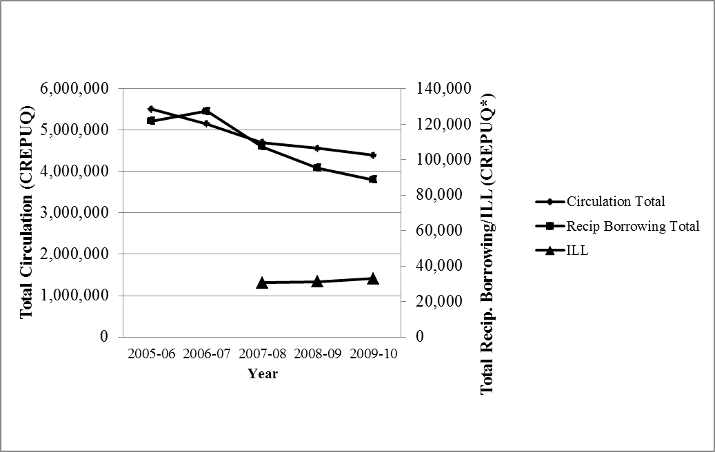
Figure 1. Total Annual CREPUQ Circulation and Reciprocal Borrowing Activity (2005-2010) and Interlibrary Loan Activity (2007-2010)

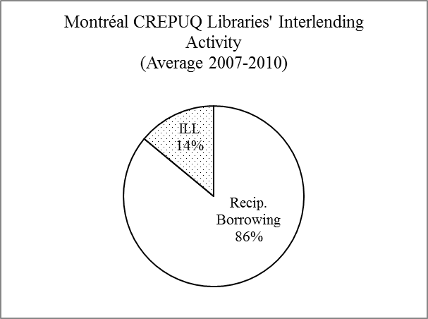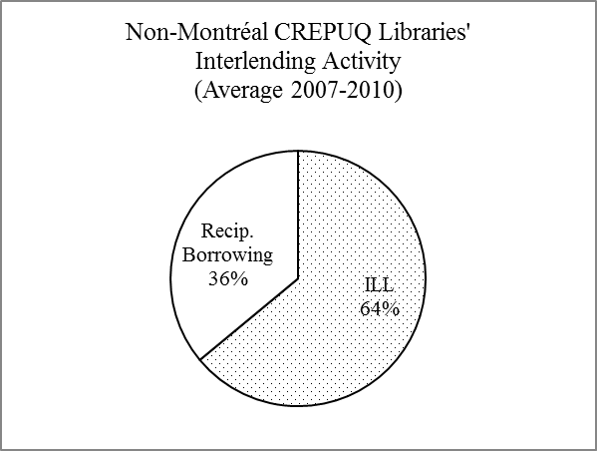

Figure 2. Percentage of ILL and Direct Reciprocal Borrowing Activity for Montréal and non- Montréal CREPUQ Libraries

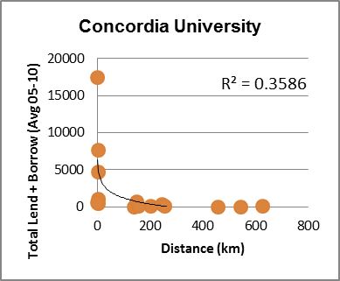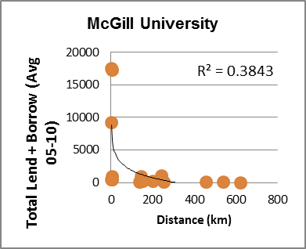
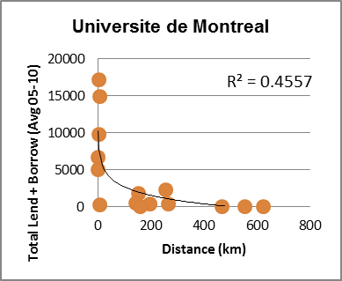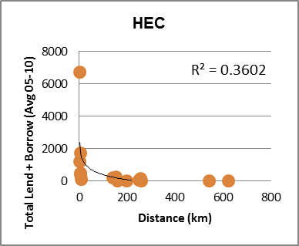
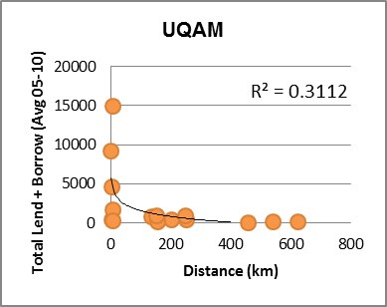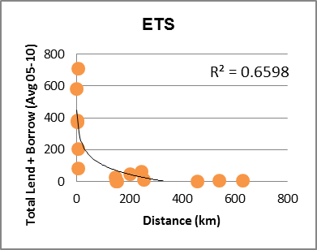
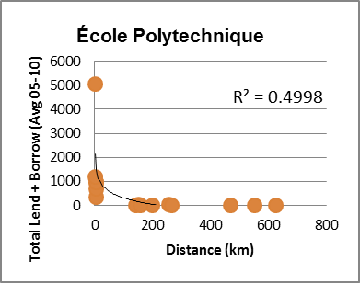
Figure 3. Direct Reciprocal Borrowing/Lending (Average 2005-10) and Distance: Montréal CREPUQ Libraries
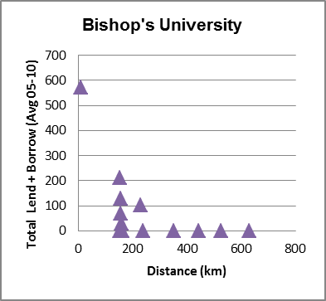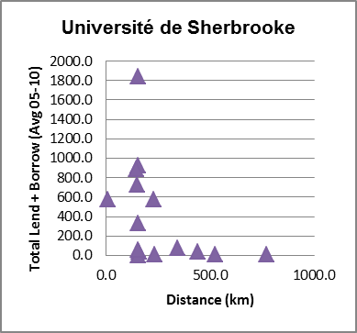
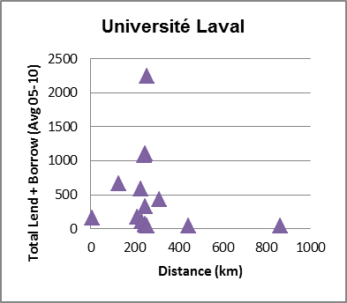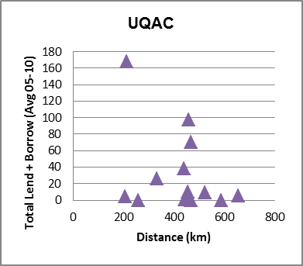
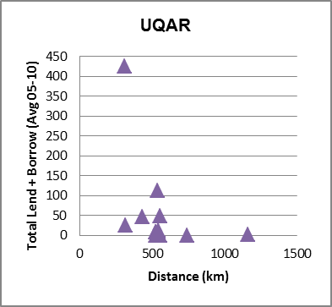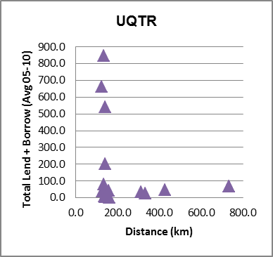
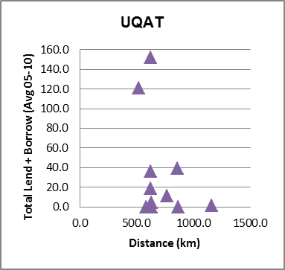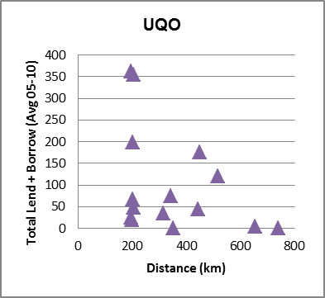
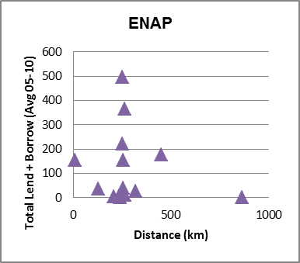

Figure 4. Direct Reciprocal Borrowing/Lending (Average 2005-10) and Distance: non-Montréal CREPUQ Libraries

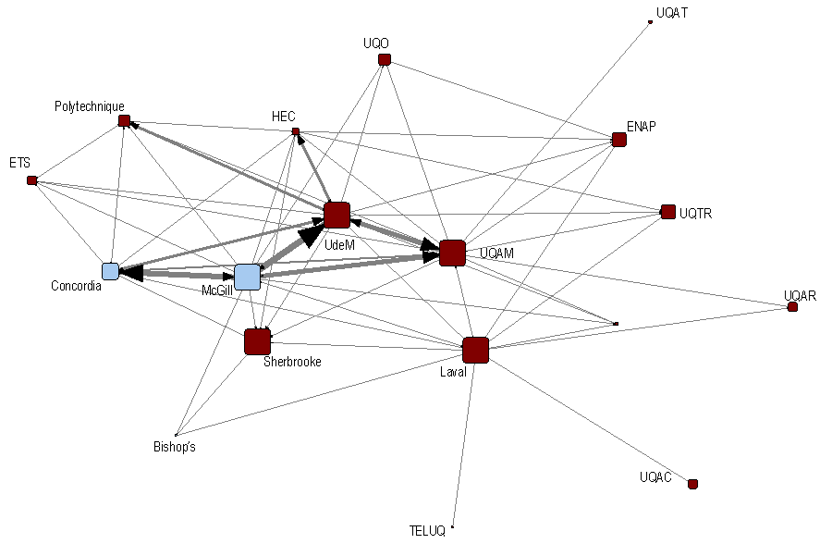
Figure 5. Social Network Analysis of CREPUQ’s Direct Reciprocal Borrowing Activity

References
Ballard, T. (1990). The unfulfilled promise of resource sharing. American Libraries, 21(10), 990-993.

Canadian University Reciprocal Borrowing Agreement. (2012). Retrieved from: http://www.curba.ca/

Conference des recteurs et principaux des recteurs et des principaux du Québec. (2010). Procedures for direct undergraduate borrowing privileges in Québec university libraries, extending, the CREPUQ agreement for faculty and graduate students. Retrieved from: http://www.crepuq.qc.ca/IMG/pdf/Procedure_undergraduate_June18_2008_vr13vril2010.pdf

Conference des recteurs et principaux des recteurs et des principaux du Québec. (2012). Statistiques generales des bibliotheques universitaires Québecoises. Retrieved from:
http://www.crepuq.qc.ca/spip.php?article1369&lang=en

Costello, J. & Duffy, C. (1990). Academic interlibrary loan in New York state: A statistical analysis. Journal of Interlibrary Loan and Information Supply 1(2), 41-43

Cram, J. (1995). Forging links, making connections, identifying assumptions – are cooperation, resource sharing and networking beneficial to libraries? Australian Public Libraries and Information Services 8(2), 64-77.

Davis, D. (2005). Reciprocal borrowing agreements widespread. American Libraries, 36(1), 26.

Duy, J. & Larivière, V. (2012). Relationships between interlibrary loan and research activity in Canada. College and Research Libraries. In press.

Ellison, S. (1993). Reciprocal borrowing: access and risks the Wayne State University perspective. Resource Sharing & Information Networks, 9(1), 33-44.

Foote, J.B., & Person, R.C. (1995). The unexpected effect of online databases on undergraduate use of interlibrary loan. Journal of Interlibrary Loan, Document Delivery & Information Supply 5(4), 65-73.

Freeman, L.C. (1979). Centrality in networks: I. Conceptual clarification. Social Networks, I, 215-239.

Guterman, L. (2007). What good is undergraduate research, anyway? Chronicle of Higher Education, 53(50), 11.

Heiney, B.Z. & Lilla, R.R. (1998). Building partnerships: one university’s experience in building reciprocal borrowing alliances. Journal of Interlibrary Loan, Document Delivery & Information Supply, 9(1), 27-35.

Jackson, M. E. (1994). Reciprocal agreements. Wilson Library Bulletin, 68(7), 67-134.

Jackson, Mary E. (2004). Assessing ILL/DD services: New cost-effective alternatives. Washington, DC: Association of Research Libraries. Retrieved from: http://archive.org/details/assessingillddse00jackrich

Kies, C. (1993). Patron rationales for using reciprocal borrowing. Resource Sharing and Information Networks, 9(1), 11-32.

Knoke, D. & Yang, S. (2008). Social network analysis, Second Edition. Los Angeles: Sage Publications.

Leon, L. and Kress, N. (2012). Looking and resource sharing costs. Interlending & Document Supply, 40(2), 81-87.

Otte, E. & Rousseau, R. (2001). Social network analysis: a powerful strategy, also for the information sciences. Journal of Information Science, 28(6), 441-453.

Palmer, E. S. (1981). The effect of distance on public library use: a literature survey. Library Research, 3: 315-354.

Park, S.J. (2011). Measuring public library accessibility: A case study using GIS. Library and Information Science Research, 34: 13-21.

Paustian, R. P. (1981). Collection size and interlibrary loan in large academic libraries. Library Research, 3, 393-400.

Prabha, C.G. & O’Neill, E.T. (2001). Interlibrary borrowing initiated by patrons: Some characteristics of books requested via OhioLINK. Journal of Library Administration 34(3/4), 329-338.

Schultz-Jones, B. (2009). Examining information behavior through social networks: an interdisciplinary review. Journal of Documentation, 65(4), 592-631.

Statistics Canada. (2011). Population and dwelling counts, for Canada and census subdivisions (municipalities), 2011 and 2006 censuses [Data file]. Retrieved from:
http://www12.statcan.gc.ca/census-recensement/2011/dp-pd/hlt-fst/pd-pl/Table-Tableau.cfm?LANG=Eng&T=301&S=3&O=D

Statistics Canada. (2011). Population and dwelling counts, for Canada, census metropolitan areas, census agglomerations and census subdivisions (municipalities), 2011 and 2006 census [Data file]. Retrieved from:
http://www12.statcan.gc.ca/census-recensement/2011/dp-pd/hlt-fst/pd-pl/Table-Tableau.cfm?LANG=Eng&T=203&CMA=462&S=0&O=D&RPP=25

Williams, J. A. & Woolwine, D. E. (2011). Interlibrary loan in the United States: An analysis of academic libraries in a digital age. Journal of Interlibrary Loan, Document Delivery and Electronic Reserve, 21, 165-183.

Williams, K. C. (2008). Consortial and reciprocal agreements in academic libraries: a survey of common practices. Journal of Interlibrary Loan, Document Delivery & Electronic Reserve, 18(2), 265-278.

