Irreversible does not mean unavoidable

H. Damon Matthews¹ and Susan Solomon²
¹ Department of Geography, Planning and Environment, Concordia University
damon.matthews@concordia.ca

² Department of Earth, Atmospheric and Planetary Sciences, MIT
solos@mit.edu

CO₂ emissions cuts implemented today would affect the rate of future global warming immediately, without any lag from carbon-climate system inertia.

There is a commonly held belief among both scientists and the general public that there is a delay between the CO₂ emissions we put into the atmosphere, and the resulting climate change. As a consequence, there is a perception that current and near-future climate warming is pre-determined by past CO₂ emissions, and by extension, that CO₂ emissions reductions implemented now will not have any effect on the future rate of global warming for at least several decades. In this perspective, we argue that this conclusion is based on an incomplete interpretation of the inertia of the climate system. Considering the opposing effects of both physical climate and carbon cycle inertia, there is a compelling argument that the climate response to CO₂ emissions cuts would not be delayed by lags in the climate system. Consequently, climate mitigation efforts implemented today would be of immediate importance for future global temperatures. This has important implications for climate policy: the potential for a rapid climate response to prompt CO₂ emissions cuts opens the possibility that the climate benefits of emissions reductions would occur on the same timescale as the political decisions themselves.

This question of how decreases in CO₂ emissions would affect global temperatures has unfortunately been clouded in recent years in part by confusion regarding physical climate issues of ‘unrealized warming’ and irreversibility(1). The notion that there is unrealized warming or ‘warming in the pipeline’(2) if the concentrations of carbon dioxide (and other radiative forcing agents) were to remain fixed at current levels has been misinterpreted to mean that increases in the Earth’s global temperature are inevitable, regardless of how much or how quickly we decrease our emissions(1). Such statements have been widely reported in both popular coverage of climate change and in scientific publications. Further misunderstanding likely stems from recent studies that have shown that the warming that has already occurred due to past anthropogenic carbon dioxide increases is irreversible on a time scale of at least a thousand years(4, 5) – but irreversibility of past changes does not mean that further warming is unavoidable.

The distinction between how much irreversible warming is expected based on past emissions versus how much can be avoided through our coming choices is linked not only to inertia in how the climate responds to CO₂ concentration changes, but also to inertia in the uptake of CO₂ emissions by the global carbon cycle. The climate responds to increases in atmospheric CO₂ levels by warming, but the warming is slowed by the long timescale of heat storage in the ocean, which represents the physical climate inertia. There would indeed be unrealized warming associated with current CO₂ concentrations, but only if they were held fixed at current levels(2). If emissions decrease enough, the CO₂ levels in the atmosphere can also decrease. This potential for atmospheric CO₂ to decrease over time results from inertia in the carbon cycle associated with the slow uptake of anthropogenic CO₂ by the ocean. This carbon cycle inertia affects temperature in the opposite direction as the physical climate inertia, and is of approximately the same magnitude(1, 5). Because of the equal and opposing effects of physical climate and carbon cycle inertia, there is almost no additional unrealized warming from past CO₂ emissions. If emissions were to abruptly cease, global average temperatures would remain approximately constant for many centuries, but they would not increase very much, if at all. Similarly, if emissions were to decrease, temperatures would increase less than they otherwise would have (Figure 1A).

This means that while the CO₂-induced warming already present on our planet – the cumulative result of our past emissions – is irreversible, any further increase in CO₂-induced warming is entirely the result of current CO₂ emissions. Warming at the end of this century (and beyond) will depend on the cumulative emissions we emit between now and then. But future warming is not unavoidable: CO₂ emissions reductions would lead to an immediate decrease in the rate of global warming.

Why then are many different near-term projections of global temperature change very similar? Modeled estimates of increases in CO₂-induced warming over the next two decades are similar because even socioeconomic scenarios that produce very different cumulative emissions by the end of the century are not very different over the next two decades (see Supplementary Figures 1 and 2). While the climate system physics implies that further increases in warming could in principle be stopped immediately, it is our human systems that have longer time scales. Existing carbon-emitting infrastructure such as vehicles, power plants, and buildings is designed to benefit humankind for years to many decades, and each year’s additional infrastructure of the same type implies added stock intended to last and emit CO₂ for many decades. Our dependence on CO₂-emitting technology therefore generates a commitment to current and near-future emissions(7). While cleaner alternatives are being developed, and carbon capture and storage is being tested, technological development and diffusion is subject to substantial inertia(8). Thus societal inertia, rather than the inertia of the climate system, is the critical driver for urgency if we wish to begin to decrease the rate of CO₂-induced global warming in the near future.

The strong dependence of future warming on future cumulative carbon emissions also implies that there is a quantifiable cumulative amount of CO₂ emissions that we must not exceed if we wish to keep global temperature below 2 °C above pre-industrial temperatures. Given uncertainties in both the climate and carbon cycle responses to CO₂ emissions, as well as the climate response to emissions of other greenhouse gases and aerosols, there is large uncertainty in any estimate of this allowable cumulative emissions budget. Several recent analyses, however, have suggested that total CO₂ emissions of about 1000 PgC (3700 Pg CO₂) would give us about even odds of meeting the 2 °C target(9-12). To meet such a target given historical emissions would mean that the world has approximately half of our allowable emissions budget remaining, about 500 PgC.

There are, however, substantial issues of global equity surrounding differences in emissions amongst countries, and particularly between countries in the developed and developing world(13). Cumulative carbon emissions from the developed world currently exceed those from developing countries, and this has greatly improved human health and welfare in locations such as Europe, North America, Oceania, and Japan. But rapid economic growth in emerging economies is expected to reverse this pattern within a few decades (See Figure 1B and Supplementary Figure 2). Nonetheless, it is remarkable that per capita cumulative emissions from developed countries are expected to remain far higher than those from developing nations throughout the 21st century (see Figure 1C). This conclusion holds for both high and low emission scenarios, and is insensitive to future population growth. Thus, the question facing society is the ethical nature of a world in which economies that develop in the 21st century do so on much less cumulative carbon per capita compared to those who already developed in past centuries. In the absence of technological advances, this presents a stark scenario for emerging economies of the 21st century – how can they be expected to develop using much less carbon per capita than those who already developed? As society grapples with fairness in view of this difference, a critical factor will be technological investments and innovation, to increase the availability of reduced-carbon sources of energy that are more competitive in price, so that development can continue to improve the lives of people in emerging economies without driving global climate change to increasingly dangerous levels. It is clear that these humanitarian and ethical issues related to development are a critical driver of urgency in dealing with climate change and energy issues in the near future. If reduced-carbon energy sources are not advanced rapidly, then a great deal of carbon-intensive infrastructure is likely to be put in place in the developing world, implying a large and ongoing societal commitment to further global CO₂ emissions and consequent climate warming(7).

Given the irreversibility of CO₂-induced warming(4, 5), every increment of avoided temperature increase represents less warming that would otherwise persist for many centuries. Emissions reductions cannot return global temperatures to pre-industrial levels, but do have the power to avert additional warming on the same timescale as the emissions reductions themselves. Climate warming tomorrow, this year, this decade, or this century is not predetermined by past CO₂ emissions; it is yet to be determined by future emissions.

This differentiation between the idea of unavoidable warming due to inertia inherent in the climate system, and difficult-to-avoid warming that results from the inertia of human systems is not merely a question of semantics. The source and perceived inevitability of future warming is directly relevant to mitigation strategies and decisions. There is more hope for averting difficult-to-avoid negative impacts by accelerating advances in technology development and diffusion, than for averting climate system changes that are already inevitable. For an issue as international and serious in scope as climate change, clarifying such points of hope can provide motivation for change.
Acknowledgements
We thank Sarah Turner, Andrew Weaver, Simon Lewis and members of the Concordia Climate Lab for helpful discussions surrounding earlier versions of this work. Funding from Concordia University, the Natural Science and Engineering Research Council of Canada and the Canadian Foundation for Climate and Atmospheric Sciences is gratefully acknowledged.

References

1. H. D. Matthews, A. J. Weaver, Nature Geoscience 3, 142–143 (2010).
2. J. Hansen et al., Science 308, 1431 (2005).
3. IPCC, in Climate Change 2007: Impacts, Adaptation and Vulnerability. Contribution of Working Group II to the Fourth Assessment Report of the Intergovernmental Panel on Climate Change, M. Parry, C. Hanson, P. van der Linden, J. Palutikof, O. Canziani, Eds. (Cambridge University Press, 2007), pp. 7–22.
4. S. Solomon, G. Plattner, R. Knutti, P. Friedlingstein, Proceedings of the National Academy of Sciences 106, 1704 (2009).
5. H. Matthews, K. Caldeira, Geophys Res Lett 35, L04705 (2008).
6. R. H. Moss et al., Nature 463, 747–756 (2010).
7. S. J. Davis, K. Caldeira, H. D. Matthews, Science 329, 1330–1333 (2010).
8. D. G. Victor, Global Warming Gridlock (Cambridge University Press, 2011).
9. M. R. Allen et al., Nature 458, 1163–1166 (2009).
10. H. D. Matthews, N. P. Gillett, P. A. Stott, K. Zickfeld, Nature 459, 829–832 (2009).
11. S. Solomon et al., Climate stabilization targets (National Academies Press, Washington, DC, 2011).
12. H. D. Matthews, S. Solomon, R. Pierrehumbert, Philosophical Transactions of the Royal Society A 370, 4365–4379 (2012).
13. B. Bolin, H. S. Kheshgi, Proceedings of the National Academy of Sciences 98, 4850 (2001).

Figure 1:
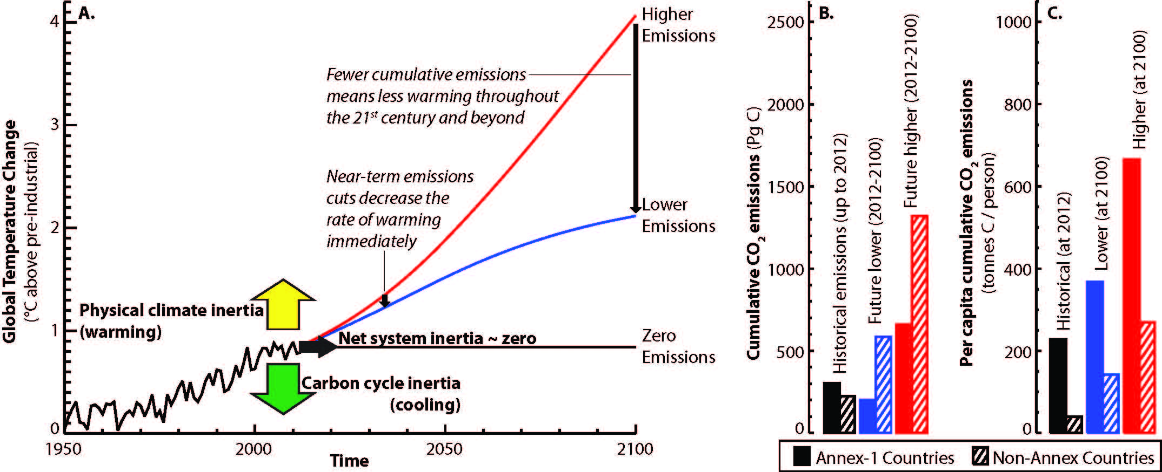
Figure Legend
Figure 1: The climate response to CO₂ emissions is influenced by both physical climate and carbon cycle inertia, with the result that the net system inertia is close to zero (A). Consequently, future climate warming depends only on current and future CO₂ emissions, and the rate of warming will respond immediately to CO₂ emissions cuts. Cumulative emissions from developed (Annex-1) countries currently exceed those from developing (non-Annex) countries, but this pattern is expected to reverse for future emissions scenarios (B). However, per capita cumulative emissions from developed countries are expected to remain much higher than those from developing countries (C). The illustrative future scenarios shown here are from SRES scenarios B1 (blue line and bars) and A1FI (red line and bars), with idealized warming calculated as a linear function of cumulative CO₂ emissions. Observed historical temperature and cumulative emissions are shown in black.

“… the changes in the current climate that have been observed across the planet are the products of only about 50 percent of the warming to which we have already committed ourselves with our past emissions.” Quoted from: "Hurricane Sandy's Link To Climate Change: Does It Matter?" The Huffington Post, November 1, 2012. http://www.huffingtonpost.com/tom-zeller-jr/hurricane-sandy-link-to-climate-change_b_2059179.html (Accessed November 10, 2012) * "The planet has already warmed about 0.8°C on the surface over the past century. But we haven’t yet seen the full warming effects from all the carbon dioxide we’ve put in the air — there’s typically a delay of a few decades thanks to the thermal inertia of the oceans." Quoted from: "Sandy shows the U.S. is unprepared for climate disasters" The Washington Post, October 31, 2012. http://www.washingtonpost.com/blogs/ezra-klein/wp/2012/10/31/why-the-united-states-is-so-unprepared-for-climate-disasters/ (Accessed November 10, 2012)
For example, the IPCC’s 2007 Summary for Policymakers from Working Group II includes the following statements: “Past emissions are estimated to involve some unavoidable warming …" with the consequence that "Adaptation will be necessary to address impacts resulting from the warming which is already unavoidable due to past emissions (p. 19)(3)”

