**Theory of EPR lineshape in samples concentrated in paramagnetic spins: Effect of enhanced internal magnetic field on high-field high-frequency (HFHF) EPR lineshape**

Sushil K. Misraa and Stefan Diehla,b

a Physics department, Concordia University, 1455 de Maisonneuve Boulevard West, Montreal (Quebec) H3G 1M8, Canada

bPhysikalisches Institut, Justus Liebig Universität, 35390 Gießen, Germany

A theoretial treatment is provided for the calculation of EPR (electron paramagnetic resonance) lineshape as affected by interactions with a cluster of paramagnetic ions in the sample. The internal fields seen by the various paramagnetic ions due to interactions with clusters of paramagnetic ions in their vicinity, as well as the resulting lineshapes, are different at high magnetic fields required in high-frequency EPR. The resulting EPR signals for the various ions are characterized by different g-shifts and lineshapes, so that the overall EPR lineshape, which is an overlap of these, becomes distorted, or even split, from that observed at lower frequencies. The observed EPR lineshapes in MnSO4.H2O powder and K3CrO8 single-crystal samples have been simulated here to show that in these samples, concentrated in paramagnetic spins, the position and lineshapes of EPR signals are significantly modified in high-field high-frequency (HFHF) EPR involving very high magnetic fields. These simulations show that it is important to take into account the effect of enhanced internal fields and modifications of HFHFEPR lineshapes to provide a more accurate interpretation of the observed EPR signals.

**P.A.C.S. Classification**: **76.30 Fc**

**Key words**: high-field high-frequency (HFHF) EPR, internal magnetic field, g-shift, concentrated paramagnetic spins, high frequencies, high magnetic fields

**1. Introduction**

EPR (electron paramagnetic resonance) is a very sensitive technique to probe the environment of a paramagnetic ion in a magnetic field, not possible with many common characterization techniques. This is why it has been exploited for EPR imaging and EPR microscopy. Multi-frequency electron paramagnetic resonance (EPR) is a useful technique in itself,1 and a viable complement to other methods of spectroscopic investigations, such as NMR, conductivity, susceptibility measurements and infra-red spectroscopy. Exploitation of EPR spectra with multi-frequency technique is helpful in discerning which mechanisms are operative in a particular sample.1 Furthermore, this information can provide key insights for discriminating amongst competing models of relaxation processes, useful in elucidating structural and dynamical processes in a wide variety of systems. EPR spectra of polycrystalline and single crystals can show complicated frequency/magnetic field-dependent behavior.

In the early EPR literature, there are reported observations2-4 of exchange narrowing, or 10/3-effect, of EPR linewidth with increasing resonance frequency for a paramagnetic system with identical spins. There occurs broadening of EPR lines due to the contribution of the nonsecular terms of the dipole-dipole interaction between the paramagnetic ions to the linewidth. The broadening of the EPR lines by the factor 10/3 occurs if the average field of the dipolar interaction, Hdd, exceeds the resonant magnetic field, or in case of exchange narrowing of dipole-dipole broadened line, if the exchange-interaction constant, |J| exceeds the energy of the quantum of magnetic-resonance frequency. Increasing the resonance frequency causes narrowing of EPR lines, because then the 10/3 non-secular broadening is no-longer significant. Accordingly, if other effects, e.g. internal fields are negligible, occurrence of exchange-narrowed EPR spectrum as a function of magnetic-resonance frequency can be used to estimate |J|. To this end, measurements to verify these predictions were reported for frequencies ≤ 105 GHz: (i) Cu(NH3)4SO4.H2O single crystal at 300 K:5 the observed linewidths being 11.5 G, 10 G, 9.5 G, 7.5 G, 7 G, 6 G, 5 G at 3, 9.5, 13, 21, 33, 50, 105 GHz, respectively, characterized by |J| = 3.15 K (~65 GHz); (ii) K2CuCl4.2H2O single crystal:6 the observed linewidths being 183, 175, 138, 115, 84, 80, 54, 40, 35 G at 3, 5, 9, 10, 16, 18, 23, 35, 46 GHz, respectively, characterized by |J| = 0.24 K (~5 GHz).

Recently, with the advent of very high-frequency (VHF, > 140 GHz) EPR spectrometers, the prediction of exchange narrowing with increasing frequency for samples with |J| > 100 GHz can be seriously tested. As well, for concentrated samples containing identical paramagnetic ions, the exchange interaction can be estimated by multi-frequency measurements by finding the frequency above which exchange narrowing occurs provided that other broadening effects are negligible, e.g. internal fields. With the recent availability of high-frequency spectrometers, this project started with the objective to explore the 10/3-exchange narrowing of an EPR line with increasing frequency,2 including VHF frequencies, e.g. at frequencies of 9.6 (X-band), 35.7 (Q-band), 95 (W-band), 190, 288, and 387 GHz. To this end, the system of MnSO4.H2O was chosen. Contrary to the expectation, no narrowing of EPR line was found with increasing frequency, instead a distortion/splitting of EPR line was found. A similar effect was reported in K3CrO8 crystal by Cage *et al.*7,8

The effect of internal fields on lineshape in HFHF EPR in samples concentrated in paramagnetic spins can be very profound due to resulting g-shifts, associated with modifications of lineshapes. One relevant example reported in the literature is that of the EPR spectrum of the paramagnetic ion Cr5+ (electron spin S = ½, nuclear spin I = 0) in a single crystal of K3CrO8 at 370 GHz in a variable frequency measurement in the range 1 – 370 GHz by Cage *et al.*, observing splitting of EPR lines at 370 GHz7 in K3CrO8.The interpretation of spectra was made in terms of the exchange narrowing of EPR signal in solids, based on a simple Hamiltonian. It was found that the linewidth decreased monotonically as a function of frequency from 1 to about 100 GHz, which then started to increase as the frequency was increased. Comparing their data on a magnetically diluted spin system in diamagnetic K3NbO8, containing ~0.5 mole % of K3CrO8, taking into account the broadening effect of the magnetic-field dependent terms, e.g. broadening due to g-strain and magnetization of the sample holder and waveguide up to 14 T, the K3CrO8 linewidths were analyzed in terms of Anderson-Weiss model,3  taking into account the various line-broadening effects. They found agreement, within 5%, for the exchange constant J (=1.35 K) and about 25% for the dipolar field Hp (=16 mT).6 Nevertheless, they noted some deviations and unusual splitting in the EPR spectrum at 370 GHz, whose origin they could not identify. In a subsequent measurement in undiluted Cr5+ salts at 375 GHz,8 they interpreted the broadening of the EPR peaks due to g-strain, and found better resolution enhancement with increasing applied Zeeman field up to 14 T, which was so significant that a single unresolved peak at fields less than 1 T became split into its three g-tensor components at fields greater than 10 T. No attempts were made in Refs. 7, 8 to interpret data in terms of internal fields due to different clusters of paramagnetic spins in the sample at sufficiently high magnetic field, bringing into existence different g-shifts associated with their particular modified lineshapes. As discussed below, this is due to an overlap of EPR lineshapes due to different g-shifts, being proportional to B/T, where B is the intensity of the external magnetic field and T is the temperature. This manifests in splitting, or distortion, of EPR lineshape at high magnetic fields, a phenomenon that does not occur at low magnetic fields used in low-frequency EPR.

It is the purpose of this paper to

1. provide a theoretial treatment for the calculation of EPR (electron paramagnetic resonance) lineshape as affected by interactions with a cluster of paramagnetic ions in the sample; and
2. analyze multifrequency, including HFHF, EPR data using the theory developed in (i). This will include data on MnSO4.H2O powder samples and a K3CrO8 single crystal, in which the various paramagnetic spins experience significant g-shifts at high magnetic fields due to the internal fields produced by the clusters of paramagnetic ions in their environments in the sample. The resulting EPR spectrum is then an overlap of different EPR lineshapes situated at different values of the external magnetic field. This has been verified here by simulation. EPR spectra were also recorded on sufficiently diluted MnSO4.H2O powder by mixing it with diamagnetic KBr powder and/or vacuum grease to show that there is no splitting/distortion of EPR lines, because the Mn2+ mini-crystals constituting the polycrystalline sample are sufficiently apart from each other not able to induce any significant internal magnetic fields. In addition, the published spectrum of K3CrO8 single crystal at 370 GHz8 has been satisfactorily simulated here as an overlap of EPR spectra, characterized by their different lineshapes, situated at different values of the external magnetic field due to different internal fields from clusters of paramagnetic spins situated in their environments in the crystal.

**2. Theory**

**2.1 Calculation of internal field and lineshape in a sample due to a cluster of paramagnetic spins.** The model for calculation that will be used here is as follows. When the intensity of the external magnetic field (***B***) is sufficiently high, a paramagnetic spin in the sample experiences an effective field at its site: ***Be = B + Bint* ,** where ***Bint*** is the internal magnetic field at its site due to other paramagnetic spins in the vicinity, the interactions with which also modifies its lineshape. Since EPR is sensitive to the environment of a paramagnetic spin, different spin clusters produce their individual effects on EPR lineshapes, with their particular ***Be*** and lineshapes, which can be approximated by a particular composition of Gaussian and Lorentzian shapes. The calculation of the effect of a cluster of paramagnetic ions on the line position and lineshape of a paramagnetic spin is described below, following the lineshape calculations of Kambe and Usu11 in the nuclear context.

**2.1.1 Spin Hamiltonian.** The system to be considered is a spin ***S0*** interacting with a cluster of m spins ***Si*** (i = 1,2,3,…,m), so that the spin Hamiltonian is the sum of its spin Hamiltonian, ***H0***, as well as pair-wise interactions with the spins of the cluster, ***H0*i ,** as follows:



with

(2)



where, the first term on the right hand side of ***H0*** in Eq. (2) is the Zeeman interaction with  being the Bohr magneton and  being the g-matrix, and the second term, *H*ZFS, represents the zero-field splitting terms. The terms ***H0i*** represent the pair-wise interaction between the spins ***S0***and***Si***, including both the exchange and dipolar interactions.

**3.1.2 EPR lineshape: moments.** Under the action of a microwave field (***B1***), the interaction Hamiltonian:

 , (3)

induces resonant transitions when the quantum of microwave energy, $hν$, where h is Planck’s constant and $ν$ is the frequency of the microwave radiation, matches energy-level separation between a pair of energy levels *En* and *En’*, provided that the transition probability, *Pnn’ = Pn’n*, is non-zero, which is given by

,

where, and is the energy per unit volume in the frequency interval about . The absorption coefficient A(), per unit frequency interval, taking into account the Boltzmann distribution of population, is defined as

, (4)

where kB is Boltzmann’s constant. The second summation over only those of $n'$ states which satisfy the condition ; and Z is the partition function defined as . The absorption coefficient is related to the imaginary part of the complex susceptibility,, as follows:. Then Eq. (4) becomes::

. (5)

Equation (5) contains the functional form of. One can now calculate the moments of the EPR lineshape from Eq. (5). These turn out to be in the form of traces of expectation values of certain operators as seen below.

**Zeroeth moment (area under the absorption curve)**. It is given by

, (6)

where the summation  extends over all those $n'$ for which . Alternatively, one can introduce the operators and , so that , as follows:

 (7a)

and

 (7b)

Equation (6) can now be transformed, using (7a) and (7b), in the form of a *tra*ce:

, (8)

where [*A,B*] *= AB – BA* and the symbol stands for the average at temperature *T*. The advantage of expression (8) is that since *Trace* is invariant under a transformation of basis, it can be calculated in any convenient representation. For the transition , ***Hint***would have non-zero matrix elements only between the levels with the energy difference .

**First moment**. It is given by



(9)

It is noted that in writing the second term in Eq. (9) the summation over has been changed to, thereby introducing a multiplication factor of ½ since in this conversion the additional summation  is equal to that over .

**Second moment**. It is expressed as



(10)

**Higher-order moments**. Following the same procedure as that used above for the calculation of first- and second-order moments, it can be shown that the even- and odd-order moments can be written as:

 (11)

and

 (12)

respectively. In Eqs. (11) and (12), the symbols  and represent the iterated commutators, as follows:

 (13)

and

 (14)

In Eqs. (13) and (14) *H* appears  times in a repetitive manner as indicated by the dots.

**Some useful expressions.** Using the above, some meaningful expressions can be obtained.

**Mean frequency.** It is defined as:

 (15)

which is different from the original frequency, , when the interaction with other paramagnetic spins is absent. The deviation of effective frequency is denoted as:

 (16)

This is equivalent to a shift in the effective resonant field by the amount

 (17)

as a consequence of the *internal field* produced by a cluster of paramagnetic ions.

**Linewidth.** It can be expressed as the mean-square deviation about the mean frequency :

 (18)

T0 further simplify (18), the density matrix is now approximated as:

, (19)

where the pair-wise interaction terms have been neglected.

Substituting Eqs. (1), (18), and (19) into Eqs. (8), (9), and (10), one obtains for the

zeroeth, first, and second moments

 (20)  (21)



(22)

In Eqs. (20) – (22),



where *H0* is the Hamiltonian of a paramagnetic spin, assuming that all spins are identical, in the absence of interaction with neighboring paramagnetic spins.

**Detailed calculations of area (zeroeth moment), internal field (first moment), and the linewidth (second moment).** For these calculations, it is necessary to take into account the exchange and dipolar interactions included in ***H0*i,** as expressed by Eqs. (1) and (2)**.** As for the pair-wise interaction, *H0i*, it can be simplified using the formalism of Van Vleck as follows:16

(23)



In Eq. (23), *J0i* is the exchange-interaction constant between the spins *S0* and *Si* , *r0i* is the distance between *S0*, the paramagnetic ion being considered and *Si* the *i-th* spin of the cluster it is interacting with; and *cos θ0i* is the direction cosine of *r0i* with respect to the z-axis.

Introducing (23) into Eqs. (20) – (22), one obtains the following expressions:

**Zeroeth moment:** ; (24)

**First moment**:  (25)

**Second moment**: 

(26)

In Eqs. (24) – (26), N is the total number of spins in the cluster.

Taking into account the Zeeman term only, and neglecting the exchange interaction, which is the case in HFHF EPR due to the large magnitude of the required magnetic field, the following values are obtained for the expectation values of the spin component *S0z* and *S0z2*, as follows:



**g-shift**. Finally, the g-shift as implied by the expression for the first moment, Eq. (25) is:

 (30)

As revealed by Eq. (30), the g-shift depends on the sum  Using now (23) for *B0i*, it can be expressed as:

 (31)

The sum in Eq. (31) depends on the shape of the sample, and

 (32)

where *N1* is the number of spins per unit volume. The sum in eq. (31) becomes the classical demagnetization factor, *N*z, when the shape is ellipsoidal, and is oriented such that one of its ellipsoidal axis is along the z-axis, the direction of the external magnetic field, so that

 (33)

Then,

 (34)

In writing (32), the expression for the susceptibility

 (35) has been used.

Equation (34) reveals that increases as increases, first linearly, thereafter attaining a constant value as ,15 being proportional to as given by Eqs. (29) and (32). ***As a consequence, in HFHF experiments involving high magnetic fields, the g-shift of an EPR line becomes significant even at room temperature due to interactions with different clusters of paramagnetic ions in the sample, similar to the situation in low-frequency EPR involving smaller magnetic fields, when the temperature is decreased sufficiently, e.g. liquid-helium temperatures. Likewise, the higher moments of the lineshape are affected significantly* as, *so that the overall lineshape is also modified significantly at room temperature.***

**3. Experimental Details**

**3.1 Samples.** MnSO4.H2O powder, with ultra-high purity, was obtained from a commercial source. The preparation of K3CrO8 single crystals is described in Refs. 7-9.

**3.2 Spectrometers. (i) MnSO4.H2O powder.** Low-frequency X-band (~9.5 GHz) and Q-band (~35.7 GHz) spectra were recorded at room temperature on Bruker and Varian commercial spectrometers. As for high multifrequency EPR spectra, they were recorded on a home-built spectrometer at the EPR facility of NHMFL (National High Magnetic Field Laboratory, Tallahassee, Florida). The instrument was a transmission-type device in which microwaves are propagated in cylindrical light pipes. The microwaves were generated by a phase-locked Virginia-Diodes source generating a frequency of 13 ± 1 GHz and producing harmonics of which the 4th, 8th, 16th, 24th and 32nd were available. A superconducting magnet (Oxford Instruments) capable of reaching a field of 17 T was employed. The field was calibrated using DPPH, with g = 2.0037. The differences between 'calibrated' and 'uncalibrated' fields are 50 - 90 Gauss. No resonance cavity was used. Detection was provided by a liquid-helium-cooled InSb hot-electron bolometer (QMC Ltd., Cardiff, UK). Magnetic-field modulation at 40 kHz and ca. 2 mT amplitude was employed. A Stanford SR830 lock-in amplifier was used to convert the modulated signal to a DC voltage. **(ii) K3CrO8 crystal**. The details of the spectrometer used are described in Refs. 7, 8.

**3.3 EPR spectra**. In this section are described experimental multifrequency EPR spectra on MnSO4.H2O samples (with varying paramagnetic concentrations), and that on K3CrO8 crystal in varying magnetic fields to show the enhanced effect of internal magnetic fields due to clusters of paramagnetic ions in the vicinity as the intensity of the external magnetic field is increased.

* + 1. **MnSO4.H2O powder**

For these measurements high-purity commercially available MnSO4.H2O powder was used, whose magnetic susceptibility is 14,200 x 10-6 cm3/mol.10

**Low frequency/magnetic fields.** The X (9.595 GHz)- and Q (35.7 GHz)-band spectra are shown in Fig. 1. No distortion of lineshape is seen at these frequencies, which require low magnetic fields.

**High frequency/magnetic fields.** Two sets of measurements were performed. These are made to see the effect of varying concentrations of paramagnetic spins, by diluting the MnSO4.H2O powder with vacuum grease and diamagnetic KBr powder.

**(a) Decreasing concentration dependence (diluted powder).** In Fig. 2 are shown spectra on a diluted powder of MnSO4.H2O, mixed in vacuum grease with equal volume, at increasing frequencies of 94.64 (A), 190.52 (B), 288.22 (C), and 387.48 (D) GHz, respectively. The spectrum D, unlike A, B, and C which are undistorted, shows distortion of lineshape due to significant internal fields produced by paramagnetic clusters at very high magnetic fields. The bottom two EPR spectra at 387.48 GHz (E, F) are for decreasing concentrations of MnSO4.H2O: (i) in grease by a factor of 2 (E), and (ii) by mixing the sample in (i) in diamagnetic KBr powder 20 times its volume (F), respectively, as compared to that in D. It is seen that the shape distortion becomes smaller in E as compared to that in D, whereas it disappears entirely in F, acquiring the same undistorted shape as those of A, B, and C, due to considerably reduced concentration of Mn2+ spins, so that the internal fields due to them are negligible.

**(b) Increasing concentration dependence (concentrated sample).** Figure 3 showsEPR spectra on MnSO4.H2O powder sample, mixed in one-half of its volume in vacuum grease, recorded at increasing microwave frequencies (magnetic fields) of 96.77 (A), 193.54 (B), 290.33 (C), and 387.084 GHz (D, E, F). They are shown in Fig. 3. The spectra E and F at 387.084 GHz are from those samples of MnSO4.H2O, in which mixing with grease was in such amounts that the concentration of MnSO4.H2Owas increased by factors of 8 (E) and 40 (F), specifically to see the effect of increased concentrations of paramagnetic ions. When comparing the spectra A, B, C, D with each other, it was found that there was no distortion of lineshape for frequencies below 387.084 GHz, whereas at 387.084 there was, indeed, seen a distortion of the lineshape. When the concentration of MnSO4 was increased by factors of 8 (E) and 40 (F), further distortions of lineshapes were seen at 387.084 GHz, increasing with the concentration.

These concentration-dependent results show that the resulting EPR lineshape in MnSO4.H2O powder is sensitive to the interactions with the paramagnetic ions in their vicinities, or in other words to the internal magnetic fields produced by the paramagnetic ions in the vicinity, associated with modified lineshapes. With sufficient dilution the distortion of the lineshape disappears, as the interactions with the paramagnetic ions in the vicinity become negligible to affect the position and EPR lineshape.

**3.3.2 K3CrO8 single crystal**

The crystal preparation and susceptibility measurements are described by Dalal et al.10 The susceptibility was measured to be *ca*. 1,250 x 10-6 cm3/mol The Cr5+ spectrum at 387 GHz on a single crystal of K3CrO8 , as reported by Cage *et al.*,7is shown in Fig. 5, which also includes simulated spectra as described in Sec. 4.

**4. Simulations**

This section describes simulations to show that the MnSO4.H2O powder and K3CrO8 single-crystal spectra observed at 387 and 370 GHz, respectively, can be shown to be superposition of EPR spectra due to interactions with different clusters of paramagnetic ions in the sample producing different internal magnetic fields, as reflected in the effective g-values of superposing EPR lines, associated with their particular lineshapes. The simulations were performed using the software SPIN,10 which uses diagonalization of the spin-Hamiltonian matrix to calculate the EPR lineshape, using the g-values and the nature of line, e.g. Gaussian, lorentzian, or a mixture of the two. The details of simulations of the lineshapes and effective g-values for the two samples are described below.

**4.1 MnSO4.H2O powder**

The Mn2+ ion possesses the electron spin S = 5/2 and nuclear spin I = 5/2. In a powder sample concentrated in spins, as in the present case, only the central fine-structure transition ½ ↔ - ½ is observed, the outer fine-structure transitions are completely broadened out.2 Furthermore, the hyperfine splitting is not all resolved. It can therefore be treated as a spin-1/2 system for the purposes of simulation. An isotropic g-value was assumed for each domain. The observed spectrum, distorted in shape, D, of Fig. 2 (shown by a continuous line in Fig. 4), recorded at 387.084 GHz, was satisfactorily simulated by trial-and-error, as an overlap (lines 1 and 2) of only two EPR lines with about the same intensity, characterized by different effective g-values that take into account the internal fields due to two clusters, with Gaussian lineshapes associated with Lorentzian components, as listed in Table 1,

**4.2 K3CrO8 single crystal**

The Cr5+ ion possesses the electron spin S = ½, along with the 53Cr nucleus possessing the spin I = 3/2, with natural abundance of 9.55%; however, the hyperfine structure was not resolved due to high concentration of Cr5+ ions in the crystal. An isotropic g-value was assumed for each domain. The observed spectrum (black continuous line, with baseline correction), recorded on the K3CrO8 single crystal at 370.7 GHz, is shown in Fig. 5. It was satisfactorily simulated (red, dotted line overlapping the observed spectrum) by trial-and-error, as an overlap of eight EPR lineshapes (denoted as 1 – 8 in the figure), with Gaussian lineshapes associated with Lorentzian components, with varying intensities, as listed in Table 3, and shown in Fig. 5. The simulated lineshape (red, dotted line superposing the experimental spectrum) fits the experimental lineshape quite well in the relevant field range.

**5. Discussion and Concluding Remarks**

In general, one requires all moments of the lineshape to describe it completely. However, their calculation is unwieldy, and not really necessary. It is sufficient to calculate only the zeroeth (area), first (position of line), and second (linewidth) moments. It is clear from the calculations presented in this paper that as a result of interaction with a cluster of paramagnetic ions the resonant field will be shifted at high magnetic fields from that in the absence of it. As well, the lineshape, that includes the linewidth, will be correspondingly affected. Different ions in the sample will see different shifts and lineshapes corresponding to interactions with different clusters in their environments, which overlap each other to produce the observed EPR lineshape. Since in the expressions for the various moments there appears the quantity B/T, e.g. in Eqs. (27) and (29), as discussed at the end of Sec. 2, the effect of interaction with a paramagnetic cluster becomes large as the magnetic field increases keeping the temperature constant, or as the temperature decreases keeping the field constant, or both with increasing field and decreasing temperature. For example, in going from X-band (~9.5 GHz) to the infra-red band at ~250 GHz, there is an increase in the external field by a factor of ~25 at room temperature. This is equivalent to the same effect as that would be obtained by the temperature decreasing from room temperature (295 K) to ~6 K at X-band. As a consequence, the “g-shift”, which is significant only at low temperatures at X-band, can now be observed at room temperature by increasing appropriately the frequency of the microwave field, or equivalently the magnitude of the magnetic field. The data presented in this paper, and their analysis, confirmed by selected examples from many simulations of similar HFHF spectra not shown here, confirm that at sufficiently high magnetic fields, there appear significant internal magnetic fields at the sites of paramagnetic ions over and above the external magnetic field due to clusters of paramagnetic ions in their vicinity. They are significant even at room temperature in HFHF EPR, involving very high external magnetic fields. When this happens the EPR lineshape becomes distorted, or even split up depending upon the conglomerate of paramagnetic clusters in the vicinity of the various paramagnetic ions. This should be taken into account when analyzing high-field EPR lineshapes. For example, Shin *et al.*14 reported the observation of unexplained EPR lines at the high field of ca. 8.9 T at 250 GHz, not seen at the low magnetic field of ca. 0.35 T at 9.5 GHz, apparently due to the presence of internal fields at the paramagnetic ions due to clusters of paramagnetic ions in the sample at 250 GHz in Cs+ (18-crowis-6)2X-, where X-= e-, Na-, or, Cs- (S = ½, I=1).14 Similar high-field effects have been reported by Budil *et al.*15

***Acknowledgments.*** The authors are grateful to Dr. Hans van Tol for his assistance in recording the multifrequency EPR spectra on MnSO4.H2O powder at the National High Magnetic Field Laboratory (NHMFL), Tallahassee, Florida, USA. Thanks are due to Dr. B. Cage for providing us with the digital version of the spectrum for K3CrO8 single crystal, simulated in this paper, to Professors N. Dalal (Florida State University) and J. Freed (Cornell University) for their interest in this investigation, and to Professor L. Berliner (Univerisity of Denver) for a critical reading of this manuscript.

**References**

1. S. K. Misra, Ed., Multifrequency Electron Paramagnetic Resonance: theory and Applications, Wiley-VCH (Weinheim, Germany, 2011), Chapter 2.

2. A. Abragam and B. Bleaney, Electron Paramagnetic Resonance of Transition

Metal Ions, Oxford University Press, 1970.

3. C.J. Gorter and J.H. Van Vleck, *Phys. Rev*. **72**, 1128 (1947).

4. P.W. Anderson and P.R. Weiss, *Rev. Mod. Phys*. **25**, 269 (1953).

5. A.J. Henderson Jr. and R.N. Rogers, *Phys. Rev*. **152**, 218 (1966).

6. F. Carboni and P.M. Richards, *Phys. Rev. Lett.* 18, 1016 (1967).

7. B. Cage, A. K. Hassan, L. Pardi, J. Krzystek, L-C Brunel, and N. S. Dalal, *J. Magn.*

*Reson*. **124**, 495 (1997).

8. B. Cage, P. Cevec, R. Blinc, L-C Brunel, and N. S. Dalal, *J. Magn. Reson*. **135**, 178

(1998).

9. N. S. Dalal, J. M. Millar, M. S. Jagadeesh, and M. S. Seehra, *J. Chem*. *Phys.* **74**, 1916

(1981).

10. Landolt-Bernstein*, Numerical Data and Functional Relationships in Science and*

*Technology, New Series*, II/2, II/8, II/10, II/11,and II/12a, *Coordination and*

*Organometallic Transition Metal Compounds*, Springer-Verlag, Heidelberg, 1966-

1984.

11. K. Kambe and T. Usui, Prog. Th. Phys. (Japan) 8, 302 (1952).

12. A. Ozarowski, *SPIN software*. Private Communication, 2006.

13. D. C. Giles and D. L. Atherton, *J. Mag. Mag. Mater****.* 61**, 48 (1986).

14. D. H. Shin, J. L. Dye, D. E. Budil, K. A. Earle, and J. H. Freed, *J. Phys. Chem*. **97**,

1213 (1993).

15. D. E. Budil, K. A. Earle, W. B. Lynch, and J. H. Freed, in Advanced EPR

Applications in Biology and Biochemistry, A. J. Hoff, ed., Chapter 8, Elsevier,

Amsterdam, 1989.

16. J. H. van Vleck, Phys. Rev. 74, 1168 (1948).

17. G. E. Pake and T. E. Estle, The Physical Principles of Electron Paramagnetic resonance, W. A. Benjamin, Inc., Reading, Massachusetts (1973), pp. 8,9.

**Table 1.** The parameters of the two EPR lineshapes (1 and 2 in Fig. 4), overlapped to constitute the observed spectrum D of Fig. 2 (solid line in Fig. 4) of MnSO4.H2O. The colors represent the individual lines as shown in Fig. 4. The plotted g -value takes into account the shift due to the internal field of its magnetic domain.

|  |  |  |  |
| --- | --- | --- | --- |
| **number of individual EPR lineshape**  **(from right to left)** | **g-value** | **linewidth**  **(Gauss)** | **% Gaussian**  **(in Lorentzian lineshape)** |
| 1 | 2.0108 | 150 | 50 |
| 2 | 2.0075 | 110 | 30 |

**Table 2.** List of the parameters of the individual lineshapes, whose overlap constitutes the simulated lineshape (solid line in Fig. 5). The relative height in the last column is with respect to the peak-to-peak total height of the experimental lineshape. The plotted g -value takes into account the shift due to the internal field of its magnetic domain.

|  |  |  |  |  |
| --- | --- | --- | --- | --- |
| **number of individual EPR lineshape**  **(from right to left peak-wise)** | **g-value** | **linewidth**  **(Gauss)** | **% Gaussian**  **(in Lorentzian lineshape)** | **relative height (%)** |
| 1 | 1.987200 | 20 | 75 | 12.29 |
| 2 | 1.987000 | 20 | 75 | 10.28 |
| 3 | 1.986920 | 4.1 | 75 | 27.84 |
| 4 | 1.986820 | 4.3 | 75 | 42.19 |
| 5 | 1.986800 | 5.5 | 75 | 19.42 |
| 6 | 1.986710 | 5.0 | 75 | 94.79 |
| 7 | 1.986527 | 11.5 | 100 | 81.16 |
| 8 | 1.986440 | 5 | 75 | 9.64 |

**Figure captions**

**Fig. 1.** EPR at low magnetic-fields: X-band (9.565 GHz) spectrum of a sample of MnSO4.H2O powder in the range 250 – 450 mT. The inset shows the spectrum at the low magnetic-field Q-band (35.7 GHz).

**Fig. 2.** EPR at very high magnetic-fields: EPR spectra of a sample of MnSO4.H2O powder sample mixed with grease at increasing frequencies of 94.64 (A), 190.52 (B), 288.22 (C), and 387.48 (D, E, F) GHz. Two more spectra are recorded at the highest frequency 387.48 GHz (E and F) with decreased concentration of MnSO4.H2O: (E) by a factor of 2 in grease, and (F) by an additional factor of 20 in diamagnetic KBr powder, respectively, as compared to that in D. The magnetic fields have been shifted so that the centers of the lines at different frequencies match. (The center field can be calculated using the formula *B0* = *hν/(2.0023µB.*)

**Fig. 3.** EPR at very high magnetic-fields: EPR spectra of a sample of MnSO4.H2O powder sample mixed with grease at increasing frequencies of 94.64 (A), 190.52 (B), 288.22 (C), and 387.48 (D, E, F) GHz. Two more spectra are recorded at the highest frequency 387.48 GHz (E and F) with increased concentration of MnSO4.H2O in grease: (E) by a factor of 8, and (F) by a factor of 40, respectively, as compared to that in D. The magnetic fields have been shifted so that the centers of the lines at different frequencies match. (The center field can be calculated using the formula *B0* = *hν/(2.0023µB.*)

**Fig. 4.** The experimental (solid line) and simulated (dotted, superimposed on the experimental spectrum) lineshape to reproduce the experimentally observed EPR spectrum at 387.48 GHz in MnSO4.H2O powder over the magnetic-field range ~ 13.67 – 13.85 T. The parameters (g-values, linewith, % of Gaussian in Lorentzian lineshape) of the two individual lineshapes (dotted 1 and 2), whose overlap produces the experimental spectrum satisfactorily, are listed in Table 1.

**Fig. 5.** The experimental and simulated lineshape to reproduce the experimentally observed EPR spectrum in K3CrO8 single crystal at 370.7 GHz over the magnetic-field range ~ 13.32 – 13.34 T. The parameters (g-values, linewith, % of Gaussian in Lorentzian lineshape) of the individual lineshapes (dotted lines 1 - 8), whose overlap (dashed line) produces the experimental spectrum satisfactorily, are listed in Table 2.

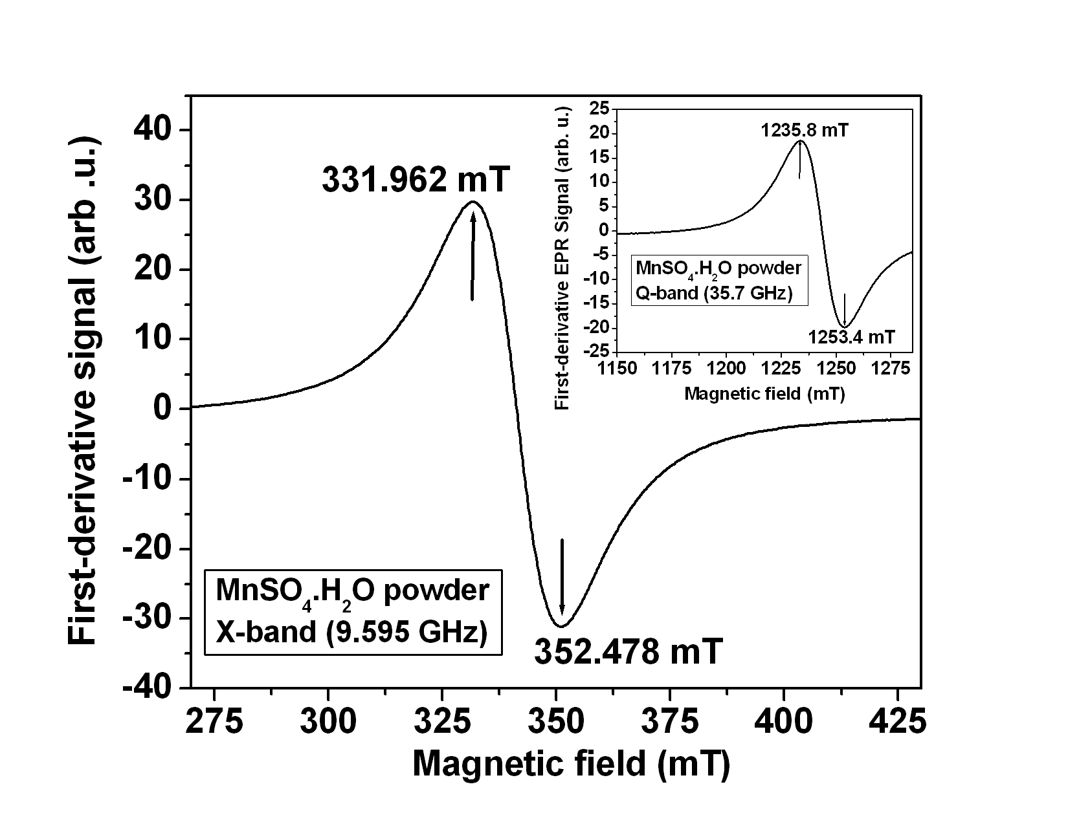

**Fig. 1.** EPR at low magnetic-fields: X-band (9.565 GHz) spectrum of a sample of MnSO4.H2O powder in the range 250 – 450 mT. The inset shows the spectrum at the low magnetic-field Q-band (35.7 GHz).

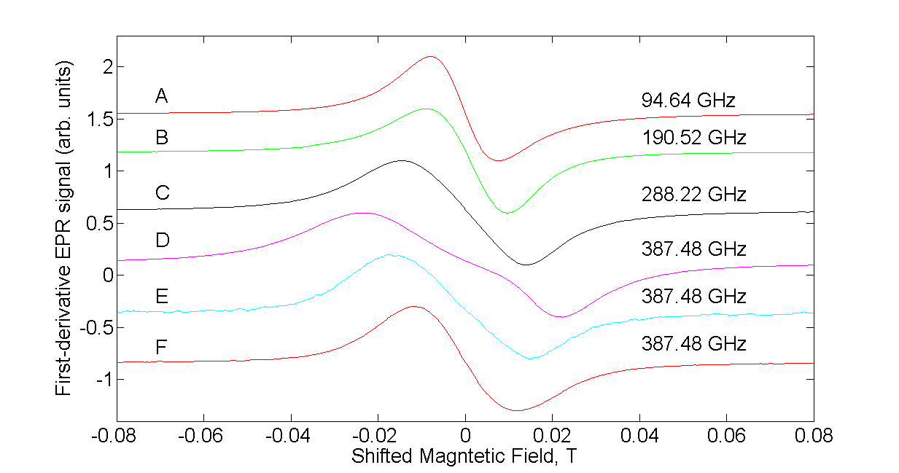

**Fig. 2.** EPR at very high magnetic-fields: EPR spectra of a sample of MnSO4.H2O powder sample mixed with grease at increasing frequencies of 94.64 (A), 190.52 (B), 288.22 (C), and 387.48 (D, E, F) GHz. Two more spectra are recorded at the highest frequency 387.48 GHz (E and F) with decreased concentration of MnSO4.H2O: (E) by a factor of 2 in grease, and (F) by an additional factor of 20 in diamagnetic KBr powder, respectively, as compared to that in D. The magnetic fields have been shifted so that the centers of the lines at different frequencies match. (The center field can be calculated using the formula *B0* = *hν/(2.0023µB.*)

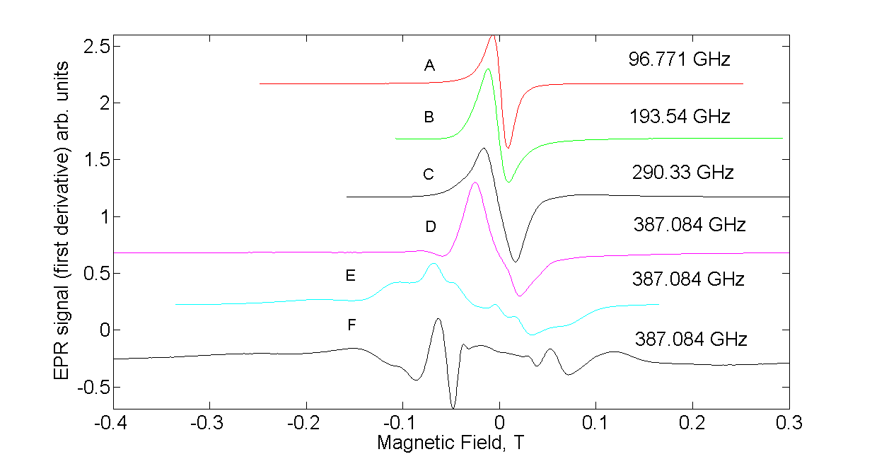

**Fig. 3.** EPR at very high magnetic-fields: EPR spectra of a sample of MnSO4.H2O powder sample mixed with grease at increasing frequencies of 94.64 (A), 190.52 (B), 288.22 (C), and 387.48 (D, E, F) GHz. Two more spectra are recorded at the highest frequency 387.48 GHz (E and F) with increased concentration of MnSO4.H2O in grease: (E) by a factor of 8, and (F) by a factor of 40, respectively, as compared to that in D. The magnetic fields have been shifted so that the centers of the lines at different frequencies match. (The center field can be calculated using the formula *B0* = *hν/(2.0023µB.*)

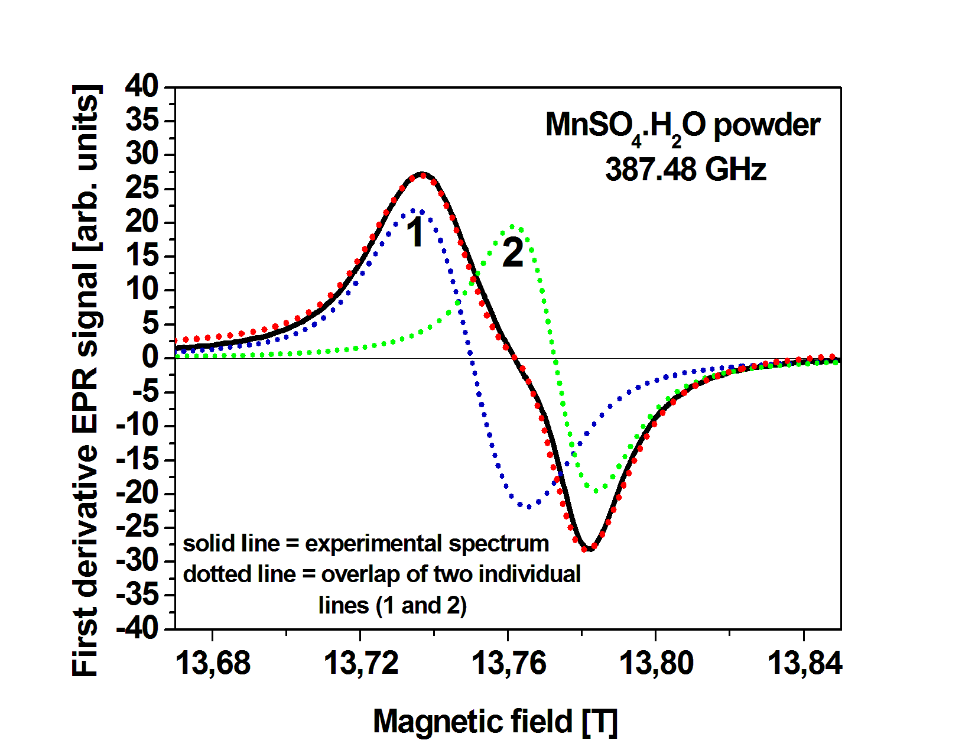

**Fig. 4.** The experimental (solid line) and simulated (dotted, superimposed on the experimental spectrum) lineshape to reproduce the experimentally observed EPR spectrum at 387.48 GHz in MnSO4.H2O powder over the magnetic-field range ~ 13.67 – 13.85 T. The parameters (g-values, linewith, % of Gaussian in Lorentzian lineshape) of the two individual lineshapes (dotted 1 and 2), whose overlap produces the experimental spectrum satisfactorily, are listed in Table 1.

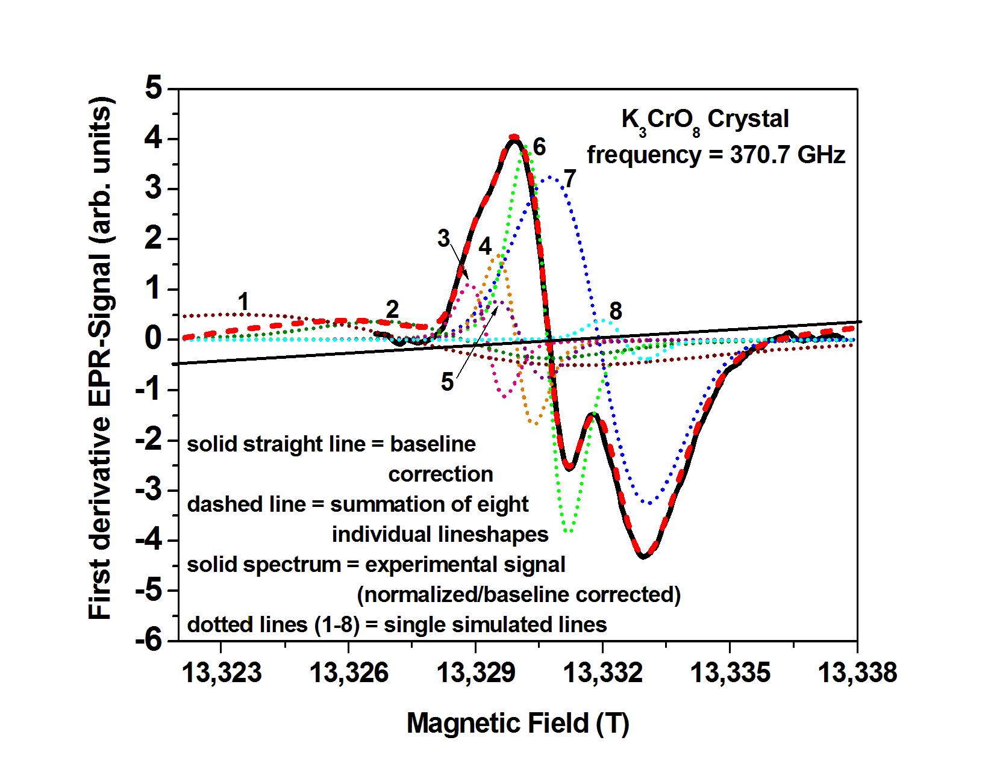

**Fig. 5.** The experimental and simulated lineshape to reproduce the experimentally observed EPR spectrum in K3CrO8 single crystal at 370.7 GHz over the magnetic-field range ~ 13.32 – 13.34 T. The parameters (g-values, linewith, % of Gaussian in Lorentzian lineshape) of the individual lineshapes (dotted lines 1 - 8), whose overlap (dashed line) produces the experimental spectrum satisfactorily, are listed in Table 2.