**The third member of the eIF4E family represses gene expression via a novel mode of recognition of the methyl-7 guanosine cap moiety**

Michael J. Osborne1&, Laurent Volpon1&, Biljana Culjkovic-Kraljcic1, Jack A. Kornblatt2 and Katherine L.B. Borden1,*

1Institute of Research in Immunology and Cancer (IRIC), Department of Pathology and Cell Biology, Université de Montréal, Pavillion Marcelle-Coutu, Chemin Polytechnique, Montreal, Qc, H3T 1J4, Canada. 2CSFG and Department of Biology, Concordia University, Montreal, Qc, H4B 1R6, Canada.

* Corresponding author. Institute of Research in Immunology and Cancer (IRIC), Université de Montréal, Pavillion Marcelle-Coutu, 2950, Chemin Polytechnique, Montreal, Qc, H3T 1J4, Canada. Phone: (514) 343-6291, Fax: (514) 343-7379. e-mail: Katherine.Borden@umontreal.ca

& these authors contributed equally to this work

**Short Title:** NMR and functional study of eIF4E3

**Keywords:** eIF4E3; NMR; m7G cap

**Abbreviations:** eIF, eukaryotic initiation factor; 4E-BP, eIF4E-binding protein; HSQC, Heteronuclear Single Quantum Correlation; rmsd, root mean square deviation; *K*d, dissociation constant; NOE, Nuclear Overhauser Effect; NOESY, Nuclear Overhauser Effect Spectroscopy; TOCSY, total correlation spectroscopy; hNOE, heteronuclear NOE; TCEP, Tris (2-carboxyethyl) phosphine; ITC, Isothermal titration calorimetry; m7G, 7-methylguanosine; m7GDP, 7-methyl guanosine 5’-diphosphate; m7GTP, 7-methyl guanosine 5’-triphosphate. PML, Promyelocytic leukemia; LFV, Lassa fever virus.

**Abstract (140/140 words)**

The eukaryotic translation initiation factor eIF4E promotes proliferation, survival and oncogenic transformation dependent on binding the methyl 7-guanosine (m7G) mRNA cap. eIF4E1/2 family members bind the m7G cap *via*  packing with two conserved aromatic residues. The third member of this family, eIF4E3, has one conserved aromatic residue replaced by a cysteine. Yet we demonstrate eIF4E3 specifically binds the m7G cap. The NMR structure of m7GDP-eIF4E3 reveals a unique mode of cap recognition among the eIF4E family which involves the conserved Trp98, the conserved Cys52 and a preceding loop, and a novel region toward the C-terminus. In cells, eIF4E3 represses both target expression and oncogenic transformation in a cap dependent manner. Leukemia patients have reduced eIF4E3 levels compared to healthy volunteers consistent with a loss of a negative regulator ~~here~~. Taken together, eIF4E3 appears to act as a tumour suppressor that represses target expression by competing with eIF4E1 for target mRNAs.

**(article: about 4600 / 4000-4500)**

The eukaryotic translation initiation factor eIF4E is a major effector of gene expression, playing key roles in mRNA translation and in the export of a subset of transcripts from the nucleus to the cytoplasm (1, 2). eIF4E is overexpressed in about 30% of human cancers and is oncogenic in cell culture and animal models (3, 4), generating significant interest in developing new cancer therapies targeting aberrant activation of eIF4E, either directly or indirectly. These include antisense targeting of eIF4E (11), 4EBP1-fusion peptides (13), inhibitors targeting the upstream mTOR pathway (5-10), eIF4E phosphorylation (12), and eIF4E interactions with eIF4G (14, 15). Targeting the m7G cap binding site of eIF4E, which was shown by mutational studies to be important for mRNA export, translation and oncogenic transformation, with ribavirin is one of the most promising strategies (16). Ribavirin is a competitive inhibitor for m7G cap, and thereby inhibits eIF4E function (17, 18). In a phase II clinical trial in leukemia, targeting eIF4E with ribavirin was correlated with clinical responses, including remissions, in several patients (16). Thus, understanding principles of cap recognition is clinically relevant.

Crystallographic studies first revealed the mode by which eIF4E bound its m7G ligand (19, 20). Here, the cap, which has a partial positive charge at pH 7.5, intercalates between two tryptophans (Trp56 and Trp102 in human eIF4E), which provide a negative charge due to their -electron clouds REF-Polish, Carberry for charge (Figure 1). The affinity of the m7G cap is enhanced uponthe addition of phosphates, which enable further interactions on the eIF4E protein via Arg157, Lys162 as well as otherresidues. Other cap binding proteins, such as VP39 and CBP20, use a similar stacking strategy to associate with the cap (21-23).

The eIF4E family consists of three members: eIF4E1 (the most commonly studied and referred to here as eIF4E), eIF4E2 (also known as eIF4E-HP) and eIF4E3 (24, 25). Like eIF4E1, eIF4E2 uses two conserved aromatic residues to pack against the m7G base of the cap. The eIF4E3 family is highly unusual in that the majority of species have only one conserved aromatic, Trp98 (in mouse equivalent to Trp102 in human eIF4E1). The second site (equivalent to Trp56 in human eIF4E1) is replaced with a cysteine residue in vertebrates (Cys52 in mouse eIF4E3; for numbering between eIF4E families refer to Fig. 1). Further, there are no aromatic residues, at least in terms of primary sequence near to Cys52, which would be positioned to act as the other aromatic.

eIF4E3 members share ~25% identity and ~50% similarity with the two other eIF4E families, and the eIF4E3 family itself is highly conserved with ~75% identity and ~85% similarity (Figure 1)REF. Very little is known about eIF4E3, either functionally (25) or structurally. Recent studies have appeared on drosophila eIF4E3 (Dm4E3) (26) and *Ascaris suum* eIF4E3 (As4E3) (27), however these actually belong to the eIF4E1 family (third eIF4E1 in those species) and are not eIF4E3 family members. Unfortunately, nomenclature for eIF4E families, and members within these families, has not evolved without confusion. Here, eIF4E3 refers to the third family of eIF4E proteins. We demonstrate that eIF4E3 specifically binds the m7G cap in cells and *in vitro*. Given the model for binding eIF4E1, it is difficult to envisage how a cysteine replaces a tryptophan, suggesting that there are fundamentally different structural and biophysical underpinnings to m7G cap recognition in eIF4E3 relative to the other eIF4E family members. Using NMR techniques we determined the structure of the apo and cap-bound forms of eIF4E3 and characterized, with isothermal titration calorimetry (ITC) and NMR, its binding properties. eIF4E3 forms interactions with residues from the C-terminus and a loop preceding Cys52 to overcome the loss of the energetically favorable cation- interactions in the absence of the Trp residue. We also show that eIF4E3 associates with proteins that regulate eIF4E1 function *in vitro*. Further, we functionally characterized eIF4E3 in cells revealing, surprisingly, that it potently inhibits expression of target mRNAs and transformation, and this depends on its unique cap binding activity. Consistent with this, we observe eIF4E3 levels are lower in specific subtypes of AML patients relative to blood specimens from healthy volunteers. This suggests that the eIF4E3 family may represent a novel set of tumor suppressors that compete with eIF4E1 to repress the expression of proliferative and survival promoting targets. This constitutes a novel mode of regulation of eIF4E1.

**Results**

**eIF4E3 specifically binds the m7G cap *in vitro***

Structures of eIF4E1 and eIF4E2 complexed with m7G cap implicate a critical role for two conserved aromatic residues in discriminating binding of m7G cap from guanosine, via cation- interactions with the positively charged ribose of m7G cap (2, 28, 29). Given eIF4E3 has an unusual Cys-Trp pair of residues in the traditional eIF4E family cap binding site (Fig. 1), we set out to determine whether eIF4E3 binds the m7G cap and, if it discriminates between the cap, guanosine and trimethylated cap. Using purified recombinant mouse eIF4E3 protein we showed by ITC that eIF4E3 bound m7GDP and m7GTP relatively tightly, with Kd’s of 7.8 M and 1.1 M, respectively. The binding affinity is reduced by 10-20 fold relative to eIF4E1 (Table 1). ITC did not detect eIF4E3 binding to GTP and GDP under similar conditions (Supplementary Fig. 1a). An NMR 1H-15N HSQC titration (Supplementary Fig. 1b) did detect a very weak association of eIF4E3 with GTP (Kd ~ 1mM) indicating ~1000-fold increase in affinity of m7G cap relative to guanosine. Taken together, our data show eIF4E3 specifically binds the m7G cap and is thus positioned to associate with mRNAs in the cell.

We then characterized the relative importance of the conserved Cys52 and Trp98 residues for cap recognition (Table1). The W98A and C52A mutants had severely impaired m7G cap binding by ITC and NMR, while NMR studies confirmed that these mutants were folded. The C52W mutant led to 3-5 fold reduction in binding relative to wildtype eIF4E3. Thus, the affinity is not improved, but rather the inverse, upon trying to reconstitute an eIF4E1 like binding site by replacement with the tryptophan. In summary, both Cys52 and Trp98 play important roles in cap recognition in eIF4E3.

**eIF4E3 represses gene expression *in vivo***

Given there were no previous studies on any aspect of the cellular function of eIF4E3, we determined the effects of eIF4E3 on eIF4E1 gene target expression and assessed the relevance of its cap binding activity. Using a specific antibody, we noted that unlike eIF4E1, eIF4E3 was not detectable in many cells lines such as fibroblasts or U2OS cells but was expressed in primary normal human peripheral mononuclear cells and in acute myeloid leukemia (AML) cell lines THP-1 and KG-1 (Supplementary Fig. 2a). Significantly, cap chromatography experiments demonstrated that endogenous eIF4E3 bound the cap in these cells where eIF4E1 is also present despite its weaker cap affinity (Figure 2A).

To examine the physiological affects of eIF4E3, we overexpressed both eIF4E3 and the W98A mutant and assessed their activity relative to eIF4E1 overexpression in NIH3T3 and U2OS cells. Cap chromatography on wild type and W98A eIF4E3 confirmed our *in vitro* results that the W98A mutation abolishes cap binding (Fig. 2b and Supplementary Fig. 2b). Immunofluorescence and confocal studies showed eIF4E3 was found in the nucleus where it formed discrete bodies and throughout the cytoplasm suggesting it plays similar roles to eIF4E1 in both mRNA export and translation (Fig. 2c). There was no change in localization of the W98A mutant relative to wildtype eIF4E3, consistent with previous studies that eIF4E1 localization was not altered by mutation of the cap binding site (Supplementary Fig. 2c) (30). To examine the functional effects, we monitored the production of known eIF4E1 mRNA export and translation targets as a function of eIF4E3 overexpression (Fig. 2c and Supplementary Fig. 2c). As expected in cells overexpressing eIF4E1, all targets examined increased relative to vector controls. Strikingly, eIF4E3 overexpression led to decreased expression of all targets examined including VEGF, c-Myc, Cyclin D1, and NBS1 in both U2OS and NIH 3T3 cells (Fig. 2d and Supplementary Fig. 2e). In contrast, the W98A mutant had little effect on target protein levels giving similar results to vector controls. Oncogenic transformation activity was assessed using anchorage dependent foci formation assays in NIH 3T3 and U2OS cells to examine effects of eIF4E3, the W98A mutant and for comparison, eIF4E1. Consistent with the above results, eIF4E3 repressed oncogenic transformation in this assay, showing no obvious increase in foci formation, but rather repressing background transformation by ~3 fold (Fig. 2e and Supplementary Fig. 2e). By contrast, eIF4E1 led to increased foci relative to vector by ~3 fold and 8 fold relative to eIF4E3. Finally to address the biological significance of these findings, we monitored eIF4E3 levels in primary human blood specimens from healthy volunteers and AML patients with previously assessed eIF4E1 levels (3). M4 and M5 AML patients have highly elevated eIF4E1 levels well generally M1 and M2 subtypes do notREFTop2003;Kraljacic2011. Here, we observe that eIF4E3 levels are substantially reduced in M4 and M5 AML patients relative to healthy volunteers (Supplementary Fig. 2a). In M1 and M2 AML specimens, eIF4E3 levels are the same as or higher than in M4/M5 patients with the exception of the one M1 case that had high eIF4E1, and again here eIF4E3 levels were reduced relative to normals. eIF4E1 levels in these specimens were reported previously REFKraljacic2011. Thus, there is an interesting correlation that in AML characterized by elevated eIF4E1, there is a concomitant loss of eIF4E3 suggesting the loss of important regulator may contribute to oncogenesis. Thus, while eIF4E3 is similar to eIF4E1 in terms of its subcellular localization, target transcripts and cap dependent activity, its functional effects are inhibitory rather than stimulatory. Thus our findings strongly suggest that eIF4E3 is a novel tumor suppressor and that it requires its cap binding activity for this function.

Having established that eIF4E3 specifically binds the m7G cap, and that this activity is biologically relevant, we determined the structures of apo and cap-bound eIF4E3 and assessed the effects of cap binding on protein dynamics.

***Chemical shift perturbation and dynamics studies elucidate regions of eIF4E3 involved in cap binding***

To characterize the cap-binding site we carried out 1H-15N HSQC chemical shift perturbation mapping and additional mutational studies. Standard methods were used to assign both the apo and cap bound forms of eIF4E3 (see methods). Separate regions incorporating Trp98 (equivalent to Trp102 in eIF4E1) and Cys52 (equivalent to Trp56 in eIFE1) were substantially affected by cap binding (Fig. 3a), consistent with our ITC and cap chromatography experiments. Surprisingly, an additional region compared with eIF4E1 or eIF4E2, was involved in cap-binding: part of the C-terminus. We tested its importance via ITC and NMR chemical shift perturbation experiments on mutants and C-terminal truncations. Residues His197, Phe200 and the C-terminal truncation from residue 199 severely impaired cap binding (Table 1) whereas deletion from residue 205 only had modest effects. Thus, unique to eIF4E3 there is a third key region required for cap recognition. The region, after His194 is highly conserved in the eIF4E3 family, but not in eIF4E2 or eIF4E1 families.

The steady-state heteronuclear {1H}-15N NOE (hNOE) data was employed to investigate motions on the ps-ns timescale for apo and m7GDP-bound eIF4E3 (Fig. 3c). Interestingly, all three sites proposed to interact with m7GDP from chemical shift perturbations exhibit decreased motions upon association with m7GDP, further evidence they are important for complex formation. Especially striking are the data for the S1-S2 loop (43-53) and residues toward the C-terminus (196-201). These regions are relatively mobile in apo-eIF4E3 (hNOE values < 0.6) which may be important for m7G cap recognition.

***The******apo eIF4E3 structure reveals a common eIF4E1 fold***

The NMR solution structure of apo eIF4E3 was determined from distance and dihedral restraints using the autoassign module in CYANA2.1 and further refined with XPLOR-NIH. As expected from the sequence similarity with eIF4E1, the structures retain the eIF4E scaffold: a central curved -sheet consisting of 7 antiparallel -strands flanked by three -helices at its convex surface (Fig. 4a). The apo eIF4E3 structure is mainly disordered at the N-terminus (residues 1-30) with a single turn -helix (0) (residues 16-20). The disorder in the N-terminus was confirmed by low hNOE values and the lack of numerous long range NOEs in this region. However, there are a small number of NOE’s between this helix and the 1 helix for apo-eIF4E3. Mutations of residues Leu16 or Leu20 to alanine, or deletion of the first 19 residues (but not the first 14 residues) clearly perturb amide resonances of residues in 1 and in particular Asn74 and Ile75 in the 1H-15N HSQC spectra (data not shown). We note that the hNOE data indicates that 0 helix is highly flexible ( Fig. 3c) and its interaction with 1 is likely transient.

***Comparison of the apo eIF4E3 with the apo eIF4E1 and apo eIF4E2***

The root-mean-square deviation (rmsd) between the mean coordinate position of eIF4E3 and eIF4E1 (32) apo forms, is 1.86 Å for backbone atoms for regular secondary structure elements (102 out of 163 residues) (Fig. 4b). At the C terminal region of eIF4E1, the loop following strand 7 is attached to the central -sheet through an 8th strand. Instead, the last 12 residues of eIF4E3 are disordered, as for eIF4E2 (29). Here, no contact with the rest of the protein was observed in any of the NOESY spectra, and deletion of the last 9 residues (199-207) did not show any perturbation in the 15N-HSQC for the amide resonances of residues in 7 of the apo eIF4E3 1H-15N HSQC spectrum (data not shown). Finally, in contrast to eIF4E1 and eIF4E2 for which no helix was detected in the S1-S2 loop, a small helix (designated 1-2) was observed in apo-eIF4E3. This helix, albeit smaller, is observed for all eIF4E members but only upon cap binding.

***The eIF4E3-cap complex reveals a novel mode of cap recognition***

The eIF4E3-m7GDP solution structure was determined using NOESY-derived NOE distance constraints. This included 36 intermolecular distance constraints (Supplementary Fig. 3) derived from a 3D 13C edited NOESY spectrum on a sample of 13C/15N labeled m7GTP with eIF4E3, and confirmed with a select-filter NOESY experiment on a 13C/15N eIF4E3 sample and unlabelled m7GDP. The eIF4E3-m7GDP solution structure is overall well-defined (**Supplementary Fig. 4**) with an rmsd of **XX** for ordered residues (30-201). The disordered N-terminus retains the helix 0, however, unlike apo-eIF4E3, long range NOEs from 0 to the rest of the eIF4E3 were not observed.

The NMR structures of apo and m7GDP eIF4E3 overlay well (Fig 5a) with an rmsd for backbone atoms of 1.2 Å for regions which are not mobile or involved in cap binding, was 1.2 Å (residues 1-35, 42-56, 92-105 and 195-207 were excluded). The per-residue rmsd between these structures (Figure 3b) highlight the major differences, which occur at the regions involved in m7G cap binding (detailed below) and the disordered N-terminus. (overall rmsd is 4.37 Å residues 30-194). Thus, similar to eIF4E1 REFVolpon2006, m7GDP binding does not induce global changes in protein structure but rather local changes mainly focused on the m7G-cap binding site.

The NMR structure of the eIF4E3-m7GDP complex reveals three distinct regions of eIF4E3 that participate in m7G-cap binding (Fig. 5b,d,e need to improve!). These regions include Trp98 which is conserved throughout all eIF4E families (Trp102 in eIF4E1), the S1-S2 loop and 1-2 helix including Cys52 (equivalent to Trp56 in eIF4E1), and a unique C-terminal site that was mobile in the apo form (Fig. 3c,d). We observed intermolecular NOEs from the side chain of Ala199 and H2 of His197 to m7GDP, which is reflected in the structure by contacts between these residues and the ribose ring. Given the proximity of Phe200 to this region, and knowledge that two aromatic residues are used to bind m7G cap in eIF4E1/2, we searched exhaustively for NOEs from the cap to Phe200. Preparation of a fully 15N, 12C, 2H-labelled except for 15N, 13C, 1H labeled Phe, Tyr and His residues eIF4E3 sample for this purpose did not detect any NOEs to the aromatic ring of Phe200. Indeed, the position of the C-terminus is on the same cap-binding face as Trp98, so an aromatic residue from this region would compete with Trp98 rather than complete a sandwich-binding site. We do note that defining the precise orientation for the m7guanosine moiety can prove difficult due to a lack of proton density (see Supplementary Figure 3b), *e.g.* only 6 1H NMR signals are observed for m7GDP (which is comprised of 44 atoms). In the phosphate-binding region the charged residues Arg152, Lys 192 and Arg 84 are sufficiently close to the phosphates in three or more of our ensemble of structures to make favorable contacts, although no constraints were added . Consistently, these backbone amide resonances were among the most affected when comparing the HSQC spectra of m7GDP and m7GTP-bound eIF4E3.

***Comparison with eIF4E1-cap structure***

Our NMR structures of eIF4E3 indicate it is unique amongst eIF4E families by not utilizing a cation-  or -  stacking aromatic sandwich to bind the cap. Instead, only residue Trp98 (equivalent to Trp102 in eIF4E1) stacks against m7GDP (Fig. 5d). Comparison with the x-ray structure of eIF4E1-m7GDP (RMSD for structural elements: 1.6Å) reveals a similar overall fold with eIF4E1(Fig. 5b-e). Cys52 which replaces the second aromatic residue in the eIF4E1 family, also makes contacts with the purine ring and the methyl group of m7GDP. The structure of eIF4E1 shows very few contacts outside the Trp sandwich to the purine ring and ribose (Fig. 5). In contrast eIF4E3 recruits the S1-S2 loop and the C-terminal arm contribute to cap binding: specifically, the side chain of Ser43, the backbone of Leu44 and Pro45 which contact the sugar, whilst backbone and side chain contacts are observed for Ala47 and Ala49 with the purine ring (Fig. 5). Additional contacts are provided by the C-terminus from residue His197 and Ala199. ITC on mutants in these regions confirms these contacts are critical to eIF4E3-m7G cap interaction (Table 1). Additionally, these residues are highly conserved in the eIF4E3 family but not in eIF4E1 and eIF4E2 (highlighted in green in Fig. 1). Thus it would appear eIF4E3 recruits additional contacts to compensate for the absence of the second aromatic residue and associated -packing. Analysis of the surfaces of the eIF4E-cap complexes (Fig. 5) reveal that in eIF4E3 the combination of interactions at both the S1-S2 loop and the C-terminus shields the cap from the solvent whereas in eIF4E1 the cap is much more solvent exposed.

The electrostatic potential map of the eIF4E3 complex shows that the purine pocket is highly negatively charged (with contributions from the  cloud of Trp98 and backbone carbonyl oxygens from the S1-S2 loop and the C-terminal arm). This may be important for forming favorable interactions with the positive charge introduced by methylation of the purine base, and therfore a determinant for differentiating m7G versus guanosine binding.

The residue Thr48 acts as an Ncap for the small helix containing Cys52, stabilizing the helix by formation of a hydrogen-bond from its side chain with the backbone of Cys52 and/or Glu51 (both are possible in our ensemble of structures). Although no direct contacts with m7GDP are observed with the side chain of Thr48, a T48A mutant reduces affinity for m7G by ~ 20-fold, similar to the C52A mutation (Table 1). It is likely that this mutant, where alanine cannot act as an Ncap, destabilizes helix formation, which in turn is important for positioning Cys52 and the S1-S2 loop for favorable interactions with m7GDP. All cap bound structures of eIF4E1, show that Trp56 (equivalent to Cys52) forms a small helix, but this helix is not formed in the apo NMR structure. Preforming this helix in apo eIF4E3 likely makes this interaction more energetically favorable. Sequence alignment amongst the eIF4E families for interacting residues in the eIF4E3 cap binding in the S1-S2 loop, including the Ncap Thr48, are highly conserved in the eIF4E3 family, but there is no similarity with eIF4E1 or eIF4E2, underscoring its importance in eIF4E3 cap recognition.

***Comparison to other cap-complexes***

Other non-eIF4E cap binding proteins, e.g. CBP20(REF) and VP39 (REF) bind the cap via cation- or - stacking arrangements using two aromatic residues similarly to eIF4E1/2. These studies indicate there is some differential importance of one or the other aromatic. For instance, alignment of Trp102 of eIF4E1 with the A-face of the m7G ligand deviates from parallel stacking compared to Trp56, where Trp102 contributes little of its 5 membered ring to the stack, Trp56 does (28). Consistently, the W102A eIF4E1 mutant retains some cap-binding activity relative to the W56A mutation, albeit substantially reduced relative to wildtype eIF4E1 (Table 1). In contrast in VP39, the contribution of Tyr22 and Phe180 to aromatic stacking is equal. Thus, the precise role of the aromatic residues differs from complex to complex. Indeed, other cap-binding proteins do chelate cap via a strategy different to  contacts from two aromatic residues. For instance, in reovirus polymerase lambda3, the m7G is sandwiched between two largely aliphatic side chains with no apparent aromatic stacking (34). In the decapping scavenger enzyme DcpS, the m7G base is stacked between Tyr175 and Leu206. Interestingly, the L206A mutation does not severely affect DcpS activity (35) suggesting that both faces of the site are not equally important for cap binding here or are readily compensated for by backbone interactions. Here we observe a half sandwich similar to DcpS but with an additional third arm that participates in stabilizing the cap-eIF4E3 interaction. Given this similarity, we tested whether eIF4E1 modification to a more DcpS type structure could be observed. We mutated Trp102 to Leu in eIF4E3, and observed a reduction in affinity but not nearly as much as with the W102A or W56A mutations consistent with the idea that eIF4E1 could also support a half sandwich cap binding mode (Table 1).

***eIF4E3 and eIF4E1 bind common partner proteins***

In addition to recognition of m7G cap, eIF4E1 function is mediated via interactions with a variety of regulatory proteins through its dorsal surface, roughly comprising residues from the N-terminus (His37, Pro38 – human eIF4E1 numbering) and residues from two helices (*e.g.* 1, Val69, Trp73 and 2, Leu131, Glu132, Leu135). Given the relatively well-conserved sequence similarity between eIF4E1 and eIF4E3 in these regions, we examined whether eIF4E3 also binds proteins known to interact with eIF4E1. The best-described family of eIF4E1 regulators include eIF4G and 4E-BPs which contain a conserved consensus binding motif, YXXXXL, where X is any residue and  any hydrophobic (36). A more recently described class includes the RING containing proteins PML and Z. NMR and ITC were employed to examine whether eIF4E3 binds full length 4E-BP1, full length 4E-BP2, a 17 residue peptide comprising the minimal binding motif of eIF4G (denoted 4Gp, see methods section for sequence) and the RING domains of LFV-Z and human PML. ITC as well as chemical shift perturbations of 15N-labelled eIF4E3 1H-15N HSQC spectra upon addition of unlabeled partner protein in molar excess showed that all tested regulators formed complexes with eIF4E3 (Fig. 6, Supp Figure XX). ITC experiments showed apparent Kd’s of 2.17 ± 0.24 M for 4E-BP1 and 1.26 ± 0.16 M for 4Gp which are weaker than observed for eIF4E1 with Kd’s of 5.93 nM and 0.15 M for full length BP1 and 4Gp respectively (37)(REF PAKU Biochem J, 2012, 237-245). These findings suggest that the dorsal surface of eIF4E3 is capable of binding factors with the YXXXXL or RING motifs.

Given that binding to eIF4G and 4E-BP1 were weaker *in vitro* than is observed for eIF4E1 (by as much as ~ 500-fold for 4E-BP1), we examined whether these factors associated with eIF4E3 in cells using immunoprecipitation of endogenous eIF4G and 4E-BP1 and overexpressed eIF4E3. Strikingly, we detect no interaction with eIF4E3 in either case (Fig. 6e) suggesting that while eIF4E3 can bind proteins with these motifs *in vitro*, eIF4E1 likely outcompetes such binding *in vivo*. Alternatively, there could be other factors with the YXXXXL consensus (or RING motifs) that preferentially bind the dorsal surface of eIF4E3 relative to eIF4E1. By way of contrast, endogenous eIF4E3 binds the cap in cells even in the presence of endogenous eIF4E1 (Fig. 2a). Taken together, our data suggest a model whereby eIF4E3 inhibits eIF4E1 activity through a competition mechanism whereby it binds the same target pool of RNAs, via the cap, sequestering them from the export and translation machinery. eIF4E3 does not compete for eIF4G or 4E-BPs in the cells we examined, suggesting that another suite of regulatory proteins likely containing YXXXXL or RING motifs exist for eIF4E3.

**Conclusions**

eIF4E3 interacts with the m7G cap in a novel way dispensing with the traditional aromatic sandwich, and yet still discriminates between m7G and guanosine with a 1000 fold greater affinity for the cap. eIF4E3 uses three distinct regions to form a pocket defined by W98, the aliphatic and backbone residues in the S1-S2 loop including Cys52, and the C-terminus. This is a unique tripartite recognition strategy not found in other cap binding proteins to date. Our data strongly suggest that eIF4E3 is a novel tumour suppressor that competes for the same pool of target transcripts as eIF4E1, repressing their expression via its novel cap binding activity. In support of this, recent studies relate the loss of eIF4E3 to the malignant phenotype in oral cancers (38) and here, we show that eIF4E3 expression is lower in M4 and M5 AML patients, with elevated eIF4E1, than healthy volunteers (Supplementary Fig. 2a). In cells, it is possible that binding key partner proteins increases the affinity of eIF4E3 for the cap enabling it to more efficiently compete and thereby suppress eIF4E1 activity. In summary, our studies indicate that eIF4E3 is a tumour suppressor targeting eIF4E1 sensitive transcripts.

**Materials and Methods**

**Expression and purification.** The plasmid containing the full-length cDNA for mouse eIF4E3 (ATCC 35709) was cloned into the pET-15b and pET-47b+ vectors (Novagen) (thrombin and Prescission protease cleavage sites, respectively) and was expressed in *Escherichia coli* BL21 (DE3) (NEB). All mutants were generated by PCR-directed mutagenesis, sequenced and cloned into similar *E. coli* expression vectors as the wild-type protein. All constructs were expressed at 37°C and induced by 0.5 mM isopropyl-**-d-thiogalactopyranoside (IPTG) at 30°C for 18 h. The harvested cells were lysed, and the cleared lysate was loaded onto Ni-NTA agarose beads. The protein was eluted with 500 mM imidazole either in PBS or TBS supplemented with 100 M TCEP for eIF4E3 coming from pET-15b or pET-47b+ vectors, respectively. The N-terminal histidine tag was cleaved by the specific protease which was added to the overnight dialysis solution. The protein was then applied to a gel filtration column (Superdex-75, Amersham Biosciences) column by FPLC. Isotopically enriched eIF4E3 wild-type and mutants were prepared from cells grown on minimal M9 media containing 1g of [15N]ammonium chloride with or without 2g of [13C6]glucose (Cambridge Isotopes Laboratory, Andover, MA). The uniformly 15N-2H labeled eIF4E3 was prepared as described (39). Typical yields were 2-6 mg/L depending on labeling level of the protein.

Uniformly 13C/15N labeled m7GTP and 13C-C7 m7GDP were synthesized from starting materials 13C/15N GTP and unlabeled GDP, respectively. 13C-labeled dimethylsulfate was used as the alkyating agent as described by Kore et al. (40). Purity of the product was confirmed by Mass spectrometry, HPLC and NMR.

RING domains of PML and Z were expressed and purified similarly to Z (41). The 4E-BP1 and 4E-BP2 plasmids were cloned into pGEX-6p1 vector. After an overnight induction at 30°C with 0.5mM IPTG, full length 4E-BPs were purified on Glutathione Sepharose 4FF following the manufacturer’s standard protocol (Amersham Biosciences, Inc.). Both proteins were further purified on a Superdex 75 gel filtration column.

**NMR spectroscopy**. The solution conditions used for NMR assignment of the apo and cap-bound eIF4E3 were 0.2 - 0.3 mM protein in 93% H2O/7% D2O containing 50 mM phosphate buffer (pH 7.0), 100 mM NaCl, 100 M TCEP, 0.02% NaN3. NMR experiments for resonance assignment were acquired at 600 MHz on a Varian INOVA spectrometer equipped with an HCN cold probe at 20 and 27ºC for the apo and cap-bound form of eIF4E3, respectively. Assignment of the main-chain atoms was achieved using the following experiments in Biopack: HNCO, HN(CA)CO, HNCA, HN(CO)CA, HNCACB, HN(CA)CB, CBCA(CO)NH; while HCCH-COSY, HCCH-TOCSY, 2D (HB)CB(CGCD)HD and 2D (HB)CB(CGCDCE)HE experiments were carried out for assignment of the 1H and 13C side chain resonances. All triple resonance experiments were acquired using non-uniform sampling acquisition schemes readily available from the Biopack software under the “Digital Filter/NLS” page in VNMRJ. Typically, 420 complex fids were accumulated using a sampling schedule corresponding to a maximum of 60 and 32 points in the 13C and 15N dimensions, respectively. Assignments were almost complete: a total of ~90 (92)% of the protons and ~80 (88)% of the carbons were unambiguously assigned for the apo (cap-bound) eIF4E3. Non-linear and linear sampled experiments were processed with RNMRTK (<http://webmac.rowland.org/rnmrtk/>) and NMRPipe (42) respectively. Analysis of NMR data was performed using Sparky (43) or NMRView (44). Chemical shift data are available from the BioMagResBank under accession no. XXXX (apo-eIF4E3) and XXXX (m7GDP-eIF4E3 complex).

Steady-state heteronuclear {1H}-15N NOE spectra were recorded in an interleaved manner in which each sequential fid was recorded with and without 4 seconds of presaturation plus a 1 second recycle delay using the pulse sequence from Biopack. Errors for the heteronuclear NOE values were estimated from the root mean square variation of noise in empty regions of the two spectra as described previously (45).

**Structure calculation for the apo-eIF4E3 and m7GDP-eIF4E3**

Three-dimensional 15N-edited NOESY, 13C-edited NOESY (conducted in both H2O and D2O), and 13C-aromatic-edited NOESY (in D2O) spectra with a mixing time of 100 ms recorded at 800 and 600 MHz were used to obtain distance restraints. For the m7G-cap bound structure, intermolecular NOEs were obtained from the following experiments: 3D 15N-edited NOESY on a 2H-15N labeled eIF4E3 sample bound to m7GDP, 3D 13C-edited NOESY on 13C/15N-labeled eIF4E3 and 13C/15N m7GTP and a 13C C7-labeled m7GDP sample and a 13C-edited select filter experiment on a 13C/15N eIF4E3 and unlabeled m7GDP. In addition, a selectively labeled aromatic sample was generated to identify aromatic interactions with the m7G cap.

Backbone  and  dihedral angle restraints were generated from secondary shifts of the 1H, 13C, 13C, 13C’ and 15N nuclei shifts using the program TALOS+ (33). In total, 253 and 275 ** and ** dihedral angle restraints were used in the structure calculation for apo and m7G cap bound eIF4E3, respectively. Also, a lyophilized sample of 15N-labeled eIF4E3 was dissolved in D2O, and 1H-15N HSQC experiments were collected immediately after re-suspension. Resonances that exchanged slowly enough to be protected from exchange were considered hydrogen-bonded. The hydrogen-bonded partners were determined based on preliminary structures calculated using only NOE restraints. Slowly exchanging amides with ambiguous attribution of the bonded partner were not constrained. For each hydrogen bond, two distance restraints were applied for HN(*i*)-O(*j*) and N(*i*)-O(*j*)..

Structures were generated in an automated manner using the torsion angle dynamics program CYANA 2.1 (46). For the m7GDP bound structure, intermolecular NOE’s were manually assigned and included as an upper limit distance restraint file in the automated NOE analysis in CYANA 2.1. The m7GDP ligand was generated using the pdb2reslib program (http://fermi.pharm.hokudai.ac.jp/olivia/) and manually edited to adhere to CYANA format. The final upper limit distances determined from Cyana were increased by 10% then converted to Xplor format. The conformer with the lowest target function was then subjected to a simulated annealing protocol for structure refinement using XPLOR-NIH (25). The m7GDP ligand was treated as a rigid body using the IVM in Python XPLOR-NIH. The apo eIF4E3 structure was refined with residual dipolar couplings (RDCs). No RDC values were determined for the m7G cap eIF4E3 structure, since substantial chemical shift perturbations were seen upon addition of the alignment mediun (PEG/hexanol) were observed, in particular for residues around the m7G cap binding site. For the apo-eIF4E3 structure the RDCs were measured by calculating the difference between 1H and 15N coupling for isotropic and partially aligned samples. Clore et al. (47) have shown that the axial and rhombic components of the alignment tensor (*D*a and *R*) can be estimated from the high and low extreme values and from the most populated value in a histogram showing the distribution of residual dipolar couplings. From the distribution of RDCs measured in a medium composed of PEG/hexanol (48), the predicted values were found to be *D*a = 9.35 Hz and *R* = 0.42. A grid search (49) method was then employed to obtain the optimal *D*a and *R* values, using XPLOR. In the grid search, lowest overall energies were used as a target function and *D*a was varied from 5 to 12 Hz and *R* was varied from 0.20 to 0.60. The grid search identified optimal values of *D*a = 7.50 Hz and *R* = 0.42, very close to the original values.

The quality of structures obtained was assessed with PROCHECK (50) and Molprobity (51) without the unstructured residues. The graphic representations of the three-dimensional structures were performed using MOLMOL (52) or PyMOL (53). Coordinates were deposited in the Protein Data Bank under PDB ID code XXX and XX for apo and m7G cap-eIF4E3.

**NMR titrations and Isothermal titration calorimetry.** The different eIF4E3 protein samples, as well as the wild-type and mutant human eIF4E1 proteins, the full-length 4E-BP1 and 4E-BP2 proteins (cloned into the pET-15b vector), were prepared using the same protocol described below. The protein Z as well as the RING fragment of the PML protein (residues 48-128) were expressed and purified as described (41). The eIF4G peptide (4Gp) (816-KKQYDREFLLDFQFMPA-832) was synthesized by fluorenylmethoxycarbonyl (Fmoc) solid-phase peptide synthesis and purified by reverse phase chromatography on a C18 Vydac (Hesperia, CA) column. The composition and purity of the peptide was verified by ion-spray quadrupole mass spectroscopy.

The NMR titrations of eIF4E1/4E3 (~200M) and their mutants with the different ligands (cap analogues, regulatory proteins) were followed by 15N-1H HSQC spectra recorded at 20°C at different molar ratios (up to1:60 for weaker complexes). The concentrated unlabeled partners were added to both 15N-labeled eIF4E proteins and chemical shift perturbations for each resonance were calculated using the equation obs = [(HN2 + N2/25)/2]1/2 (54). The dissociation constants were estimated based on the changes in the chemical shifts of selected amino acids upon addition of ligand and fitting the experimental data to the quadratic equation:

obs =max(*Kd*+[*P*]*t*+[*L*]*t*-{(*KD*+[*P*]*t* +[*L*]*t*)2-(4[*P*]*t*[*L*]*t*)}1/2 )/2[*P*]*t* ,

where obs is the observed chemical shift at with different concentration of ligand [L]t and [P]t is the protein concentration. Kd values were estimated for multiple resonances and an average value reported. Isothermal titration Calorimetry (ITC) was performed with a Microcal VP-ITC calorimeter, operating at 20°C. The data were analyzed with Origin software (Northhampton, Mass.).

PDB accession for both structures is ongoing.

**Acknowledgements**

We would like to thank the Canadian National High Field NMR Centre (NANUC) for their assistance and use of their 800 MHz spectrometers. We are grateful to Dr Pierre Thibault and Dr Eric Bonneil (Proteomic platform, IRIC, Montreal) for use of the mass spectrometer and their expertise. Research was supported by NIH R01 80728 and a Translational Research Program grant from the Leukemia and Lymphoma Society. The ITC determinations were supported in part by an NSERC grant to JAK. K.L.B.B. holds a Canada Research Chair.

Table 1. Thermodynamic parameters measured by ITC for cap binding to wild-type and mutants eIF4E3 and eIF4E1.

eIF4E variant cap analog *K*d (M)

eIF4E3 WT m7GDP 7.7 ± 0.3

eIF4E3 WT m7GTP 1.8 ± 0.1

eIF4E3 WT GDP NB*a*

eIF4E3 WT GTP 925 ± 80*b*

eIF4E3 T48A m7GDP 128.9 ± 12.9

eIF4E3 T48A m7GTP 31.4 ± 1.5

eIF4E3 C52A m7GDP NB*a*

eIF4E3 C52A m7GTP 123.9 ± 10.9

eIF4E3 C52W m7GDP 24.9 ± 6.5

eIF4E3 C52W m7GTP 10.0 ± 0.6

eIF4E3 W98A m7GDP NB*a*

eIF4E3 W98A m7GTP NB*a*

eIF4E3 H197A m7GDP 64.9 ± 3.2

eIF4E3 F200A m7GDP 324 ± 46*b*

eIF4E3 F200A m7GTP NB*a*

eIF4E3 205-207 m7GDP 12.9 ± 0.8

eIF4E3 205-207 m7GTP 7.1 ± 0.5

eIF4E3 199-207 m7GDP NB*a*

eIF4E3 199-207 m7GTP NB*a*

eIF4E1 WT m7GDP 0.17 ± 0.03

eIF4E1 WT m7GTP 0.14 ± 0.02

eIF4E1 W56A m7GTP 40.63 ± 4.16

eIF4E1 W102A m7GTP 16.81 ± 3.50

*a*No binding observed. *bK*d values determined by NMR spectroscopy.

**Figure legends**

**Figure 1:** Alignment of amino acid sequences of the three eIF4E families. Numbers and secondary structures are shown above the sequences for eIF4E1 and eIF4E3. The mouse eIF4E3 (studied in this paper) is shown on the top. The pair of tryptophan residues important for cap recognition in eIF4E1 and eIF4E2 (see text) are labeled in red and corresponding residues in eIF4E3 are in blue. The other residues important for cap recognition in eIF4E3 are highlighted in yellow (in Vertebrata).

**Figure 2:** Functional analysis of eIF4E3 activity. (a) Cap column chromatography with THP-1 and KG lysates. (b) NIH 3T3 cells stably overexpressing Myc-tagged eIF4E3 wildtype, W98A mutant, eIF4E1 or vector control were used for cap column chromatography. Cap bound and unbound samples were analyzed by Western blot (WB), confirming that W98 is essential for cap recognition. (c) U2OS cells overexpressing Xpress-tagged eIF4E3 and appropriate vector control were analyzed by immunofluorescence in conjunction with confocal microscopy with indicated antibodies to assess eIF4E subcellular localization. Magnification 100x. (d) NIH 3T3 cells were analyzed by WB with indicated antibodies to assess effect of eIF4E3 expression on eIF4E1 targets. (e) Foci assays in NIH 3T3 cells stably transfected as indicated. Representative of three independent experiments. Error bars indicate SD.

**Figure 3:** Effects of m7GDP binding on eIF4E3 (a) Per-residue plot of chemical shift perturbations at a ratio 1:20 (eIF4E3/m7GDP). The secondary-structure elements are indicated below. (b) Per-residue rmsd between the lowest energy conformers of apo and m7GDP-bound eIF4E3. Superposition was based on residues 30-201. The unstructured regions in both structures are hatched. (c) hNOEs for backbone amide nitrogens of the apo-eIF4E3 (top) and m7GDP-eIF4E3 (bottom).

**Figure 4:** Structural comparison of the three different classes of eIF4E in their apo form. (a) Superposition of the 10 lowest-energy NMR structures of eIF4E3. Side chain of Trp98 is shown. (b) Representative structure of the ensemble of NMR structures for eIF4E1 (PDB: 2GPQ) (32). (c) Crystal structure of human eIF4E2 (PDB: 2JGC) (29). Note that the Tyr78-containing loop (equivalent to Trp56 in human eIF4E1) and the C-terminal end were not located in the electron density map.

**Figure 5:** NMR solution structure of the m7GDP-eIF4E3. (a) Overlay of the apo-eIF4E (cyan) and m7GDP-eIF4E3 (blue) structures. (b) and (c) Electrostatic potential and surface representation of eIF4E3-cap and eIF4E1-cap structures, respectively. (d) Stacking of the cap (yellow) purine ring and Trp98 (red) in eIF4E3-cap. (e) eIF4E3-cap interactions, from the S1-S2 loop and the C-terminal residues. (f) eIF4E1 interaction with cap is dominated by the conserved Trp56 and Trp102.

**Figure 6:** Superposition of the 1H-15N HSQC spectrum of the apo-eIF4E3 (red) with either the eIF4E3/4E-BP1 (dark green, a), eIF4E/4Gp (light green, b), eIF4E3/PML RING (cyan, c) or eIF4E3/LFV Z (dark blue, d). For the NMR measurements, the different regulators tested here were all saturated (five- to ten-fold molar excess compared to eIF4E3) on the basis of the titration experiments. (e) Immunoprecipitation by c-Myc antibody from NIH 3T3 cells stably overexpressing eIF4E3 wildtype, W98A mutant or eIF4E1. WB analysis of immunoprecipitated complexes revealed absence of eIF4E3 interaction with 4E-BP1 and eIF4G *in vivo*. L.Ch. indicates antibody light chain.

**References**

1. Culjkovic B, Topisirovic I, & Borden KL (2007) Controlling gene expression through RNA regulons: the role of the eukaryotic translation initiation factor eIF4E. *Cell Cycle* 6(1):65-69.

2. von der Haar T, Gross JD, Wagner G, & McCarthy JE (2004) The mRNA cap-binding protein eIF4E in post-transcriptional gene expression. *Nat Struct Mol Biol* 11(6):503-511.

3. Topisirovic I*, et al.* (2003) Aberrant eukaryotic translation initiation factor 4E-dependent mRNA transport impedes hematopoietic differentiation and contributes to leukemogenesis. *Mol Cell Biol* 23(24):8992-9002.

4. Graff JR & Zimmer SG (2003) Translational control and metastatic progression: enhanced activity of the mRNA cap-binding protein eIF-4E selectively enhances translation of metastasis-related mRNAs. *Clin Exp Metastasis* 20(3):265-273.

5. Xue Q*, et al.* (2008) Palomid 529, a novel small-molecule drug, is a TORC1/TORC2 inhibitor that reduces tumor growth, tumor angiogenesis, and vascular permeability. *Cancer Res* 68(22):9551-9557.

6. Feldman ME*, et al.* (2009) Active-site inhibitors of mTOR target rapamycin-resistant outputs of mTORC1 and mTORC2. *PLoS Biol* 7(2):e38.

7. Thoreen CC*, et al.* (2009) An ATP-competitive mammalian target of rapamycin inhibitor reveals rapamycin-resistant functions of mTORC1. *J Biol Chem* 284(12):8023-8032.

8. Yu K*, et al.* (2010) Beyond rapalog therapy: preclinical pharmacology and antitumor activity of WYE-125132, an ATP-competitive and specific inhibitor of mTORC1 and mTORC2. *Cancer Res* 70(2):621-631.

9. Garcia-Martinez JM*, et al.* (2009) Ku-0063794 is a specific inhibitor of the mammalian target of rapamycin (mTOR). *Biochem J* 421(1):29-42.

10. Chresta CM*, et al.* (2010) AZD8055 is a potent, selective, and orally bioavailable ATP-competitive mammalian target of rapamycin kinase inhibitor with in vitro and in vivo antitumor activity. *Cancer Res* 70(1):288-298.

11. Graff JR*, et al.* (2007) Therapeutic suppression of translation initiation factor eIF4E expression reduces tumor growth without toxicity. *J Clin Invest* 117(9):2638-2648.

12. Zhang M*, et al.* (2008) Inhibition of polysome assembly enhances imatinib activity against chronic myelogenous leukemia and overcomes imatinib resistance. *Mol Cell Biol* 28(20):6496-6509.

13. Borden KL (2009) Tissue targeting in cancer: eIF4E's tale. *Clin Cancer Res* 15(13):4254-4255.

14. Moerke NJ*, et al.* (2007) Small-molecule inhibition of the interaction between the translation initiation factors eIF4E and eIF4G. *Cell* 128(2):257-267.

15. Tamburini J*, et al.* (2009) Protein synthesis is resistant to rapamycin and constitutes a promising therapeutic target in acute myeloid leukemia. *Blood* 114(8):1618-1627.

16. Assouline S*, et al.* (2009) Molecular targeting of the oncogene eIF4E in acute myeloid leukemia (AML): a proof-of-principle clinical trial with ribavirin. *Blood* 114(2):257-260.

17. Kentsis A, Topisirovic I, Culjkovic B, Shao L, & Borden KL (2004) Ribavirin suppresses eIF4E-mediated oncogenic transformation by physical mimicry of the 7-methyl guanosine mRNA cap. *Proc Natl Acad Sci U S A*.

18. Kentsis A*, et al.* (2005) Further evidence that ribavirin interacts with eIF4E. *Rna* 11(12):1762-1766.

19. Marcotrigiano J, Gingras AC, Sonenberg N, & Burley SK (1997) Cocrystal structure of the messenger RNA 5' cap-binding protein (eIF4E) bound to 7-methyl-GDP. *Cell* 89(6):951-961.

20. Niedzwiecka A*, et al.* (2002) Biophysical studies of eIF4E cap-binding protein: recognition of mRNA 5' cap structure and synthetic fragments of eIF4G and 4E-BP1 proteins. *J Mol Biol* 319(3):615-635.

21. Hu G, Gershon PD, Hodel AE, & Quiocho FA (1999) mRNA cap recognition: dominant role of enhanced stacking interactions between methylated bases and protein aromatic side chains. *Proc Natl Acad Sci U S A* 96(13):7149-7154.

22. Hodel AE, Gershon PD, Shi X, Wang SM, & Quiocho FA (1997) Specific protein recognition of an mRNA cap through its alkylated base. *Nat Struct Biol* 4(5):350-354.

23. Calero G*, et al.* (2002) Structural basis of m7GpppG binding to the nuclear cap-binding protein complex. *Nat Struct Biol* 9(12):912-917.

24. Joshi B, Cameron A, & Jagus R (2004) Characterization of mammalian eIF4E-family members. *Eur J Biochem* 271(11):2189-2203.

25. Joshi B, Lee K, Maeder DL, & Jagus R (2005) Phylogenetic analysis of eIF4E-family members. *BMC Evol Biol* 5:48.

26. Hernandez G*, et al.* (2012) Eukaryotic initiation factor 4E-3 is essential for meiotic chromosome segregation, cytokinesis and male fertility in Drosophila. *Development*.

27. Liu W*, et al.* (2011) Structural basis for nematode eIF4E binding an m(2,2,7)G-Cap and its implications for translation initiation. *Nucleic Acids Res* 39(20):8820-8832.

28. Quiocho FA, Hu G, & Gershon PD (2000) Structural basis of mRNA cap recognition by proteins. *Curr Opin Struct Biol* 10(1):78-86.

29. Rosettani P, Knapp S, Vismara MG, Rusconi L, & Cameron AD (2007) Structures of the human eIF4E homologous protein, h4EHP, in its m7GTP-bound and unliganded forms. *J Mol Biol* 368(3):691-705.

30. Culjkovic B, Topisirovic I, Skrabanek L, Ruiz-Gutierrez M, & Borden KL (2005) eIF4E promotes nuclear export of cyclin D1 mRNAs via an element in the 3'UTR. *J Cell Biol* 169(2):245-256.

31. Lazaris-Karatzas A, Montine KS, & Sonenberg N (1990) Malignant transformation by a eukaryotic initiation factor subunit that binds to mRNA 5' cap. *Nature* 345(6275):544-547.

32. Volpon L, Osborne MJ, Topisirovic I, Siddiqui N, & Borden KL (2006) Cap-free structure of eIF4E suggests a basis for conformational regulation by its ligands. *Embo J* 25(21):5138-5149.

33. Shen Y, Delaglio F, Cornilescu G, & Bax A (2009) TALOS+: a hybrid method for predicting protein backbone torsion angles from NMR chemical shifts. *J Biomol NMR* 44(4):213-223.

34. Tao Y, Farsetta DL, Nibert ML, & Harrison SC (2002) RNA synthesis in a cage--structural studies of reovirus polymerase lambda3. *Cell* 111(5):733-745.

35. Gu M*, et al.* (2004) Insights into the structure, mechanism, and regulation of scavenger mRNA decapping activity. *Mol Cell* 14(1):67-80.

36. Mader S, Lee H, Pause A, & Sonenberg N (1995) The translation initiation factor eIF-4E binds to a common motif shared by the translation factor eIF-4 gamma and the translational repressors 4E-binding proteins. *Mol Cell Biol* 15(9):4990-4997.

37. Marcotrigiano J, Gingras AC, Sonenberg N, & Burley SK (1999) Cap-dependent translation initiation in eukaryotes is regulated by a molecular mimic of eIF4G. *Mol Cell* 3(6):707-716.

38. Shi T*, et al.* (2010) cDNA microarray gene expression profiling of hedgehog signaling pathway inhibition in human colon cancer cells. *PLoS One* 5(10).

39. Gardner KH & Kay LE (1998) The use of 2H, 13C, 15N multidimensional NMR to study the structure and dynamics of proteins. *Annu Rev Biophys Biomol Struct* 27:357-406.

40. Kore AR & Parmar G (2006) An industrial process for selective synthesis of 7-methyl guanosine 5'-diphosphate: versatile synthon for synthesis of mRNA cap analogues. *Nucleosides Nucleotides Nucleic Acids* 25(3):337-340.

41. Volpon L, Osborne MJ, Capul AA, de la Torre JC, & Borden KL (2010) Structural characterization of the Z RING-eIF4E complex reveals a distinct mode of control for eIF4E. *Proc Natl Acad Sci U S A* 107(12):5441-5446.

42. Delaglio F*, et al.* (1995) NMRPipe: a multidimensional spectral processing system based on UNIX pipes. *J Biomol NMR* 6(3):277-293.

43. Goddard TD & Kneller DG (2003) Sparky 3, University of California, San Francisco, CA.

44. Johnson BA & Blevins RA (1994) NMRView: A computer program for the visualization and analysis of NMR data. *J. Biomol. NMR* 4:603-614.

45. Dutta K, Shi H, Cruz-Chu ER, Kami K, & Ghose R (2004) Dynamic influences on a high-affinity, high-specificity interaction involving the C-terminal SH3 domain of p67phox. *Biochemistry* 43(25):8094-8106.

46. Herrmann T, Guntert P, & Wuthrich K (2002) Protein NMR structure determination with automated NOE assignment using the new software CANDID and the torsion angle dynamics algorithm DYANA. *J Mol Biol* 319(1):209-227.

47. Clore GM, Gronenborn AM, & Bax A (1998) A robust method for determining the magnitude of the fully asymmetric alignment tensor of oriented macromolecules in the absence of structural information. *J Magn Reson* 133(1):216-221.

48. Ruckert M & Otting G (2000) Alignment of biological macromolecules in novel nonionic liquid crystalline media for NMR experiments. *J. Am. Chem. Soc.* 122:7793-7797.

49. Clore GM, Gronenborn AM, & Tjandra N (1998) Direct structure refinement against residual dipolar couplings in the presence of rhombicity of unknown magnitude. *J Magn Reson* 131(1):159-162.

50. Laskowski RA, MacArthur MW, Moss DS, & Thornton JM (1993) PROCHECK: a program to check the stereochemical quality of protein structures. *J. Appl. Crystallogr.* 26:283-291.

51. Davis IW*, et al.* (2007) MolProbity: all-atom contacts and structure validation for proteins and nucleic acids. *Nucleic Acids Res* 35(Web Server issue):W375-383.

52. Koradi R, Billeter M, & Wuthrich K (1996) MOLMOL: a program for display and analysis of macromolecular structures. *J Mol Graph* 14(1):51-55.

53. The PyMOL Molecular Graphics System Vrp, Schrödinger, LLC (

54. Grzesiek S*, et al.* (1996) The solution structure of HIV-1 Nef reveals an unexpected fold and permits delineation of the binding surface for the SH3 domain of Hck tyrosine protein kinase. *Nat Struct Biol* 3(4):340-345.

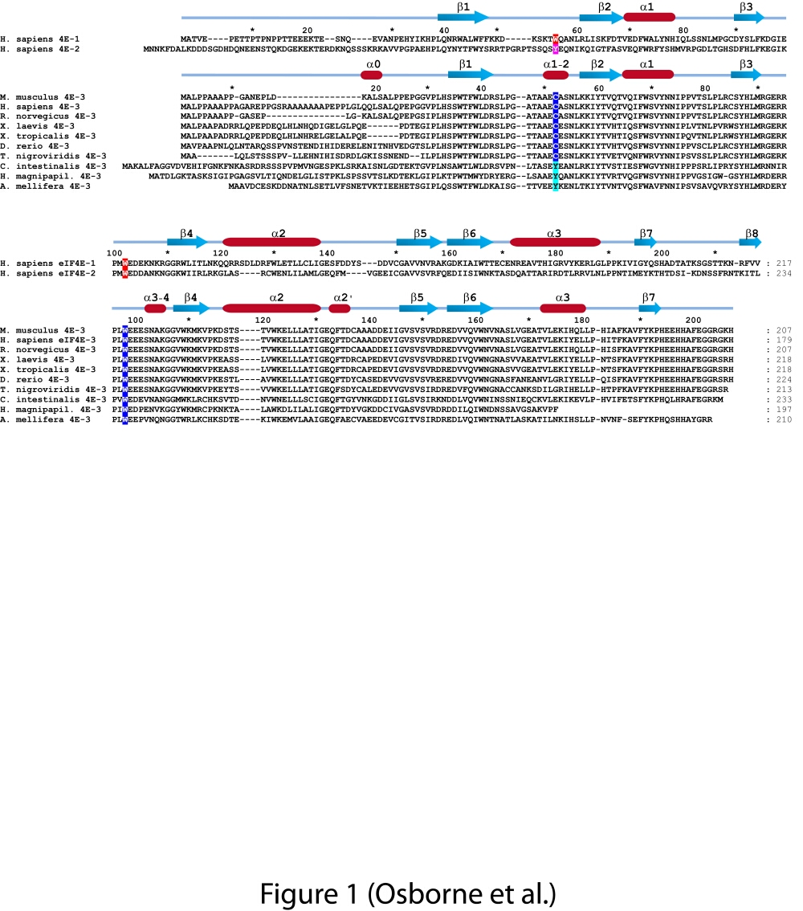

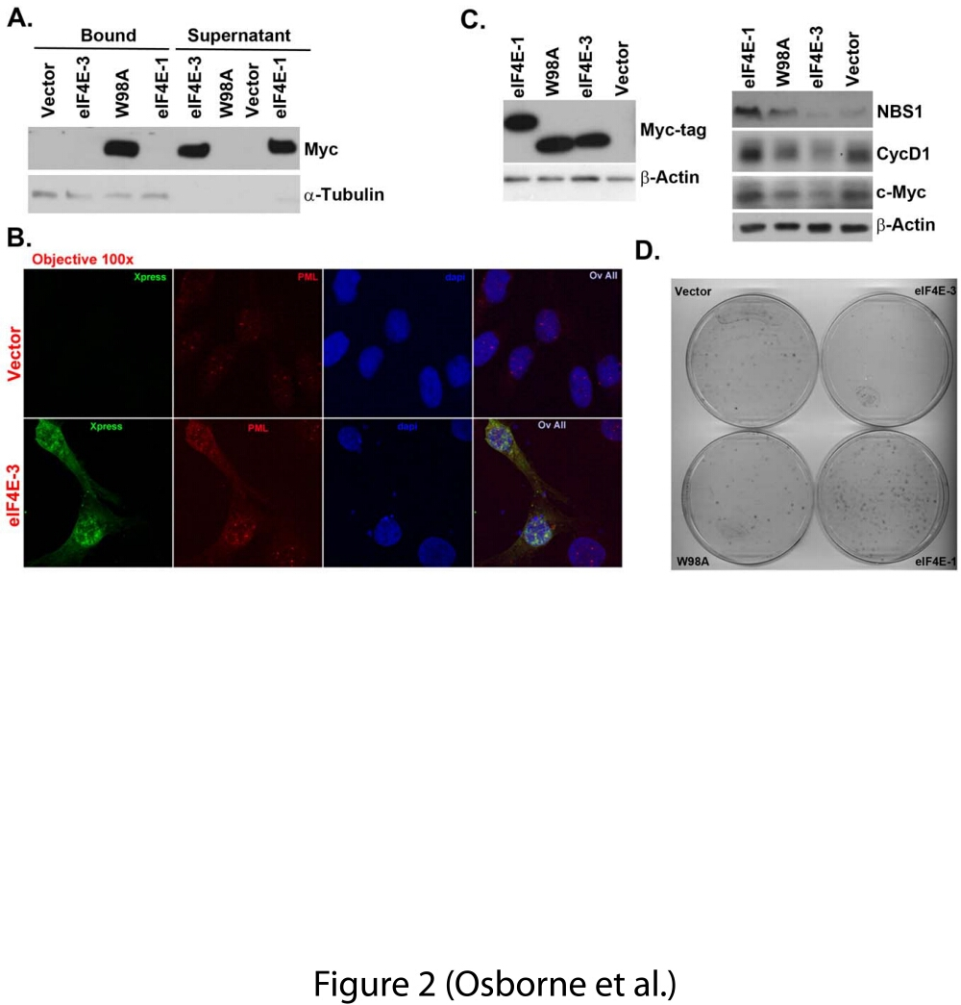

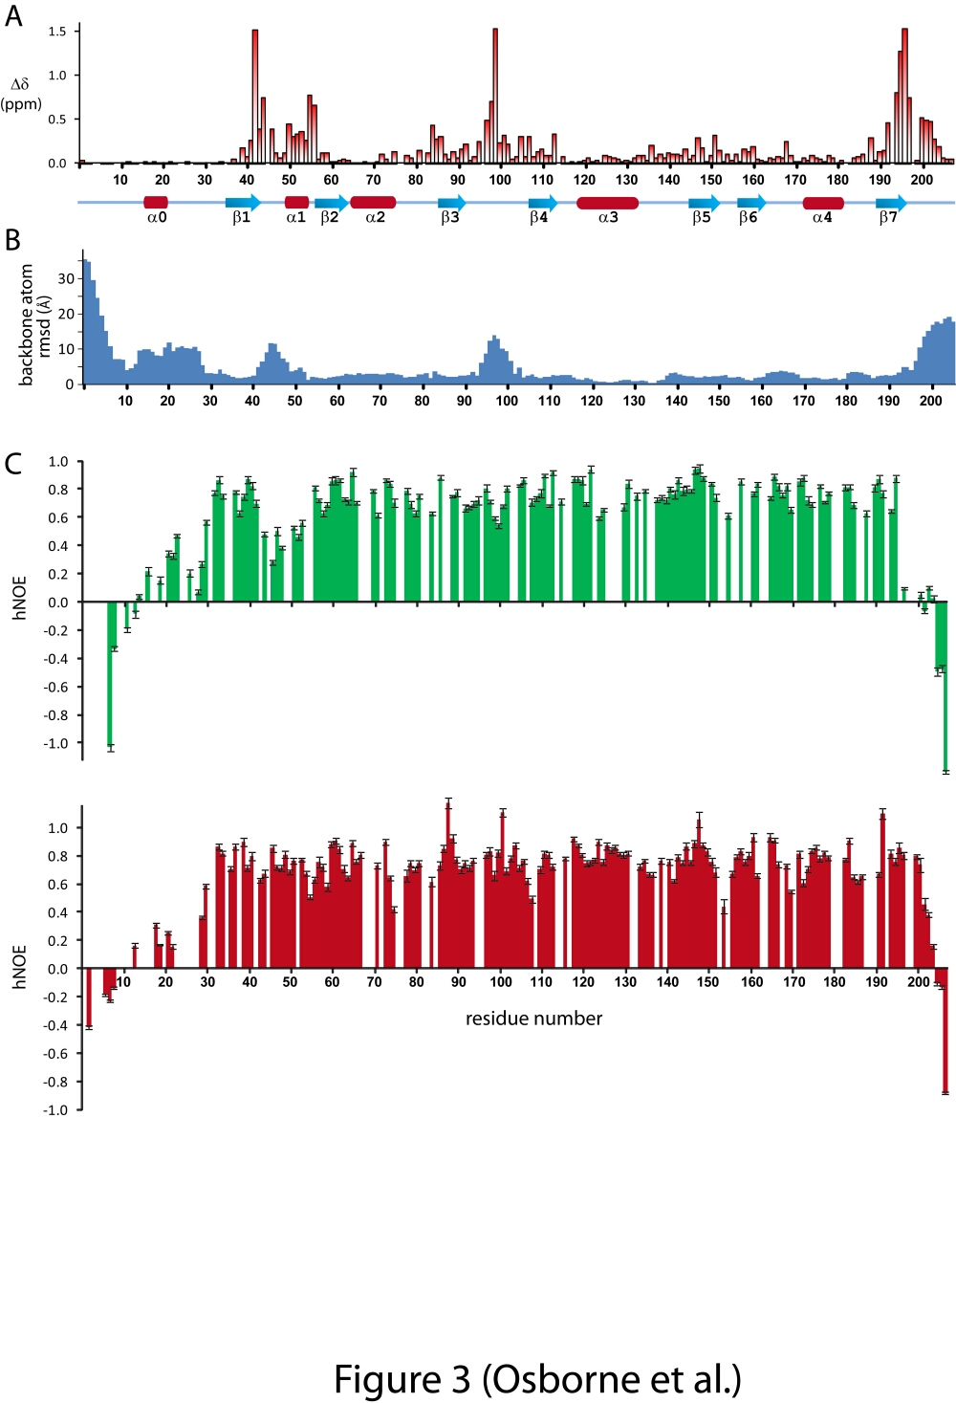

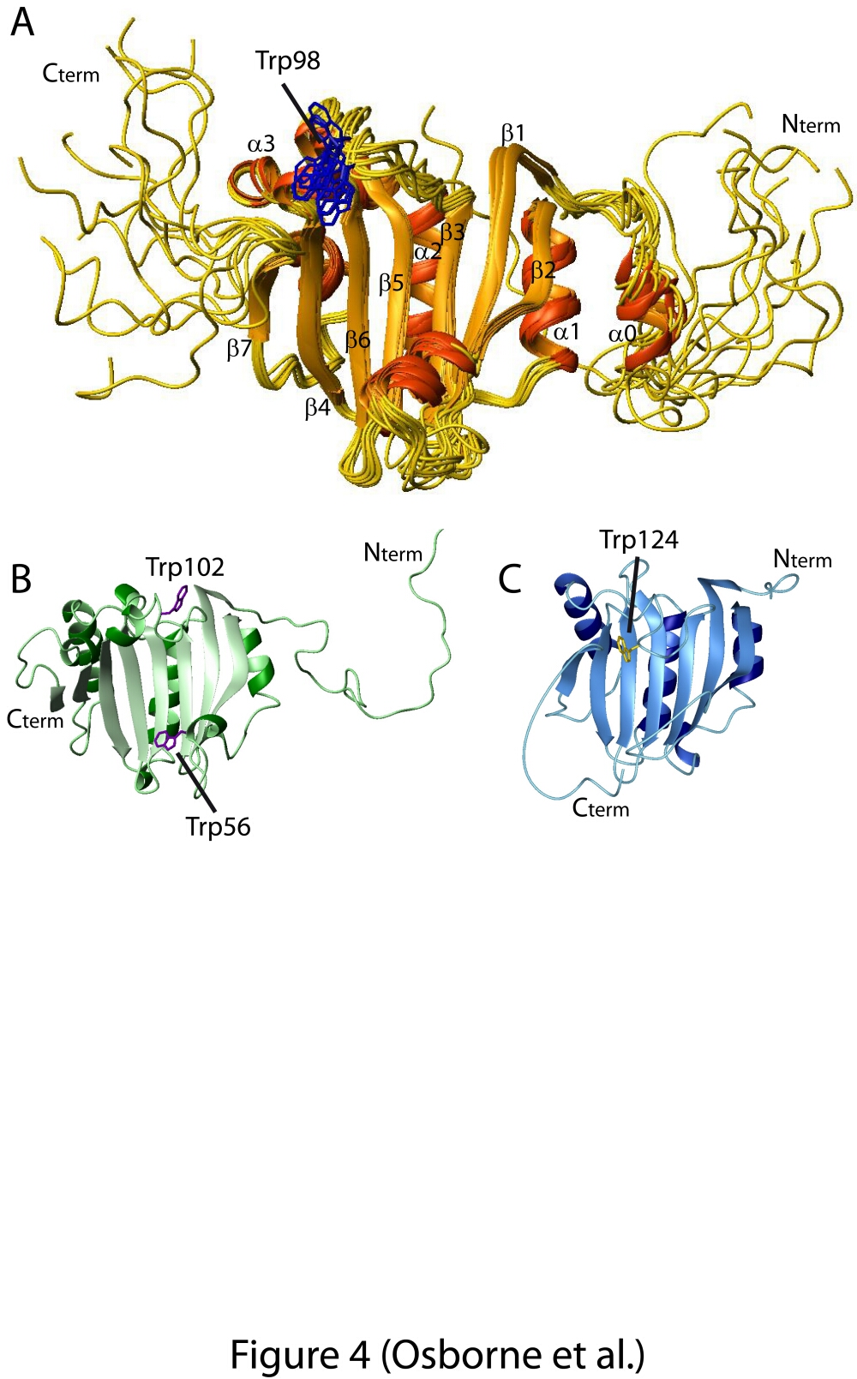

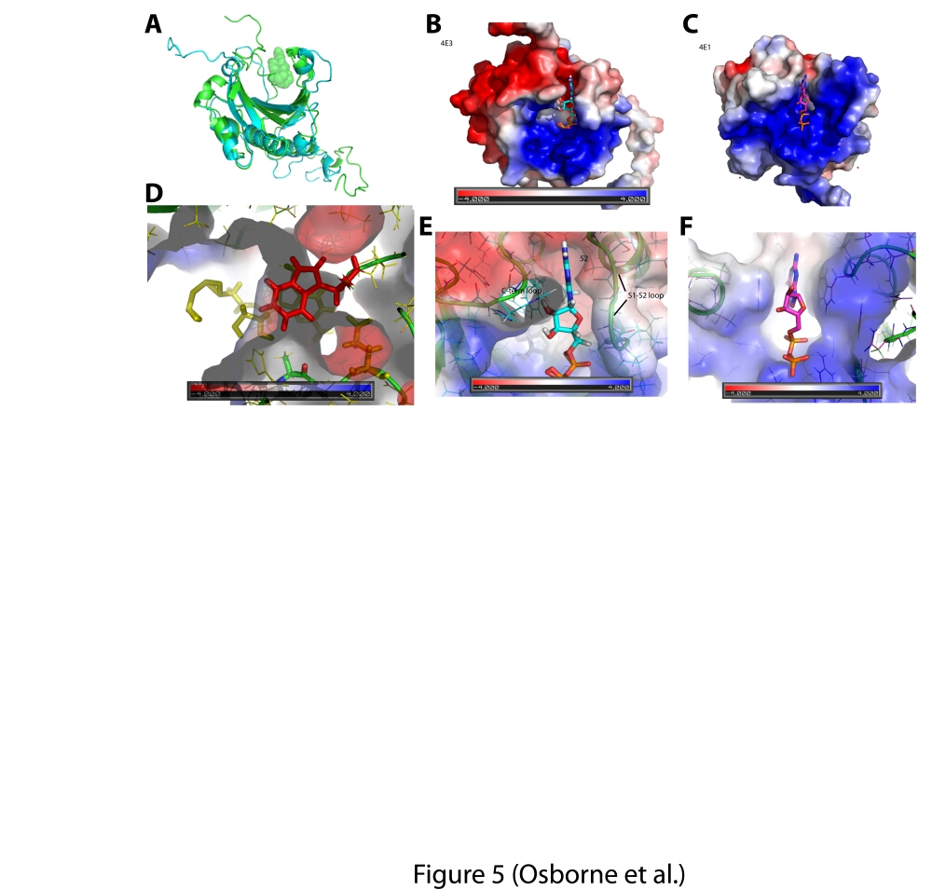

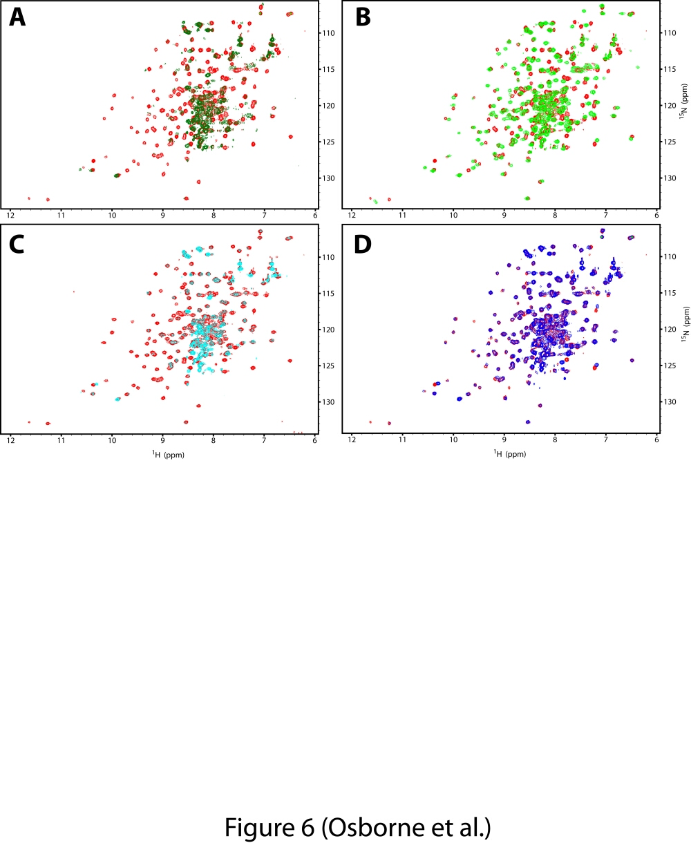



Supplementary Fig. 1 (a &b)