Flame-made TiO₂(B)
Keroles B. Riad¹, Paula M. Wood-Adams¹, Karsten Wegner²*
1) Laboratory for the Physics of Advanced Materials, Department of Mechanical and Industrial Engineering, Concordia University, Montreal, Canada.
2) Particle Technology Laboratory, Institute of Process Engineering, Department of Mechanical and Process Engineering, ETH Zürich, Sonneggstrasse 3, CH-8092 Zürich, Switzerland.

*Corresponding Author
wegner@ptl.mavt.ethz.ch

Abstract: Titania nanoparticles containing both monoclinic (TiO₂(B) – a promising battery material and catalyst) and anatase crystal phases are synthesized with a low-cost, scalable flame spray pyrolysis (FSP) process, as confirmed by X-ray diffraction, transmission electron microscopy and Raman spectroscopy. The latter reveals TiO₂(B) contents of up to 27 % in the crystalline phase fraction. The amount of TiO₂(B) increases as the time for nanoparticle growth in the flame decreases through quenching with ambient air. It can be controlled by varying the flow rates of precursor solution and dispersion oxygen into the flame. The FSP-made titania outperforms commercial titania P25 in the photocuring of epoxy, indicating its potential as a photocatalyst.

Keywords: nanostructures, oxides, semiconductors, catalytic properties, crystal structure

1. Introduction
Titanium dioxide nanoparticles are typically produced in industry with flame reactors through oxidation of titanium tetrachloride vapor, as is the majority of pigmentary-grade titania [1]. In fact, TiO₂ is the second largest commodity made by flame reactors, outnumbered in tonnage only by carbon black [2]. Unless dopants are employed to increase the rutile yield, e.g. for application as white pigments [1, 3], product powders are a mixture of anatase and rutile polymorphs. One prominent example is high surface area (~50 m²/g) titania P25 (Evonik Industries AG) with approximately 88 wt% anatase and 12 wt% rutile [4] that has broad application as a photocatalyst. Titania nanopowders have also been produced by flame spray pyrolysis (FSP) [5-12] in which a liquid mixture of an organic solvent and a titanium-containing compound, typically titanium (IV) tetraisopropoxide, is atomized and combusted. With flames burning in air, phase compositions similar to P25 are obtained, while careful adjustment of the oxygen partial pressure in the FSP reactor allows control of the anatase content between 6 and 96 wt% with the balance being rutile [7].
TiO₂ can also attain other crystal phases than anatase and rutile, namely brookite, TiO₂(Ⅱ), TiO₂(H), and monoclinic TiO₂(B) [13]. Recently, TiO₂(B) has gained special attention as it has the lowest density [14] and most open crystal structure [15, 16] of all titania polymorphs with open channels along the b-axis in the [001] direction [17]. These properties allow for fast Li⁺ intercalation [18], making it ideal for rechargeable lithium-ion battery applications [14, 19, 20]. Smaller TiO₂(B) nanoparticles provide shorter diffusion paths [21], improving battery charging and discharging times [15]. Furthermore, TiO₂(B), is attractive due to its energy bands which differ from and interact with those of other crystal structures [22]. Consequently, it may lead to photocatalytic activity similar to or better than P25 [22, 23].
TiO₂(B) is found in nature only in trace amounts[13] and was first synthesized from potassium octatitanate via hydrolysis and ion exchange followed by complete dehydration [24]. Other synthesis routes include sol-gel [25] and microwave [23, 26] processes. All current synthesis techniques are multi-step procedures and rather time-consuming compared to single-step flame synthesis that generates nanoparticles within milliseconds [27]. To the best of our knowledge, the TiO₂(B) phase has never been reported for products of flame reactors.
Here, we take a closer look at titania nanopowders produced via flame spray pyrolysis with the help of Raman spectroscopy, high resolution transmission electron microscopy (HRTEM) and X-ray diffraction (XRD). We observe up to 27 wt% of TiO₂(B) in product powders along with anatase and some rutile, and show how this fraction can be controlled by process conditions. The FSP-made powders are evaluated in the photocuring of epoxy and compared with P25 as well as TiO₂(B) produced by a wet-phase process.

2. Experimental
2.1 Particle synthesis
A precursor solution with 0.5 mol/L Ti concentration is prepared by diluting titanium (IV) tetraisopropoxide (Sigma Aldrich, 97%) with xylenes (Sigma Aldrich, Reagent grade). This precursor is fed at 1 to 5 mL/min through the capillary of the flame spray pyrolysis reactor [28], and atomized by 2 to 5 L/min of oxygen. These process conditions are denoted by P/D here where P is the precursor flow rate in mL/min, and D is the dispersion oxygen flow rate in L/min. The precursor spray is ignited with a pilot flame fueled by 1.25 L/min of CH₄ premixed with 2.5 L/min of O₂. Product titania particles are collected on glass fiber filters (Albet-Hahnemühle, GF 6, 25.7 cm diameter) placed in a water-cooled stainless-steel holder with the help of a vacuum pump (Busch, Seco SV 1040 C). In some experiments, the flame is surrounded by a quartz glass tube (5 cm inner diameter, 20 cm length) following Waser et al. [29]. When the tube is installed, sheath oxygen of 10 L/min is introduced in co-flow to the spray flame to reduce nanoparticle deposition on the tube walls. In some instances, samples are annealed for 2h at 500 °C in air in a muffle furnace (Carbolite CWF 1300).
TiO₂(B) is synthesized using a sol-gel method according to Amstrong et al. [19] and Yang et al. [22]. Anatase titania (Sigma Aldrich) is treated with 10M NaOH at 180 °C for 48 hours in an autoclave with Teflon beaker. The resulting cake is mixed with dilute HCl (0.05 M) for 4 hours followed by washing with distilled water and filtration. Product titanate is transformed into TiO₂(B) by annealing in air for 4 hours at 400 °C in a muffle furnace (Carbolite CWF 1300).

2.2 Particle characterization
X-ray powder diffraction (XRD) is performed with a Bruker D8 Advance diffractometer (Cu Kα radiation, 40 kV, 30 mA, Bragg−Brentano geometry, equipped with Lynxeye detector, 0.02° step size, 2 s/step) in the range of 10° < 2θ < 70°. Samples are analyzed pure and with 15 wt% of nickel oxide as an internal standard to quantify the amorphous and crystalline contents [4, 9, 30]. Phase fractions are determined by peak area integration at 15°, 25.5°, 27.5°, and 42.5° for TiO₂(B), anatase, rutile and NiO respectively. The following equations are used:
$f_{\left(anatase,rutile,monoclinic\right)}=\frac{{area}_{anatase,rutile,monoclincic}}{(\frac{85}{15})×{area}_{NiO}}$ (1)
$f_{amorphous}=1-f_{anatase}-f_{rutile}-f_{monoclinic}$ (2)
Transmission electron microscopy (TEM) is performed with a Tecnai F30 (FEI) microscope operated at 300 kV (point resolution ca. 0.2 nm). Images are recorded with a Multiscan CCD 794 camera (Gatan Inc.). Specific surface areas are determined by nitrogen adsorption (Micrometritics Tristar II) at 77 K employing the Brunauer-Emmett-Teller (BET) isotherm after degassing the sample in nitrogen at 150 °C for at least 2 hours. An SSA-equivalent primary particle diameter is calculated as d_{SSA}[nm] = 6000 / (SSA∙[m²/g] ρ_{p} [g/cm³]) with ρ_{p} = 3.8 g/cm³ for anatase titania.
Raman spectra are recorded with a Renishaw spectrometer, using a 785 nm laser at 50% power with 10 seconds exposure time from 100 cm⁻¹ to 800 cm⁻¹. 5% laser power is used in the case of sol-gel TiO₂(B) due to signal saturation at higher power. The Raman shifts at 144 and 123 cm⁻¹ for anatase and TiO₂(B) respectively are deconvoluted to quantify the relative ratio of anatase to TiO₂(B) nanoparticles following Beuvier et al. [31]. The average and standard deviation of scans at six different spots are reported.

2.3 Epoxy curing
Mixtures (1.5 g total weight) consisting of 1-4 cyclohexane dimethanol diglycidyl ether (referred to as “epoxy” here, Sigma-Aldrich, technical grade), 5 wt% isopropanol (Sigma-Aldrich, 99.5%), and 5 wt-% nanoparticles are stirred overnight and then sonicated for 30 minutes while being water-cooled (5 s on, 20 s off for a total time of 40 min, 95% amplitude, 40 W, 100 kJ total energy) using a Vibracell VCX 500 equipped with a cup horn. Mixtures are prepared with commercial titania P25 (Evonik) or FSP-made nanoparticles and blade-coated on microscope glass slides using 0.0025-inch-thick kapton tape (McMaster-Carr). These films are then radiated for up to 144 hours with a 365 nm UVA lamp (UVP, XX-15M), having a light intensity of approximately 2 mW/cm² at the surface of the films. The cure percentage is measured by Fourier transform infrared (FTIR) spectroscopy in ATR mode on 6 different spots of each film using 64 scans at 1 cm⁻¹ resolution and scanning from 600 to 4000 cm⁻¹ (Bruker Vertex 70v).
3. Results and Discussion
3.1 Particle characteristics
Figure 1 shows how the specific surface area (SSA) of titania nanoparticles can be controlled between 98 and 252 m²/g by varying the oxygen dispersion gas flow at constant 1 mL/min precursor feed (triangles) or changing the precursor flow at constant 5 L/min dispersion-O₂ (squares). Specifically, the SSA increases from 160 to 252 m²/g as the dispersion gas flow increases from 2 (1/2 flame) to 5 L/min (1/5 flame). This is typically observed in FSP synthesis of nanoparticles as higher dispersion gas flows lead to shorter, colder and more dilute flames, and hence shorter high temperature residence times for nanoparticle growth [27, 28]. In contrast, increasing the precursor feed at constant oxygen dispersion gas flow decreases the SSA from 252 m²/g (1/5 flame) to 98 m²/g (5/5 flame) due to longer high temperature residence times and higher particle concentrations. The SSA of the 5/5 product is in excellent agreement with Jossen et al. [8] reporting 100 m²/g for a similar flame but toluene as solvent.
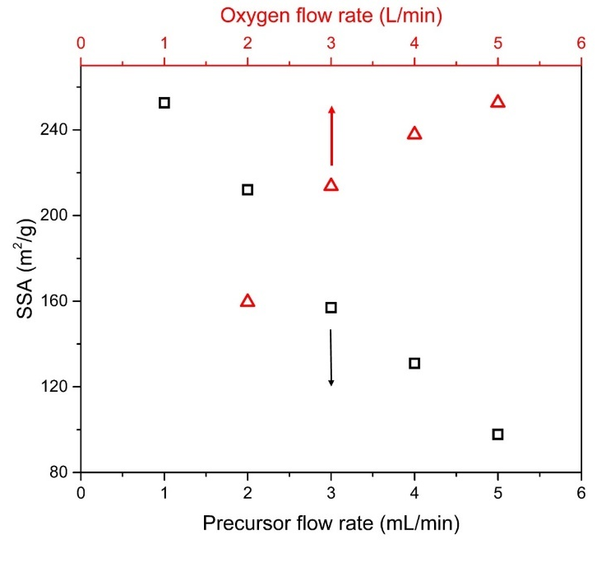
Figure 1. Specific surface area of FSP-made titania as a function of precursor flow rate at constant 5 L/min dispersion-O₂ (black squares, bottom abscissa) as well as of dispersion O₂ flow at constant 1 mL/min precursor feed (red triangles, top abscissa). Increasing the precursor flow and thereby the flame enthalpy and particle concentration decreases the SSA rather linearly while it is increased by higher oxygen flow rates.

Figure 2 shows the XRD patterns of commercial titania P25 (top), FSP-titania as well as sol-gel made TiO₂(B) (bottom) in the region of the most intense reflections between 10° ≤ 2Θ ≤ 35°. The pattern of P25 shows the characteristic reflections of anatase (25.5°, PDF 86-1156) and rutile (27.5°, PDF 87-0710). Peak analysis with the help of a 15 wt% NiO standard (reflection at 42.5°, data not shown, PDF 44-1159) reveals a fully crystalline sample with 88 wt% anatase and 12 wt% rutile similar to Ohtani et al. [4]. Note, however, that in some P25 samples, Ohtani et al. [4] reported up to 13 wt% amorphous fraction, while Jiang et al. [32] determined 7 wt%. Also Bickley et al. [33] and Ohno et al. [34] detected some amorphous material in P25 powders by TEM. An amorphous content of ~23 wt% was determined here for FSP-titania made in the 5/5 flame (green line in Figure 2), along with 68 wt% anatase and the balance rutile. Similar amorphous fractions in FSP titania were recently reported by Fujiwara et al. [9] for an 8/5 flame but lower titanium (IV) tetraisopropoxide concentration (0.16M) and different solvents (2-ethylhexanoic acid and acetonitrile). The anatase to rutile ratio of the FSP 5/5 sample here is similar to that of P25 as well as FSP-made titania reported by Jossen et al. [8], who did not consider the presence of an amorphous fraction.
When the ratio of precursor to dispersion oxygen flow is decreased by reducing the precursor or increasing the dispersion oxygen flow rate, diffraction peaks become broader indicating smaller crystallites in agreement with the increasing specific surface area (Figure 1). Furthermore, the rutile reflection at 27.5° becomes weaker and a reflection at 15° appears indicating the presence of another phase while the peak at 25.5° remains dominant. This is most pronounced for the 1/5 flame having the lowest precursor and highest dispersion oxygen flow rates making it the shortest and coldest flame. These effects did not allow a reliable quantitative determination of the amorphous product fraction for flame ratios below 5/5. However, at least similar amorphous contents are expected as shorter high temperature particle residence times and faster quenching should promote the formation of amorphous domains. This has been observed for instance by Yang et al. [35] and Memon et al. [36] for titania synthesis with diffusion flame reactors as well as in systems employing laser ablation [37], sputtering [38] or electron beam evaporation [39] where particles undergo rapid cooling.
Figure 2. XRD patterns of P25 (top), FSP-titania made with precursor / dispersion oxygen ratios of 1/5 to 5/5, and pure sol-gel TiO₂(B) (bottom) along with the characteristic reflections of TiO₂(B) (bars), anatase (square), rutile (triangle) and brookite (stars). A reflection at ~15° corresponding to TiO₂(B) appears and grows stronger in intensity as the flame ratio is decreased.

The reflection at 15° neither is characteristic for anatase (square) nor rutile (triangle) nor brookite titania (stars, PDF 29-1360). It is the characteristic reflection of TiO₂(B), as shown by comparison with PDF 46-1237 (bars at the bottom of Figure 2) and corresponds to the 001 plane and a spacing of 0.64 nm which is unique to TiO₂(B) [25]. The XRD pattern of a predominantly TiO₂(B) nanopowder made here by a sol-gel process is shown in the bottom row of Figure 2. Reflections at 15°, 25.5°, 28° and 33° can be observed. While the reflection at 15° is unique to TiO₂(B) amongst all TiO₂ crystal structures, the reflection at 25.5° is the dominant reflection for both TiO₂(B) and anatase titania. This overlap makes it difficult to identify TiO₂(B) as the other reflections of TiO₂(B) at 28° and 33° are much weaker and coincide with those of rutile (28°) and brookite (33°).
Interestingly, the presence of TiO₂(B) has never been reported for product titania nanopowders made with flame spray reactors or conventional diffusion or premixed burners, to the best of our knowledge. Many of the previous studies [6-10, 12] even used the same FSP reactor type and similar reactant flow rates. However, XRD analysis was typically performed only in the 2Θ region above 20° [6-8, 10, 11], missing the identifying TiO₂(B) reflection at 15°. This reflection is also not observed in the diffractograms of Teleki et al. [12] and Fujiwara et al. [9] starting at 2Θ=10° and 15°, respectively. Note, however, that both studies employed rather high precursor to dispersion oxygen ratios (5/5 and 8/5 flames, respectively), which result in very small, if any, TiO₂(B) fractions, making detection by XRD almost impossible, in agreement with our work (Fig. 2, 5/5 flame). Very low precursor to dispersion oxygen ratios similar to the 1/5 flame here that yield high TiO₂(B) fractions have seemingly not yet been employed for the production of titania nanoparticles.Figure 3 shows high-resolution TEM images of nanoparticles made in the 1/5 flame. Primary particle sizes are in the order of 5 nm, in agreement with an SSA-equivalent particle diameter of 6 nm, and characteristic for this powder made in a rather cold flame with short high temperature residence time. Sinter necks between primary particles indicate aggregation as particles did not have sufficient time to fuse into larger spheres. In many particles, lattice fringes are discernible up to the surface corroborating a monocrystalline structure. In some particles, the unique 0.64 nm spacing of the 001 plane of TiO₂(B) that gives rise to the reflection at 2Θ = 15° (Figure 2) is revealed (magnification in Figure 3b). This indicates the presence of individual TiO₂(B) crystals in the product nanopowder.
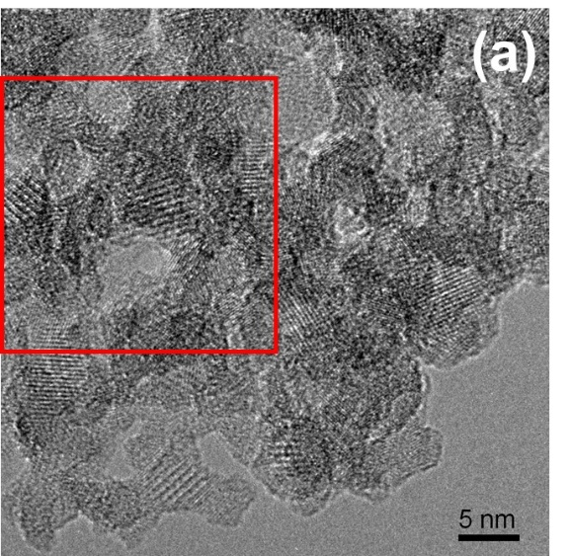
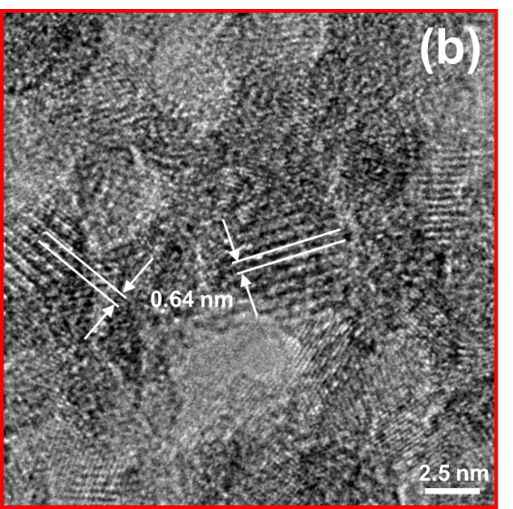
Figure 3. HRTEM image of titania nanoparticles made in the 1/5 FSP flame showing aggregated primary particles of ~5 nm size. The magnified area (red rectangle) shown in (b) reveals the 0.64 nm spacing characteristic for TiO₂(B) in some particles.

Raman spectroscopy is conventionally used to quantify the TiO₂(B) crystal fraction [31]. Figure 4 shows the Raman spectra of P25 (top), the FSP-made titania nanopowders of Figure 2, and sol-gel derived TiO₂(B) (bottom). P25 and all FSP-made powders show the characteristic and pronounced anatase bands [40] at 144, 201, 398, 515 and 639 cm⁻¹. The band at 144 cm⁻¹ shifts slightly as the dispersion oxygen flow rate increases or the precursor flow rate decreases (inset). Such a shift has been reported before for decreasing anatase crystallite sizes [41]. Here, smaller primary particles (Figure 1) and crystals (Figure 2) are produced as the precursor to dispersion oxygen flow ratio decreases. A characteristic Raman mode of rutile titania is at 447 cm⁻¹ but is rather weak and typically difficult to see [40]. It is indicated by a small hump in the spectrum of P25 but is hardly discernible in FSP-made powders here, in line with low rutile contents suggested by XRD (Figure 2).
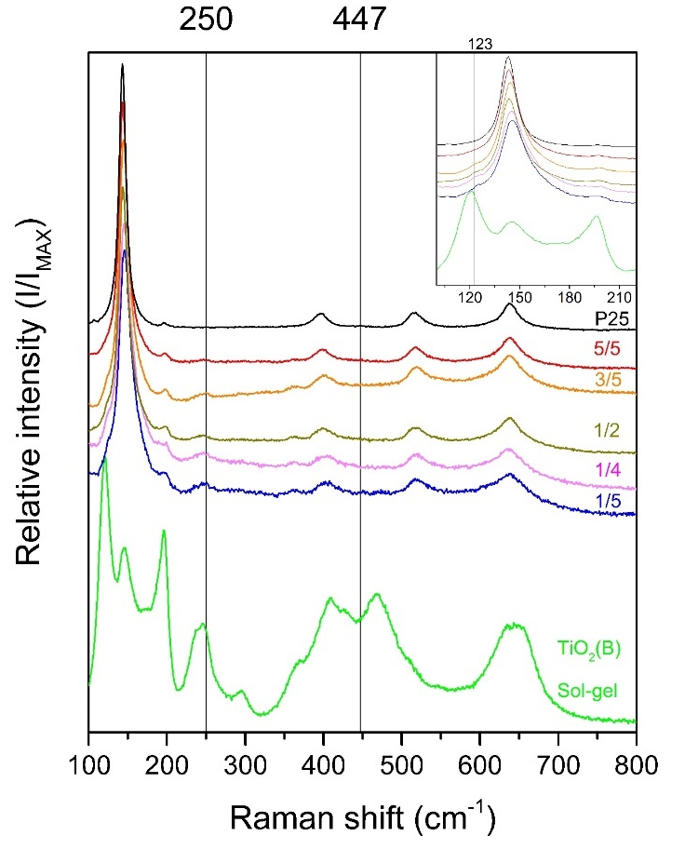
Figure 4. Raman spectra of P25 (top), FSP-made titania, and pure sol-gel TiO₂(B) (bottom) showing the band at 250 cm⁻¹ corresponding to TiO₂(B). The higher magnification in the inset shows the shoulder at 123 cm⁻¹ corresponding to TiO₂(B) as well as the shift of the Raman band around 144 cm⁻¹ due to particle size.

However, a band at 250 cm⁻¹ and a shoulder at 123 cm⁻¹ can be observed in FSP-made titania but not in P25. Those bands are characteristic of TiO₂(B) [20, 31], as is also apparent from the sol-gel TiO₂(B) sample (bottom spectrum in Figure 3). The TiO₂(B) bands at 250 cm⁻¹ and shoulder at 123 cm⁻¹ are strongest in the particles made in the coldest flame with 1/5 setting and weakest in the particles made in the hottest flame, (5/5) in line with XRD results (Figure 2). Such TiO₂(B) bands are also discernible in the Raman spectra of FSP-titania reported by Teleki et al. [12] for a 5/5 flame, the same precursor composition and a similar reactor but had not been assigned.
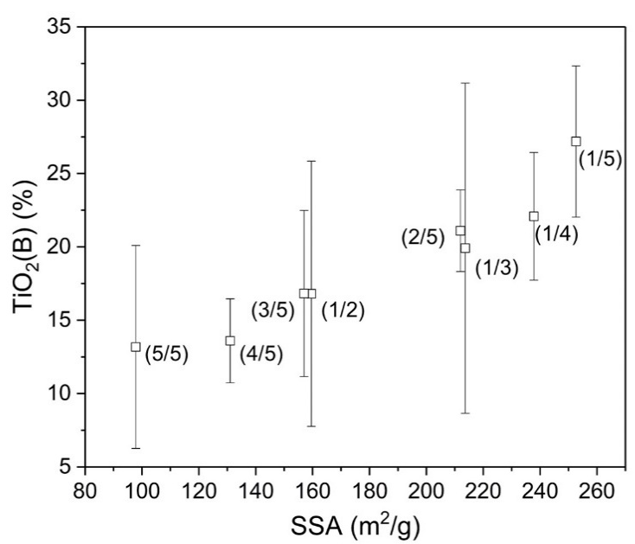
Figure 5. Amount of TiO₂(B) in the crystalline titania fraction (%) as a function of the specific surface area (m²/g). Increasing the specific surface area by decreasing the precursor to dispersion gas feed ratio (P/D) increases the weight fraction of monoclinic titania, TiO₂(B), from ~13% at 98 m²/g to ~27% at 252 m²/g (1/5 flame). Note that the rutile content was negligible in these powders and that a potential amorphous fraction would lower the contributions of the crystalline phases.

The ratio of anatase to TiO₂(B) is quantified by deconvoluting the Raman shifts at 144 cm⁻¹ (anatase) and 123 cm⁻¹ (TiO₂(B)) following Beuvier et al. [31]. Figure 5 shows the amount of TiO₂(B) in the crystalline fraction of the nanopowder as a function of the specific surface area, assuming negligible rutile content. Despite some rather large error bars related to the accuracy of the deconvolution procedure, a clear trend of increasing TiO₂(B) content from ~13 wt-% at 98 m²/g (5/5 flame) to ~27 wt-% at 252 m²/g (1/5 flame) is observed. Particles made in different flames but with similar specific surface area (flames 2/5 and 1/3 or 3/5 and 1/2 flames in Figure 5) also have similar TiO₂(B) contents. It should be kept in mind that the FSP-made titania most likely contains an amorphous fraction, as indicated by Fujiwara et al. [9] and our finding of ~23 wt% for the product of the 5/5 flame. As a consequence, actual fractions of crystalline anatase and TiO₂(B) in the product should be lower than shown in Figure 5. Though, none of those flame conditions produce pure TiO₂(B), it has been demonstrated that titania particles with as little as 5 wt% of TiO₂(B) improve the first discharge capacity of lithium batteries by 20% and rate performance by 25% compared to pure anatase particles [42].
The increasing TiO₂(B) content with increasing specific surface area (Figure 5) indicates that colder and shorter flames, i.e. shorter high temperature particle residence times and possibly faster quenching, promote the formation of monoclinic titania. TiO₂(B) is metastable and recrystallizes into anatase titania at temperatures above 550 °C [43]. FSP flames typically have maximum temperatures above 2000 K [27, 28, 44], much higher than the TiO₂(B) to anatase transition temperature. However, computational fluid dynamics simulations and FSP reactor scaling proposed by Gröhn et al. [27, 44] suggest that a 1/5 xylene-based flame should have a high temperature particle residence time in the order of 1 ms while it is ~10 ms for a 4/5 flame. Apparently, there is simply not enough time at high temperature for TiO₂(B) to recrystallize into the more stable anatase and rutile phases at the high quenching rates encountered in the FSP flames. Other possible explanations for the presence of such a metastable phase in small flame-made particles may be the preferred crystallization in the simplest structure and the formation of the lowest density phase to counteract high surface energies [45]. This is consistent with our observations of increasing TiO₂(B) content with shorter high temperature residence time and resulting smaller primary particles, since TiO₂(B) has the lowest density among all TiO₂ phases and the monoclinic system is one of the simplest crystal structures.
Annealing the nanopowder with the highest TiO₂(B) content made in the 1/5 flame at 500°C for 2 hours removes all characteristic features of TiO₂(B) in both XRD and Raman. Note that this temperature is lower than the phase transition temperature reported by Brohan et al. [43]. Additionally, the rutile XRD reflection at 27.5° can be observed after annealing, as anatase starts to convert into the thermodynamically stable rutile at such temperatures [46]. Similarly, surrounding the 1/5 flame by a tube and thereby preventing ambient air entrainment and flame quenching [29] leads to longer high temperature residence times, and eliminates all signs of TiO₂(B) in XRD and Raman (data not shown). Longer residence times at high temperature may also be the reason why no TiO₂(B) but some rutile is observed in flame-synthesized commercial titania P25 and in nanopowders made with hot-wall reactors [3] or laboratory diffusion flame burners [31, 35].

3.2 Epoxy curing
The performance of FSP-titania made in the 1/5 and 5/5 flames is tested for the photocuring of epoxy and compared to P25, the gold standard for photocatalytic activity, and sol-gel TiO₂(B). Photocuring of polymers is integral in applications like coating, dentistry, the manufacturing of printed circuit boards, and stereolithography 3D printing [47-49]. Previous work demonstrated a novel mechanism to photocure epoxy using semiconducting nanoparticles [50]. Here, we use this reaction to evaluate the photocatalytic activity of the FSP-titania. Note that the power intensity in these experiments is 2 mW/cm², orders of magnitude lower than the W/cm² used in typical stereolithography 3D printing applications employing epoxy photocuring.

Figure 6 shows curing kinetics for the 1/5 (squares) and 5/5 (triangles) FSP titanias, P25 (circles), and sol-gel TiO₂(B) (diamonds) as determined from FTIR spectra by normalizing the epoxide peak [51] at ~910 cm⁻¹ relative to the aliphatic peaks. Titania made in the 5/5 flame having the lowest TiO₂(B) content and being closest in composition to P25 performs similar to P25, despite a more than twice as high surface area of 98 m²/g vs. 47 m²/g. FSP particles made in the 1/5 flame which have the highest TiO₂(B) crystal fraction and the highest surface area (252 m²/g) perform 2-3 times more efficiently than P25. This improvement cannot be explained by the higher surface area alone given the small effect of surface area inferred by comparing the similar performances of P25 and 5/5 titania. This relatively small effect of particle surface area has previously been observed for this reaction also with pure anatase particles [50]. Sol-gel TiO₂(B), with SSA of 39 m²/g, has the poorest performance of all the particles tested. This is attributed to the fact that these are single phase particles. Interactions between multiple crystal structures in mixed phase particles (P25 and FSP-made powders here) reduce the rate of electron hole recombination, significantly improving the photocatalytic activity [22, 50]. Note that the TiO₂(B) to anatase ratio in 1/5 titania is the same as the rutile to anatase ratio in P25.
The amorphous content of FSP-TiO₂ may also affect its photocatalytic activity. Bickley et al. [33] suggested that localized Anderson electronic states at the band edges of the amorphous phase may increase the recombination lifetimes of holes and electrons. On the other hand, Ohtani et al. [52] (1997) reported that the contribution of amorphous titania in mixtures with anatase in three different photocatalytic reactions was negligible. Clearly, a better understanding of the microstructure of FSP-TiO₂ nanoparticles and their interaction is required before the observed enhanced activity in the photocuring of epoxy can be attributed to certain constituents.
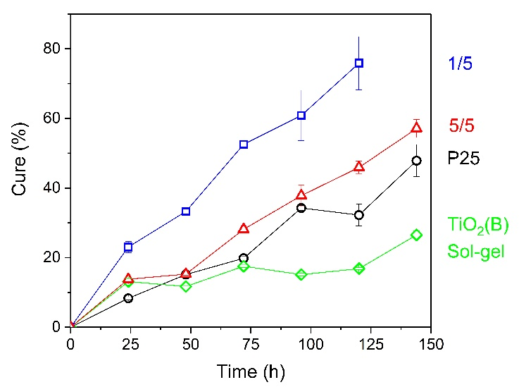
Figure 6. Epoxy photocuring determined from FTIR spectra as a function of time using titania made in 1/5 and 5/5 FSP flames, commercial titania P25, and sol-gel TiO₂(B) as catalysts. Mixtures are epoxy, isopropanol (5 wt%), and nanoparticles (5 wt%). Error bars are 90% confidence limits. Note that flame-made titania outperforms P25, and single phase TiO₂(B).

4. Conclusions
For the first time, we demonstrate the presence of TiO₂(B) in titania nanoparticles made by flame spray pyrolysis, accounting for up to ~27 % of the crystalline fraction. The formation of this metastable phase is attributed to very short (milliseconds) high-temperature residence times and steep temperature gradients of the FSP flame. In addition to anatase and TiO₂(B), FSP-made titania may contain an amorphous weight fraction, as high as ~23%. These phases should be considered in the characterization and performance evaluation of flame-made nanopowders.
Based on catalyst weight, flame-made titania can show higher photocatalytic efficiency for photocuring epoxy compared to P25, the gold standard for photocatalytic activity. Continuous, single-step mass production of such particles can be readily achieved with flame spray pyrolysis in the same manner as P25 is currently mass produced. Monoclinic/anatase mixed particles may open the door to a new class of catalysts and new applications. Here, we show only one such application, catalyzing epoxy photocuring. The performance of these particles should also be investigated in photovoltaic and battery applications. Perhaps this mixture of TiO₂(B) and anatase could replicate the impact of the rutile-anatase system of P25.

Acknowledgments
We thank Professor Sotiris E. Pratsinis for his hospitality and invaluable insights, F. Krumeich for the HRTEM investigations, R. Büchel for help with Raman spectroscopy, and D. Chie for support throughout the project (all ETH Zurich). KBR thanks the Concordia Individualized Program, the Concordia Institute of Aerospace Design and Innovation and the Graduate Student mobility award for travel funding.

References
[1] G. Auer, Titanium Dioxide, in: Industrial Inorganic Pigments, 3rd ed., G. Buxbaum, G. Pfaff (eds.), Wiley-VCH, Weinheim, 2005, pp 51-81.
[2] K. Wegner, S.E. Pratsinis, Scale-up of nanoparticle synthesis in diffusion flame reactors, Chem. Eng. Sci. 58 (2003) 4581-4589.
[3] M.K. Akhtar, S.E. Pratsinis, Dopants in vapor-phase synthesis of titania powders, J. Am. Ceram. Soc. 75 (1992) 3408-3416.
[4] B. Ohtani, O.O. Prieto-Mahaney, D. Li, R. Abe, What is Degussa (Evonik) P25? Crystalline composition analysis, reconstruction from isolated pure particles and photocatalytic activity test, J. Photochem. Photobiol. A - Chemistry 216 (2010) 179-182.
[5] C.R. Bickmore, K.F. Waldner, R. Baranwal, T. Hinklin, D.R. Treadwell, R.M. Laine, Ultrafine titania by flame spray pyrolysis of a titanatrane complex, J. Eur. Ceram. Soc. 18 (1998) 287-297.
[6] W.Y. Teoh, L. Mädler, D. Beydoun, S.E. Pratsinis, R. Amal, Direct (one-step) synthesis of TiO₂ and Pt/TiO₂ nanoparticles for photocatalytic mineralisation of sucrose, Chem. Eng. Sci. 60 (2005) 5852-5861.
[7] Y.K. Kho, W.Y. Teoh, L. Mädler, R. Amal, Dopant-free, polymorphic design of TiO₂ nanocrystals by flame aerosol synthesis, Chem. Eng. Sci. 66 (2011) 2409-2416.
[8] R. Jossen, M.C. Heine, S.E. Pratsinis, S.M. Augustine, M.K. Akhtar, Thermal stability and catalytic activity of flame-made silica-vanadia-tungsten oxide-titania, Appl. Catal. B - Environ. 69 (2007) 181-188.
[9] K. Fujiwara, U. Müller, S.E. Pratsinis, Pd Subnano-clusters on TiO₂ for solar-light removal of NO, ACS Catal. 6 (2016) 1887-1893.
[10] L. Mädler, W.J. Stark, S.E. Pratsinis, Simultaneous deposition of Au nanoparticles during flame synthesis of TiO₂ and SiO₂, J. Mater. Res. 18 (2003), 115-120.
[11] S. Kim, J.J. Gislason, R.W. Morton, X.Q. Pan, H.P. Sun, R.M. Laine, Liquid-feed flame spray pyrolysis of nanopowders in the alumina-titania system. Chem. Mater. 16 (2004) 2336-2343.
[12] A. Teleki, N. Bjelobrk, S.E. Pratsinis, Flame-made Nb- and Cu-doped TiO₂ sensors for CO and ethanol. Sens. Actuators B 130 (2008) 449-457.
[13] J.F. Banfield, D.R. Veblen, D.J. Smith, The identification of naturally occurring TiO₂(B) by structure determination using high-resolution electron microscopy, image simulation and distance-least-squares refinement, Am. Mineral. 76 (1991) 343-353.
[14] M. Fehse, E. Ventosa, Is TiO₂(B) the future of titanium-based battery materials? ChemPlusChem 80 (2015) 785-795.
[15] T. Fröschl, U. Hörmann, P. Kubiak, G. Kučerovà, M. Pfanzelt, C.K. Weiss, R.J. Behm, N. Hüsing, U. Kaiser, K. Landfester, M. Wohlfahrt-Mehrens, High surface area crystalline titanium dioxide: potential and limits in electrochemical energy storage and catalysis, Chem. Soc. Rev. 41 (2012) 5313-5360.
[16] A.R. Armstrong, G. Armstrong, J. Canales, P.G. Bruce, TiO₂-B nanowires, Angew. Chem. Int. Ed. 43 (2004) 2286-2288.
[17] G. Nuspl, K. Yoshizawa, T. Yamabe, Lithium intercalation in TiO₂ modifications, J. Mater. Chem. 7 (1997) 2529-2536.
[18] M. Zukalová, M. Kalbáč, L. Kavan, I. Exnar, M. Graetzel, Pseudocapacitive lithium storage in TiO₂(B), Chem. Mater. 17 (2005) 1248-1255.
[19] A.R. Armstrong, G. Armstrong, J. Canales, R. García, P.G. Bruce, Lithium ion intercalation into TiO₂-B Nanowires, Adv. Mater. 17 (2005) 862-865.
[20] G. Armstrong, A.R. Armstrong, P.G. Bruce, P. Reale, B. Scrosati, TiO₂(B) nanowires as an improved anode material for lithium-ion batteries containing LiFePO₄ or LiNi_{0.5}Mn_{1.5}O₄ cathodes and a polymer electrolyte, Adv. Mater. 18 (2006) 2597-2600.
[21] Z. Sun, X. Huang, M. Muhler, W. Schuhmann, E. Ventosa, A carbon-coated TiO₂(B) nanosheet composite for lithium ion batteries, Chem. Commun. 50 (2014) 5506-5509.
[22] D. Yang, H. Liu, Z. Zheng, Y. Yuan, J. Zhao, E.R. Waclawik, X. Ke, H. Zhu, An efficient photocatalyst structure: TiO₂(B) nanofibers with a shell of anatase nanocrystals, J. Am. Chem. Soc. 131 (2009) 17885-17893.
[23] S. Yin, P. Zhang, B. Liu, X. Liu, T. Sato, D. Xue, S.W. Lee, Microwave-assisted hydrothermal synthesis of monoclinic nitrogen-doped titania photocatalyst and its DeNOx ability under visible LED light irradiation. Res. Chem. Intermed. 36 (2010) 69-75.
[24] R. Marchand, L. Brohan, M. Tournoux, TiO₂(B) a new form of titanium dioxide and the potassium octatitanate K₂Ti₈O₁₇, Mat. Res. Bull. 15 (1980) 1129-1133.
[25] T. Kogure, T. Umezawa, Y. Kotani, A. Matsuda, M. Tatsumisago, T. Minami, Formation of TiO₂(B) nanocrystallites in sol-gel-derived SiO₂-TiO₂ film. J. Am. Ceram. Soc. 82 (1999) 3248-3250.
[26] R. Grosjean, M. Fehse, S. Pigeot-Remy, L. Stievano, L. Monconduit, S. Cassaignon, Facile synthetic route towards nanostructured Fe-TiO₂(B), used as negative electrode for Li-ion batteries. J. Power Sources 278 (2015) 1-8.
[27] A.J. Grӧhn, S.E. Pratsinis, A. Sánchez-Ferrer, R. Mezzenga, K. Wegner, Scale-up of nanoparticle synthesis by flame spray pyrolysis: the high-temperature particle residence time, Ind. Eng. Chem. Res. 53 (2014) 10734-10742.
[28] L. Mädler, H.K. Kammler, R. Mueller, S.E. Pratsinis, Controlled synthesis of nanostructured particles by flame spray pyrolysis, J. Aerosol Sci. 33 (2002) 369-389.
[29] O. Waser, O. Brenner, A.J. Groehn, S.E. Pratsinis, Process design for size-controlled flame spray synthesis of Li₄Ti₅O₁₂ and electrochemical performance, Chem. Process Eng. 38 (2017) 51-66.
[30] C.R. Hubbard, R.L. Snyder, RIR - measurements and use in quantitative XRD, Powder Diffraction 3 (1988) 74-77.
[31] T. Beuvier, M. Richard-Plouet, L. Brohan, Accurate methods for quantifying the relative ratio of anatase and TiO₂(B) nanoparticles, J. Phys. Chem. C 113 (2009) 13703-13706.
[32] X. Jiang, M. Manawan, T. Feng, R. Qian, T. Zhao, G. Zhou, F. Kong, Q. Wang, S. Dai, J.H. Pan, Anatase and rutile in Evonik aeroxide P25: Heterojunctioned or individual nanoparticles? Catal. Today 300 (2018) 12-17.
[33] R.I. Bickley, T. Gonzalez-Carreno, J.S. Lees, L. Palmisanto, R.J.D. Tilley, A structural investigation of titaniumdioxide photocatalysts, J. Solid State Chem. 92 (1991) 178-190.
[34] T. Ohno, K. Sarukawa, K. Tokieda, M. Matsumura, Morphology of a TiO₂ photocatalyst (Degussa, P-25) consisting of anatase and rutile crystalline phases, J. Catal. 203 (2001) 82-86.
[35] G. Yang, H. Zhuang, P. Biswas, Characterization and sinterability of nanophase titania particles processed in flame reactors, NanoStructured Mater. 7 (1996) 675-689.
[36] N.K. Memon, D.H. Anjum, S.H. Chung, Multiple-diffusion flame synthesis of pure anatase and carbon-coated titanium dioxide nanoparticles, Combust. Flame 160 (2013) 1848-1856.
[37] M.H. Jilavi, W.M. Kriven, H. Chung, J. Mazumder, Microstructure characterization of oxide coatings deposited by pulsed excimer laser ablation, J. Mater. Res. 18 (2003) 1623-1630.
[38] F. Meng, Z. Sun, Enhanced photocatalytic activity of silver nanoparticles modified TiO₂ thin films prepared by RF magnetron sputtering, Mater. Chem. Phys. 118 (2009) 349-353.
[39] B. Scheffel, T. Modes, C. Metzner, Reactive high-rate deposition of titanium oxide coatings using electron beam evaporation, spotless arc and dual crucible. Surf. Coat. Technol. 287 (2016) 138-144.
[40] T. Ohsaka, F. Izumi, Y. Fujiki, Raman spectrum of anatase, TiO₂. J. Raman Spectroscopy 7 (1978) 321-324.
[41] A. Li Bassi, D. Cattaneo, V. Russo, C.E. Bottani, E. Barborini, T. Mazza, P. Piseri, P. Milani, F.O. Ernst, K. Wegner, S.E. Pratsinis, Raman spectroscopy characterization of titania nanoparticles produced by flame pyrolysis: The influence of size and stoichiometry, J. Appl. Phys. 98 (2005) 074305.
[42] W. Zhuang, L. Lu, W. Li, R. An, X. Feng, X. Wu, Y. Zhu, X. Lu, In-situ synthesized mesoporous TiO₂-B/anatase microparticles: Improved anodes for lithium ion batteries, Chin. J. Chem. Eng. 23 (2015) 583-589.
[43] L. Brohan, A. Verbaere, M. Tournoux, G. Demazeau, La Transformation TiO₂(B) →Anatase, Mat. Res. Bull. 17 (1982) 355-361.
[44] A.J. Grӧhn, S.E. Pratsinis, K. Wegner, Fluid-particle dynamics during combustion spray aerosol synthesis of ZrO₂, Chem. Eng. J. 191 (2012) 491-502.
[45] R.M. Laine, Liquid Feed-Flame Spray Pyrolysis (LF-FSP), in: Ceramics Science and Technology: The Synthesis of Single- and Mixed-Oxide Nanopowders, R. Riedel, I. Chen, I. (eds) Wiley-VCH, Weinheim, 2012; pp 102-103.
[46] W.D. Kingery, Introduction to Ceramics, John Wiley, New York, 1960.
[47] R.W. Peiffer, Applications of Photopolymer Technology, in: ACS Symposium Series 673, Photopolymerization, A.B. Scranton, C.N. Bowman, R.W. Peiffer (eds) American Chemical Society, 1997, pp 1-14.
[48] Crivello, J. V. The discovery and development of onium salt cationic photoinitiators. J. Polymer Sci. A: Polymer Chem. 37 (1999), 4241-4254.
[49] Y. Yagci, S. Jockusch, N.J. Turro, Photoinitiated polymerization: Advances, challenges, and opportunities. Macromol. 43 (2010) 6245-6260.
[50] K.B. Riad, Photocuring epoxy with quantum dots for 3D printing. Master’s Dissertation, Concordia University, Montreal, 2016.
https://spectrum.library.concordia.ca/980875/1/Riad-%20MSc%20INDI-S2016.pdf
[51] J. Mu, Y. Liu, S. Zheng, Inorganic-organic interpenetrating polymer networks involving polyhedral oligomeric silsesquioxane and poly(ethylene oxide). Polymer 48 (2007) 1176-1184.
[52] B. Ohtani, Y. Ogawa, S. Nishimoto, Photocatalytic activity of amorphous-anatase mixture of titanium(IV) oxide particles suspended in aqueous solutions, J. Phys. Chem. B, 101 (1997) 3746-3752.

